49003 - Economic Evaluation

Western Sydney International Airport Project – Project Evaluation Report

|  |  |  |
| --- | --- | --- |
| **Group 15** | | |
| **Student Name** | **Student Number** | **Percentage Contributed** |
|  |  | 100% |
|  |  | 100% |
|  |  | 100% |
|  |  | 100% |
|  |  | 100% |

# Executive Summary

Sydney Kingsford Smith International Airport (KSA) currently accounts for most of the passenger and airfreight services into New South Wales. However, demand for these services is likely to exceed KSA’s capacity by 2037. Western Sydney International Airport (WSA) is a second international airport currently under construction in the Greater Sydney Region, has been designed to meet the predicted future passenger and airfreight needs of New South Wales.

The project evaluation in this report identified multiple benefits from the construction and operation of WSA. Consumers benefit from additional flight choices offered by multiple airport operators and the local economy benefits through the construction of the aerotropolis which supports the airport operations. There are costs associated with any infrastructure project, and WSA is no exception. The construction and operation cost will be significant, exceeding $5 billion dollars to the 2026 financial period. The financial evaluation conducted shows that the benefits identified far exceed the costs, with a positive Net Present Value and Benefit-to-Cost Ratio above one showing the project will benefit the economy of NSW and Australia.

The final recommendation is that construction of WSA should continue as it provides net benefits to the Australian economy.

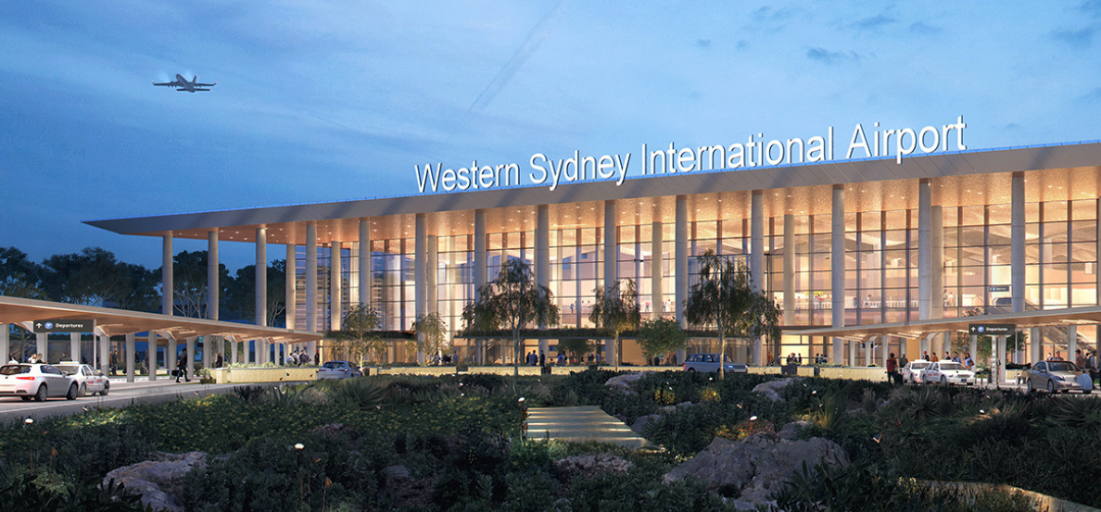

# Introduction

Western Sydney International Airport (WSA) is being constructed to fulfill future demand for passenger and airfreight services arriving at New South Wales. Construction of secondary airports in Melbourne and Brisbane have shown that increasing the capacity of a city to meet those demands results in additional growth as airport operators identify new opportunities to service consumers (Deloitte Access Economics, 2013). The objective of this report is to provide context for the economic evaluation, with a summary of the macroeconomic and microeconomic settings, cost benefit analysis, financial evaluation, and final recommendation on whether the project should continue to be constructed.

# Project Description

Western Sydney International Airport (WSA) is a high priority infrastructure project jointly funded by the Federal Government of Australia and the New South Wales Government. WSA, also known as Nancy Bird Walton International Airport after one of Australia’s greatest female aviators is currently under construction at Badgerys Creek suburb and is envisioned to be an aerotropolis and act as a third centre in the Greater Sydney Region, along with the Sydney CBD and Paramatta. Stage 1 of the WSA project, the construction of the airport facilities and runway operations is expected to be completed and running by late 2026 (Infrastructure Australia, 2016).

## Problem Statements

As Australia’s prime aviation gateway, Sydney Kingsford Smith Airport (KSA) accounts for a substantial percentage of consumer airline and freight services coming into New South Wales. Aviation also has a major contribution to Australia’s economy.

According to an ITAT report (The Importance of Air Transport to Australia, 2018), KSA contributed to 5.5% of Australia’s Gross Domestic Product (GDP) and created 716,000 direct or indirect jobs in 2017. With government intervention on altering aviation policies, KSA is hitting its service capacity in 2037 (Infrastructure Australia Project Business Case Evaluation, 2016). The unmet demand caused by limited capacity would act as a constraint that hinders the growth of the economy around the region.

## Macroeconomic Setting

### Gross Domestic Product (GDP)

Appendix 1 (The World Bank, 2020) shows that Australia’s GDP was 1.77 trillion in 2020 (Converted from USD to AUD). It can also be seen from the graph that it is the first decrease in GDP since 2014, caused by the negative impact of the pandemic.

The WSA project brings in a significant amount of investment from the federal and state governments. The total investment for this project is estimated at $6 billion (Deloitte Australia, 2013). The investment package is set to bring more benefits return value due to characteristic of the Multiplier Effect.

* The additional jobs created by the WSA project leads to an increase in income, which flows into an increase in consumption from employees and related corporations.
* The expanded aviation capacity will secure more trade both domestically and internationally. Australia has been keeping a healthy trade balance over the past years (*Australia’s Trade Balance*, 2021). The expected increase in trade volume by aviation routes will be the main driver that increases our net export value.

In short, the WSA project will contributes a positive impact onto the economy and will result in an increase on Australia’s Gross Domestic Product.

### Interest Rate

Interest rate is the amount of money due when a loan is taken over a period. The interest rate has a significant impact on evaluating the value and viability of a project and its importance should not be overlooked.

Appendix 2 shows a trend of lowering interest rate starting early 2020. The Cash Rate Target was set to 0.10% by the Reserve Bank of Australia and intended to stay at that rate until the inflation rate drops back within the targeted 2-3%. This low interest rate monetary policy intends to stimulate consumption. Consumers feel financially insecure during a pandemic, so they increase their savings rate.

A rise in investments can be expected for an economy with low interest rates as it is easier and cheaper to secure funding from various channels. The WSA project is likely to benefit from low interest rates due to the sizeable investment and the reduction in interest they would be required to pay back over the time.

## Microeconomic Setting

### Supply and Demand of Commercial Flights

The ongoing pandemic restrictions have illustrated a negative impact on the aviation industry. BITRE’s data (Appendix 3, Appendix 4) shows a sharp drop of international and domestic commercial transport activity. In addition to that, the financially unsecured consumers are less likely to purchase high price air transport as this is not considered a necessity. The combination of these two factors means that supply and demand are unlikely to meet equilibrium unless the restriction is lifted.

The good news is that Australia is transitioning to the Vaccination Transition Phase of the National Plan (Australia’s National COVID-19 Response, 2021), 70.8% of the suitable population have been fully vaccinated (Vaccination Numbers and Statistics, 2021). It can be expected that the rehabilitation of aviation industry will start once the interstate border restrictions are eased.

In the short term, the low demand for commercial aviation is still going to hinder the aviation industry. Nonetheless, the aim of the WSA project is to achieve a long-term economic growth for the economics of the region. A second airport will encourage more households and businesses to move into the surrounding area, which results in a greater demand for goods and services, thus boosting the economy around the area.

### Availability of Labour and Wages

The pandemic has had an enormous impact on the Australian labour market. According to a report (Australian National Skills Commission, 2020), although the employment rate for full-time and part-time recovered strongly after an initial dip, the ongoing coronavirus restrictions still prevent some industries from recovering completely. These health restrictions could be a draw back to the progress of the WSA project as certain industries may not operate at full capacity.

Another impactful factor is the increase in minimum wages for selected common types of construction works across Australia (Building and Construction Commission, 2021). This increase in payroll costs could be a significant amount when totalled, altering the hiring strategy for the WSA project and thus could delay the completion of the project.

# Project Evaluation

## Benefits

The WSA project is expected to bring in significant benefits. The identified tangible and intangible benefits are listed below provided with explanation.

### Tangible Benefits

Tangible benefits are benefits that can be quantifiable and measurable in financial terms. There are a few benefits fall into this category.

#### Consumer

The WSA project is expected to benefit air passengers whether they are on business trip or leisure trip. The WSA project meets the needs aviation requirements of the greater Sydney region and ensures more air passengers can be served as KSA reaches maximum capacity.

WSA will provide more airline options for the consumers to choose from. Furthermore, there will be no curfew for the WSA so passengers have more options when selecting what time, they can travel to or from Sydney. These options would make air transport more affordable and accessible.

#### Airport Operators

The increase of air passengers will benefit the airport operators as they are no longer limited by the capacity of KSA. The airport facilities will also provide income through ancillary shopping and entertainment services or other airport related services.

The curfew-less WSA also enables 24x7 operation for commercial airlines or airfreight. This would increase airport efficiency and reduce operation cost.

### Intangible Benefits

Intangible benefits are benefits with impacts but will not be included in the evaluation calculation because they are not monetary and are hard to quantify and calculate. There are a few benefits fall into this category.

#### More Employment Opportunities

The biggest intangible benefit brought by the WSA is the employment opportunities it brings. It is estimated to create around 30,000 additional direct jobs for the Western Sydney region (Deloitte Australia, 2013). More indirect jobs will be created when more businesses are attracted to the aerotropolis. Additional jobs mean more earning and more spending for the people. This would lead to a positive multiplier effect that stimulates economic growth.

#### Better Connectivity

A new airport means better connectivity for the people or businesses inside the aerotropolis. The infrastructure package will provide convenience for consumers and businesses as it enhances passenger and freight movements in terms of cost and time. The quality of life and business profits for the surrounding area is expected to arise.

#### Less Noise for residents around KSA

The approval of WSA implies there are no further expansions planned for KSA. The WSA will also redirect some of the flights away from KSA so the people living along the flight path near WSA will suffer less noise pollution.

#### More Business Opportunities

The WSA and surrounding aerotropolis will form new communities and bring in business opportunities for investors. These opportunities are expected to benefit the local community and spur economic growth in the Greater Sydney Region.

## Costs

### Tangible Costs

The three main tangible costs identified in this project are opportunity costs of land, capital expenditure and operating and maintenance (Australian Government Department of Infrastructure and Regional Development, 2016).

The opportunity cost of land is the potential benefit WSA is forgoing by using the land for airport construction and operation. The cost of this opportunity is measured to be AUD 81 million.

The construction of the airport and other related items require capital. The amount is calculated to be AUD 4,173.9 million.

When the airport is constructed and ready for its operations, another cost incurs. The cost is known as operating and maintenance. The amount for this cost is AUD 1,716.7 million.

The costs mentioned above are discounted at 7% starting in 2015 (Australian Government Department of Infrastructure and Regional Development, 2016).

### Intangible Costs

While the tangible costs can be quantified as shown above, the projects also incur some intangible costs which cannot be easily measured. These costs derive from social and environmental factors.

Among many intangible costs, noise pollution and sonic vibration causes harm along the flight path and airport surroundings. This negative externality is unavoidable and would occur as WSA is expected to allow flights at any time (Australian Government Department of Infrastructure and Regional Development, 2016).

Additional intangible costs are the loss of biodiversity in the surrounding area as construction of the airport demolishes the local habitats of flora and fauna. The noise and air pollution may also cause health issues for the surrounding residents, negatively impacting their quality of life (Australian Government Department of Infrastructure and Regional Development, 2016).

Hazards and risks are another cost that needs to be mentioned. The operation of the airport and its related activities are not guaranteed to be always successful even though the operations follow strict rules and standards. The businesses and individuals who live or operate within the area might suffer from any risks incurred which are related to the operation of the airport (Australian Government Department of Infrastructure and Regional Development, 2016).

Project Viability Indicators – Financial

To estimate the project viability from the financial perspective, two indicators are used: Net Present Value (NPV) and Benefit-to-Cost Ratio (BCR).

### Net Present Value (NPV)

Due to the scarcity of the data related to the differences in costs and benefits for each year within the duration of the project, the following formula is used to calculate the NPV.

A positive NPV shows that the project will be viable.

The benefits and costs are already adjusted from the data source, therefore the PVIFAi,n and PVIFi,n is removed from the formula. Moreover, the salvage value cannot be determined and is assumed to be zero because there is insufficient data on the purchase price of land and the useful life of the resources is not mentioned. Therefore, the formula becomes:

### Benefit to Cost Ratio (BCR)

The benefit-to-cost ratio expresses the worthiness of a project by taking the ratio of cash inflows (benefits) over cash outflows (costs). A BCR above 1 suggests the project will be beneficial.

Both the NPV and BCR results suggest that the project is viable.

## Project Viability Indicators – Socioeconomic

Noise is a concerning factor for residents and businesses around the airport. Even though there will be an increase in noise around Western Sydney airport, there will be a reduction in noise around KSA because some flights can be redirected to the new airport.

Moreover, the WSA project could bring more opportunities in terms of employment and business opportunities which could offset the hazards and risks involved with the operation of the airport.

Even though the quality of air, water and biodiversity is impacted by the construction and operation of the airport, the new airport improves connectivity which could bring about new opportunities that enhance the quality of the lives of people within the area nearby the airport.

Therefore, it can be argued that the benefits derived from the new airport exceed the costs which mean the project is feasible from a socioeconomic perspective.

# Recommendation and Further Analysis

The project evaluation shows that the construction and operation of Western Airport Project would bring significant benefits to the New South Wales and overall Australian economy.

As noted in our report, tangible benefits include the consumer benefits through competitive prices and increased flight choices offered by the flight operators based out of Western Sydney Airport.

Intangible benefits include increased employment opportunities derived from the construction of the Western Sydney Airport and surrounding aerotropolis, better connectivity through a reduction in passenger and freight travel times and the transfer of flights from Kingsford Smith Airport to Western Sydney Airport will reduce the amount of flight noise over residential areas.

The financial evaluation conducted also supports the construction of Western Sydney Airport, with a positive Net Present Value (NPV) result of $5,441 billion and Benefit to Cost Ratio of 1.9 showing that the project will bring a positive result to the Australian economy.

This report’s final recommendation is that Western Sydney Airport should continue to be constructed to meet the future passenger and airfreight needs of Australia.

There are several limitations in our report which may adversely impact the chance of achieving the estimated economic benefits. Key limitations identified in the report include.

* Reliance on second-hand data from previously published reports makes it difficult to confirm the accuracy of the data used for the financial evaluation.
* The economic benefits are derived from long term passenger demand forecasts which are only accurate 80% of the time.
* Broader economic benefits from increased trade, tourism and foreign direct investment were identified in the project evaluation but were unable to be quantified.
* The Net Present Value was calculated using a discount rate of 7% over the 60-year period. This discount rate is an estimate, and the real interest rate may vary from this estimate depending on the economic conditions at the time.

The reader should be aware of these limitations and adjust their expectations accordingly.

# **References**

An Airport for Western Sydney. (2016). *Australian Government, Department of Infrastructure and Regional Development - DIRD*. <https://www.westernsydneyairport.gov.au/sites/default/files/summary_brochure-an_airport_for_WS.pdf>

Australian Government Department of Infrastructure and Regional Development. (2016). *Western Sydney Airport Business Case Summary.* <https://www.westernsydneyairport.gov.au/sites/default/files/WSA_Business_Case_summary.pdf>

Australia’s National COVID-19 Response. (2021, July). *Department of the Prime Minister and Cabinet, Australian Government.* <https://www.pm.gov.au/sites/default/files/media/national-plan-060821_0.pdf>

Australia’s Trade Balance. (2021). *Australian Government Department of Foreign Affairs and Trade.* from <https://www.dfat.gov.au/trade/resources/trade-statistics/australias-trade-balance>

Building and Construction Commission. (2021). *FWC announces minimum wage increase | ABCC*. <https://www.abcc.gov.au/news-and-media/fwc-announces-minimum-wage-increase>

Central Banks to Pour Money Into Economy Despite Sharp Rebound. (2021, April 20). Bloomberg. <https://www.bloomberg.com/tosv2.html?vid=&uuid=99c33e72-2b21-11ec-8029-61466c6d5563&url=L25ld3MvYXJ0aWNsZXMvMjAyMS0wNC0xOS9yb2J1c3QtcmVib3VuZC13b24tdC1hdWd1ci1lbmQtdG8tc3RpbXVsdXMtY2VudHJhbC1iYW5rLWd1aWRl>

Deloitte Access Economics (2013). *Economic Impact Of A Western Sydney Airport.* <https://www2.deloitte.com/content/dam/Deloitte/au/Documents/finance/deloitte-au-fas-economic-impact-western-sydney-airport-240914.pdf>

Domestic Air Fares. (2021). Bureau of Infrastructure and Transport Research Economics. <https://www.bitre.gov.au/statistics/aviation/air_fares>

Economic Response to COVID-19. (n.d.). Australian Government Treasury. <https://treasury.gov.au/coronavirus>

EY. (2016). *Western Sydney Airport Environmental Impact Statement.* <https://www.westernsydneyairport.gov.au/sites/default/files/WSA-EIS-Volume-4-Appendix-P3-Economic-analysis.pdf>

Hawkins, J. (2021, July 28). *Now that Australia’s inflation rate is 3.8%, is it time to worry?* The Conversation. <https://theconversation.com/now-that-australias-inflation-rate-is-3-8-is-it-time-to-worry-165098>

Hurley, P., & Matthews, H. (2021, August 24). *The government has again rescued the childcare sector from collapse. But short-term fixes still leave it at risk*. The Conversation. <https://theconversation.com/the-government-has-again-rescued-the-childcare-sector-from-collapse-but-short-term-fixes-still-leave-it-at-risk-166568>

Infrastructure Australia. (2016). *Infrastructure Australia Project Business Case Evaluation.* <https://www.infrastructureaustralia.gov.au/sites/default/files/2019-06/WSA_Project_Brief_0.pdf>

International airline activity. (2021). Bureau of Infrastructure and Transport Research Economics - BITRE. <https://www.bitre.gov.au/statistics/aviation/international>

NSW Treasury. (2017). NSW Government Guide to Cost Benefit Analysis. <https://www.treasury.nsw.gov.au/sites/default/files/2017-03/TPP17-03%20NSW%20Government%20Guide%20to%20Cost-Benefit%20Analysis%20-%20pdf_0.pdf>

Reserve Bank of Australia. (n.d.). *Cash Rate Target*. <https://www.rba.gov.au/statistics/cash-rate/>

The Importance of Air Transport to Australia. (2018). IATA Economics. <https://www.iata.org/en/iata-repository/publications/economic-reports/australia--value-of-aviation/>

The World Bank. (2020). *Australia GDP 2000–2020 (current US$)* <https://data.worldbank.org/indicator/NY.GDP.MKTP.CD?end=2020&locations=AU&start=2000>

United States Inflation Rate. (n.d.). TRADING ECONOMICS <https://tradingeconomics.com/united-states/inflation-cpi>

Vaccination numbers and statistics. (2021, October 13). Australian Government Department of Health <https://www.health.gov.au/initiatives-and-programs/covid-19-vaccines/numbers-statistics>

Western Sydney Airport. (2021, September). *About the airport*. <https://www.westernsydneyairport.gov.au/about>

Western Sydney Airport. (2020). *Annual Report 2020.* <http://www.westernsydney.com.au/sites/default/files/2020-10/WSA%20Annual%20Report_2020.pdf>

Western Sydney Planning Partnership. (2020). *Draft Aerotropolis Precinct Plan.* <https://shared-drupal-s3fs.s3-ap-southeast-2.amazonaws.com/master-test/fapub_pdf/00+-+Planning+Portal+Exhibitions/Western+Syd+Aero+Planned+Precincts+/WSAPP+new/WesternSydneyAerotropolis_PrecinctPlanningReport_v9.pdf>

# Appendix

## Appendix 01 - Australian GDP from 2000-2020 in USD (Trillion)

*Appendix 1, Australian GDP from 2000-2020 in USD (Trillion) (The World Bank, 2020)*

## Appendix 02 - Graph of the Interest (Cash) Rate Target of Australia

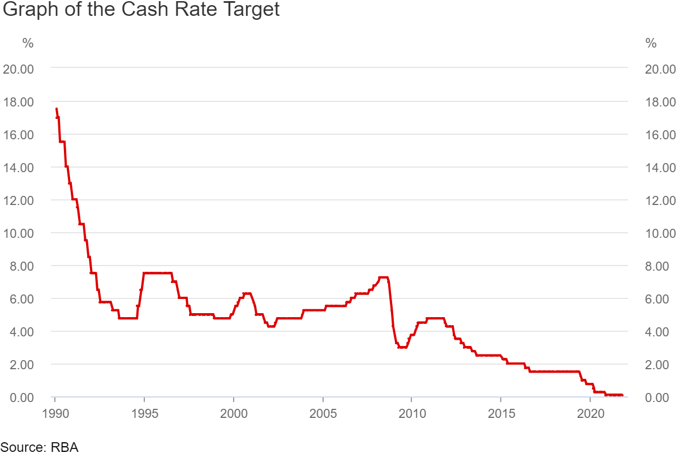

*Appendix 2, Graph of the Interest (Cash) Rate Target of Australia (Reserve Bank of Australia, n.d.)*

## Appendix 03 - International Passengers by Month (millions)

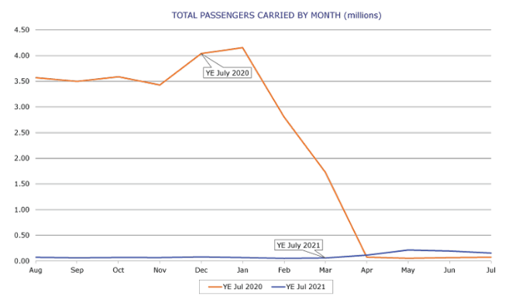

*Appendix 3, International Passengers by Month (millions) (International Airline Activity, 2021)*

## Appendix 04 - Domestic Passenger Traffic (millions)

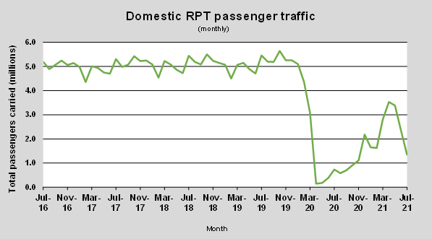

*Appendix 4, Domestic Passenger Traffic (millions) (Domestic Air Fares, 2021)*

## Appendix 05 (Summary of Reports)

Multiple data sources were identified and collated to identify appropriate datasets which allowed the authors calculate the Net Present Value (NPV) and Benefit-to-Cost Ratio (BCR).

Below is a summary of the economic indicators/evaluations identified in each report.

1. **Department of Infrastructure and Regional Development – Business Case Summary**

This business case summary was submitted to Infrastructure Australia in October 2016 and contained an economic analysis incorporating.

* An economic cost-benefit assessment (including an NPV and BCR).
* Socioeconomic assessment
* Economic impact assessment (how the project impacts the land, household income and jobs of the surrounding area).

The NPV table provides an appropriate dataset, however the financial figures were already discounted by 7% over a 60-year period (see below).

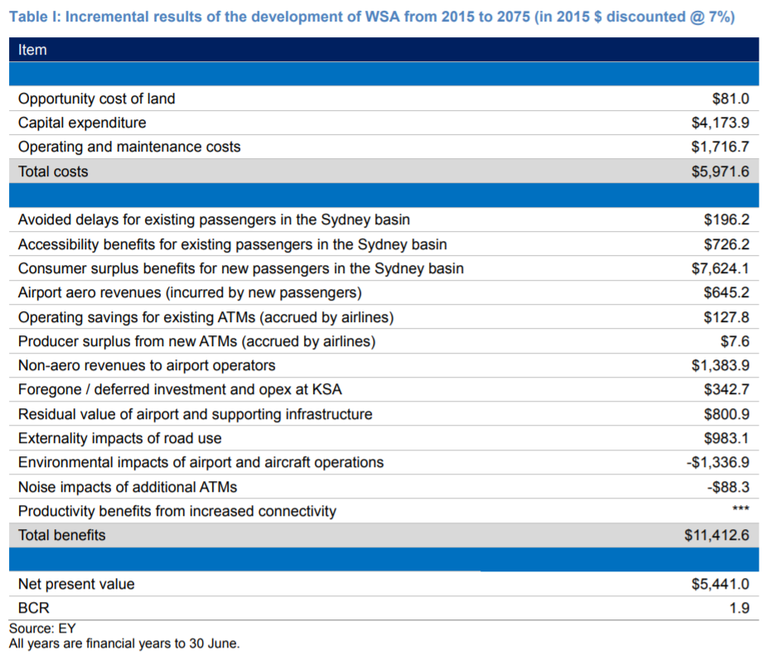

*Appendix 5, Table of NPV and BCR data (Deloitte Australia, 2013)*

The above figures were used to determine the customer’s NPV and BCR.

1. **Infrastructure Australia – Project Business Case Evaluation**

This report used the same figures noted in Appendix 5 above.

The report writers provided an overview of the assumptions used in calculating the economic evaluation. These issues include.

* Long-term passenger demand forecast modelling issues
* Exclusion of the change in air fares
* Inconsistent treatment of real escalation in costs and benefits
* Fuel taxes have been included in vehicle operating costs when they should be excluded
* Urban congestion cost estimates have been applied
* Broader economic impacts such as impacted trade, tourism and foreign direct investment were identified, but not quantified in the above table

1. **Deloitte Access Economics – Economic Impact of a Western Sydney Airport**

This report identified the economic impact of a Western Sydney Airport by identifying the NPV impact over a 30-year period from 2020 to 2050. The benefits for the Sydney economy overall were estimated to range from $15.7 billion to $25.6 billion.

3 possible growth scenarios were provided in the report.

1. Scenario 1: Western Sydney Airport expanding only to meet unmet demand for a constrained Kingsford Smith Airport
2. Scenario 2: Demand growth in addition to scenario 1, with a growth of 5-20% of passenger demand.
3. Scenario 3: Growth in line with scenario 2, with additional freight activity in the earlier stages of the airport.

Passenger movement estimates, market share calculations, industry employment estimates, wages growth estimates and small to medium business growth estimates were also calculated and included in the report.

1. **EY – Western Sydney Airport Environmental Impact Statement**

The economic indicators covered in this report cover the economic/employment impact of airport construction, direct employment at the airport and land use modelling.

However, this report did not include the economic ramifications of the total airport usage, so the economic indicators are unlikely to be useful for our evaluation.

1. **Western Sydney Airport – Annual Report 2020**

The annual report provides the corporate governance statement, statement of comprehensive income, statement of financial position and statement of changes in equity.

None of these figures were used in our project evaluation.

## Appendix 06 (NSW Cost benefit Guide)

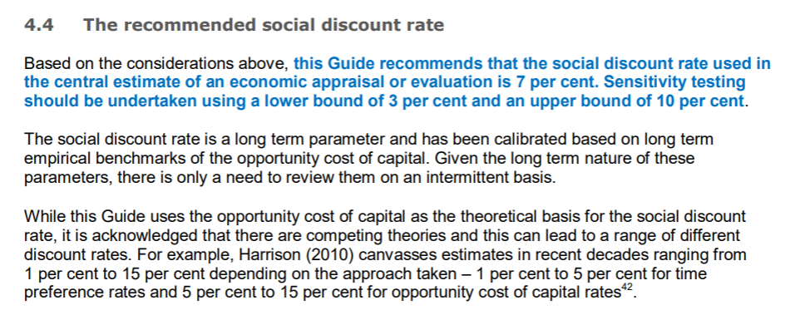

Extract from the NSW Treasury Cost Benefit Guide highlighting in blue why the discount rate has been set at 7%.

## Appendix 07 (Infrastructure Australia Report)

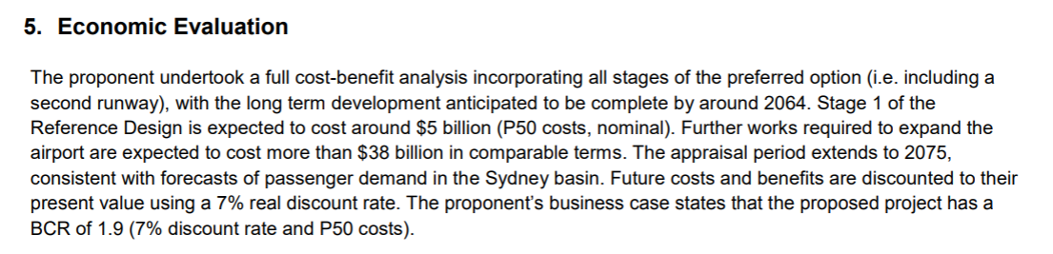

Extract from the Infrastructure Australia report showing the costs expected to be incurred at each stage.

## Appendix 08 (Infrastructure Australia Report)

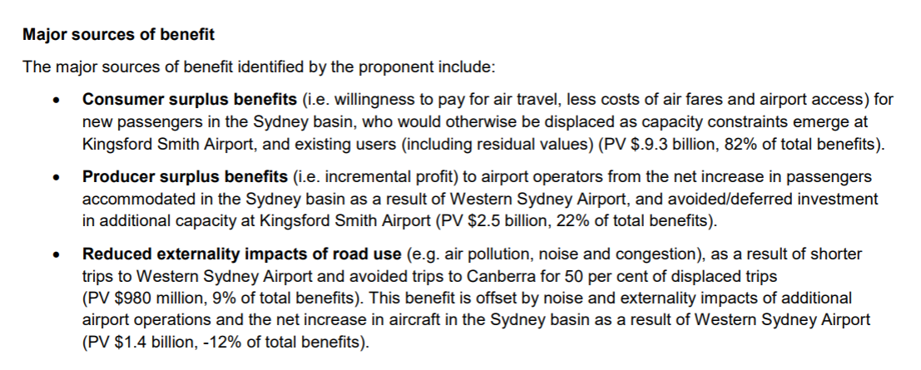

Extract from the Infrastructure Australia report showing the major sources of benefits expected to arise from construction of the Western Sydney Airport.

## Appendix 09 - Dataset

### Cost

|  |  |  |  |
| --- | --- | --- | --- |
| **Cost Name** | **Data Figure** | **How it was collected** | **Data Source** |
| Capital Expenditure | 4173.9 million PV (2015) | Directly extracted from the report | Pp6, (*Infrastructure Australia Project Business Case Evaluation*, 2016) |
| Operating and maintenance costs | 1716.7 million PV (2015) | Directly extracted from the report | Pp6, (*Infrastructure Australia Project Business Case Evaluation*, 2016) |

### Tangible Benefits

|  |  |  |  |
| --- | --- | --- | --- |
| **Benefit Name** | **Data Figure** | **How it was collected** | **Data Source** |
| Consumer Benefit | 9,300 million  PV (2015) | Directly extracted from the report | pp 6, WSA Project Brief (*Infrastructure Australia Project Business Case Evaluation*, 2016) |
| Airport Operator Benefits | 2,500 million  PV (2015) | Directly extracted from the report | pp 6, WSA Project Brief (*Infrastructure Australia Project Business Case Evaluation*, 2016) |

### Intangible Benefits Table

|  |  |
| --- | --- |
| **Benefit** | **Description** |
| More Employment Opportunities | Intangible in financial terms.  Create around of 30,000 additional direct jobs by 2050. More indirect jobs are created by the growth the businesses sparked by the airport circle (Deloitte Australia, 2013). |
| Less Noise for residents around KSA | Intangible in financial terms. No more expansion and less flight in KSA will lead to less noise generation. |
| Better Connectivity | Intangible in financial terms. Enhance the quality of life and business by providing convenient travel and freight. |
| Less Noise for residents around KSA | The approval of KSA implicates no further expansion in KSA so that they do not need to push the operation into late hours. |
| More business opportunities | New communities and bring in business opportunities for investors. |

### Others

|  |  |  |  |
| --- | --- | --- | --- |
| **Data Type** | **Data Figure** | **How it was collected** | **Data Source** |
| Real discount rate (2015) | 7% | Directly extracted from the report | pp 6, WSA Project Brief (*Infrastructure Australia Project Business Case Evaluation*, 2016) |
| Lifespan of the Project (n) | 60 years, (2015 – 2075) | Key years (starting and ending) extracted from the report. Calculated by finding the difference. | Pp2, WSA Project Brief (*Infrastructure Australia Project Business Case Evaluation*, 2016) |
| Salvage Value  (L) | N/A | The land purchase price was unable to be determined as the land was purchased in various transactions beginning in the 1980’s. | N/A |