Abstract—

Binaural Masking Level Difference (BMLD) assessment is a crucial tool for evaluating binaural hearing loss, and binaural audio tone stimuli are commonly used for this purpose. However, there is currently no consensus on the optimal frequency, duration, and phase of these stimuli to produce the most accurate and reliable BMLD measurements. n this paper, we present the results of a study aimed at establishing the optimal parameters of binaural audio tone stimuli for BMLD assessment in binaural hearing loss. A total of 35 participants with normal hearing were recruited for the study. Binaural audio tone stimuli were presented at different frequencies (125, 250, 500, 750, and 1000 Hz), durations (3, 18, and 48 ms), and with different phase differences (0 and 180 degrees). We used Wilcoxon, Friedman, and post hoc Nemenyi statistical tests.The results showed that the optimal frequency for BMLD assessment varied depending on the duration of the stimulus. For 18 ms and 48 ms stimuli, 750 Hz was the optimal frequency, while 500 Hz produced the best results for 3 ms duration stimuli. Additionally, longer stimulus durations (18 ms and 48 ms) produced more reliable BMLD measurements than shorter durations (3 ms). Finally, out-of-phase stimuli were found to produce larger BMLDs than in-phase stimuli, indicating their potential usefulness for detecting binaural hearing loss.These findings provide valuable insights into the optimal parameters of binaural audio tone stimuli for BMLD assessment in binaural hearing loss and may help improve the accuracy and reliability of this important diagnostic tool.

Stimuli
A Blackmann windowed pure tone was used for testing. The tone was embedded in a 10 Hz bandwidth and of 500 ms duration Gaussian noise masker. We tested the frequencies 125 Hz, 250 Hz, 500 Hz, 750 Hz and 1000 Hz. The center frequency of the masker and the frequency of the tone were set the same for each set of the trials. The tones for BMLD testing were given with a duration of 3 ms , 18 ms and 48 ms. The initial dB level for the masker is set as 20 dB while it is set at 40 dB for the tone. A total of 50 trials are done for each frequency, out of which 25 had stimuli with both tone and noise in phase (S0N0) in both the ears while the remaining had stimuli with the tone out of phase and the noise in phase (SπN0).

Analysis and results

IBM SPSS Statistics V26 (IBM Corp., Armonk, NY, USA), and Excel Office 2010 (Microsoft, Redmond, WA, USA) were used for the statistical analysis.
The data were studied to understand the distribution among subjects and groups. The BMLD measurements obtained for the input stimuli 3 ms, 18 ms and and 48 ms respectively at five different frequencies are plotted in Fig. 4. It can be seen that the variability among the three signals of different duration per frequency. The data points represent the average across the thirty five normal hearing subjects. Error bars represent ±1 standard error of the mean. However, they differ for different frequencies. For all signal durations, 3 ms 18 ms and 48 ms the frequency of 125 Hz produced significantly higher BMLD values compared to the other four frequencies (250 Hz, 500 Hz, 750 Hz and 1000 Hz). This agrees with previous literature.

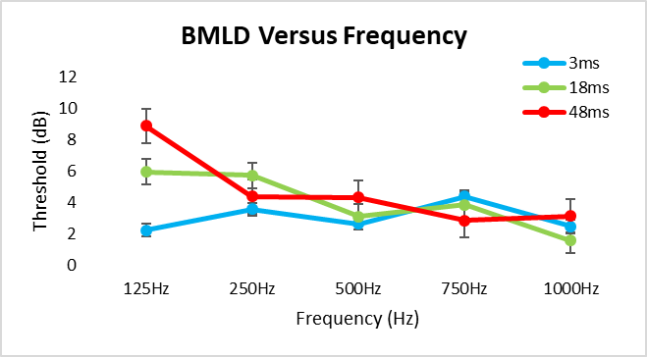
Fig. 1. BMLD Vs Frequency

The mean (M) and standard deviations (SD) for each condition were calculated and are shown in Table II.

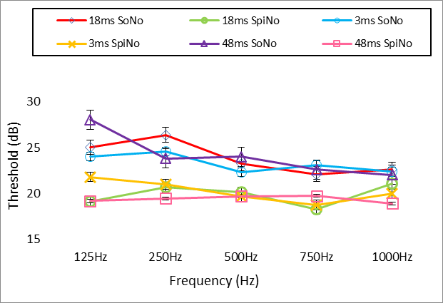
Fig. 2.SoNo and SpiNo Vs Frequency for 3ms, 18ms and 48ms input signals

The plots in Fig. 5. provide an overview of the distribution of SoNo and SpiNo data for different frequencies of different durations. The data points represent the average across the thirty five normal hearing subjects. Error bars represent ±1 standard error of the mean. Both S0N0 and SπN0 thresholds vary with the frequency although the S0N0 thresholds vary more drastically. While considering the changes among signals of different duration, for 125 Hz and 500 Hz the S0N0 BMLD is increasing. However, for all other frequencies, the variation among the signals is constant. At high frequencies (750 Hz and 1000Hz), the BMLD values are higher for the 3 ms signal than for the longer signals. For the lower frequencies, the BMLD values are mostly lower for the 3ms input signal than for the longer signals.

Table 2
Descriptive statistics of Data Set

 |  |  | 3ms |  | 18ms |  | 48ms
 |  | N | Mean | Standard Deviation (SD) | Mean | Standard Deviation (SD) | Mean | Standard Deviation (SD)
125 Hz | BMLD | 35 | 2.22 | 8.27 | 5.93 | 9.85 | 8.87 | 8.89
125 Hz | SoNo | 35 | 24.04 | 9.23 | 25.06 | 10.9 | 28.05 | 11.69
125 Hz | SpiNo | 35 | 21.82 | 8.79 | 19.13 | 8.59 | 19.19 | 8.25
250 Hz | BMLD | 35 | 3.55 | 7.56 | 5.71 | 6.29 | 4.36 | 6.08
250 Hz | SoNo | 35 | 24.58 | 10.56 | 26.41 | 12.17 | 23.85 | 11.48
250 Hz | SpiNo | 35 | 21.03 | 10.57 | 20.7 | 9.75 | 19.49 | 8.74
500 Hz | BMLD | 35 | 2.63 | 5.78 | 3.1 | 6.24 | 4.3 | 7.76
500 Hz | SoNo | 35 | 22.34 | 8.58 | 23.28 | 10.74 | 24.03 | 11.94
500 Hz | SpiNo | 35 | 19.71 | 8.36 | 20.18 | 8.85 | 19.73 | 8.32
750 Hz | BMLD | 35 | 4.36 | 5.48 | 3.85 | 5.94 | 2.85 | 6.28
750 Hz | SoNo | 35 | 23.13 | 11.32 | 22.13 | 11.45 | 22.62 | 11.38
750 Hz | SpiNo | 35 | 18.77 | 8.37 | 18.27 | 7.66 | 19.77 | 9.33
1000 Hz | BMLD | 35 | 2.48 | 7.5 | 1.57 | 5.84 | 3.12 | 6.37
1000 Hz | SoNo | 35 | 22.45 | 11.48 | 22.66 | 10.35 | 22.05 | 11.37
1000 Hz | SpiNo | 35 | 19.97 | 8.38 | 21.1 | 12.09 | 18.93 | 8.99

The dataset under analysis is numerical, and to test the influence of phase reversal and establish significant differences between the means of threshold recorders under inphase and antiphase conditions, a statistical test was conducted. To determine which inferential statistics could be performed, normality of data and equality in variance were tested. Normality was checked using the Shapiro-Wilks test, with the null hypothesis assuming that the data was normally distributed. Results shown in TABLE III indicated that most of the data rejected this null hypothesis, indicating that the data was not normally distributed. To check the equivalence of variance between threshold recordings under phasic and antiphasic conditions, Levene's Test was performed, and the results suggested that the variances were not equal.

TABLE 3
Shapiro-Wilks Test Results

 |  | Frequencies | N | Statistic | p-value | Decision at level (5%)
BMLD | 3ms | 125 | 35 | 0.94533 | 0.08144 | Can't reject normality
BMLD | 3ms | 250 | 35 | 0.95037 | 0.11634 | Can't reject normality
BMLD | 3ms | 500 | 35 | 0.88876 | 0.002 | Reject normality
BMLD | 3ms | 750 | 35 | 0.9849 | 0.90157 | Can't reject normality
BMLD | 3ms | 1000 | 35 | 0.93469 | 0.03864 | Reject normality
BMLD | 18ms | 125 | 35 | 0.82539 | 6.6885E-5 | Reject normality
BMLD | 18ms | 250 | 35 | 0.9403 | 0.05716 | Can't reject normality
BMLD | 18ms | 500 | 35 | 0.94207 | 0.0647 | Can't reject normality
BMLD | 18ms | 750 | 35 | 0.82819 | 7.6633E-5 | Reject normality
BMLD | 18ms | 1000 | 35 | 0.90334 | 0.00487 | Reject normality
BMLD | 48ms | 125 | 35 | 0.94204 | 0.06457 | Can't reject normality
BMLD | 48ms | 250 | 35 | 0.82204 | 5.6901E-5 | Reject normality
BMLD | 48ms | 500 | 35 | 0.9306 | 0.02915 | Reject normality
BMLD | 48ms | 750 | 35 | 0.92563 | 0.02078 | Reject normality
BMLD | 48ms | 1000 | 35 | 0.83849 | 1.2775E-4 | Reject normality
SoNo | 3ms | 125 | 35 | 0.85524 | 3.0396E-4 | Reject normality
SoNo | 3ms | 250 | 35 | 0.87617 | 9.6068E-4 | Reject normality
SoNo | 3ms | 500 | 35 | 0.86515 | 5.1892E-4 | Reject normality
SoNo | 3ms | 750 | 35 | 0.94607 | 0.08581 | Can't reject normality
SoNo | 3ms | 1000 | 35 | 0.9412 | 0.06086 | Can't reject normality
SoNo | 18ms | 125 | 35 | 0.86809 | 6.1028E-4 | Reject normality
SoNo | 18ms | 250 | 35 | 0.92769 | 0.0239 | Reject normality
SoNo | 18ms | 500 | 35 | 0.901 | 0.00421 | Reject normality
SoNo | 18ms | 750 | 35 | 0.85257 | 2.6388E-4 | Reject normality
SoNo | 18ms | 1000 | 35 | 0.96295 | 0.27989 | Can't reject normality
SoNo | 48ms | 125 | 35 | 0.88288 | 0.00141 | Reject normality
SoNo | 48ms | 250 | 35 | 0.87403 | 8.5062E-4 | Reject normality
SoNo | 48ms | 500 | 35 | 0.94315 | 0.06983 | Can't reject normality
SoNo | 48ms | 750 | 35 | 0.87687 | 9.9989E-4 | Reject normality
SoNo | 48ms | 1000 | 35 | 0.84098 | 1.4494E-4 | Reject normality
SpiNo | 3ms | 125 | 35 | 0.83323 | 9.8194E-5 | Reject normality
SpiNo | 3ms | 250 | 35 | 0.84652 | 1.9249E-4 | Reject normality
SpiNo | 3ms | 500 | 35 | 0.8654 | 5.2599E-4 | Reject normality
SpiNo | 3ms | 750 | 35 | 0.93236 | 0.03291 | Reject normality
SpiNo | 3ms | 1000 | 35 | 0.83235 | 9.4022E-5 | Reject normality
SpiNo | 18ms | 125 | 35 | 0.84969 | 2.2690E-4 | Reject normality
SpiNo | 18ms | 250 | 35 | 0.92642 | 0.02192 | Reject normality
SpiNo | 18ms | 500 | 35 | 0.87951 | 0.00116 | Reject normality
SpiNo | 18ms | 750 | 35 | 0.89779 | 0.00345 | Reject normality
SpiNo | 18ms | 1000 | 35 | 0.87777 | 0.00105 | Reject normality
SpiNo | 48ms | 125 | 35 | 0.91346 | 0.00928 | Reject normality
SpiNo | 48ms | 250 | 35 | 0.80761 | 2.8873E-5 | Reject normality
SpiNo | 48ms | 500 | 35 | 0.84525 | 1.8025E-4 | Reject normality
SpiNo | 48ms | 750 | 35 | 0.86055 | 4.0379E-4 | Reject normality
SpiNo | 48ms | 1000 | 35 | 0.82903 | 7.9836E-5 | Reject normality

Based on the normality test, the equivalence of variance, and a sample size of 35, non-parametric tests such as the Wilcoxon rank-sum test or Kruskal-Wallis test were considered more appropriate as they are more robust to small sample sizes than parametric tests.

It was important to consider whether the data were paired or non-paired. In this study, the same subjects were tested against different conditions, making the data paired. A Kruskal-Wallis test would assume independence between observations, whereas repeat observations on the same subjects were related. Therefore, the non-parametric Wilcoxon signed rank test, which accounts for the pairing of observations by making pairwise comparisons, was applied to determine statistical significance.

The test statistic calculated by the Wilcoxon signed rank test was the sum of the signed ranks of the differences between the two samples, i.e., under inphase and antiphase conditions, with positive ranks given to the sample with the larger value. In this case, a large absolute value of the test statistic indicated strong evidence against the null hypothesis, and a small absolute value indicated weak evidence against the null hypothesis. The sign of the test statistic indicated the direction of the difference between the medians of the two samples.

If the p-value returned by the Wilcoxon test was greater than the chosen significance level (p=0.05), and the test statistic (sum of the positive signed ranks of the differences between the two samples) was relatively high, it meant that there was weak or no evidence against the null hypothesis, which in this case was that the mean of threshold recorded under inphase and antiphase conditions were significantly different. Table 6 showed the result of the Wilcoxon test performed on the threshold of 35 subjects in inphase condition vs. antiphase for all three durations and all five frequencies. Statistical differences between SoNo and SpiNo conditions were statistically different except for the combination where the duration was 3 ms seconds, and the frequency was 1000Hz.

TABLE 4 Wilcoxon Test Results

duration | freq | pvalue | Significance | STATS
3ms | 125 | 0.0387335 | Significant | 189
3ms | 250 | 0.0074584 | Significant | 141
3ms | 500 | 0.0042495 | Significant | 120.5
3ms | 750 | 4.227E-05 | Significant | 58
3ms | 1000 | 0.0618649 | Non Significant | 176
18ms | 125 | 0.000998 | Significant | 105
18ms | 250 | 1.532E-05 | Significant | 38.5
18ms | 500 | 0.000998 | Significant | 105
18ms | 750 | 0.0001936 | Significant | 79.5
18ms | 1000 | 0.0091218 | Significant | 145
48 | 125 | 2.692E-06 | Significant | 23
48 | 250 | 3.922E-05 | Significant | 57
48 | 500 | 0.0044193 | Significant | 131
48 | 750 | 0.0062278 | Significant | 137.5
48 | 1000 | 0.0075571 | Significant | 131

In this study, we utilized BMLD data to evaluate the impact of time duration and frequency. BMLD represents the difference in minimum detectable levels between in-phase and anti-phase presentations and is measured in decibels (dB). We selected one duration and compared the BMLD for all 5 frequencies (125Hz vs 250Hz, 500Hz vs 750Hz vs 1000Hz). We repeated this test for two additional durations. As the BMLD data failed the normality test, we opted for a non-parametric test, specifically the Friedman test. The Friedman test is useful for determining significant differences between the means of three or more related groups, unlike the Wilcoxon signed-rank test, which compares two related groups.

The F score generated by the Friedman test was used to evaluate the degree of difference between the groups being compared. A higher F score indicates a greater degree of difference, while a lower F score indicates less difference. The results of the Friedman test are shown in Table 5, and it was found that the results for the 3ms duration were not significant, with a correspondingly low F score compared to the results for the 18ms and 48ms durations.

TABLE 5 FRIEDMAN Test Results

Friedman Test:
125hz vs 250Hz vs 500Hz vs 750 Hz vs 1000hz
Duration | Fscore | P_value | significance
3 | 3.0117 | 0.55587 | Non significat
18 | 11.079 | 0.02569 | signifiacant
48 | 15.947 | 0.00309 | signifiacant

The Nemenyi test, also referred to as the Nemenyi-Damico-Wolfe-Dunn (NDWD) test, is a post-hoc test commonly used to compare all possible pairs of frequencies subsequent to the null hypothesis being rejected in a Friedman test. This test compares all potential groups using a critical value that is based on the Studentized range distribution. If the mean rank difference between a pair of groups is larger, then these two groups are significantly different from each other. By utilizing the mean rank differences, the groups can be ranked based on their performance, with the group possessing the highest mean rank being considered the top performer and the group possessing the lowest mean rank being considered the worst performer. The results of these test are given in table 6 7 and 8.
TABLE 6 FRIEDMAN Test Results
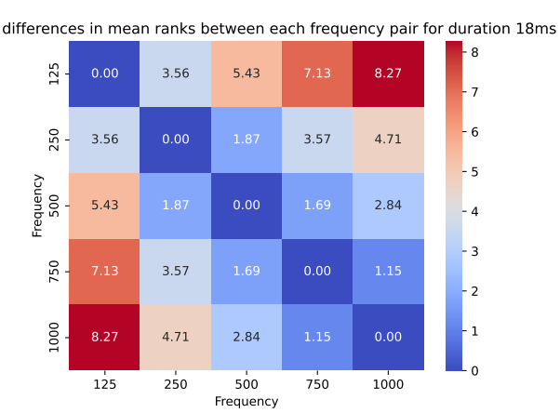
TABLE 7 FRIEDMAN Test Results

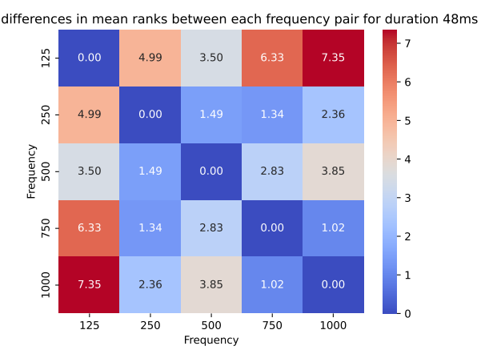

TABLE 8 FRIEDMAN Test Results

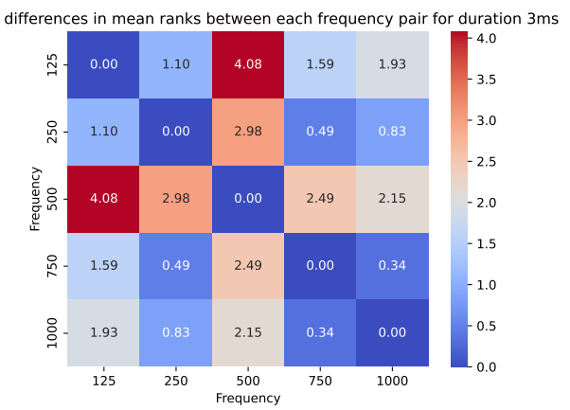
The interpretation of the Mean Rank Differences for BMLD using Nemenyi test involves identifying significant differences in performance between the frequncies based on their mean ranks and the critical difference value(cd= 1.258 for this 18 and 48 ms data).If the mean rank difference between two groups is greater than the CD value, the two groups are considered significantly different from each other.

Based on the mean rank differences, we can rank the frecuncies in terms of their performance. The frequencey with the highest mean rank is considered to perform the best, while the frequncy with the lowest mean rank is considered to perform the worst.Fig 3 and figure 4 show the mean rank differece of all frequncies for all three durations
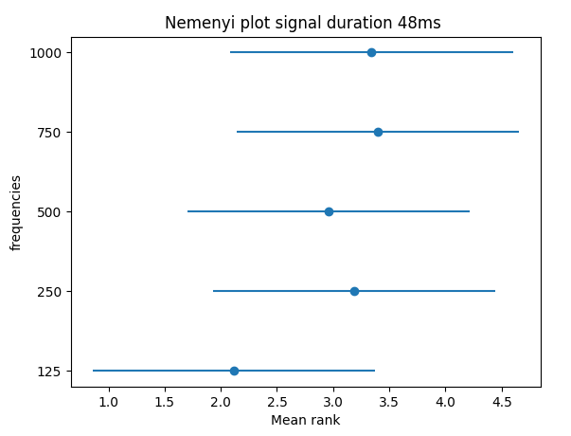
Fig. 3. Mean Ranks of frequencies for 48ms

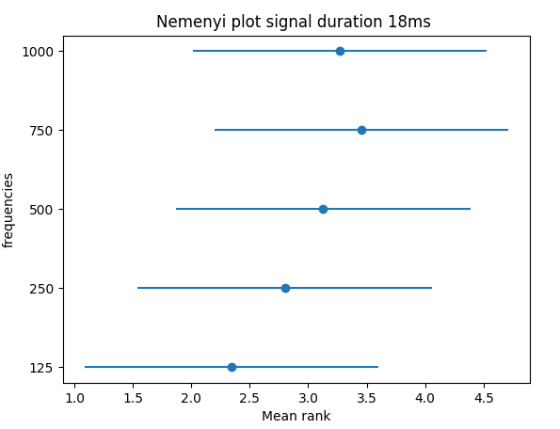
Fig. 4. Mean Ranks of frequencies for 18ms
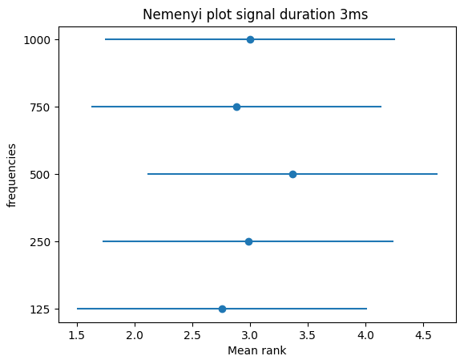
Fig. 5. Mean Ranks of frequencies for 3ms

Discussion
The results of BMLD experiments conducted mainly comes up with some findings in relative to the basic analysis to complex statistical tests. In the initial analysis with the data collected and plotted, the lower frequency indicates the highest BMLD regardless of the 3ms, 18ms and 48ms stimuli responses. In our study, 125Hz has the highest BMLD value which agrees with previous studies [4]. Considering the mean value, the difference between the two signal conditions in phase (S0N0) and out of phase (SπN0), seems to be relevant.
When the phase of the stimuli is the same with that of noise, the threshold is high because the stimuli and noise seem to be in the same source. However, in the antiphasic condition, the signal is reversed relative to that of the noise, and the threshold value is low, seeming to be a different source [5].
Based on the results presented in Table 4, it can be concluded that there is a statistically significant increase in the binaural masked threshold (BMLD) under the antiphase condition as compared to the inphase condition, as indicated by a positive Wilcoxon test statistic. Therefore, it can be inferred that the SπN0 condition provides better auditory cues compared to the S0N0 condition. Furthermore, the lower threshold observed under the antiphase condition suggests an improvement in the detectability of signals in noise. [6]. The normality test for the data proved that the samples are not normally distributed which supports findings of similar BMLD studies in literature[7].

On the other hand, the significance of the collected data sets together with the selection of best stimuli type and frequencies were also the major objectives of the study. The Friedman non-parametric test conducted for the three significant data combinations indicates the best stimulus duration for further cortical. As per the result of Friedman for three combination of data as show in Table 5 and explained in anyslsis section , the 18ms and 48ms BMLD values across all frequency groups were significantly different whereas the BMLD of 3ms was not [8]. The difference in the origin of response might be one of the reasons for non-significance of the 3ms data. The 3ms signals originate from the brainstem, however the 18ms and 48ms are considered as the cortical responses[8]. While considering the reference to the hearing anatomical facts, the 3ms might show the cochlear nuclei to inferior pathways which does not includes the output from the neurons responsible for BMLD generation [9, 10]. This may be a reason for the significance in the values of BMLD for slow cortical auditory evoked potentials (48ms) and for the middle latency response (18ms). This indicates that the brain processes corresponding to BMLD occur in a different pathway from brainstem or beyond the brain stem auditory processing [11]. Since there exist literature for lower contribution of 3ms for BMLD, the 18ms and 48ms signals are to be analysed in detail in the future research. The awakeness and attentiveness for the subjects during the test may also improve the 18ms and 48ms values [12]. The Nemenyi test post hoc statistical test is used to see pairwise statistical significance between the frequency pair under different time duration .From the result of Nemenyi test it can be seen that parir wise mean rank differences for frequencies for 18ms and 48ms in table 6 and 7 are significantly higher then pair wise mean rank differences for 3ms which further strength that 18ms and 48ms stimuli duration are more appropriate to elicit EEG response for the measurement of electrophysiological BMLD.

The frequencies were also studied for the different signals. The best frequencies for BMLD with respect to the type of stimuli are different for different signals. Nemenyi plot are used to rank all the frequncies for each duration with respect to mean rand differce as show in figure 3 ,4, and 5.As per our , Nemenyi plot 750 Hz best choice for the 18ms and 48m stimuli duration and 500hz is the most appropriated frequency for the duration of 3ms .However 3ms we have fail to establish the statistical significance between frequencies for the duration 3ms .As the frequency selection for further studies resulted in different choices, it is important to analyse the effect of various frequencies in the electrophysiological studies too.
The results of different studies in literature indicate that the underlying mechanisms for binaural processing at both low and high frequencies are similar. Hence the frequency-dependent variations in BMLDs were probably small [13].

The following Table XII sums up the findings of the current study which forms a base reference for the conduction of electrophysiological BMLD study with the same set of stimuli. However, the study will be conducted for 18ms and 48ms but for low to high frequencies.

TABLE XII
Findings of the study

Best Condition | - Antiphasic (SpiNo)
Best Frequencies | - 500 Hz for 3ms  - 750 for 18ms  - 750 for 48ms
Best signal duration for BMLD | - 18ms

Conclusion
The present study concludes that the SπN0 provides better auditory cues compared to that of the S0N0 condition. Also, the 18ms and 48ms are the best signals to be used for further studies on binaural interactions. The brain processes corresponding to BMLD occur in a different pathway beyond the brainstem processing. This indicates the significance of binaural interaction study with the 18ms and 48ms signals for future research. The frequency dependency on BMLD generation is not the same for all type of auditory evoked potential generating stimuli, however on basic analysis we concluded that as frequency increases, BMLD decreases.

Future research
The future scope of the current study is to analyze the underlying auditory processing for subcortical region with the best BMLD generating stimuli. As a result of present study, the electrophysiological studies for understanding binaural processing will be carried out in the future with the 18ms and 48ms stimuli for all the same frequencies. The stimuli conditions and samples would remain same in future research to perform a comparison on binaural interactions for subjective and objective hearing tests.

References
[1] K. Mackie, P. J. J. o. S. Dermody, Language,, and H. Research, "Use of a monosyllabic adaptive speech test (MAST) with young children," vol. 29, no. 2, pp. 275-281, 1986.
[2] G. J. A. J. o. A. Plant, "The development of speech tests in Aboriginal languages," vol. 13, no. 1, pp. 30-40, 1990.
[3] V. Aithal, A. Yonovitz, S. J. A. Aithal, and T. New Zealand Journal of Audiology, "Tonal masking level differences in Aboriginal children: Implications for binaural interaction, auditory processing disorders and education," vol. 28, no. 1, pp. 31-40, 2006.
[4] E. Zwicker and G. B. Henning, "Binaural masking-level differences with tones masked by noises of various bandwidths and levels," Hearing Research, vol. 14, no. 2, pp. 179-183, 1984/05/01/ 1984.
[5] J. McCullagh and D.-E. Bamiou, "Measures of binaural interaction," 2014.
[6] M. Brown and F. J. T. H. J. Musiek, "Pathways: The fundamentals of masking level differences for assessing auditory function," vol. 66, no. 1, pp. 16-17, 2013.
[7] S. Koiek, C. Brandt, J. H. Schmidt, and T. J. I. J. o. A. Neher, "Monaural and binaural phase sensitivity in school-age children with early-childhood otitis media," pp. 1-8, 2021.
[8] C. G. J. J. o. S. Fowler, Language, and H. Research, "Electrophysiological evidence for the sources of the masking level difference," vol. 60, no. 8, pp. 2364-2374, 2017.
[9] C. G. Fowler and C. J. J.-A. A. O. A. Mikami, "Phase effects on the middle and late auditory evoked potentials," vol. 7, pp. 23-30, 1996.
[10] Z. Kevanishvili and Z. J. S. a. Lagidze, "Masking level difference: an electrophysiological approach," vol. 16, no. 1, pp. 3-11, 1987.
[11] W. Y. S. Wong and D. R. Stapells, "Brain Stem and Cortical Mechanisms Underlying the Binaural Masking Level Difference in Humans: An Auditory Steady-State Response Study," vol. 25, no. 1, pp. 57-67, 2004.
[12] M. J. Polonenko and R. K. J. E. Maddox, "Exposing distinct subcortical components of the auditory brainstem response evoked by continuous naturalistic speech," vol. 10, p. e62329, 2021.
[13] S. v. d. Par and A. Kohlrausch, "A new approach to comparing binaural masking level differences at low and high frequencies," vol. 101, no. 3, pp. 1671-1680, 1997.

 This work supported by Charles Darwin University, Northern Territory; Australia. (Corresponding Author: Sami Azam) Eva Ignatious is with the College of Engineering and IT; Charles Darwin University, Casuarina, Australia (e-mail: eva.ignatious@cdu.edu.au). Sami Azam is with the College of Engineering and IT; Charles Darwin University, Casuarina, Australia (e-mail: Sami.Azam@cdu.edu.au). Mirjam Jonkman is with the College of Engineering and IT; Charles Darwin University, Casuarina, Australia (e-mail: Mirjam.Jonkman@cdu.edu.au). Friso De Boer is with the College of Engineering and IT; Charles Darwin University, Casuarina, Australia (e-mail: friso.deboer@cdu.edu.au).

