Abstract— The binaural masking level difference (BMLD) is a psychoacoustic method to determine binaural interaction and central auditory processes. The BMLD is the difference in hearing thresholds in homophasic and antiphasic conditions. The duration time and frequency of the stimuli can affect the BMLD. The main aim of this study is to evaluate the BMLD for stimuli of different durations and frequencies which could also be used in future electrophysiological studies. To this end we developed a GUI to present different frequency signals of variable duration and determine the BMLD. Three different durations and five different frequencies are explored. The results of the study confirm that the hearing threshold for the antiphasic condition is lower than the hearing threshold for the homophasic condition and that differences are significant for signals of 18ms and 48ms duration. Future objective binaural processing studies will be based on 18ms and 48ms stimuli with the same frequencies as used in this paper.
Binaural Masking Level Difference for Pure Tone Signals
Eva Ignatious, Fellow, IEEE, Sami Azam, Member, IEEE, Mirjam Jonkman, Member, IEEE and Friso De Boer

Index Terms—Binaural Hearing, BMLD, Auditory Evoked Potentials, Binaural Interaction, Brain processing, Phases

Introduction
The binaural masking level difference (BMLD) is an indication of the ability of humans to detect signals masked in noise in different conditions. This relevant for clinical groups such ageing adults with and without hearing loss and cochlear implant users [1]. Many possible stimuli can be used for the BMLD, involving the supply of different combinations of signals (S) and noise (N) maskers to the ears. The most common scenario is where threshold calculations are done by presenting the signal homophasic to both ears (S0N0), compared to presenting the signal in one ear in an antiphasic way with respect to the other ear (SπN0) [1, 2]. The noise (N) masker can also be presented in an antiphasic way. A BMLD can occur when the SπN0 or S0Nπ threshold is lower than the S0N0 threshold, demonstrating the benefit of binaural processing.

The BMLD generation in response to auditory signals occurs most likely in the superior olivary complex of the brain [3-5] However, some electrophysiological studies of auditory evoked potentials indicate that the BMLD generation is at cortical level [6-8]. It is important to understand the effect of similar stimuli in both traditional psychophysical studies (BMLD tests), which are based mainly on subjective feedback from the subjects, and electrophysiological studies.

There are several characteristics that affect the size of the BMLD, including stimulus type (e.g., spondaic words or pure tones) frequency, type of masking noise, masker level and masking bandwidth. Binaural hearing affects detection of stimuli in noise as well as recognition tasks. Literature indicates that BMLDs of normal-hearing subjects for pure tones are functions of frequency [9]. The size of the BMLD is highly dependent on the stimulus frequency. BMLD thresholds can be 5–15 dB which tends to be maximal for low-frequency bands [10]. With increasing frequencies, the BMLD tends to decline [11]. Tones, clicks and speech can all elicit a BMLD [12]. However, the present study is focused on pure tones which is an area that has been identified as relevant for future research.

As there is a research gap in identifying neural correlates of BMLD generation, it is important to study the BMLD stimuli which are able to evoke potentials in physiological studies related to the brain-hearing activities. This may help future researchers to make use of suitable frequencies, signal lengths and other parameters for electrophysiological hearing studies. This study investigates the BMLD for the pure tone signals which can evoke auditory potentials in objective hearing research.

For this research a MATLAB based Graphical User Interface (GUI) is developed for the convenient conduction of BMLD experiments. This GUI makes it easier to select stimulus frequencies, types of masking noise, masker levels and masking bandwidths during the trials. This study also investigates what effect the duration of pure tone stimuli for frequencies ranging from 125 Hz to 1000 Hz has on BMLD values. The duration of signals was selected in a way that they can elicit auditory evoked potentials in the electrophysiological binaural hearing experiments, which will be described in our next paper. In the present study we make use of three stimuli durations 3 ms, 18 ms and 48 ms at five different frequencies to record the corresponding BMLD responses. During these initial studies we kept all the other tonal and noise parameters constant in order to get a good understanding of the effect of duration of pure tone of stimuli for different frequencies.

Methodology

Subjects
The study was approved by the Humans Ethics Committee of Charles Darwin University, Australia as explained in H18014 _ Detecting Binaural Processing in the Audiometric EEG [13, 14]. The willingness of volunteers to take part in the BMLD testing was documented through written consent and each subject completed a questionnaire regarding their otological history. The study group consisted of 35 participants (17 females and 18 males). The participants ranged in age from 20 to 35 years (mean age = 26.17years; SD = 4.06 years).

Screening
All participants were screened to fulfil the inclusion criteria through a questionnaire and a pure tone audiometry hearing test. The hearing test was carried out to detect the hearing threshold levels of participants at different frequencies, in accordance with the relevant Australian Standards, and to determine whether these were acceptable. All the selected subjects had normal audiograms with a threshold value of 25dB hearing level (HL) for the frequency range 125Hz to 2KHz.

Stimuli
A Blackmann windowed pure tone was used for testing. The tone was embedded in a 10 Hz bandwidth and of 500 ms duration Gaussian noise masker. We tested the frequencies 125 Hz, 250 Hz, 500 Hz, 750 Hz and 1000 Hz. The centre frequency of the masker and the frequency of the tone were set the same for each set of the trials. The tones for BMLD testing were given with a duration of 3 ms, 18 ms and 48 ms. The time durations were chosen to corresponds to the duration of signals that can be used for the generation of AEPs [13, 14]: 3 ms for the Auditory Brainstem Response (ABR), 18 ms for the Middle Latency Response (MLR) and 48 ms for the Late Latency Response (LLR). The initial dB level for the masker is set as 20 dB while it is set at 40 dB for the tone. A total of 50 trials are done for each frequency, out of which 25 had stimuli with both tone and noise in phase (S0N0) in both the ears while the remaining had stimuli with the tone out of phase and the noise in phase (SπN0). The selected condition of tone and noise is differently for each subject but 25 trials for each condition are carried out.
The stimuli were delivered to the ER.2 insert earphones via an external sound card (Creative Sound Blaster Omni Surround 5.1). The ER.2 research earphones used for the audio stimulus delivery were calibrated at 60 dB Sound Pressure Level (SPL) before the start of every hearing test.

APP Development

MATLAB was used in the study for developing a GUI to assist the data collection for BMLD. In our approach, an interactive MATLAB based CDU_BMLD APP was developed for stimulus generation and presentation. The APP enables easier and more efficient conduction of the BMLD tests for different conditions (including frequencies and time periods). Table I describes the details of the APP. Fig. 1. shows the main window of the app. This is the first window that the data collector (user) sees upon running the app.
Table I
GUI (Cdu_bmld_app) details

CDU_BMLD_APP Tiles | Options in list
General Details
Subject Code | User written
Age | User written
Trials | User written and it will be taken for SoNo condition and SpiNo condition (ex: if 25- 25 SoNo and SpiNo will be send to the subject)
Sampling Frequency (Hz) | User written - will be taken in Hz
Masker
Noise Type | Drop down options – Gaussian  - White Noise
Centre Frequency (Hz) | User written - will be taken in Hz
Bandwidth (Hz) | User written - will be taken in Hz
Duration (s) | User written - will be taken in s
Initial dB | User written - will be taken in dB
Signal
Type | Drop down options – ABR  - MLR  - LLR  - Others
Frequency (Hz) | User written - will be taken in Hz
Rise & Fall Time (ms) | User written - will be taken in ms
Window | Drop down options – Blackmann
Duration (ms) | While selecting “Type” for ABR, MLR and LLR it will be automatically 3, 18 and 48ms  For other: User written - will be taken in ms
Initial dB | User written - will be taken in dB
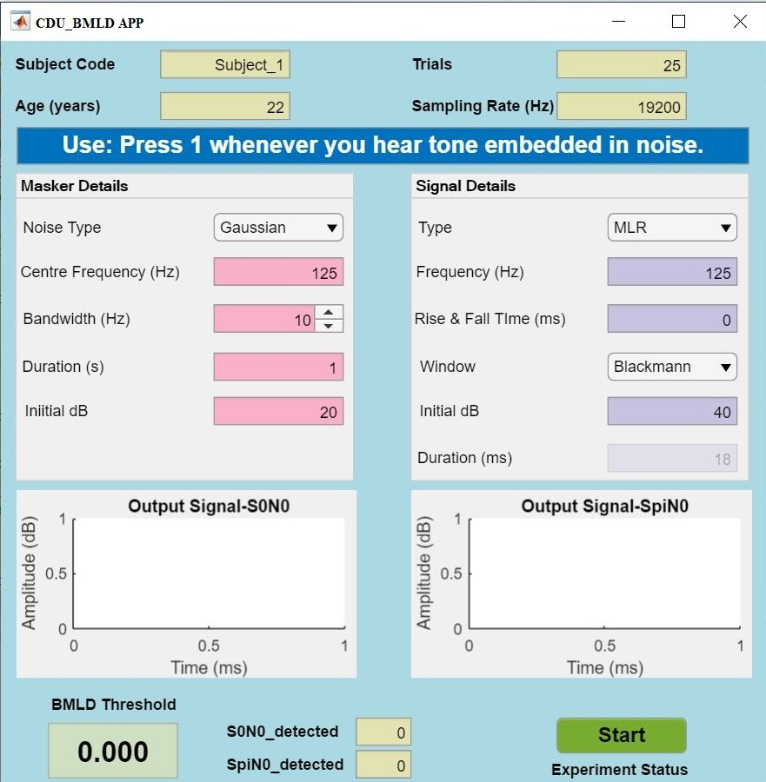
Fig. 1. Starting window of APP
Once the window appears, the user completes the initial basic fields subject code, age, number of trials and the sampling rate. The user can then select the masker and signal details that are required to generate the stimuli. After completing the details, the start button is pressed. The App will then generate signals according to specifications given by the user and shows these in the figure areas of the app window, refer to Fig. 2. The experiment is then in progress. The participant presses the key “1” when they detect the signal (tone) embedded in the masker. The key presses are saved, and once the experiment is completed, a window as in Fig. 3 is shown, from which the BMLD values can be obtained for further offline analysis.
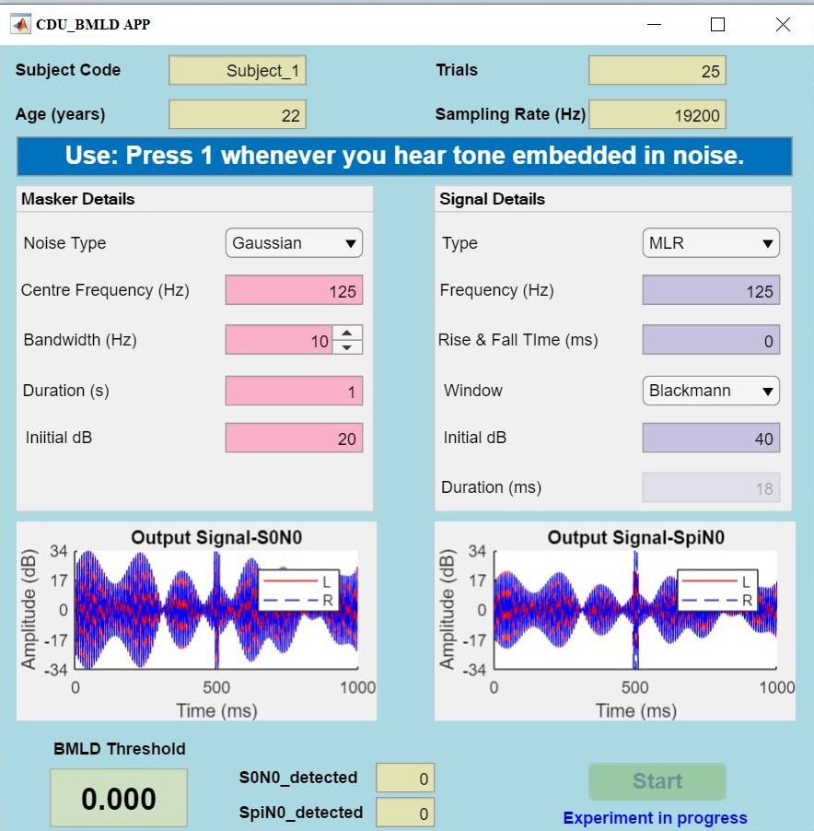
Fig. 2. APP window during experiment progress
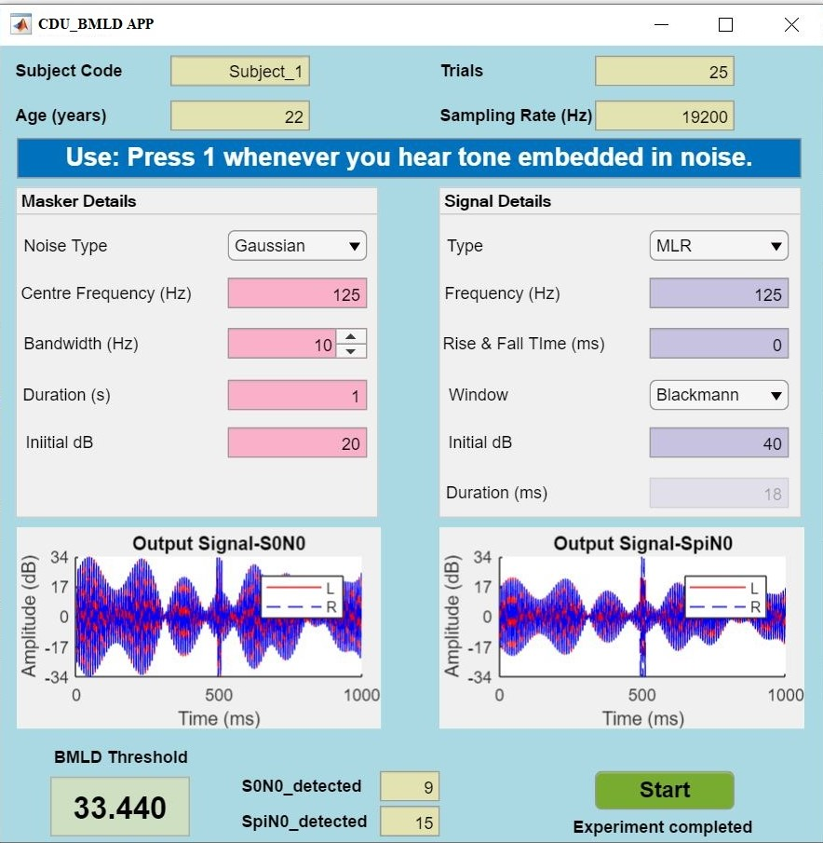
Fig. 3. APP window with BMLD value

Procedure
The participants were instructed to press the key “1” on keyboard, when they were able to detect the tone masked in the noise. Once the participant understood the test procedure, after a few practice trials, the test, designed with the GUI, was presented.
The automated test process was carried out by presenting stimuli in a simple up-down adaptive procedure [15, 16]. The stimulus was initially presented at 40 dB in a 20 dB masker noise with a starting SNR of 20 dB. Depending on the subject’s response, the level of the stimulus is either increased or decreased. If either an incorrect response or no response is given, the subsequent level of stimuli is increased by 2 dB. If a correct response is given, the stimulus level is decreased by 5 dB [17]. The order of the SoNo and SπNo conditions was randomized. After a total of 25 trials for each condition, the measurements were terminated. The measurements for each participant were completed in a single visit lasting for approximately 45 - 60 minutes, including rest intervals and breaks. All testing was conducted in a sound-proof room at the laboratory of Charles Darwin University. The BMLD was calculated by taking the difference between the corresponding SoNo and SπNo thresholds.

Analysis of results
IBM SPSS Statistics V26 (IBM Corp., Armonk, NY, USA), Excel Office 2010 (Microsoft, Redmond, WA, USA) and MATLAB 2017 were used for the statistical analysis.

The data are studied to understand the distribution among subjects and groups. The BMLD measurements obtained for the input stimuli 3 ms, 18 ms and 48 ms respectively at five different frequencies are plotted in Fig. 4. It can be seen that the variability among the three signals of different duration per frequency. The data points represent the average across the thirtyfive normal hearing subjects. Error bars represent ±1 standard error of the mean. However, they differ for different frequencies. For the signal durations 18 ms and 48 ms the frequency of 125 Hz produced significantly higher BMLD values compared to the other four frequencies (250 Hz, 500 Hz, 750 Hz and 1000 Hz). This agrees with previous literature. However, for 3ms, 125Hz signal results in the lowest BMLD. The mean (M) and standard deviations (SD) for each condition were calculated and are shown in Table II.

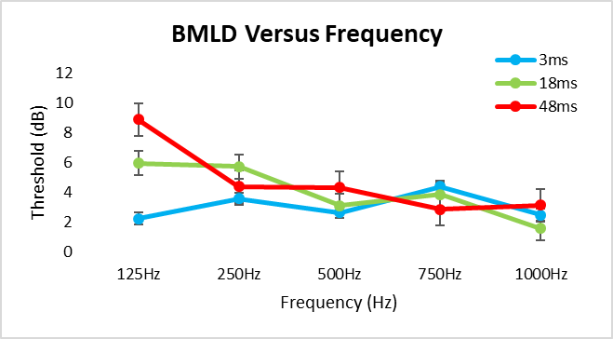
Fig. 4. BMLD Vs Frequency

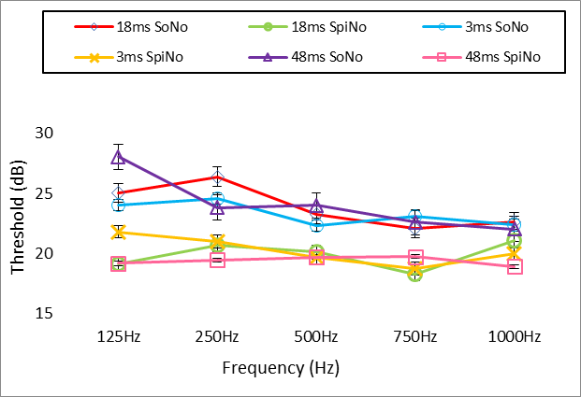
Fig. 5.SoNo and SpiNo Vs Frequency for 3ms, 18ms and 48ms input signals

The plot in Fig. 5. provides an overview of the distribution of SoNo and SpiNo thresholds for different frequencies and different durations. The datapoints represent the average thresholds for 35 normal hearing subjects. Error bars represent ±1 standard error of the mean. Both S0N0 and SπN0 thresholds vary with the frequency, although the S0N0 thresholds vary more drastically. For the lowest frequency (125Hz), the BMLD value is less for the 3ms input signal than for the longer signals.

Table II
Descriptive statistics of Data Set

 |  |  | 3ms |  | 18ms |  | 48ms
 |  | N | Mean | Standard Deviation (SD) | Mean | Standard Deviation (SD) | Mean | Standard Deviation (SD)
125 Hz | BMLD | 35 | 2.22 | 8.27 | 5.93 | 9.85 | 8.87 | 8.89
125 Hz | SoNo | 35 | 24.04 | 9.23 | 25.06 | 10.9 | 28.05 | 11.69
125 Hz | SpiNo | 35 | 21.82 | 8.79 | 19.13 | 8.59 | 19.19 | 8.25
250 Hz | BMLD | 35 | 3.55 | 7.56 | 5.71 | 6.29 | 4.36 | 6.08
250 Hz | SoNo | 35 | 24.58 | 10.56 | 26.41 | 12.17 | 23.85 | 11.48
250 Hz | SpiNo | 35 | 21.03 | 10.57 | 20.7 | 9.75 | 19.49 | 8.74
500 Hz | BMLD | 35 | 2.63 | 5.78 | 3.1 | 6.24 | 4.3 | 7.76
500 Hz | SoNo | 35 | 22.34 | 8.58 | 23.28 | 10.74 | 24.03 | 11.94
500 Hz | SpiNo | 35 | 19.71 | 8.36 | 20.18 | 8.85 | 19.73 | 8.32
750 Hz | BMLD | 35 | 4.36 | 5.48 | 3.85 | 5.94 | 2.85 | 6.28
750 Hz | SoNo | 35 | 23.13 | 11.32 | 22.13 | 11.45 | 22.62 | 11.38
750 Hz | SpiNo | 35 | 18.77 | 8.37 | 18.27 | 7.66 | 19.77 | 9.33
1000 Hz | BMLD | 35 | 2.48 | 7.5 | 1.57 | 5.84 | 3.12 | 6.37
1000 Hz | SoNo | 35 | 22.45 | 11.48 | 22.66 | 10.35 | 22.05 | 11.37
1000 Hz | SpiNo | 35 | 19.97 | 8.38 | 21.1 | 12.09 | 18.93 | 8.99

To test the influence of phase reversal, a statistical test was conducted. To determine which inferential statistics could be performed, the normality of data and equality in variance were tested. Normality was checked using the Shapiro-Wilks test, with the null hypothesis assuming that the data were normally distributed. Results shown in TABLE III demonstrate that for most of the data this null hypothesis was rejected, indicating that the data were not normally distributed. To check the equivalence of variance between threshold recordings under phasic and antiphasic conditions, Levene's Test was performed. The results suggested that the variances were not equal.

TABLE III
Shapiro-Wilks Test Results

 | Duration (ms) | Frequencies (Hz) | N | Statistic (W) | p-value | Decision at level (5%)
BMLD | 3 | 125 | 35 | 0.94533 | 0.08144 | Can't reject normality
BMLD | 3 | 250 | 35 | 0.95037 | 0.11634 | Can't reject normality
BMLD | 3 | 500 | 35 | 0.88876 | 0.002 | Reject normality
BMLD | 3 | 750 | 35 | 0.9849 | 0.90157 | Can't reject normality
BMLD | 3 | 1000 | 35 | 0.93469 | 0.03864 | Reject normality
BMLD | 18 | 125 | 35 | 0.82539 | 6.6885E-5 | Reject normality
BMLD | 18 | 250 | 35 | 0.9403 | 0.05716 | Can't reject normality
BMLD | 18 | 500 | 35 | 0.94207 | 0.0647 | Can't reject normality
BMLD | 18 | 750 | 35 | 0.82819 | 7.6633E-5 | Reject normality
BMLD | 18 | 1000 | 35 | 0.90334 | 0.00487 | Reject normality
BMLD | 48 | 125 | 35 | 0.94204 | 0.06457 | Can't reject normality
BMLD | 48 | 250 | 35 | 0.82204 | 5.6901E-5 | Reject normality
BMLD | 48 | 500 | 35 | 0.9306 | 0.02915 | Reject normality
BMLD | 48 | 750 | 35 | 0.92563 | 0.02078 | Reject normality
BMLD | 48 | 1000 | 35 | 0.83849 | 1.2775E-4 | Reject normality
SoNo | 3 | 125 | 35 | 0.85524 | 3.0396E-4 | Reject normality
SoNo | 3 | 250 | 35 | 0.87617 | 9.6068E-4 | Reject normality
SoNo | 3 | 500 | 35 | 0.86515 | 5.1892E-4 | Reject normality
SoNo | 3 | 750 | 35 | 0.94607 | 0.08581 | Can't reject normality
SoNo | 3 | 1000 | 35 | 0.9412 | 0.06086 | Can't reject normality
SoNo | 18 | 125 | 35 | 0.86809 | 6.1028E-4 | Reject normality
SoNo | 18 | 250 | 35 | 0.92769 | 0.0239 | Reject normality
SoNo | 18 | 500 | 35 | 0.901 | 0.00421 | Reject normality
SoNo | 18 | 750 | 35 | 0.85257 | 2.6388E-4 | Reject normality
SoNo | 18 | 1000 | 35 | 0.96295 | 0.27989 | Can't reject normality
SoNo | 48 | 125 | 35 | 0.88288 | 0.00141 | Reject normality
SoNo | 48 | 250 | 35 | 0.87403 | 8.5062E-4 | Reject normality
SoNo | 48 | 500 | 35 | 0.94315 | 0.06983 | Can't reject normality
SoNo | 48 | 750 | 35 | 0.87687 | 9.9989E-4 | Reject normality
SoNo | 48 | 1000 | 35 | 0.84098 | 1.4494E-4 | Reject normality
SpiNo | 3 | 125 | 35 | 0.83323 | 9.8194E-5 | Reject normality
SpiNo | 3 | 250 | 35 | 0.84652 | 1.9249E-4 | Reject normality
SpiNo | 3 | 500 | 35 | 0.8654 | 5.2599E-4 | Reject normality
SpiNo | 3 | 750 | 35 | 0.93236 | 0.03291 | Reject normality
SpiNo | 3 | 1000 | 35 | 0.83235 | 9.4022E-5 | Reject normality
SpiNo | 18 | 125 | 35 | 0.84969 | 2.2690E-4 | Reject normality
SpiNo | 18 | 250 | 35 | 0.92642 | 0.02192 | Reject normality
SpiNo | 18 | 500 | 35 | 0.87951 | 0.00116 | Reject normality
SpiNo | 18 | 750 | 35 | 0.89779 | 0.00345 | Reject normality
SpiNo | 18 | 1000 | 35 | 0.87777 | 0.00105 | Reject normality
SpiNo | 48 | 125 | 35 | 0.91346 | 0.00928 | Reject normality
SpiNo | 48 | 250 | 35 | 0.80761 | 2.8873E-5 | Reject normality
SpiNo | 48 | 500 | 35 | 0.84525 | 1.8025E-4 | Reject normality
SpiNo | 48 | 750 | 35 | 0.86055 | 4.0379E-4 | Reject normality
SpiNo | 48 | 1000 | 35 | 0.82903 | 7.9836E-5 | Reject normality

Based on the normality test, the equivalence of variance, and a sample size of 35, non-parametric tests such as the Wilcoxon rank-sum test or Kruskal-Wallis test were considered more appropriate than parametric tests.

It was important to consider whether the data were paired or non-paired. In this study, the same subjects were tested under different conditions, making the data paired. A Kruskal-Wallis test would assume independence between observations, whereas repeat observations on the same subjects can be related. Therefore, the non-parametric Wilcoxon signed rank test, which accounts for the pairing of observations by making pairwise comparisons, was applied to determine statistical significance.

The test statistic calculated by the Wilcoxon signed rank test is the sum of the signed ranks of the differences between the two samples, i.e., under inphase and antiphase conditions, with positive ranks given to the sample with the larger value. In this case, a large absolute value of the test statistic indicates strong evidence against the null hypothesis, and a small absolute value indicated weak evidence against the null hypothesis. The sign of the test statistic indicates the direction of the difference between the medians of the two samples.

If the p-value returned by the Wilcoxon test is greater than the chosen significance level (p=0.05), and the test statistic (sum of the positive signed ranks of the differences between the two samples) is relatively high, there is weak or no evidence against the null hypothesis, which in this case was that the mean of threshold recorded under inphase and antiphase conditions were not significantly different. TABLE IV showed the result of the Wilcoxon test performed for the threshold of 35 subjects in inphase condition vs. antiphase for all three durations and all five frequencies. The differences between SoNo and SpiNo conditions were statistically significant except for the duration was 3 ms seconds combined with a frequency of 1000Hz.

TABLE IV
Wilcoxon Test Results

Duration  (ms) | Frequency (Hz) | pvalue | Significance | STATS
3 | 125 | 0.0387335 | Significant | 189
3 | 250 | 0.0074584 | Significant | 141
3 | 500 | 0.0042495 | Significant | 120.5
3 | 750 | 4.227E-05 | Significant | 58
3 | 1000 | 0.0618649 | Non Significant | 176
18 | 125 | 0.000998 | Significant | 105
18 | 250 | 1.532E-05 | Significant | 38.5
18 | 500 | 0.000998 | Significant | 105
18 | 750 | 0.0001936 | Significant | 79.5
18 | 1000 | 0.0091218 | Significant | 145
48 | 125 | 2.692E-06 | Significant | 23
48 | 250 | 3.922E-05 | Significant | 57
48 | 500 | 0.0044193 | Significant | 131
48 | 750 | 0.0062278 | Significant | 137.5
48 | 1000 | 0.0075571 | Significant | 131

In this study, we utilized BMLD data to evaluate the impact of time duration and frequency. The BMLD represents the difference in minimum detectable levels between in-phase and anti-phase presentations and is measured in decibels (dB). We selected one duration and compared the BMLD for all 5 frequencies (125Hz vs 250Hz, 500Hz vs 750Hz vs 1000Hz). We repeated this test for two additional durations. As the BMLD data failed the normality test, we opted for a non-parametric test, specifically the Friedman test. The Friedman test is useful for determining whether differences between the means of three or more related groups are significant, unlike the Wilcoxon signed-rank test, which compares two related groups.

The F score generated by the Friedman test was used to evaluate the degree of difference between the groups being compared. A higher F score indicates a greater degree of difference, while a lower F score indicates less difference. The results of the Friedman test are shown in TABLE V. It was found that the results for the 3ms duration were not significant, with a correspondingly low F score compared to the results for the 18ms, 48ms durations.

TABLE V
Friedman test results (125hz vs 250hz vs 500hz vs 1000hz)

Duration (ms) | Fscore | P_value | Significance
3 | 3.0117 | 0.55587 | Non significant
18 | 11.079 | 0.02569 | signifiacant
48 | 15.947 | 0.00309 | signifiacant

The Nemenyi test, also referred to as the Nemenyi-Damico-Wolfe-Dunn (NDWD) test, is a post-hoc test commonly used to compare all possible pairs of frequencies subsequent to the null hypothesis being rejected in a Friedman test. This test compares all potential groups using a critical value that is based on the studentized range distribution. If the mean rank difference between a pair of groups is larger, then these two groups are significantly different from each other.

The interpretation of the Mean Rank Differences for BMLD using Nemenyi test involves identifying significant differences in BMLD between the frequncies based on their mean ranks and the critical difference value (CD = 1.258 for 35 subjects and 5 frequenies). If the mean rank difference between two groups is greater than the CD value, the two groups are considered significantly different from each other.Cd is calculated as following
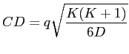

where K is the number of frequencies (5), D is the number of subjects (35) and the value of q is derived from the studentized range statistic.
The critical difference (CD), for the Nemenyi test, is a value used to determine if the mean-ranking differences between two frequnceies are significant. Mean-ranking differences above this value (CD) are significant .

Friedman test followed by the Nemenyi post hoc test, we can compare the frequencies based on their mean ranks. By utilizing the mean rank differences, the groups can be ranked, based on their BMLD difference, with the group possessing the highest mean rank being considered the best frequncey for stimuls and the group possessing the lowest mean rank being considered the worst frequencey. The results of these test are shown in Fig 6, to 11.

we have a dataset with 35 subjects and we run the Friedman test on BMLD values for 5 different frequencies (125, 250, 500, 750, and 1000 Hz). We find that the p-value of the test is less than 0.05, indicating that there is a significant difference between the frequencies. We then perform the Nemenyi post hoc test and compute the mean rank differences between all pairs of frequencies.

From figure 8 we can see that the mean rank difference between 125 Hz and 250 Hz is -4.98857142857142 for 48 ms and the mean rank difference between 125 Hz and 10000 Hz is -7.34857142857142. Based on these results, we can say that 500Hz has a higher rank than 250 Hz (on average) and a lower rank than 1000 Hz (on average). Similarly, we can compare the ranks of other pairs of frequencies. If abosulte of mean rank difference two frequency is less the critical differed value the difference is in significant and Critical difference value for all duration is 1.258. Pair wise mean rank difference their significance, and critical value is for each dureation i.e 3ms, 18ms and 48 ms are given in figure 6 7 and 8 corspondingly

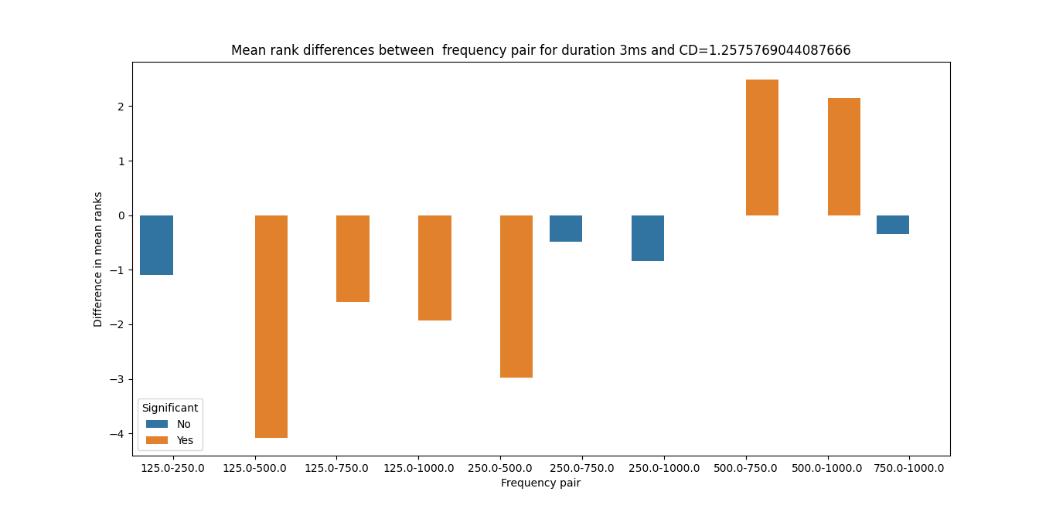

Fig. 6. Nemenyi-Damico-Wolfe-Dunn (NDWD) test result for 3ms

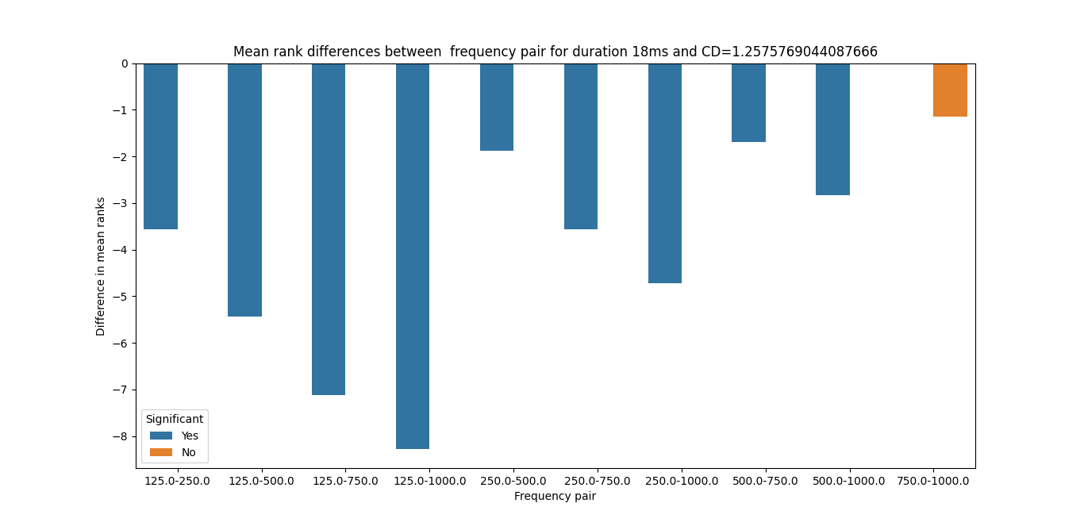

Fig. 7. Nemenyi-Damico-Wolfe-Dunn (NDWD) test result for 18ms

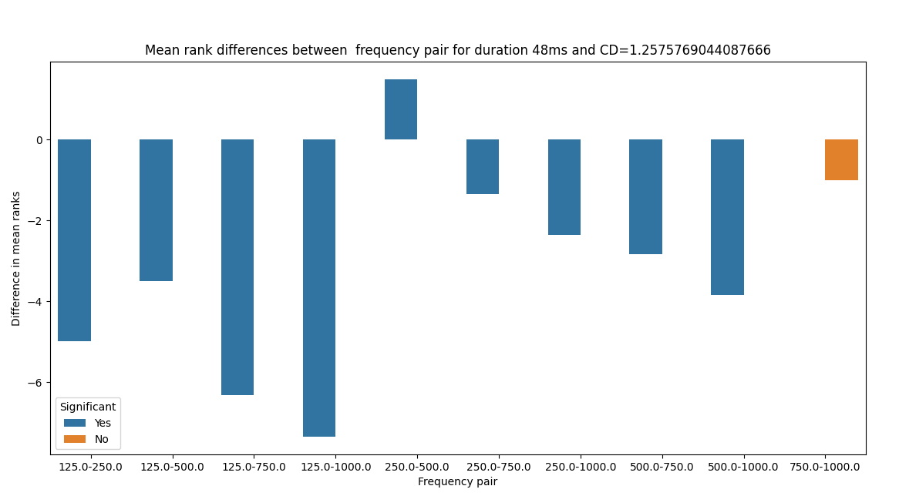
Fig. 8. Nemenyi-Damico-Wolfe-Dunn (NDWD) test result for 48ms

Orange line in figure 9,10 and 11 represent the mean rank for each frequency for 3ms ,18ms and 48ms correspondingly and vertical blue line represent variation in rank of that particular frequency when compare to other frequencies we can compare the frequencies for each duration based on their average ranks, we can simply sort them in descending order based on their mean rank across the subjects. For example, from figure 10 we can see that 750hz has highest mean rank of 3.457 for duration of 18 ms
We can say that 750 Hz has the highest rank and is therefore the most effective frequency, followed by 1000 Hz and 500 for 18ms duration .

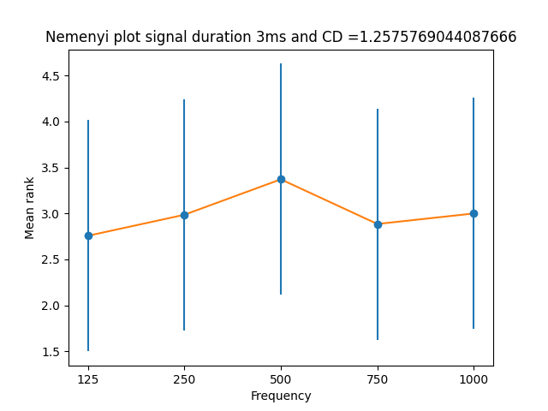
Fig. 9. Mean Ranks of frequencies for 3ms

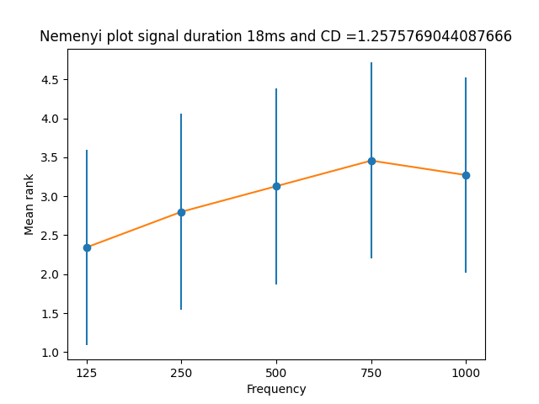

Fig. 10. Mean Ranks of frequencies for 18ms

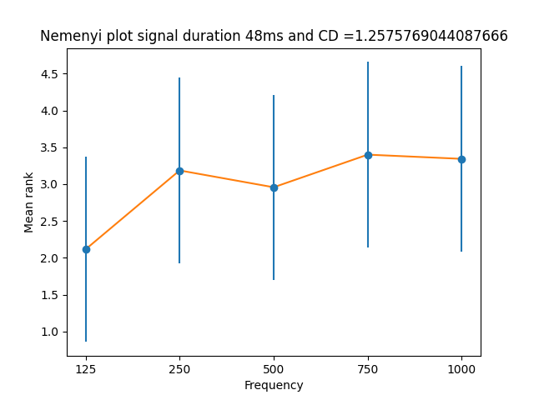

Fig. 11. Mean Ranks of frequencies for 48ms

Discussion
In the initial analysis, the lower frequencies resulted in the highest BMLDs, except for the 3ms duration stimuli. In our study, 125Hz resulted in the highest BMLD values for 18ms and 48ms signals, which agrees with previous studies [18]. However, it was not true for 3ms signal. The difference between the two signal conditions, in phase (S0N0) and out of phase (SπN0), seems to be relevant. When the phase of the stimuli is the same as that of the noise, the threshold is high because the stimuli and noise seem to be coming from the same source. In the antiphasic condition, the signal is reversed relative to that of the noise, and the threshold value is lower, as the signal and the noise seem to be coming from a different source [19]. Hence SπN0 provides better auditory cues compared to that of the S0N0 condition. The lower threshold for the antiphasic condition indicates an increase in detectability of signals in noise [20]. The normality test for the data demonstrated that the samples are not normally distributed which supports findings of similar BMLD studies in literature [21].

The higher F score obtained by the Friedman non-parametric test shows that for the 18ms and 48ms stimuli, the BMLD values were significantly different across frequencies different whereas the BMLD for the 3ms signal was not [22].
The origin of the response might be one of the reasons for non-significance of the 3ms data. The 3 ms signals may be processed in a different way [22]. It is possible that the response to such a short stimulus does not involve the output from the neurons responsible for BMLD generation [6, 23]. The brain processes corresponding to auditory processing of longer signals may follow a different pathway, resulting in the BMLD [24]. In addition, signals of low frequencies have a relatively long period and it can be questioned whether people can really detect the frequency of a tone in such a short signal. This may explain why low frequencies do not result in a large BMLDs for 3 ms stimuli. However, a significant BMLD can be observed for the 18ms and 48ms stimuli. The evoked potentials resulting from these stimuli are to be analysed in detail in future research. The alertness and attentiveness of the subjects during the test may also affect the BMLD values [25].
The Nemenyi test post hoc statistical test is used to evaluate whether there are pairwise statistically significant differences between the frequency pairs for each stimulus durations. From the pairwise mean rank differences in fig. 6 ,7 and 8 we can see for the 3ms stimuli most of mean rank differences are less then the CD value. The Friedman test also failed to show significant differences for 3ms . On the other hand, as can be seen from figure 7 and 8, most of pairwise mean rank differences are greater than the CD for the 18 and 48 ms stimuli. The corresponding Friedman test resulted in the highest F score for 48ms. These differences will be further explored in EEG experiments.

The optimal frequencies for the BMLD are different for signals of different durations. Nemenyi plots are used to show the mean rank for all the frequencies and each duration, as shown in Fig 9, 10 and 11. In figure 9 we can see that the highes mean rank, for 500Hz is 3.37. In fig 10 and 11 the highest mean ranks are found for 750Hz (3.46 and 3.4 for 18ms and 48ms respectively). We have failed to establish statistically significant difference between frequencies for the duration of 3ms. It is important to analyse the effect of various frequencies in the electrophysiological studies as well.

Conclusion
The present study confirms that the hearing thresholds for the SπN0 condition are lower than the hearing threshold for the S0N0 condition. Signals of 18ms and 48ms duration result in significant differences between in phase and antiphasic conditions and will therefore be used for further studies on binaural interactions. The frequency dependency of the BMLD is not the same for signals of different duration, however.

Future research
The future scope of the current study is to analyze the underlying auditory processing for subcortical region with the BMLD generating stimuli of different frequencies. Based on the present study, the electrophysiological studies related to binaural processing will be carried out in the future with 18ms and 48ms stimuli for the same frequencies as described in this paper. This may allow a comparison of binaural processing result based on subjective and objective hearing tests.

References
[1] J. Blauert, Spatial hearing: the psychophysics of human sound localization. MIT press, 1997.
[2] H. Fastl and E. Zwicker, Psychoacoustics: facts and models. Springer Science & Business Media, 2006.
[3] D. R. J. A. Moore, "Anatomy and physiology of binaural hearing," vol. 30, no. 3, pp. 125-134, 1991.
[4] H. J. Gilbert, T. M. Shackleton, K. Krumbholz, and A. R. J. J. o. N. Palmer, "The neural substrate for binaural masking level differences in the auditory cortex," vol. 35, no. 1, pp. 209-220, 2015.
[5] K. T. Nakamoto, T. M. Shackleton, and A. R. J. J. o. n. Palmer, "Responses in the inferior colliculus of the guinea pig to concurrent harmonic series and the effect of inactivation of descending controls," vol. 103, no. 4, pp. 2050-2061, 2010.
[6] Z. Kevanishvili and Z. J. S. a. Lagidze, "Masking level difference: an electrophysiological approach," vol. 16, no. 1, pp. 3-11, 1987.
[7] N. Xu, L. Luo, Q. Wang, and L. J. H. R. Li, "Binaural unmasking of the accuracy of envelope-signal representation in rat auditory cortex but not auditory midbrain," vol. 377, pp. 224-233, 2019.
[8] M. N. Wallace, T. M. Shackleton, and A. R. J. H. r. Palmer, "Phase-locked responses to pure tones in the primary auditory cortex," vol. 172, no. 1-2, pp. 160-171, 2002.
[9] I. J. J. T. J. o. t. A. S. o. A. Hirsh, "The influence of interaural phase on interaural summation and inhibition," vol. 20, no. 4, pp. 536-544, 1948.
[10] A. Snik, M. Agterberg, and A. Bosman, "How to Quantify Binaural Hearing in Patients with Unilateral Hearing Using Hearing Implants," Audiology and Neurotology, vol. 20(suppl 1), no. Suppl. 1, pp. 44-47, 2015.
[11] F. A. J. T. J. o. t. A. S. o. A. Webster, "The Influence of Interaural Phase on Masked Thresholds I. The Role of Interaural Time‐Deviation," vol. 23, no. 4, pp. 452-462, 1951.
[12] B. C. Moore, An introduction to the psychology of hearing. Brill, 2012.
[13] E. Ignatious, S. Azam, M. Jonkman, and F. D. Boer, "Study of Correlation Between EEG Electrodes for the Analysis of Cortical Responses Related to Binaural Hearing," IEEE Access, vol. 9, pp. 66282-66308, 2021.
[14] T. Miles, E. Ignatious, S. Azam, M. Jonkman, and F. De Boer, "Mathematically Modelling the Brain Response to Auditory Stimulus," in TENCON 2021-2021 IEEE Region 10 Conference (TENCON), 2021, pp. 151-156: IEEE.
[15] K. Mackie, P. J. J. o. S. Dermody, Language,, and H. Research, "Use of a monosyllabic adaptive speech test (MAST) with young children," vol. 29, no. 2, pp. 275-281, 1986.
[16] G. J. A. J. o. A. Plant, "The development of speech tests in Aboriginal languages," vol. 13, no. 1, pp. 30-40, 1990.
[17] V. Aithal, A. Yonovitz, S. J. A. Aithal, and T. New Zealand Journal of Audiology, "Tonal masking level differences in Aboriginal children: Implications for binaural interaction, auditory processing disorders and education," vol. 28, no. 1, pp. 31-40, 2006.
[18] E. Zwicker and G. B. Henning, "Binaural masking-level differences with tones masked by noises of various bandwidths and levels," Hearing Research, vol. 14, no. 2, pp. 179-183, 1984/05/01/ 1984.
[19] J. McCullagh and D.-E. Bamiou, "Measures of binaural interaction," 2014.
[20] M. Brown and F. J. T. H. J. Musiek, "Pathways: The fundamentals of masking level differences for assessing auditory function," vol. 66, no. 1, pp. 16-17, 2013.
[21] S. Koiek, C. Brandt, J. H. Schmidt, and T. J. I. J. o. A. Neher, "Monaural and binaural phase sensitivity in school-age children with early-childhood otitis media," pp. 1-8, 2021.
[22] C. G. J. J. o. S. Fowler, Language, and H. Research, "Electrophysiological evidence for the sources of the masking level difference," vol. 60, no. 8, pp. 2364-2374, 2017.
[23] C. G. Fowler and C. J. J.-A. A. O. A. Mikami, "Phase effects on the middle and late auditory evoked potentials," vol. 7, pp. 23-30, 1996.
[24] W. Y. S. Wong and D. R. Stapells, "Brain Stem and Cortical Mechanisms Underlying the Binaural Masking Level Difference in Humans: An Auditory Steady-State Response Study," vol. 25, no. 1, pp. 57-67, 2004.
[25] M. J. Polonenko and R. K. J. E. Maddox, "Exposing distinct subcortical components of the auditory brainstem response evoked by continuous naturalistic speech," vol. 10, p. e62329, 2021.
[26] S. v. d. Par and A. Kohlrausch, "A new approach to comparing binaural masking level differences at low and high frequencies," vol. 101, no. 3, pp. 1671-1680, 1997.

 This work supported by Charles Darwin University, Northern Territory; Australia. (Corresponding Author: Sami Azam) Eva Ignatious is with the College of Engineering and IT; Charles Darwin University, Casuarina, Australia (e-mail: eva.ignatious@cdu.edu.au). Sami Azam is with the College of Engineering and IT; Charles Darwin University, Casuarina, Australia (e-mail: Sami.Azam@cdu.edu.au). Mirjam Jonkman is with the College of Engineering and IT; Charles Darwin University, Casuarina, Australia (e-mail: Mirjam.Jonkman@cdu.edu.au). Friso De Boer is with the College of Engineering and IT; Charles Darwin University, Casuarina, Australia (e-mail: friso.deboer@cdu.edu.au).

