**Data Analysis**

We have used t following visualization for data analysis

1. **PSD plots of each subject**

**Observation:** prominent activity across all subjects for both classes (ENC, NO_ENC) in 5 -20 Hz and 25- 35 Hz

1. **visualization PSDs of delta theta alpha beta for each subject(many graphs)**

**Observation**: No fixed pattern found, activity in different bands for different subject

1. **Top maps of delta theta alpha beta bands for each object to see activity neural across**

**observation:** No fixed pattern was found; however, we can use these maps and PSD plots to reduce the number of channels for analysis.

1. **ERD/S MAP analysis ERD/S calculation for both Classes (ERD ENC vs ERD NO ENC)**

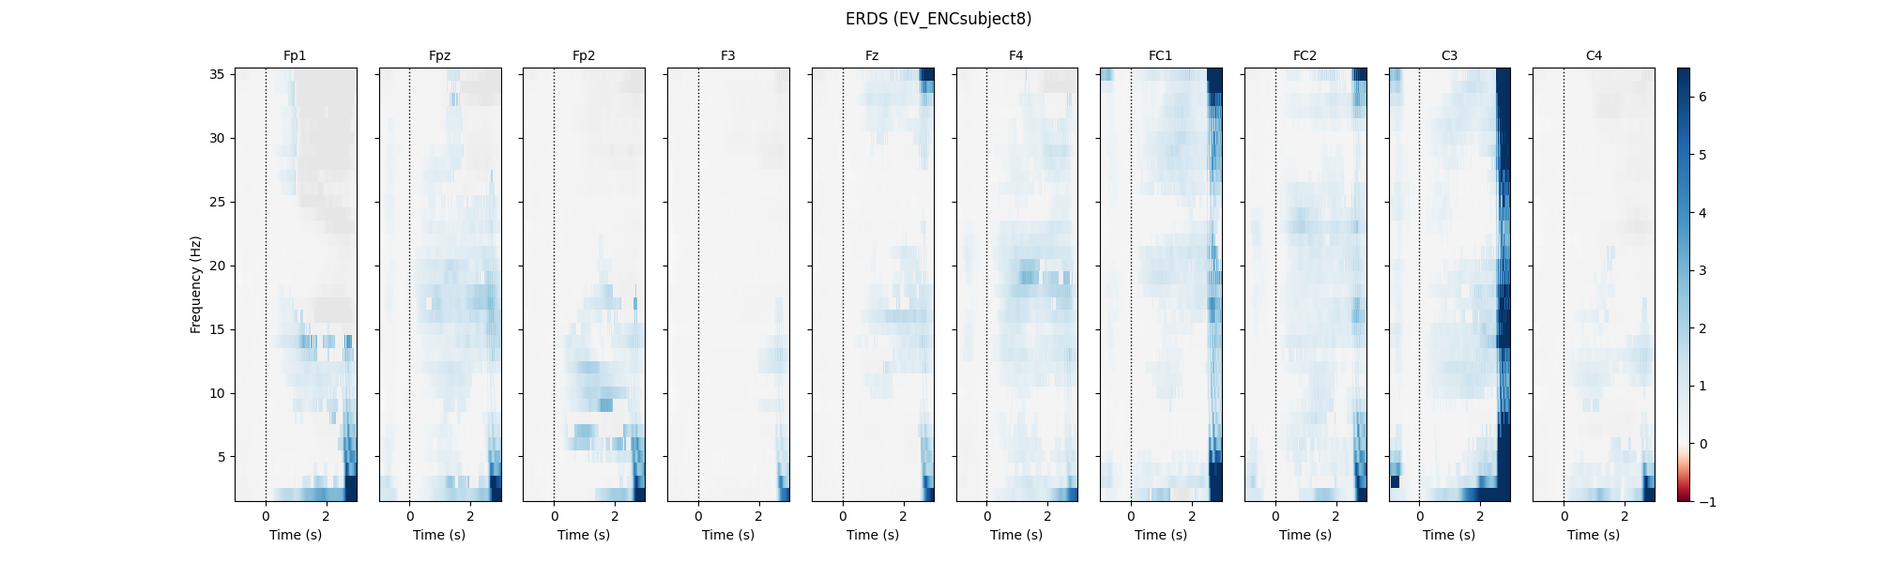

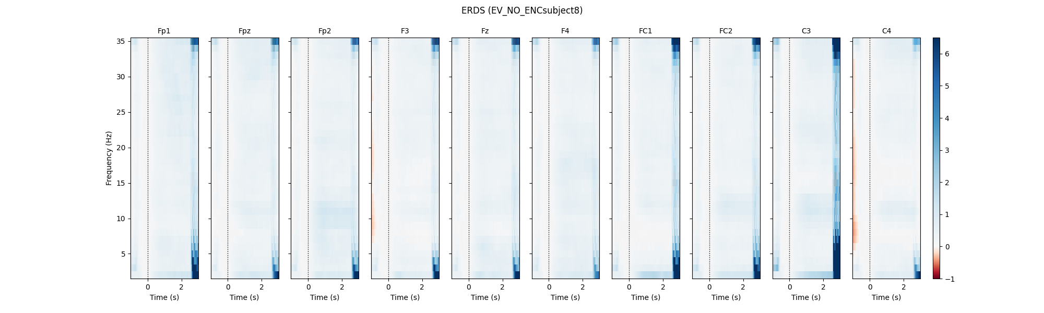

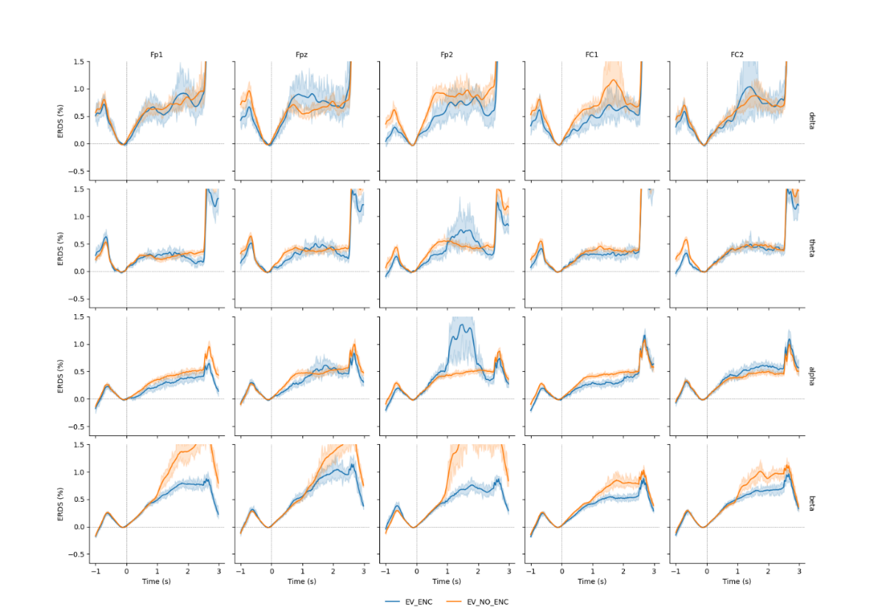

**Observation** alpha band seems to have a pattern however EERD is affected by extreme values in epochs which can be seen in can be solved by reject epochs which can result in data loss.

**Classification for each of 14 subjects**

**Classification:** Based on database result 2,3,4 we have chosen FBCSP because it has the ability to estimate subject-specific bands spatial filters to increase inter-class variance

1. **Results using SVM with RBF kernel**

Highly affected by class imbalance extremely low F1 precision and Recall scores

1. **Results using balanced random forest tress n=15 tress**

make class priors equal, by down-sampling or upsampling. Hence, BRF does this by iteratively drawing a bootstrap sample with equal proportions of data points from both the minority and the majority classes. Test accuracy has decreased however better F1 precision and Recall scores as compared to SVM

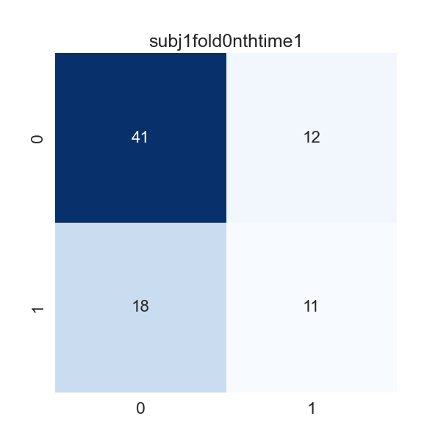

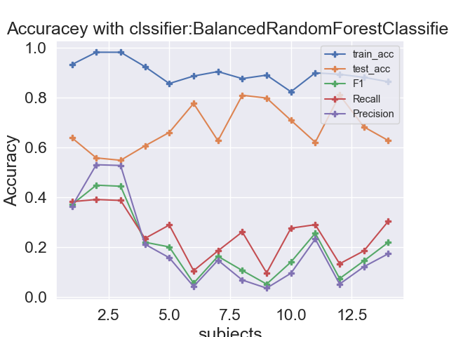

1. **Results using Synthetic Minority Oversampling SMOTE+ standard random forest tress n=150 tress**

SMOTE (Synthetic Minority Oversampling Technique) is an oversampling technique that uses a minority class to generate synthetic samples. In consequence, it overcomes the overfitting problem raised by [random oversampling](https://machinelearningmastery.com/random-oversampling-and-undersampling-for-imbalanced-classification/). SMOTE works by generating instances that are close in feature space, using interpolation between positive cases that are close to each other. It randomly selects a minority class instance and finds its nearest neighbor. Then it creates synthetic models by randomly choosing one of the neighbors and forms a line segment in the feature space. It then generates synthetic instances of the two selected instances as [convex combinations](https://en.wikipedia.org/wiki/Convex_combination). It is time to see SMOTE in action using SRF. **So far these are the best result produced by SMOTE**

