

Technical Assessment Report
Name: Muhammad Faizan Ahmed
Student ID: 25937922
Module: 6E7V0023 Programming and Virtual Commissioning Industrial Automation Systems
Institution: Manchester Metropolitan University
Academic Year: 2025–2026

ABSTRACT
This report presents the implementation of automated control and virtual commissioning for two industrial automation tasks.
In the first task, an existing mixer system with manual control was programmed to enable automatic operation. An operator-friendly HMI was developed to allow full interaction with the mixing process, including start/stop control, status indication, batch handling, and alarms. The control system was implemented using three IEC 61131-3 programming languages: Sequential Function Chart (SFC), Ladder Logic (LD), and Structured Text (STL). This approach ensured clear separation between process sequencing and low-level control, improving readability and maintainability.
In the second task, a Festo workpiece handling station was virtually commissioned using a provided CAD model. NX CAD was used to apply physics to selected components and define signals required for communication with the TIA Portal. An operator HMI was also designed to control the system, display storage counts, and generate alarms when storage limits were reached. Virtual commissioning was used to verify system behaviour, logic sequencing, and operator interaction before any physical deployment.
Overall, the work demonstrates how industrial automation systems can be designed, programmed, and validated using standard PLC programming techniques and virtual commissioning tools, reducing commissioning risks and improving system reliability.

Table of Contents
INTRODUCTION 6
TASK A – Batch Mixing Process 6
IEC-61131-3 Standard 6
Support for Legacy System Upgrades 6
Adoption by PLC Manufacturers 7
Current System Overview 7
Automated Mixer Control System Implementation 8
Test Procedure 10
Conclusion 13
TASK B - Virtual Commissioning of Workpiece Discharge Station 14
Overview 14
NX CAD modelling and physics setup 14
TIA Portal PLC Program 17
Operator Interface (HMI) 19
Testing and Validation Procedure 22
Discussion on Safety, Sustainability and Social Impact 31
Conclusion 32
Future Recommendations 32
References 33
Appendix A 34
Appendix B 35
Appendix C 37
Appendix D 39
Appendix E 40
Appendix F 41

Table of Figures
Figure 1: Batch Mixing Process (Source: Assessment Visualisation File) 7
Figure 2: HMI for Batch Mixing Operation 9
Figure 3: System ON 10
Figure 4: Start Process 10
Figure 5: Batch Completed 11
Figure 6: Reset Process 11
Figure 7: E-Stop enable 12
Figure 8: Auto Mode 12
Figure 9: Set Mixing Time 13
Figure 10: Workpiece Discharge Station CAD Model 14
Figure 11: Program Block Structure 17
Figure 12: PLC Tags 18
Figure 13: Main Screen 19
Figure 14: Alarm Screen 21
Figure 15: PLCSIM Advanced instance configuration 22
Figure 16: Opening TIA Portal Project 23
Figure 17: Figure 18: Downloading PLC Program 23
Figure 18: Opening Project Workspace 24
Figure 19: Configuring PG/PC Interface 24
Figure 20: Starting the PLC Module 25
Figure 21: Simulate the HMI Project 25
Figure 22: Figure 22: HMI Screen Simulated 26
Figure 23: Opening NX File 26
Figure 24: Running the Simulation 27
Figure 25: Turning on System Power 27
Figure 26: Starting the Process 28
Figure 27: Dropping Workpiece 28
Figure 28: Occupied Storage Area 29
Figure 29: Alarm Triggered 29
Figure 30: Guiding Operator 30
Figure 31: Resetting Process 30
Figure 32: Automated Mixer Batch Sequence 34
Figure 33: Main Flow SFC Code 37
Figure 34: Actuator Enable LAD Code 37
Figure 35: Batch Count ST Code 37
Figure 36: Mixing Time Control ST Code 37
Figure 37: Alarms ST Code 37
Figure 38: Start Request ST Code 37
Figure 39: Status Indicators ST Code 38
Figure 40: Process Status ST Code 38
Figure 41: Sensors and actuators defined in NX CAD 39
Figure 42: Rigid and Collision bodies defined in NX CAD 39
Figure 43: Signals created in NX CAD 39
Figure 44: Sliding joints in NX CAD 39
Figure 45: Main [OB!] 40
Figure 46: Automatic Sequence 41

INTRODUCTION
Automation has played a significant role in modern industrial systems by reducing the dependency on hard-wired relay circuits that were commonly used in the past. Compared to traditional relay-based control, Programmable Logic Controllers (PLCs) provide a scalable, safer, and more flexible solution with faster response times and easier maintenance. Due to these advantages, PLCs are now widely used across manufacturing and process industries.
Along with automation, virtual commissioning has become an important approach in industrial system development. Virtual commissioning allows the complete operation of an industrial system to be tested in a simulated environment before physical implementation. This helps in identifying logical, sequencing, and integration issues at an early stage, reducing commissioning time, implementation cost, and the risk of errors on the shop floor. By validating control logic, HMI interaction, and system behaviour in simulation, industries can ensure that the system meets operational and safety requirements before deployment (Resendes, 2025; Siemens, no date; Virtual Commissioning, 2025).

TASK A – Batch Mixing Process

IEC-61131-3 Standard
- IEC 61131-3 is an international standard that defines a common framework for PLC programming languages, including syntax and semantics (IEC, no date).
- It replaces vendor-specific and hard-wired control approaches with structured, software-based control.
- It ensures consistency, safety, and reliability in industrial automation systems, and is widely used in manufacturing and process control.

Support for Legacy System Upgrades
- IEC 61131-3 enables older relay-based or PLC systems to be modernised without changing the core process logic.
- It supports modular and reusable code, making systems easier to maintain and extend.
- It improves maintainability through standardised data types and error handling.

Adoption by PLC Manufacturers
- It is adopted by major PLC manufacturers worldwide, making it a global standard (PLCOpen, no date).
- It supports five programming languages:
  - Ladder Diagram (LD)
  - Structured Text (ST)
  - Function Block Diagram (FBD)
  - Instruction List (IL)
  - Sequential Function Chart (SFC)
- It promotes interoperability, reduces vendor lock-in, and allows engineers to transfer skills across platforms.
- It is supported and promoted by industry organisations such as PLCopen.

Current System Overview
The current system is a batch industrial mixing process consisting of multiple valves, sensors, and a mixer. The process follows a fixed sequence for powder dosing, water filling, mixing, and product discharge.
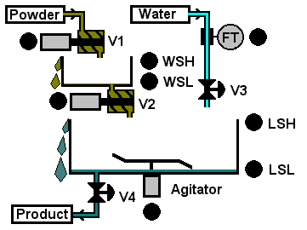
Figure 1: Batch Mixing Process (Source: Assessment Visualisation File)

System Components
Category | Components
Control Type | PLC-based discrete control
Sensors | - WSL, WSH (Weighing Vessel)  - LSL, LSH (Mixing Tank)
Actuators | - V1 (Powder Inlet)  - V2 (Powder Transfer Valve)  - V3 (Water Inlet)  - V4 (Discharge Valve)  - Agitator
Table 1: System Components

Process Flow
- Powder Dosing – V1 fills the weighing vessel until WSH is activated.
- Powder Transfer – V2 transfers powder to the tank until WSL confirms the vessel is empty.
- Water Filling – V3 fills water into the tank until LSH is activated.
- Mixing – The agitator runs for a predefined mixing duration.
- Discharge – V4 drains the final product until LSL confirms the tank is empty.

Automated Mixer Control System Implementation
A fully automated batch control system was developed based on the previously manual mixer operation. The solution was implemented using PLC programming in compliance with the IEC 61131-3 standard, ensuring a structured, modular, and industry-aligned control strategy.

Control Logic Design
The batch process logic was modelled using an SFC, which defines the high-level sequence of operations from powder dosing to final product discharge. This approach provides a clear visual representation of the process flow and ensures deterministic batch execution. The diagrammatic representation of the automated batch sequence is provided in Supporting logic was implemented using a Ladder Diagram for actuator control, allowing direct mapping for PLC outputs such as valves and the agitator. ST was used for handling batch counting, timers, alarm processing, and system status management.

Operator Interface (HMI)
An operator-focused Human Machine Interface (HMI) was designed to enable full control and monitoring of the automated mixer process. The interface allows the operator to power the system, start and stop batch operations, enable continuous auto mode, reset the process, set the mixing time, and activate an emergency stop when required.
The HMI also provides real-time visual feedback, including sensor status, actuator states, current process stage, alarm messages, batch count, and product-related parameters. This improves operational transparency and reduces the likelihood of operator error. The designed HMI is shown below in Figure 2.
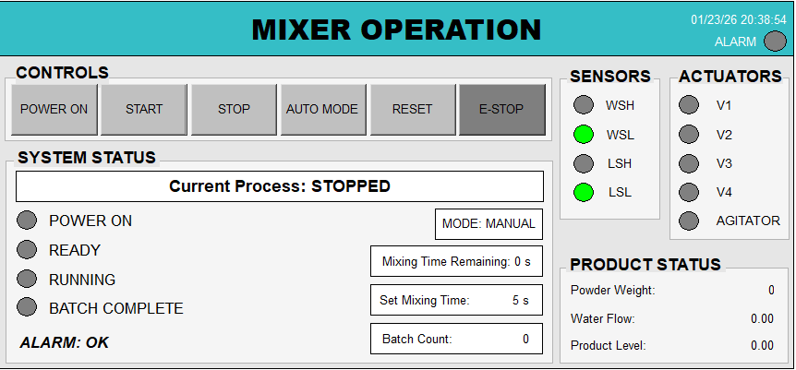
Figure 2: HMI for Batch Mixing Operation

Program Organisation Units (POUs) Overview
POU Name | Language | Purpose
MainFlow | SFC | Defines the main batch sequence from powder dosing to product discharge.
ProcessText | ST | Updates the current process status text in the HMI.
StartRequest | ST | Processes operator start requests from the HMI.
ActuatorEnable | Ladder (LD) | Enables actuators based on system power, stop, and E-stop conditions, ensuring safe actuator operation.
BatchCounting | ST | Manages batch counting operation.
MixingTimeControl | ST | Controls mixing timing.
Alarms | ST | Detects and processes system alarms.
StatusIndicators | ST | Controls system status indication lamps.

Test Procedure
This section outlines the step-by-step procedure to test and validate the automated mixer solution using the operator HMI.

Steps:
Step 1: Select the “POWER ON” button to power the system.
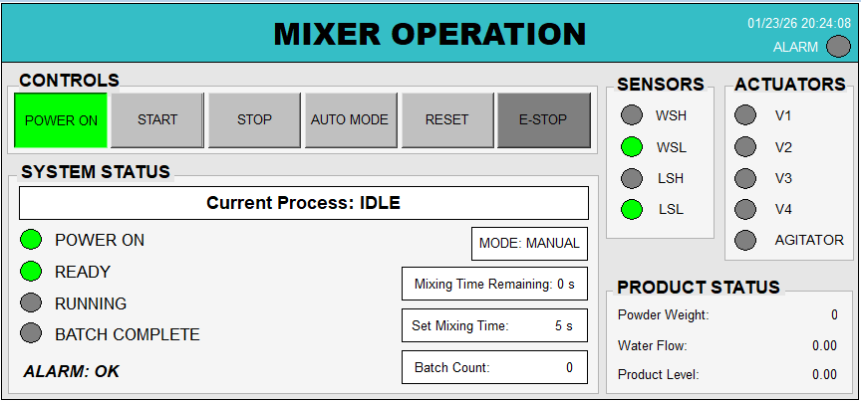
Figure 3: System ON
Step 2: Select the “START” button to start the process.
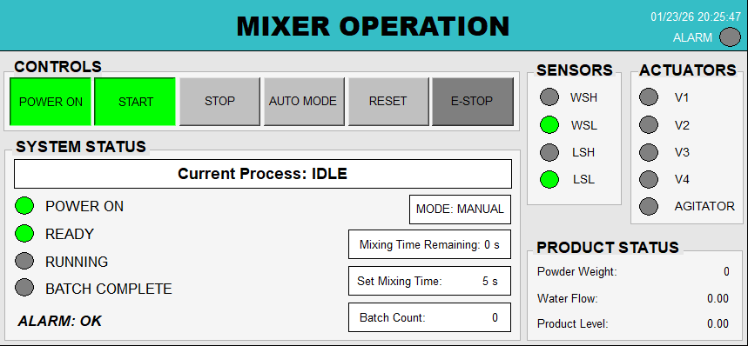
Figure 4: Start Process

Step 3: One Batch has been completed.
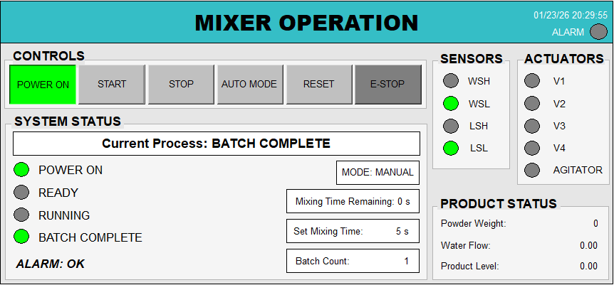
Figure 5: Batch Completed

Step 4: Select the “RESET” button and press the “START” button to start the process again.
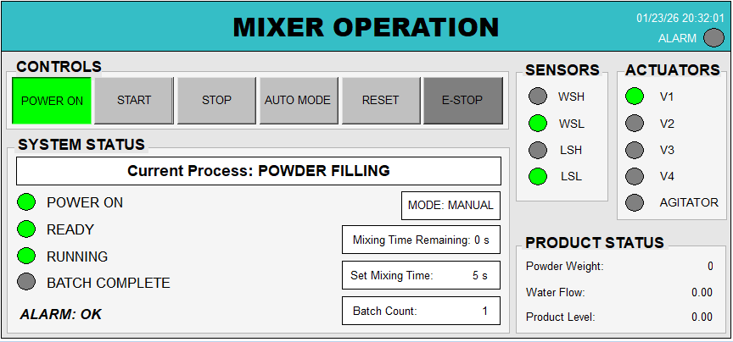
Figure 6: Reset Process

Step 5: Select the “E-STOP” button to stop the overall process. Alarm has also been enabled, and the related alarm text has also changed from “OK” to “E-STOP ACTIVE”.
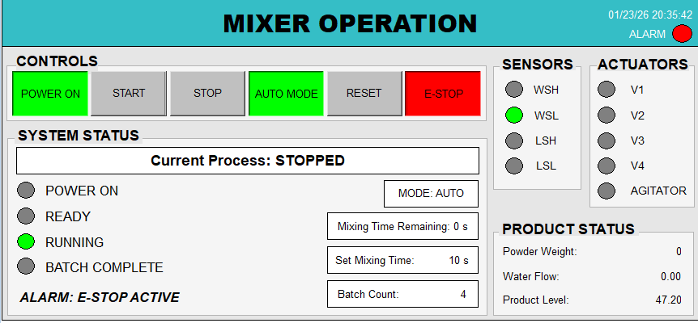
Figure 7: E-Stop enable

Step 6: Toggle the “AUTO MODE” button for continuous batching processing.
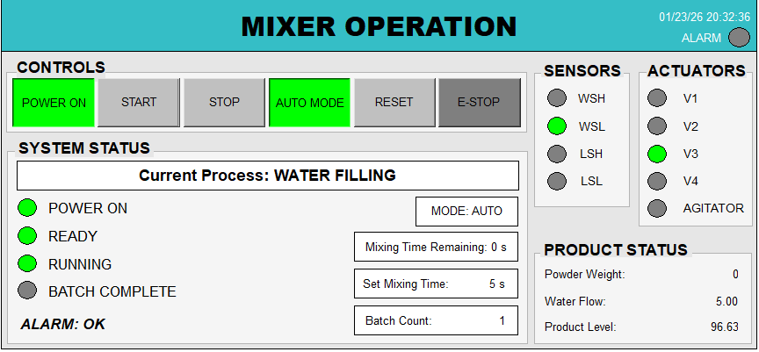
Figure 8: Auto Mode

Step 7: Set the mixing time in milliseconds based on the requirement. Default Mixing time is set to 5 seconds.
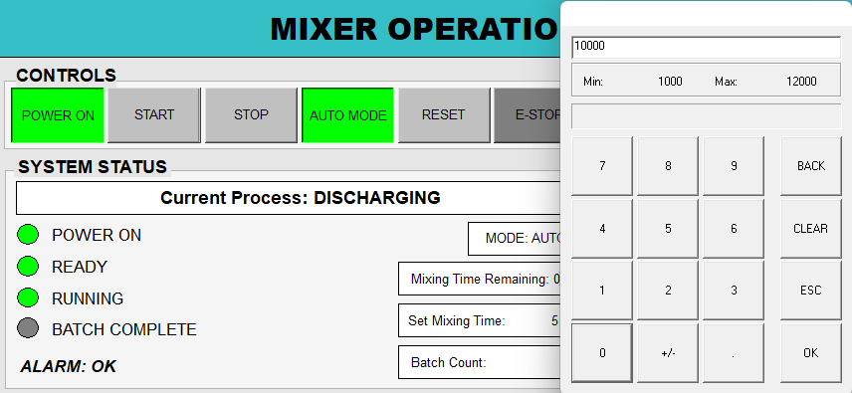
Figure 9: Set Mixing Time

Conclusion
This task successfully automated the manual mixer system using PLC programming in accordance with the IEC 61131-3 standard. System functionality was validated through step-by-step testing via the operator HMI, with screenshots included to demonstrate correct sequence execution and operator interaction. A complete list of system variables, including data types and attributes, and POU code snippets are provided in Appendix B and Appendix C to maintain clarity without overloading the main report.

TASK B - Virtual Commissioning of Workpiece Discharge Station

Overview
This task focuses on the virtual commissioning of a FESTO workpiece discharge station using Siemens NX CAD and TIA Portal. The objective is to validate the mechanical behaviour, sensing strategy, and PLC control logic in a simulated environment before physical deployment. The provided CAD model is used without geometric modification, and physics, joints, sensors, actuators, and PLC signal connections were configured to achieve a realistic and industry-aligned virtual commissioning workflow.

NX CAD modelling and physics setup

CAD Model
The provided FESTO Workpiece Discharge Station CAD model is not geometrically modified, as shown in Figure 10.
Virtual commissioning is achieved by:
- Applying physics: defining rigid and collision bodies, adding joints and constraints
- Configuring sensors, actuators, and signal connections
This approach preserves the original mechanical design while enabling realistic simulation.
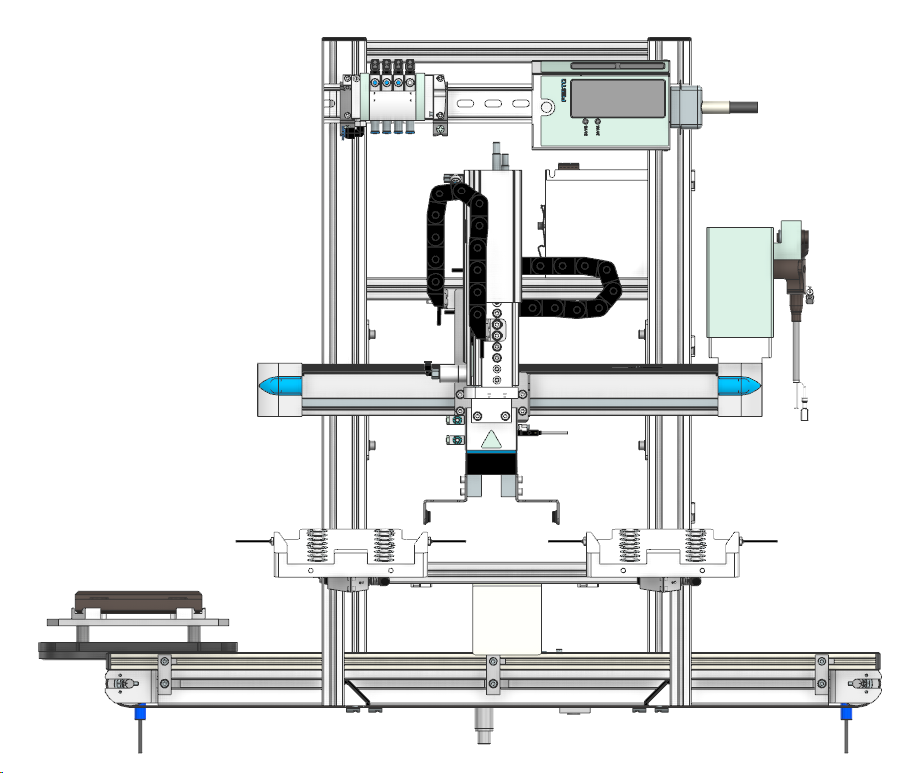

Figure 10: Workpiece Discharge Station CAD Model

Joint Selection and Motion Modelling
Fixed and Relative Fixed Joints
- A fixed joint is applied to the horizontal frame to keep it static.
- A relative fixed joint is applied to the horizontal gripper assembly so that:
  - The gripper moves together as a single mechanical unit
  - Realistic behaviour is preserved during horizontal motion
Sliding Joints
Five sliding joints are used to model linear motion, which is defined below:
Movement Type | Description
Horizontal | Left / Right / Origin
Vertical | Up / Down
Gripper (Left and Right) | Open / Close
Piston | Extend / Retract
Table 2: Sliding Joints
Motion Limits (Defined in Sliding Joints)
Joint | Lower Limit | Upper Limit
Horizontal | −120 mm (Left) | +150 mm (Right)
Vertical | 0 mm (Up) | 80 mm (Down)
Gripper (Left and Right) | 0 mm (Closed) | 5 mm (Open)
Piston | 0 mm (Retract) | 5.5 mm (Extend)
Table 3: Motion limits for Sliding Joints
Figure 44: Sliding joints in NX CAD is attached as a reference in the Appendix D, which shows the joints and constraints added in NX CAD.

Sensors and Actuators Configuration
Sensors
Sensor | Type | Purpose
Start | Capacitive | Detect pallet arrival
Middle | Inductive | Accurate pallet positioning
End | Capacitive | Detect pallet exit
Left Storage | Photoelectric | Count left storage workpieces
Right Storage | Photoelectric | Count right storage workpieces
Sink Sensor | Collision | Remove workpieces during reset
Table 4: Sensors
Actuators
Actuator | Operation
Conveyor | Forward Movement at constant speed
Horizontal Movement | Left / Right / Origin
Vertical Movement | Up / Down
Gripper (Left and Right) Movement | Open / Close
Piston Movement | Extend / Retract
Table 5: Actuators
Figure 41 is attached as a reference in the Appendix D, which shows the joints and constraints added in NX CAD.

Signals Creation
- A structured signal naming convention is used, where cs denotes sensor signals, and pc denotes actuator control signals, enabling clear communication between NX CAD and TIA Portal (Appendix D).
- Sensor signals transmit detection states from NX to TIA Portal, while actuator commands are sent from TIA Portal to NX for motion control.
- Signal optimisation was achieved by using a single control signal for gripper open and a single signal for gripper close, synchronising both left and right grippers while reducing tag count.
- Workpiece flow control was implemented using sourceCarrierWorkpiece for source activation and csSinkWorkpiece for removing stored workpieces after operator reset when storage areas are full (Appendix D).

TIA Portal PLC Program
The control logic for the virtual commissioning task was developed in TIA Portal using Structured Control Language (SCL). The PLC program is responsible for processing sensor feedback received from NX CAD, executing the required sequence of operations, and generating actuator commands that are sent back to the simulation model.

PLC program architecture
- The PLC solution is organised into OB1 + modular FBs + DBs to keep logic readable and scalable.
- Main [OB1] acts as the main program (calls the main function blocks).
- SystemSetup [FB1] handles safety logic and updates master enable / E-stop status in the HMI.
- WorkpieceStation [FB4] (SCL) handles the full automatic sequence.
- OutputInterlocks [FB2] maps internal commands to physical/NX outputs and blocks conflicting motions.

The program block structure is shown in Figure 11.
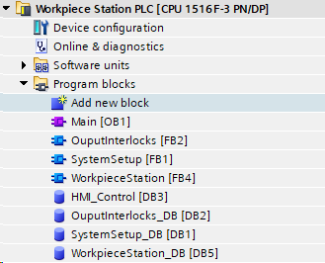
Figure 11: Program Block Structure
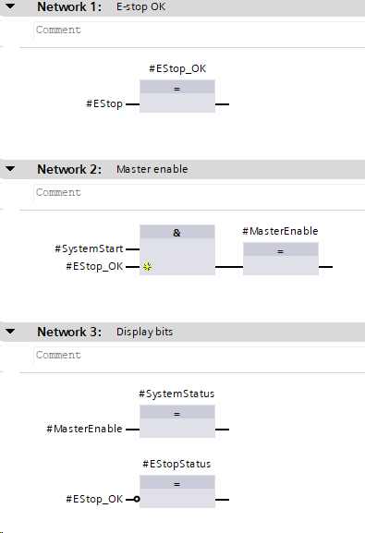

PLC Tags
The following tags are created in TIA Portal for communicating with NX simulation.
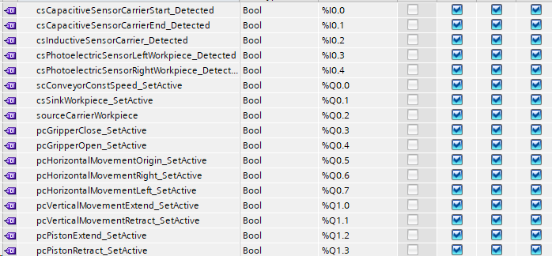
Figure 12: PLC Tags

OB1 Execution Order
The execution order within OB1 is fixed to ensure deterministic behaviour:
- SystemSetup FB – evaluates system start conditions and E-stop status.
- WorkpieceStation FB – executes the automatic sequence when MasterEnable is active.
- OutputInterlocks FB – applies motion interlocks and writes validated commands to outputs.
The Main [OB1] call sequence is shown in Figure 45 in Appendix E.
Automatic Sequence Logic (SCL)
The automatic operation of the workpiece discharge station is implemented using a step-based sequence logic. The system initially remains in an idle state, waiting for the operator to power on the system and press the start command. Once a pallet is detected at the start capacitive sensor, the conveyor is activated and transports the pallet towards the centre of the station.
When the pallet reaches the middle position, detected by the inductive sensor, the conveyor is stopped, and the piston is retracted to accurately position the pallet. A two-second delay is then applied to verify the stable presence of the pallet at the middle position before allowing the next operation to proceed. This prevents false triggering and ensures reliable pallet detection.
After the verification delay, the gripper opens, moves vertically downward, closes to grasp the workpiece, and then returns to the upper position. Following the pick operation, the system determines the horizontal movement direction based on the storage area status. By default, the gripper moves to the left storage area; however, if the left storage area is full, the gripper automatically redirects to the right side.
The workpiece is then released into the selected storage area, triggering the corresponding photoelectric sensor and incrementing the storage count. The gripper subsequently returns to its origin position, and the conveyor is reactivated to move the pallet towards the end sensor. Once the pallet exits the station, the system returns to the idle state and waits for the next pallet, enabling continuous automatic operation. If both storage areas become full, the sequence is halted, and the system waits for an operator reset before resuming operation. The complete automatic sequence is presented in a flowchart in Appendix F.

Operator Interface (HMI)
An operator-focused Human–Machine Interface (HMI) was developed using SIMATIC WinCC Runtime Advanced to allow full monitoring and control of the workpiece discharge station during virtual commissioning. The HMI is designed for automatic operation only, reflecting typical industrial practice where manual intervention is minimised.
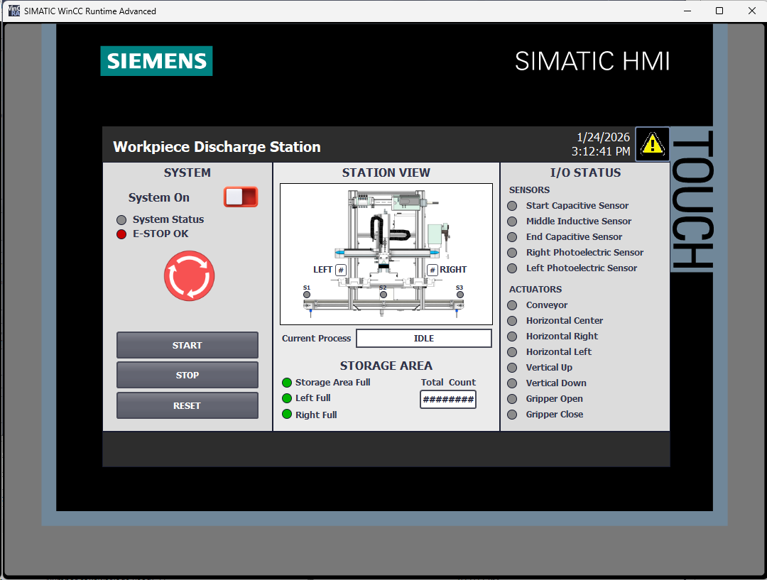

Figure 13: Main Screen
Main Operating Screen
The Main Screen (Figure 13) provides all essential controls and real-time feedback required for normal operation. System-level controls such as System ON, START, STOP, and RESET are located on the left-hand side to ensure clear and intuitive operator interaction. The process is initiated by pressing START once, after which the system continues to operate automatically until a stop condition or a storage full condition is reached.
A central station overview graphic is used to visually represent the physical layout of the station. The Current Process field displays a textual description of the active process step, which is dynamically updated based on the step variable from the SCL sequence logic.
I/O Status and Feedback
The right-hand section of the HMI displays live I/O status indicators for all sensors and actuators, including conveyor motion, axis movements, gripper states, and piston position. This allows the operator to quickly verify system behaviour during operation.
Storage area status is clearly indicated, showing left full, right full, and total workpiece count, where the total count is calculated as the sum of both storage areas. Individual storage full conditions generate warnings, while a combined full condition results in a system alarm.
Alarm Handling
An alarm icon located at the top-right corner of the main screen provides direct navigation to the Alarm Screen (Figure 14). The alarm screen displays a chronological list of alarms with time, date, and descriptive text. Alarms can be acknowledged by the operator, following standard industrial HMI practices.
When both storage areas become full, a critical alarm is generated, and the source is deactivated. The alarm text provides clear guidance to the operator to reset the process. Pressing RESET clears alarms, resets counters, sinks the stored workpieces in NX, and reactivates the source to resume operation.
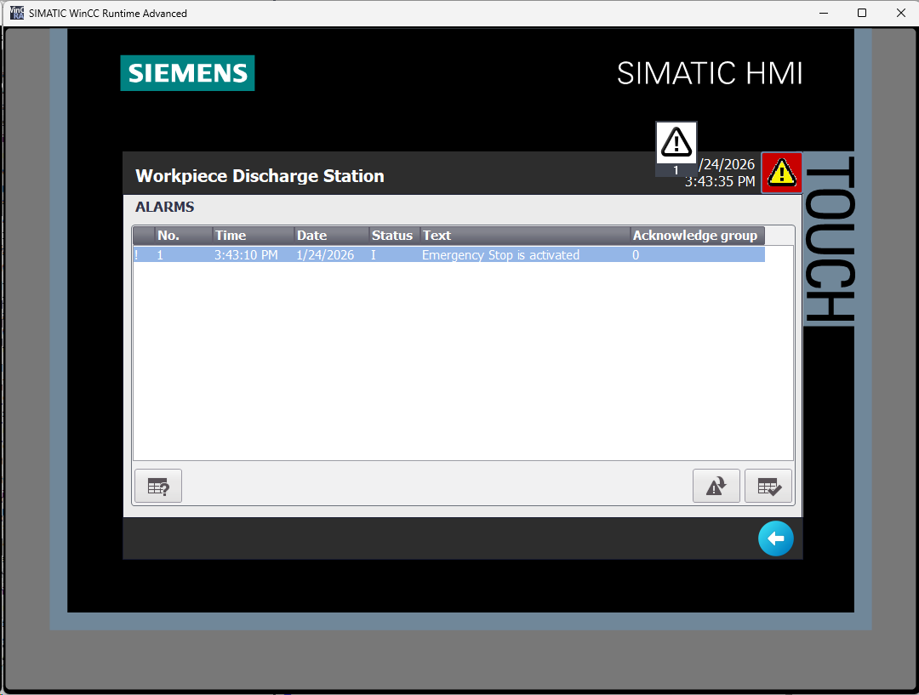
Figure 14: Alarm Screen
Safety Indication
Emergency stop status is visually indicated on the main screen. When an E-STOP condition occurs, all motion is halted, and an alarm is generated, ensuring safe system behaviour and clear operator feedback.

Testing and Validation Procedure
The virtual commissioning of the Workpiece Discharge Station was tested using S7-PLCSIM Advanced, TIA Portal, and NX Mechatronics Concept Designer. The following steps describe the complete validation workflow.

Step 1: PLC Simulation Setup
S7-PLCSIM Advanced was launched, and a simulated PLC instance named “WorkpieceStation” was created and started to emulate the S7-1500 controller.
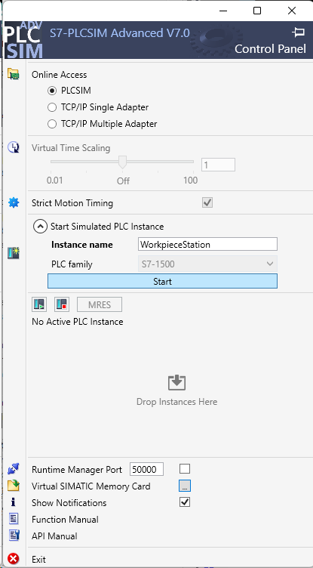

Figure 15: PLCSIM Advanced instance configuration

Step 2: Open TIA Portal Project
The archived TIA Portal project “Main Program” is opened and extracted to a local workspace.
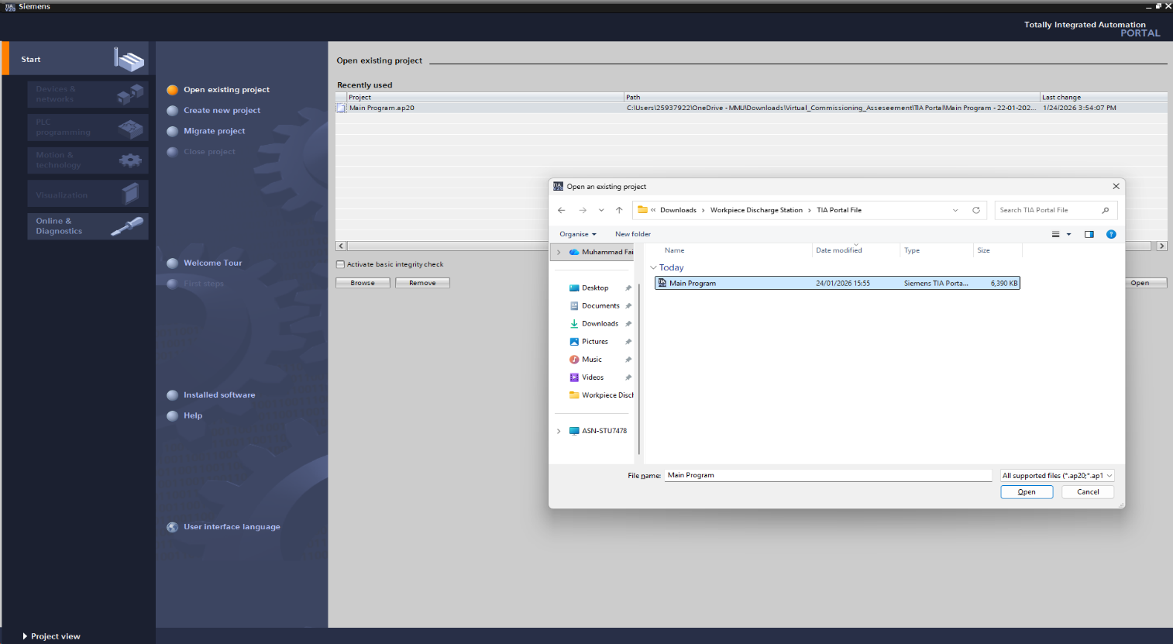
Figure 16: Opening TIA Portal Project

Step 3: Download PLC Program
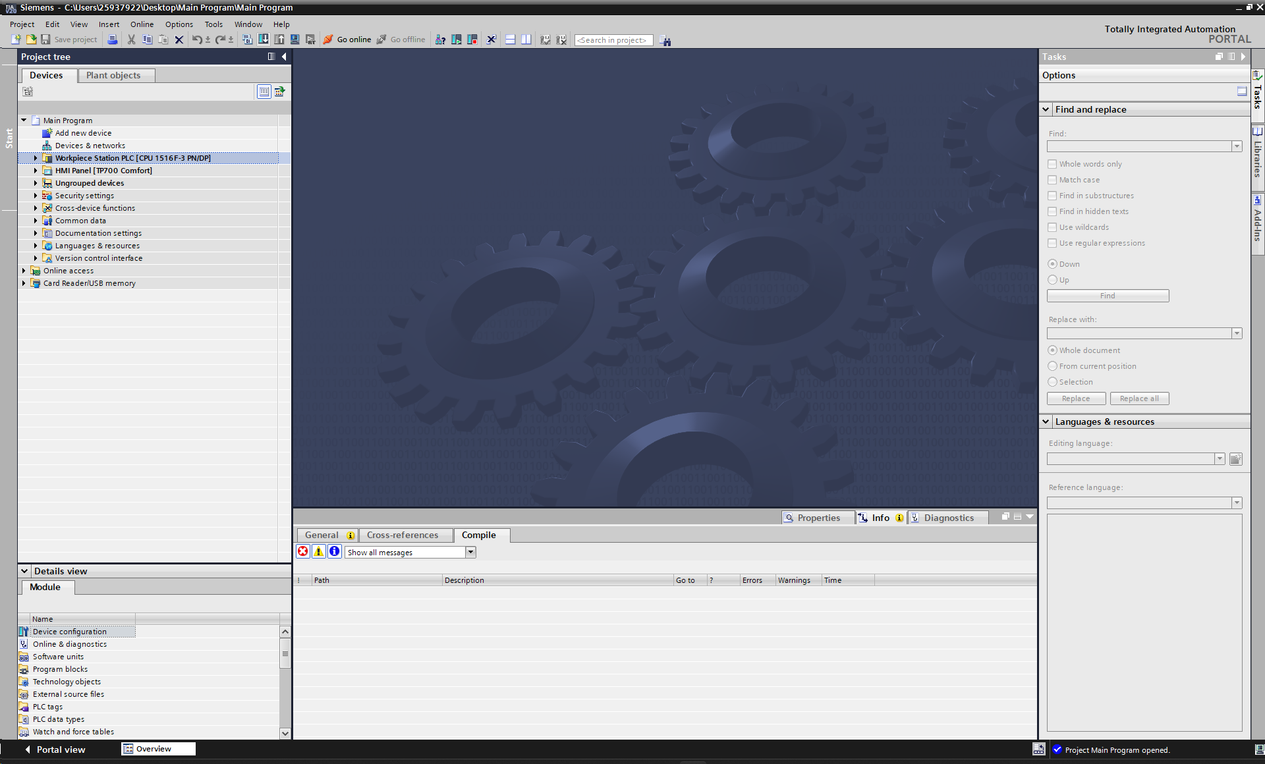
The PLC project is selected from the project tree, and the “Download to Device” button is selected.

Figure 17: Figure 18: Downloading PLC Program

Step 4: Configure PG/PC Interface
Figure 18: Opening Project Workspace
The PG/PC interface was set to PN/IE, with the connection configured as PN/IE_1. Select the “Load” button to upload the program to the PLC.
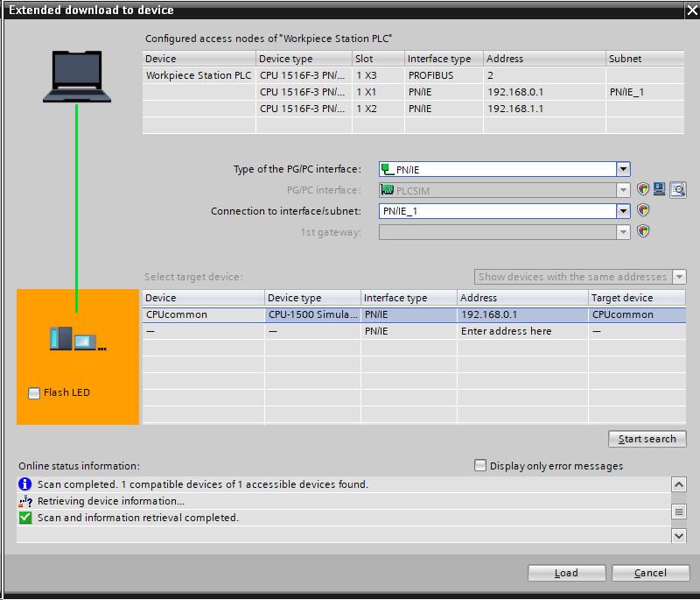
Figure 19: Configuring PG/PC Interface

Step 5: Start the PLC Module
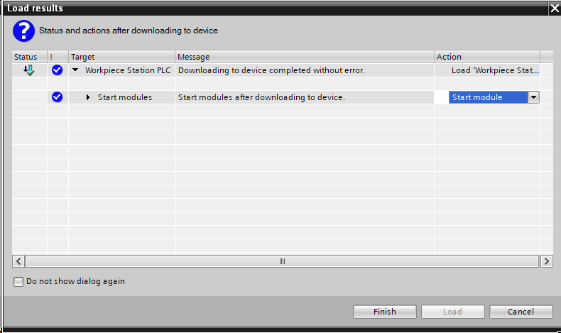
Figure 20: Starting the PLC Module

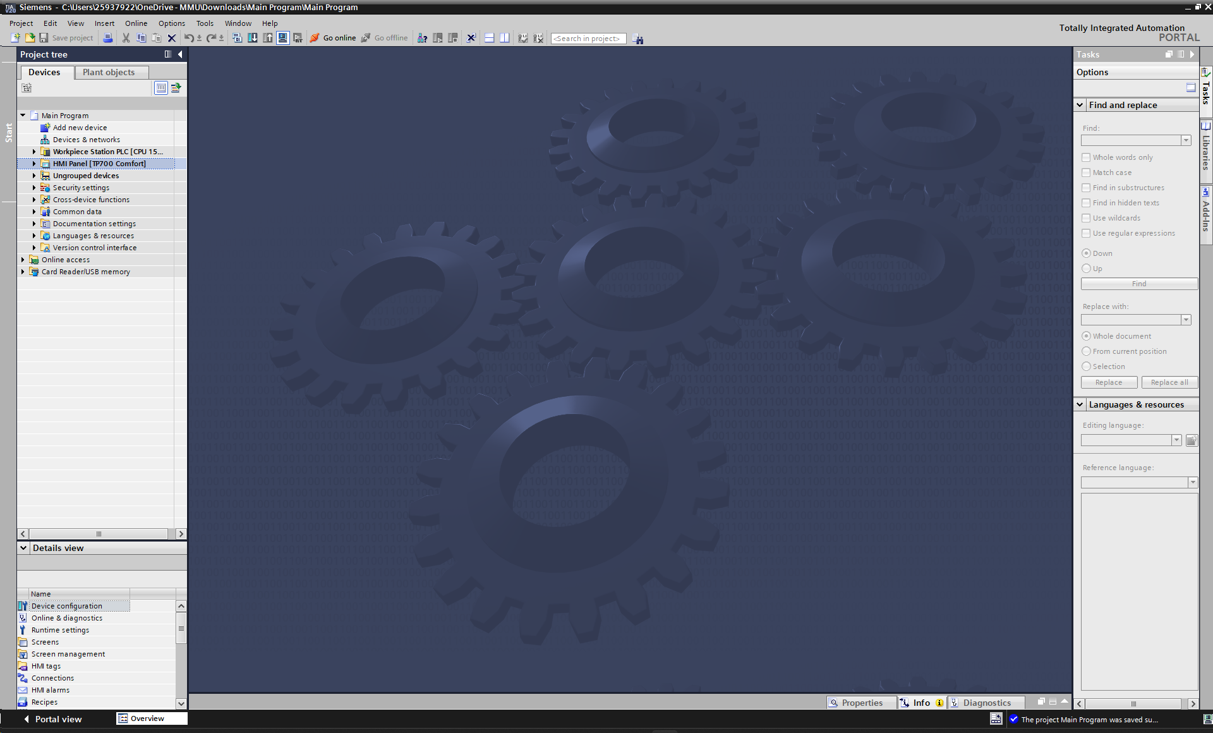
Step 6: Simulate the HMI Project
Figure 21: Simulate the HMI Project

Step 7: HMI Screen Simulated
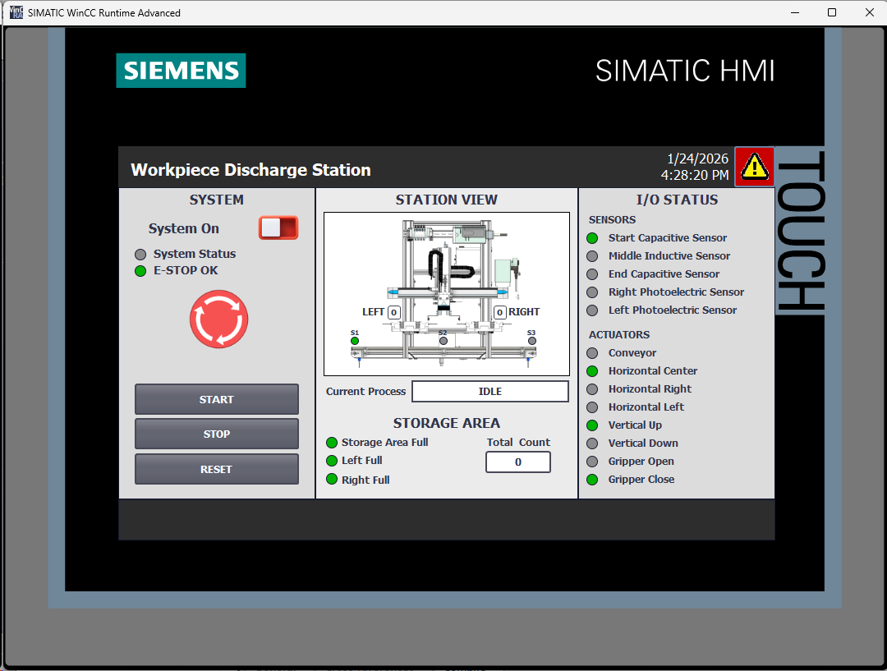
Figure 22: Figure 22: HMI Screen Simulated

Step 8: Open NX File
Load NX Mechatronics Concept Designer and open the “WorkpieceDischargeStation” file.
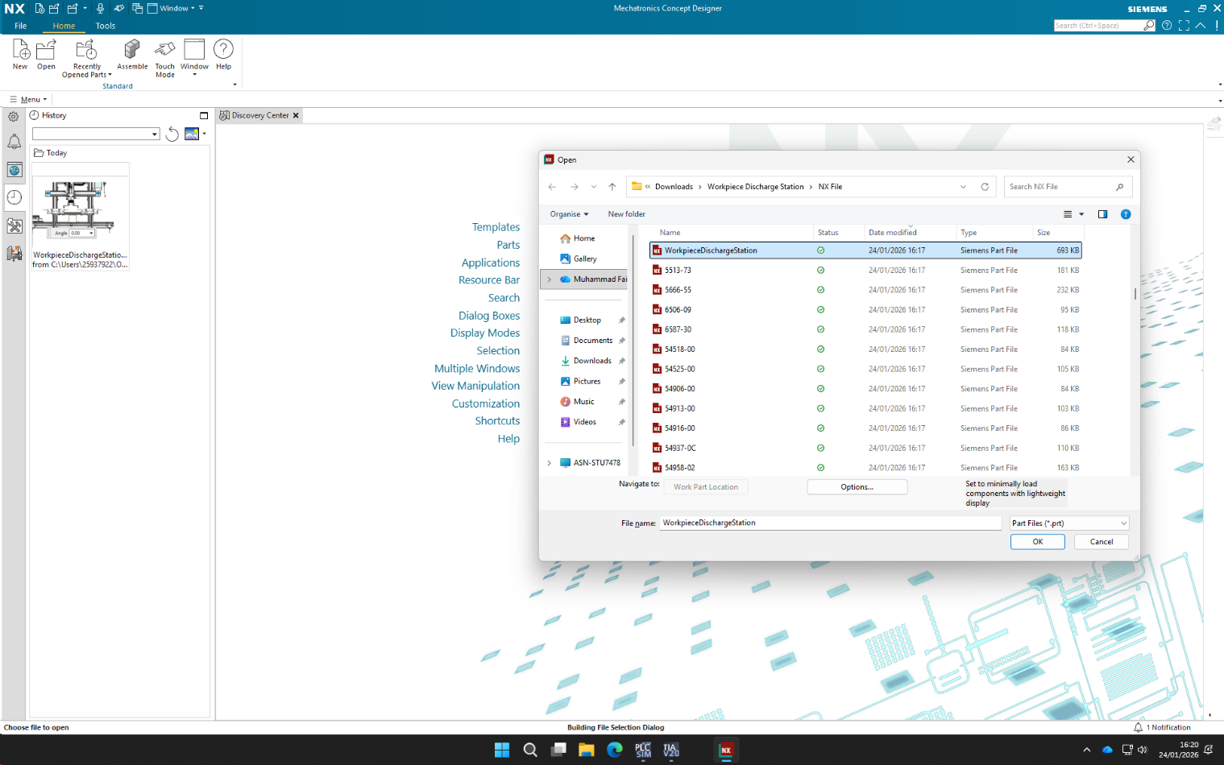

Figure 23: Opening NX File

Step 9: Run the Simulation
Select the “Play” button to run the simulation.
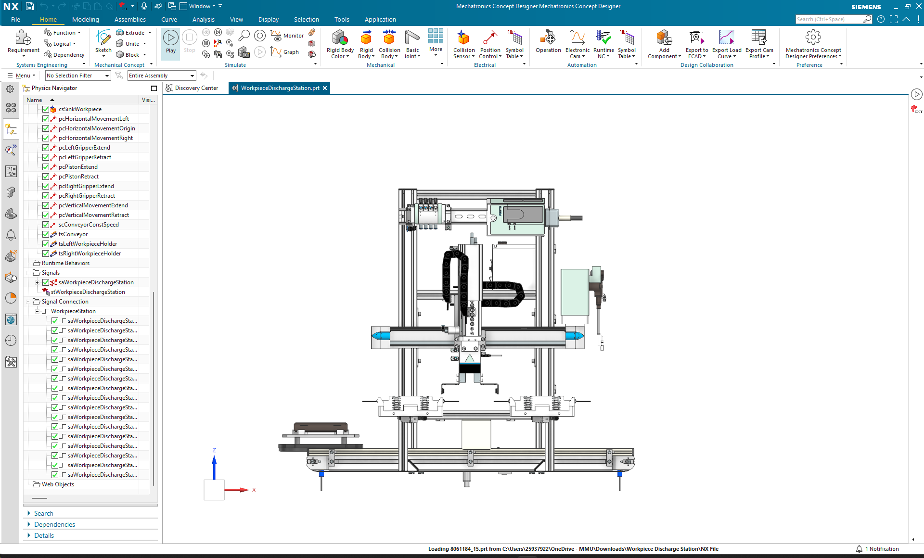

Figure 24: Running the Simulation

Step 10: Turn on System Power
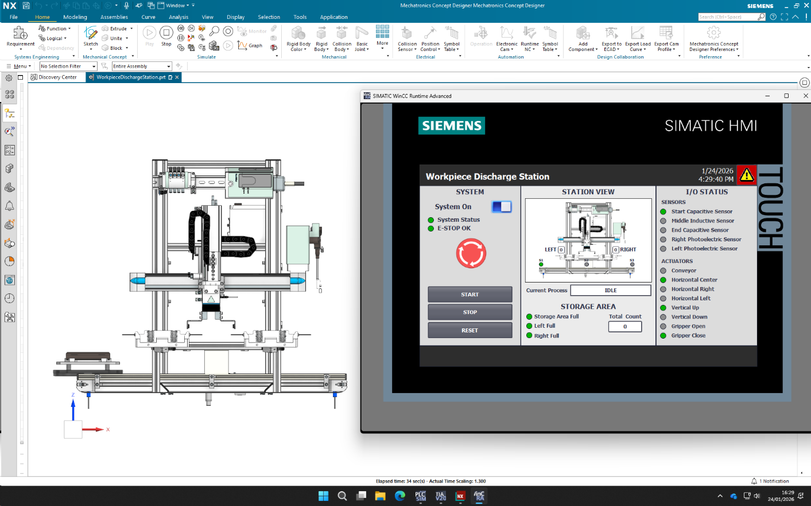
Toggle the “System On” to turn on the system power.
Figure 25: Turning on System Power

Step 11: Start the Process
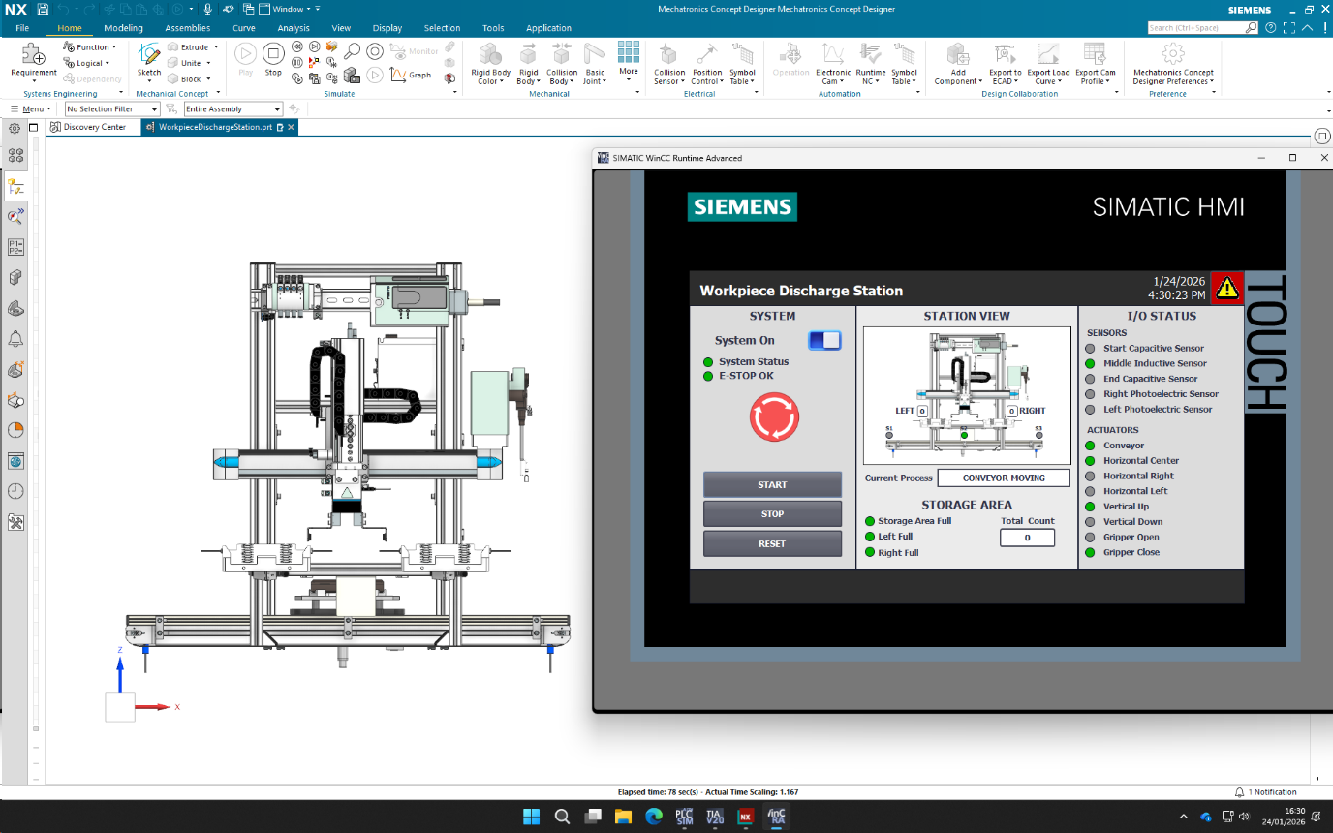
The “Start” button is pressed to start the process, and the conveyor is now stopped in the middle.

Figure 26: Starting the Process

Step 12: Drop Workpiece
Now, the workpiece is dropped in the storage area.
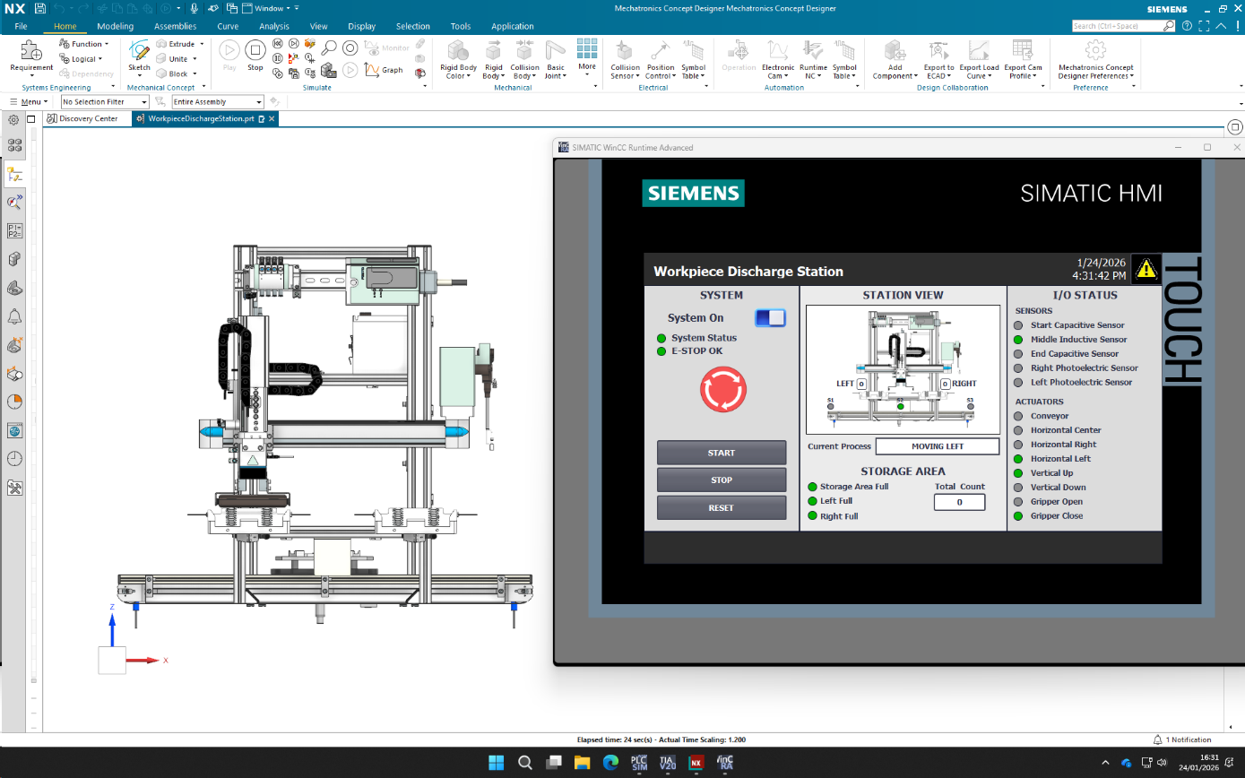
Figure 27: Dropping Workpiece

Step 13: Alarm Trigger
Now, both the storage areas are full, and the alarm has been triggered in the HMI alarm screen, which can be accessed from the top-right alarm button.
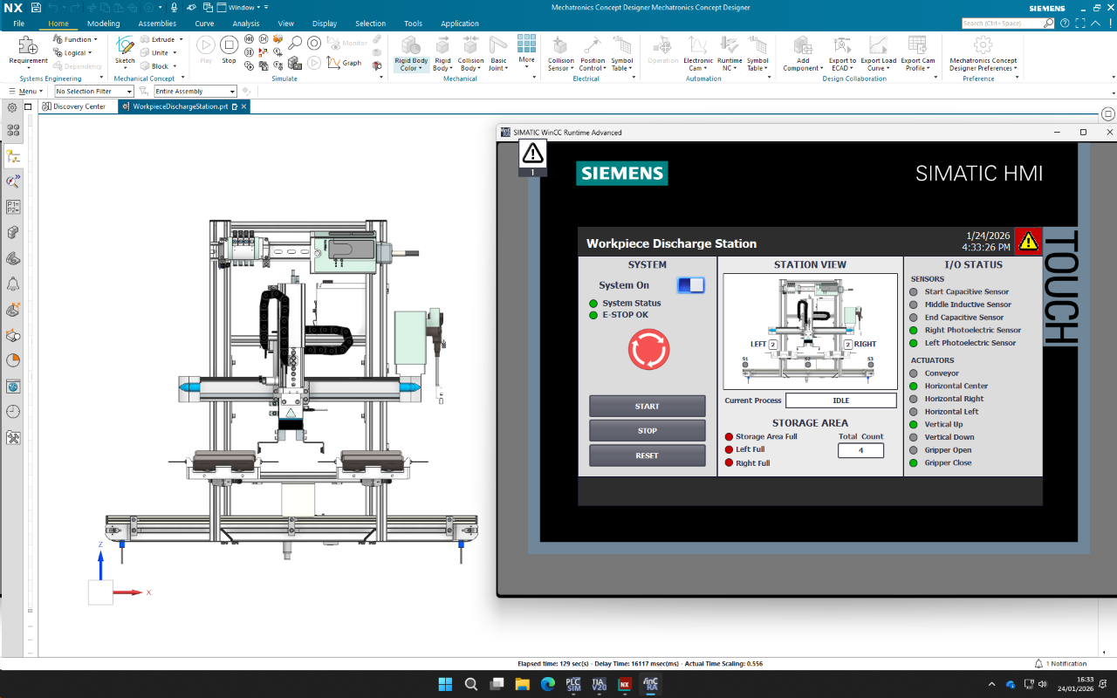

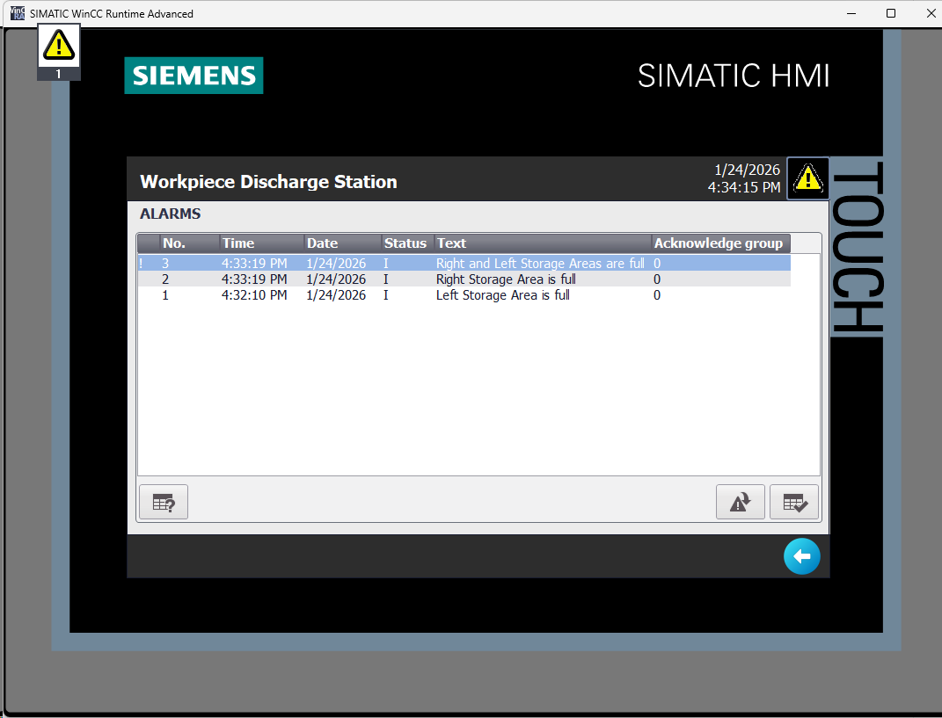
Figure 28: Occupied Storage Area
Figure 29: Alarm Triggered

Step 14: Operator Guidance
Click the icon to get guidance on alarm.
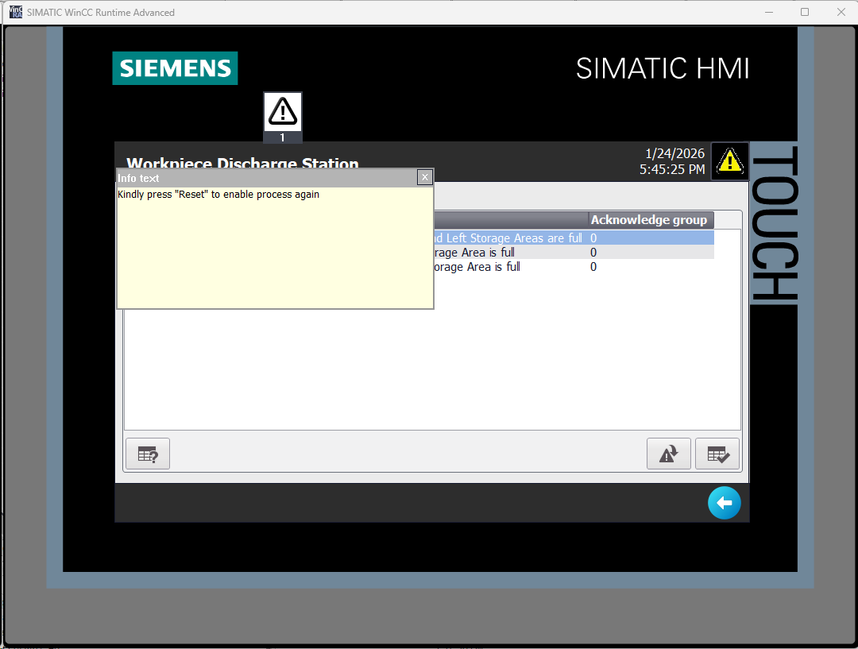

Figure 30: Guiding Operator

Step 15: Reset Process
Go back to the main screen from the back arrow in the bottom-right corner and click the “Reset” button to restart the process.
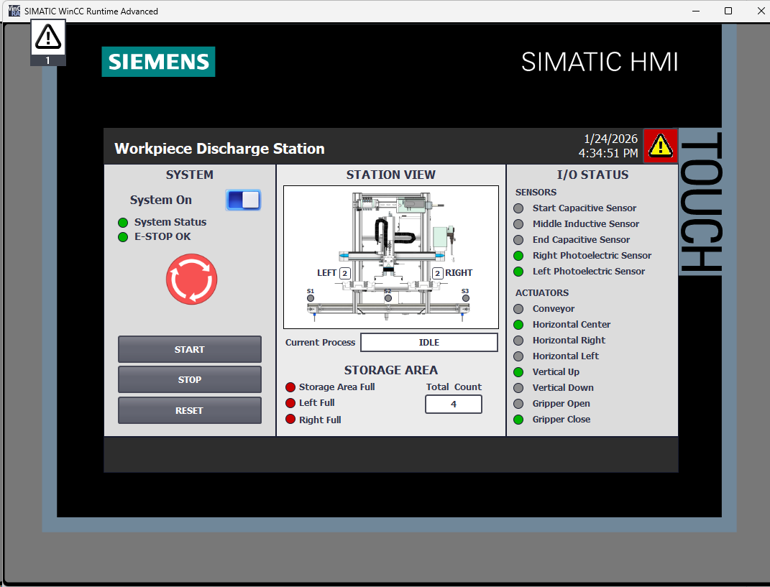

Figure 31: Resetting Process

Discussion on Safety, Sustainability and Social Impact

Human Safety Considerations
- An Emergency Stop (E-Stop) is implemented on the HMI, which immediately halts the entire virtual system when activated. This ensures safe system shutdown during abnormal or hazardous conditions.
- Motion interlocking is applied within the PLC logic to prevent conflicting actuator movements, ensuring that incompatible motions (e.g., simultaneous left and right horizontal movement) cannot occur.
- Alarm-based protection is implemented:
  - Warnings are generated when either the left or right storage area becomes full.
  - A critical alarm is generated when both storage areas are full or when the E-Stop is activated, stopping further operation until operator intervention.
- Sliding joint limits defined in NX CAD prevent mechanical over-travel, improving positional safety during virtual commissioning.

Sustainability and Resource Efficiency
- Virtual commissioning using NX Mechatronics Concept Designer and PLCSIM Advanced allows the complete system to be tested without physical hardware, reducing material waste and commissioning costs.
- Energy-efficient behaviour is incorporated in the control logic:
  - The conveyor runs only when required and remains stopped during gripping and placement operations.
  - The workpiece source is deactivated automatically when both storage areas are full, preventing unnecessary generation of parts.
- These measures reflect sustainable automation practices by minimising unnecessary motion, energy use, and resource consumption during operation.

Social Impact of Automation
- The automated workpiece handling process reduces manual handling and repetitive tasks, improving operator safety.
- The operator’s role shifts from direct manual control to system supervision and decision-making, supported by:
  - Clear process status text
  - Alarm messages with operator guidance
- Informative HMI feedback improves situational awareness, reducing operator stress and the likelihood of human error during operation.

Conclusion
This project successfully demonstrated the application of virtual commissioning techniques to an industrial workpiece handling station using NX Mechatronics Concept Designer, TIA Portal, and PLCSIM Advanced. The solution enabled full validation of control logic, motion behaviour, and operator interaction before any physical implementation, closely reflecting modern Industry 4.0 engineering practices.
The developed system integrates realistic mechanical motion, PLC-based sequential control, and an operator-focused HMI, allowing safe and structured testing of the complete automation process. Key safety considerations, such as emergency stop functionality, motion interlocking, and alarm-based operator guidance, were implemented to prevent conflicting movements and unsafe operating conditions. In addition, energy efficiency was improved by activating actuators, such as the conveyor, only when required by the process.
Virtual commissioning proved particularly valuable in verifying process logic, sensor–actuator interaction, and storage capacity handling without physical risk or material waste. The approach reduced development time, improved confidence in system behaviour, and highlighted the importance of simulation-driven validation in modern automation projects.

Future Recommendations
While the current implementation meets the project objectives, several enhancements could further improve system robustness:
- Workpiece presence detection could be added to verify whether a pallet contains a workpiece before initiating the pick-and-place operation.
- Limit-switch-based motion control could replace timer-based positioning, particularly for horizontal movements, improving accuracy and industrial realism.
Implementing these improvements would further enhance system accuracy, realism, and industrial applicability.

References
International Electrotechnical Commission (no date) IEC 61131-3:2025. Available at: https://webstore.iec.ch/en/publication/68533. (Accessed: 23-01-2026)
OpenAI (2024) ChatGPT response to Muhammad Faizan Ahmed, 23 January.
PLCOpen (no date) Status of IEC 61131-3 standard. Available at: https://www.plcopen.org/standards/logic/iec-61131-3/status-iec-61131-3-standard. (Accessed: 23-01-2026)
Resendes, W. (2025) 'Pros and Cons of PLCs in Industrial' Access Industrial Automation, 15 May. Available at: https://aiautomation.org/pros-and-cons-of-plcs-in-industrial-automation. (Accessed: 23-01-2026)
Siemens (no date) Virtual Commissioning. Available at: https://www.siemens.com/global/en/products/automation/industry-software/virtual-commissioning.html. (Accessed: 23-01-2026)
Virtual Commissioning (2025) What is Virtual Commissioning? Available at: https://virtualcommissioning.com/what-is-virtual-commissioning-2. (Accessed: 23-01-2026)

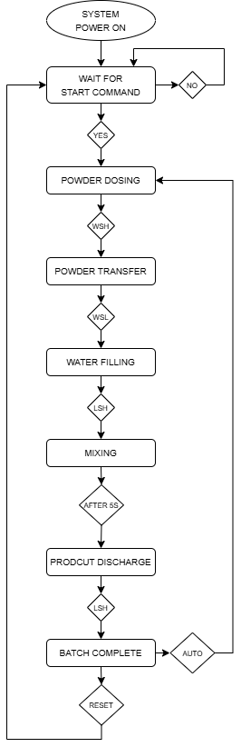
Appendix A
Figure 32: Automated Mixer Batch Sequence

Appendix B

Sensors
Variable | Data Type | Description
WSL | BOOL | Weighing vessel low-level sensor
WSH | BOOL | Weighing vessel high-level sensor
LSL | BOOL | Mixing tank low-level sensor
LSH | BOOL | Mixing tank high-level sensor

Actuators
Variable | Data Type | Description
V1 | BOOL | Powder inlet valve control
V2 | BOOL | Powder transfer valve
V3 | BOOL | Water inlet valve
V4 | BOOL | Product discharge valve
Agitator | BOOL | Mixer motor control

Control Signals
Variable | Data Type | Description
Cmd_PowerOn | BOOL | System power command from HMI
Cmd_Start | BOOL | Start batch operation
Cmd_Stop | BOOL | Stop operation
Cmd_EStop | BOOL | Emergency stop command
Cmd_Reset | BOOL | System reset command

Internal Control and Status Flags
Variable | Data Type | Description
SystemPower | BOOL | Internal system power state
PermitRun | BOOL | Safety-permitted run condition
Running | BOOL | Indicates active batch execution
BatchComplete | BOOL | Batch completion status
MixDone | BOOL | Mixing cycle completed flag

Process Parameters and Timers
Variable | Data Type | Description
Weight | REAL | Measured powder weight
WaterFlow | REAL | Water flow measurement
ProductFlow | REAL | Product discharge flow
MixTimeSet | TIME | Configured mixing duration
MixTimeRemain | TIME | Remaining mixing time

HMI Indicators and Messages
Variable | Data Type | Description
CurrentProcessText | STRING(30) | Displays active process stage
AlarmText | STRING(30) | Active alarm message
AlarmActive | BOOL | Alarm status flag
BatchCount | UDINT | Completed batch counter

Appendix C
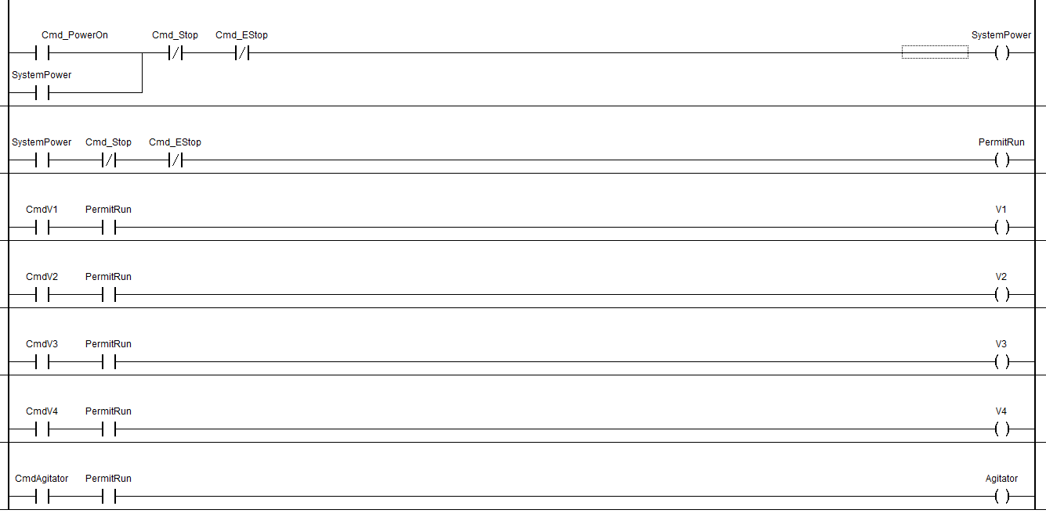
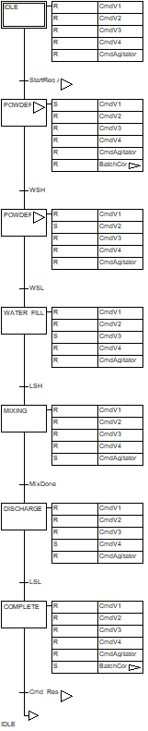
Figure 33: Main Flow SFC Code

Figure 34: Actuator Enable LAD Code
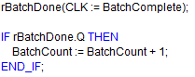
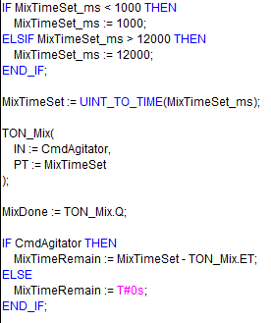
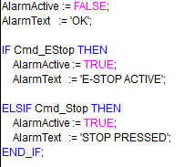
Figure 35: Batch Count ST Code
Figure 36: Mixing Time Control ST Code
Figure 37: Alarms ST Code

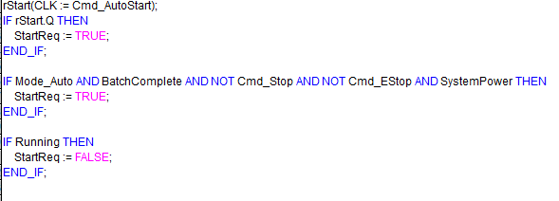

Figure 38: Start Request ST Code
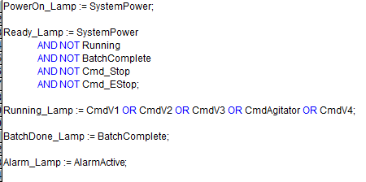

Figure 39: Status Indicators ST Code

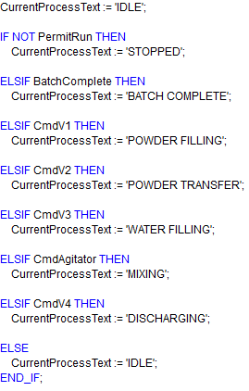
Figure 40: Process Status ST Code

Appendix D
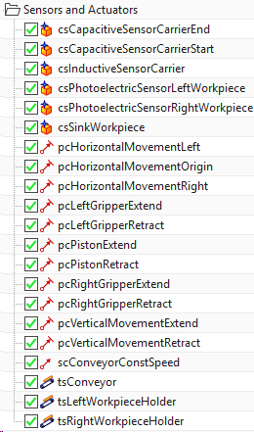
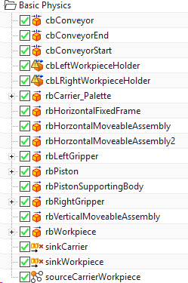

Figure 41: Sensors and actuators defined in NX CAD
Figure 42: Rigid and Collision bodies defined in NX CAD
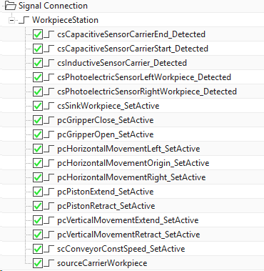
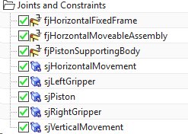
Figure 43: Signals created in NX CAD

Figure 44: Sliding joints in NX CAD

Appendix E
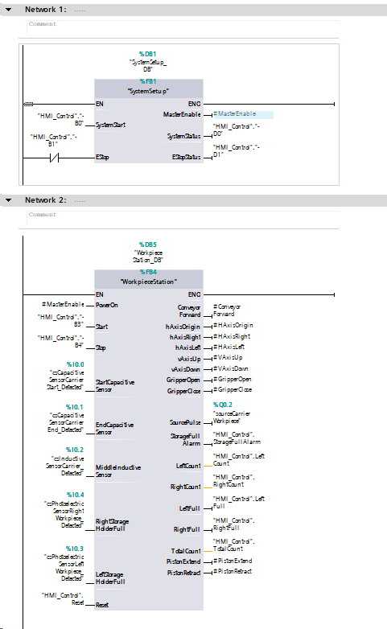
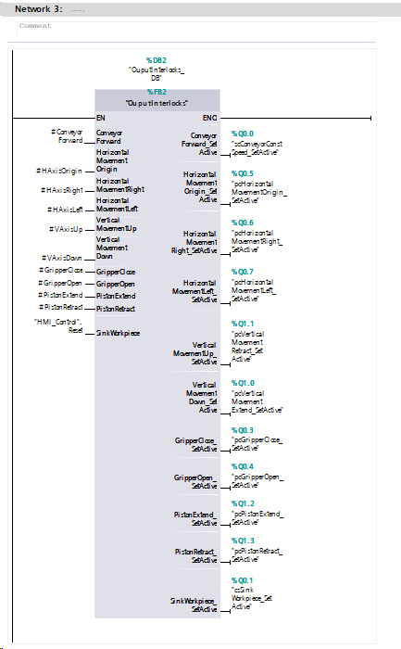
Figure 45: Main [OB!]

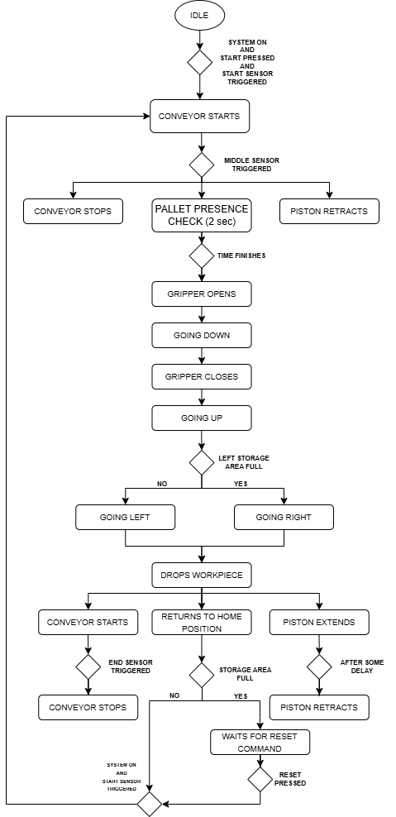
Appendix F
Figure 46: Automatic Sequence

