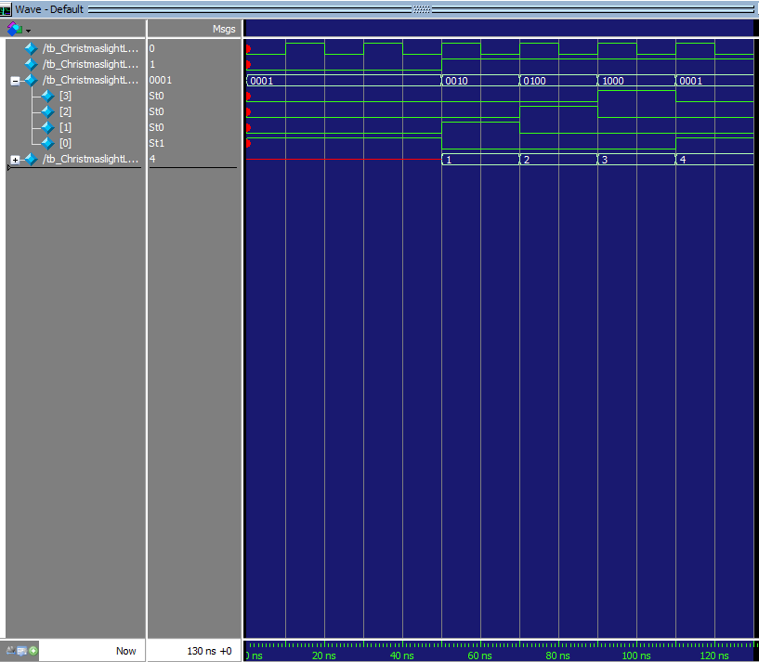
The LED controller is implemented as a 4‑state Moore FSM, where each state corresponds to exactly one LED being active. The FSM uses a synchronous state register updated on the rising edge of the clock and a separate combinational block that computes the next state and the LED outputs based only on the current state. A Verilog testbench generates a periodic clock, applies an initial reset, and then allows the FSM to advance through four clock cycles before stopping the simulation.

$$0100$$

$$1000$$

S0
S1
S2
S3
$$0010$$

RST

$$0001$$

In the ModelSim waveform, the clk signal toggles with a 20 ns period, while reset_n is asserted low at the beginning and then released, enabling state transitions. After reset, the leds[3:0] bus clearly sequences through 0001 → 0010 → 0100 → 1000 → 0001, showing that the FSM cycles through its four states, each active for one clock period before moving to the next. The simulation is stopped after these four transitions.

