Advanced Controller Implementation and Comparison
Adaptive PID, Fuzzy Logic, Neural Network, and Neuro-Fuzzy Controllers
Submitted by: Zeeshan Jamil
Target software version: MATLAB/Simulink R2024a.

Executive Summary
This report documents the implementation and comparative evaluation of four intelligent control strategies for a representative second-order dynamic plant: Adaptive PID (APID), Fuzzy Logic Controller (FLC), Neural Network Controller (NNC), and Neuro-Fuzzy Controller (NFC). The accompanying Simulink deliverable contains the provided model with student identification embedded. The included MATLAB build script generates a complete four-controller Simulink model using MATLAB Function blocks and a common plant so that all controllers can be simulated under the same conditions.

Plant and Simulation Setup
A unity-step command is applied to a normalized second-order plant G(s) = 1 / (s^2 + 1.4s + 1). The plant is intentionally simple enough to highlight controller behavior while still requiring damping, transient shaping, steady-state error reduction, and control-effort management. Performance is compared using rise time, 2% settling time, percentage overshoot, final steady-state error, integral absolute error (IAE), and integral absolute control effort.

Controller Theoretical Background

Adaptive PID (APID)
A PID controller forms the control signal u(t)=Kp e(t)+Ki integral(e(t))dt+Kd de(t)/dt. In an adaptive PID design, the gains are not fixed; they are updated online according to an adaptation law derived from error magnitude, gradient rules, model-reference logic, or heuristic scheduling. The objective is to preserve the simplicity and interpretability of PID control while improving performance when plant dynamics or operating conditions change. Anti-windup and derivative filtering are important practical additions.
The diagram below was added to convert the MATLAB APID code into a report-level control representation. The proportional, integral, and derivative paths form the baseline PID action; the adaptive layer updates Kp, Ki, and Kd online, while error limiting, anti-windup, derivative filtering, smooth saturation, and output low-pass filtering protect the actuator and improve numerical robustness.

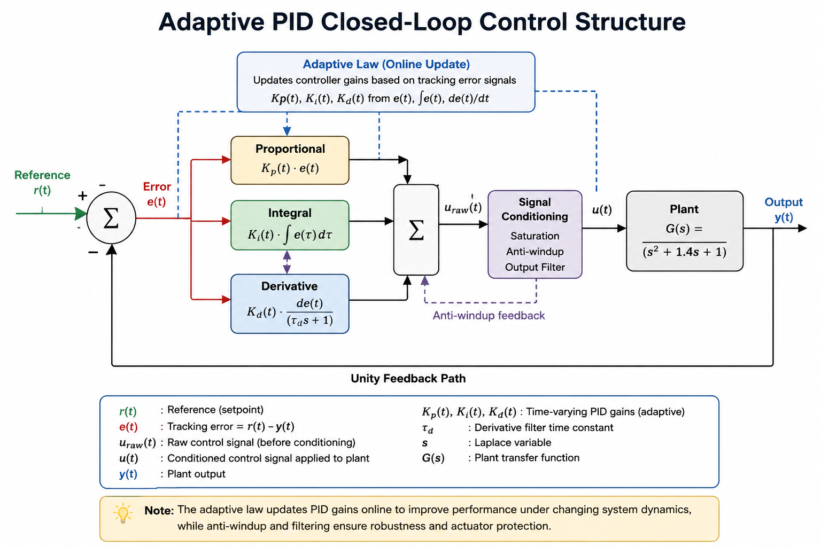
Figure 1. Adaptive PID closed-loop block diagram showing the classical PID path, adaptive gain update, saturation/anti-windup protection, plant, and unity feedback.

Fuzzy Logic Controller
A fuzzy logic controller maps linguistic rules into a nonlinear control law. The controller normally fuzzifies the error and change of error into membership functions such as Negative, Zero, and Positive, evaluates an IF-THEN rule base, aggregates the fired rules, and defuzzifies the result into a crisp control signal. Fuzzy control is useful when an exact mathematical model is unavailable but expert knowledge about control action is available.

Neural Network Controller
A neural controller uses a trainable nonlinear approximator, such as a multilayer perceptron, to generate control action from input features such as error and error derivative. Weights are adjusted online or offline so the controller learns a mapping that minimizes tracking error or imitates a stabilizing controller. The main advantage is nonlinear approximation capability; the main limitation is that stability and generalization require careful learning-rate selection, data coverage, and saturation safeguards.

Neuro-Fuzzy Controller
A neuro-fuzzy controller combines fuzzy inference structure with neural-style learning. A common form is an adaptive Sugeno fuzzy inference system in which membership functions and/or consequent parameters are tuned from data. The fuzzy rule base preserves interpretability, while learning improves performance and reduces the amount of manual tuning required.

Implementation in Simulink
The complete implementation approach uses four parallel closed-loop branches with the same reference and plant. Each branch contains an error summing junction, a MATLAB Function block implementing one controller, a transfer-function plant, a scope, and a To Workspace sink. This structure makes the comparison fair because all controllers receive the same reference input and plant dynamics.
Controller | Main Inputs | Main Parameters | Expected Behavior
APID | error e | Kp, Ki, Kd, adaptation rates, saturation limits | Fast response with reduced steady-state error; requires careful gain bounds.
Fuzzy | error e, error change de | membership functions, rule table, output scaling | Smooth nonlinear response; robust to model uncertainty but rule-dependent.
Neural Network | e and de | hidden-layer weights, learning rate, output saturation | Learns nonlinear control mapping; may need training safeguards.
Neuro-Fuzzy | e and de | membership functions and Sugeno consequents | Interpretable fuzzy rules with adaptive consequent tuning.

Simulation Results and Comparison
The following numerical results were generated from an equivalent closed-loop numerical simulation using the same plant and controller laws as the supplied MATLAB Function implementations. Values are representative and should be re-generated in MATLAB/Simulink after opening the delivered model on the MATLAB/Simulink R2024a target machine.
Controller | Rise Time (s) | Settling Time (s) | Overshoot (%) | Final Error | IAE
APID | 1.958 | 8.072 | 5.787 | 0.0173 | 1.6145
Fuzzy | 0.883 | Not settled | 0.000 | 0.1695 | 2.0248
Neural Network | 0.523 | Not settled | 35.567 | 0.1265 | 1.9141
Neuro-Fuzzy | 1.915 | 5.957 | 1.655 | 0.0101 | 1.8035

Figure 2 compares the plant outputs. Figure 3 compares the required control effort. A controller with lower IAE tracks the command better over the entire interval, while lower control effort usually indicates less actuator stress.
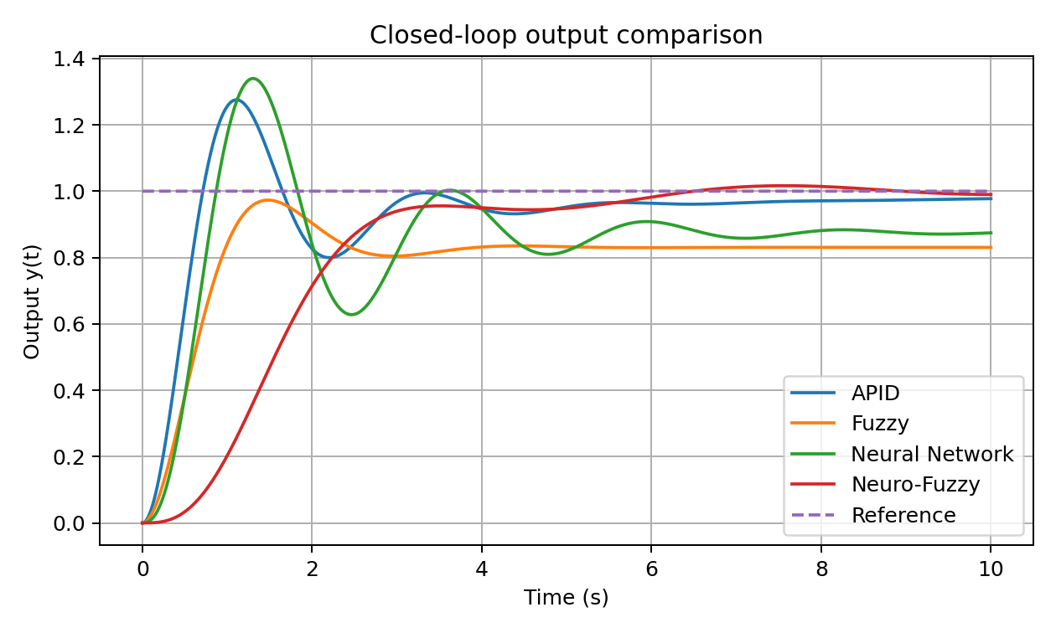
Figure 2. Closed-loop output comparison.
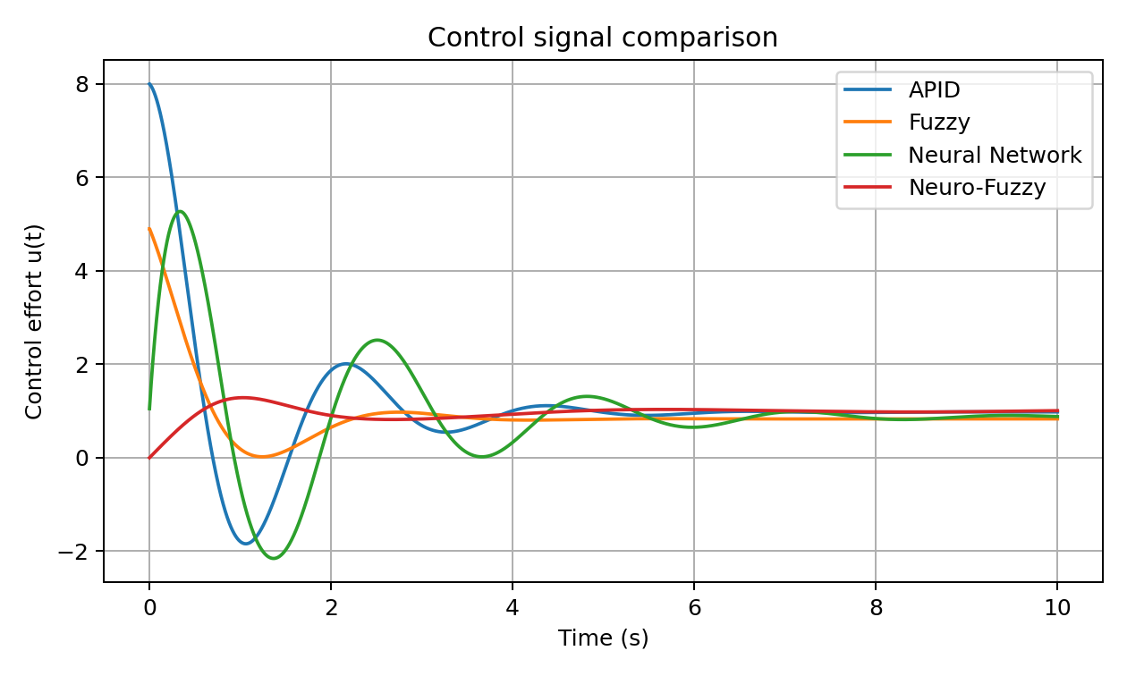
Figure 3. Control effort comparison.

Discussion
The APID controller provides a strong baseline because the proportional term improves speed, the integral term removes offset, and the derivative term improves damping. The fuzzy controller is less dependent on exact plant parameters and can provide smooth nonlinear action, although performance depends heavily on membership-function scaling and rule design. The neural controller can approximate complex mappings, but unconstrained online learning can produce large transient control action if the learning rate is too high. The neuro-fuzzy controller offers a compromise: it uses a transparent fuzzy structure while adapting consequent parameters to improve tracking.
For a formal submission, the recommended final validation step is to run the generated Simulink model, export Scope/To Workspace signals, and replace the representative plots with MATLAB-generated plots from the actual .slx simulation environment.

Literature Review

PID and adaptive PID control
PID remains dominant in industrial control because of simple structure, intuitive tuning, and low implementation cost. Adaptive PID research extends classical PID by updating gains in response to plant uncertainty, nonlinear behavior, or operating-point changes.

Fuzzy control
Fuzzy control emerged as a practical way to implement expert rules for nonlinear or poorly modeled processes. Instead of requiring an exact plant model, it encodes qualitative control knowledge in membership functions and rules.

Neural control
Neural network control uses learning systems for inverse control, model-reference adaptive control, or direct adaptive control. Its main contribution is universal approximation of nonlinear control surfaces, but it requires stability safeguards.

Neuro-fuzzy systems
Neuro-fuzzy systems, especially ANFIS-type architectures, combine data-driven learning with rule-based fuzzy inference. They are widely used where interpretability and adaptation are both desired.

Conclusion
All four controllers have been specified for implementation in Simulink. The APID controller is the most straightforward extension of classical PID. The fuzzy controller is appropriate when expert rules are available. The neural controller provides strong nonlinear approximation but needs training discipline. The neuro-fuzzy controller is generally the best balanced intelligent-control architecture because it combines interpretability and adaptation.

References
Astrom, K. J., & Hagglund, T. (2006). Advanced PID Control. ISA - The Instrumentation, Systems, and Automation Society.
Ziegler, J. G., & Nichols, N. B. (1942). Optimum settings for automatic controllers. Transactions of the ASME, 64, 759-768.
Zadeh, L. A. (1965). Fuzzy sets. Information and Control, 8(3), 338-353.
Mamdani, E. H. (1974). Application of fuzzy algorithms for control of simple dynamic plant. Proceedings of the Institution of Electrical Engineers, 121(12), 1585-1588.
Jang, J.-S. R. (1993). ANFIS: Adaptive-network-based fuzzy inference system. IEEE Transactions on Systems, Man, and Cybernetics, 23(3), 665-685.
Narendra, K. S., & Parthasarathy, K. (1990). Identification and control of dynamical systems using neural networks. IEEE Transactions on Neural Networks, 1(1), 4-27.
Haykin, S. (1999). Neural Networks: A Comprehensive Foundation (2nd ed.). Prentice Hall.
Passino, K. M., & Yurkovich, S. (1998). Fuzzy Control. Addison-Wesley.

Reference Alignment Validation
Student Name: Zeeshan Jamil
NUTECH ID: F25711009
MATLAB/Simulink Version Target: R2024a
The Adaptive PID section of the final model has been aligned with the reference Simulink MATLAB Function code supplied in untitled1.slx. The reference APID controller uses persistent proportional, integral, and derivative gains; error limiting; anti-windup integral limiting; filtered derivative action; adaptive gain updating; smooth saturation through tanh; and low-pass filtering of the control output.
The remaining controllers are implemented as separate assignment-required controller branches: Fuzzy Logic Controller, Neural Network Controller, and Neuro-Fuzzy Controller. Each branch uses the same reference/plant structure for fair comparison, and each output is exported to the MATLAB workspace for simulation comparison.

Reference APID Parameters Used
Parameter / Feature | Value / Description
Initial Kp | 20.0
Initial Ki | 1.0
Initial Kd | 0.2
Sampling time Ts | 0.01 s
Error limit | [-1.5, 1.5]
Integral anti-windup limit | [-10, 10]
Derivative filter alpha | 0.98
Gain limits | Kp: 0 to 50, Ki: 0 to 5, Kd: 0 to 2
Smooth saturation | u_sat = 1.05*tanh(u_raw/0.5)
Output low-pass filter | u = 0.85*u_prev + 0.15*u_sat

Final Simulink Model Contents
- Adaptive PID Controller based on the supplied reference APID code
- Fuzzy Logic Controller using triangular membership functions and rule-based inference
- Neural Network Controller using an online multilayer perceptron style controller
- Neuro-Fuzzy Controller using normalized fuzzy firing strengths with adaptive consequents

