PROJECT TOPIC: TOUR AND TRAVEL TRIBE

Group No.: 02

Project Group Members:
- Sanjay Chahar (D-32/2384200184) 2.Sumit Singh(D-46/2384200215)
3. Vishnu Rajput (C-54/2384200249) 4.Dhruv Panday(C-19/2384200062)
5. Ashish Kumar(C-12/2384200039)

Project Supervisor: Mrs. Sonika Bhardwaj Assistant Professor

About the Project: A Tour and Travel Tribe is a software-based Application/project in Java programming language. The main purpose of this project is how to manage the booking of hotels, packages and check sites. This application will help to accessing the information related to the travel. The users can track the information related to their tours.

Motivation: The Motivation of Our Tour and Travel Tribe is to help travel companies manage their Operations, Customers, Vehicles and Agents.. It makes all operation of tourist Easy and accurate. The main aim of our project is to satisfy customer by saving their time by payment process, maintaining records, and allowing the customer to view his/her records and permitting them to update their details
Innovation:
- Trip Planner Artificial Intelligence:- it is used for those person who want travel only with no plannings.
- Voice Search & Multilingual Support :- it is for International Tourists.
- Dynamic Pricing Algorithm :-it is a Data-Driven Model that uses AI &ML to automatically adjust prices in real-time.
- Digital Marketing :- You can also use NFC(Nearest Field Communication) for Transition, no more pay scan .the help of anitina that exist behind the battrey or back cover in smartphones eg.ApplePay.
- Customer Application Page :- in which customer can find tour packages based on their budget and tour locations.
Project Planning: The development of the app is structured in five key phases:
1.Research and Planning:- Initial project setup and defining goals.
2. Learning Phase:- Collecting and analyzing system requirements.
3. System Design:- Creating technical designs and system architecture .
4. Partial Development:- - Building and integrating system features.

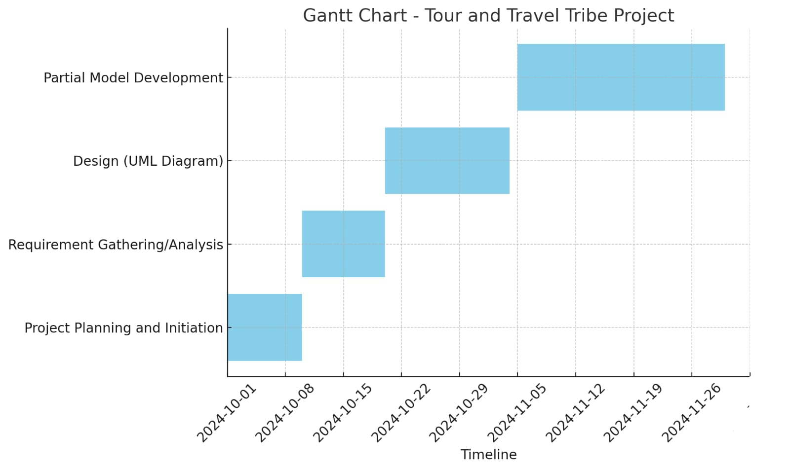

Tools required:
- Hardware Requirements System type: 64-bit, x64-bassed processor.
- Installed memory (RAM):8.00 GB (7.43 GB Usable)
- Total size of Hard disk: 1 TB

Software Requirements:

- Operating system Microsoft windows 11.
- Integrated Development Environment: Intellij
- MySQL Command Line Client
- Programming language: JAVA

Signature of Project Supervisor: _____________________

