NED UNIVERSITY OF ENGINEERING AND TECHNOLOGY

Department of Electrical Engineering Section D


TOPIC:
Computer Hardware Stress Testing and Resource Analysis
SUBJECT:
IT Fundamentals and Applications
COURSE CODE:
EF-101
SUBMITTED TO:
DR. Fezan Rafique
SUBMITTED BY:
Javeria Rukhsar (EE-154)
Rehab Kaleem (EE-155)
Hafsa Hasan Siddique (EE-157)
DATE OF SUBMISSION:
09-November-2026

EF-101 -P04 Report

1. Problem Statement
The primary problem addressed in this project is the lack of practical understanding regarding how computer hardware (CPU, RAM, SSD, GPU) behaves under varying workloads. Users often face system slowdowns or overheating without knowing the root cause. This project bridges the gap between theoretical concepts and real-world behavior by experimenting with hardware stress and analyzing the results.

2. Objectives
· To record and analyze the complete specifications of the test machine.
· To establish an idle baseline of the system.
· To apply distinct stress loads (CPU, RAM, Storage, GPU, Mixed) and monitor the system's response.
· To log hardware metrics using monitoring tools and export them to CSV.
· To visualize the collected data using Excel graphs.
· To identify hardware bottlenecks, thermal behavior, and resource limitations.

3. System Architecture
The system architecture follows a sequential data flow. The physical hardware components (CPU, RAM, SSD, GPU) are managed by the Operating System (Windows 11). Third-party stress and monitoring tools (Prime95, HWiNFO64, CrystalDiskMark) interact with the OS to apply workload and record telemetry. The raw data is logged into CSV files, which are then analyzed using Microsoft Excel to generate trend graphs and comparison charts.
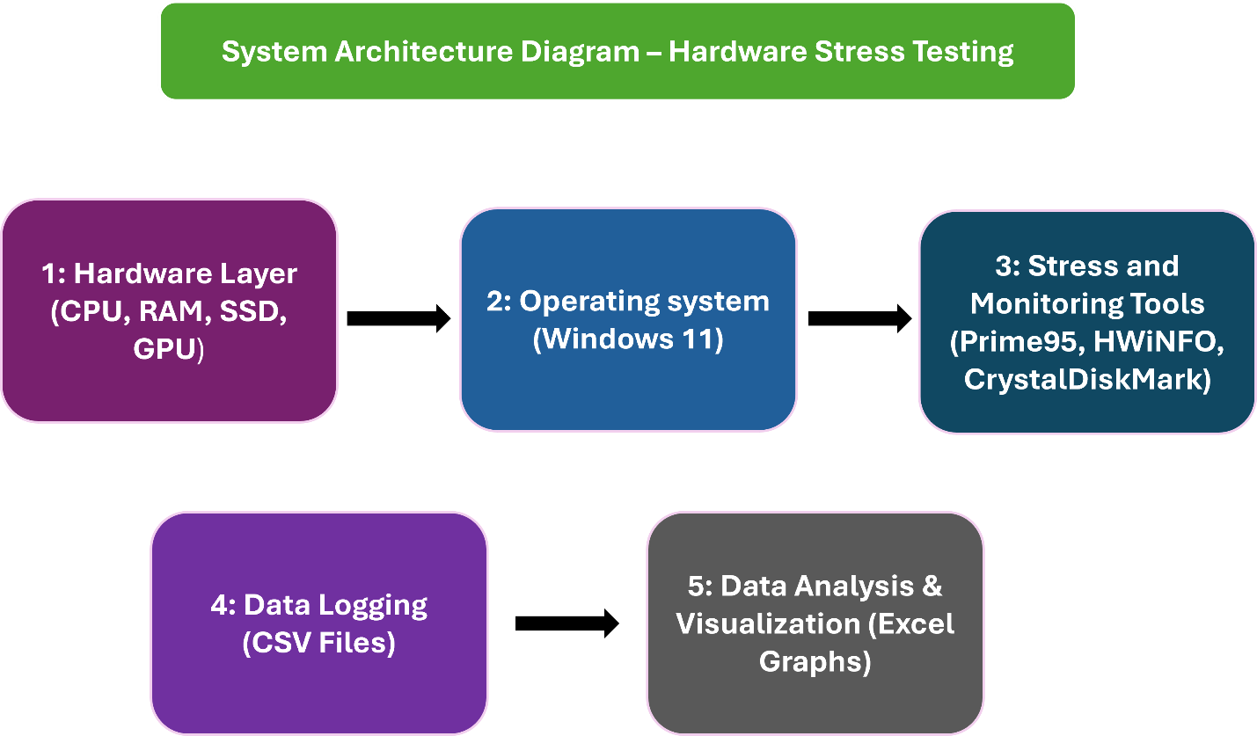

4. Technology Selection
· HWiNFO64: Selected for real-time, accurate hardware monitoring and CSV data logging.
· Prime95: Used for generating maximum CPU and RAM load (Torture Test).
· CrystalDiskMark: Chosen for benchmarking SSD read/write speeds.
· WebGL Aquarium: Used as a safe browser-based GPU stress tool.
· MS Excel: Used for data cleaning, calculations, and graph generation.

5. Data Design
· File Structure: The project is organized into folders (01_specs, 02_logs_raw, 04_graphs, 05_screenshots).
· Dataset Fields: Raw data logs were generated using HWiNFO64 in CSV format. Key variables include Time, Core Max [°C], Physical Memory Load [%], GPU Core Temperature [°C], and Total CPU Usage [%].

6. Implementation / Method
The testing process was divided into six phases, each lasting 5 minutes, logged at a 1-second interval:

1. Idle Baseline: System left untouched after a fresh boot.
2. CPU Stress: Prime95 (Small FFTs) run to maximize CPU heat.
3. RAM Stress: Prime95 (Blend) run to force physical memory near 100%.
4. Storage Stress: CrystalDiskMark executed to test NVMe throughput.
5. GPU Stress: WebGL-based 3D aquarium rendering.
6. Mixed Workload: 1080p video, 15 browser tabs, and Prime95 executed simultaneously.

7. Testing and Results
Phase 1: Idle Baseline
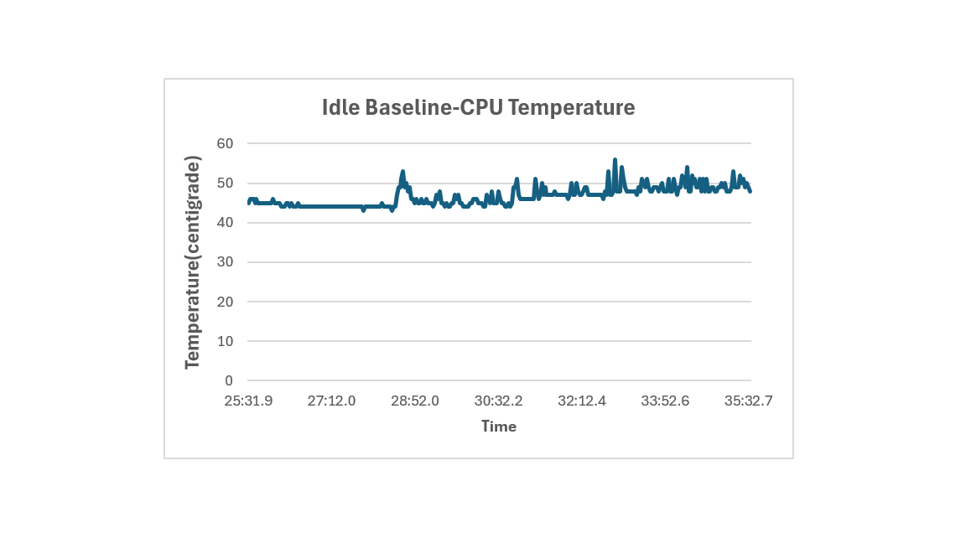The system maintained an average temperature of 46°C with 14% CPU utilization.

Phase 2: CPU Stress
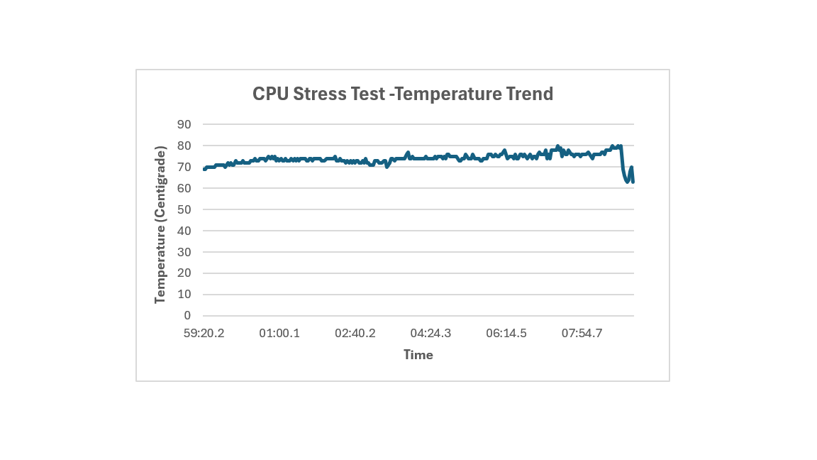CPU utilization hit 100%, with the maximum temperature reaching 77°C. No thermal throttling was observed.

Phase 3: RAM Stress
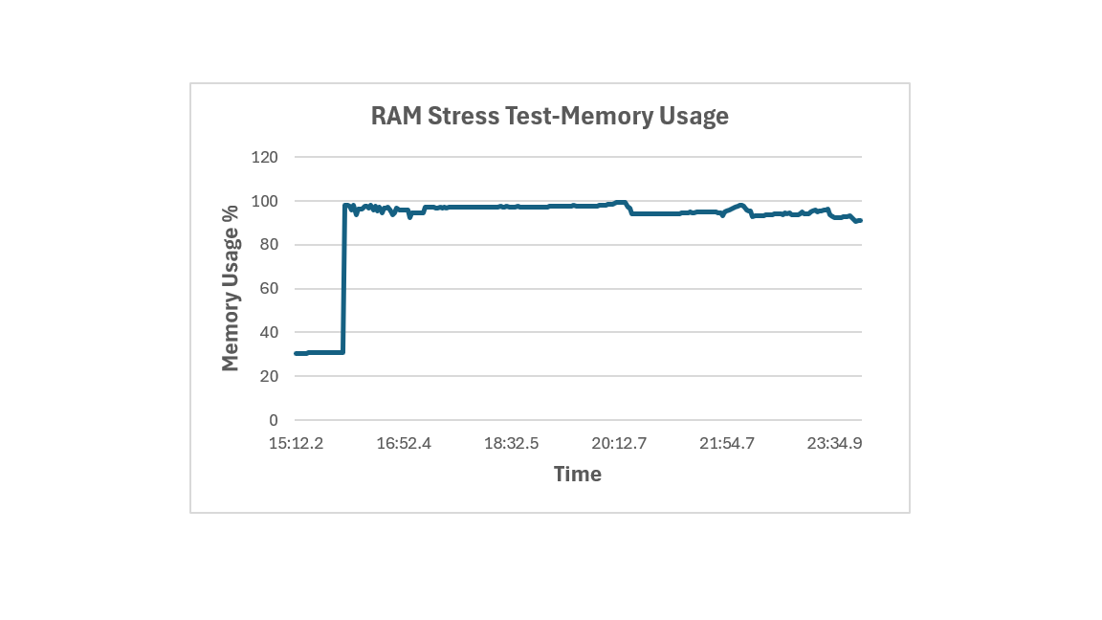
Memory usage peaked at 98.1%, and the system utilized virtual memory (Page File). Max temp was 80°C.

Phase 4: Storage Test
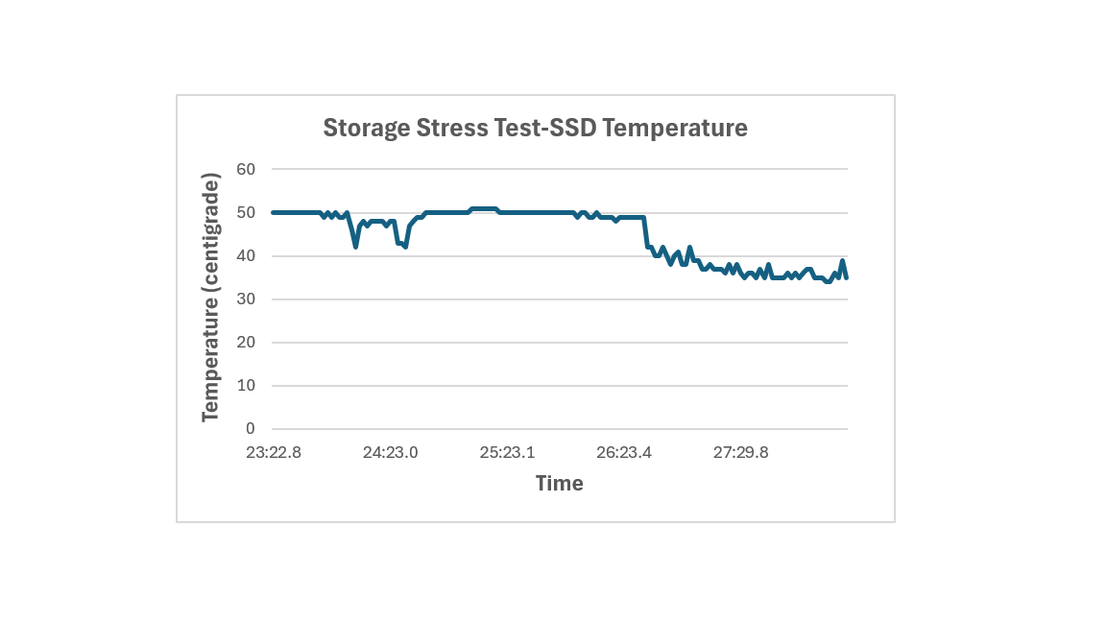
The ADATA NVMe SSD achieved read speeds up to 2403 MB/s and write speeds of 1255 MB/s.

Phase 5: GPU Stress
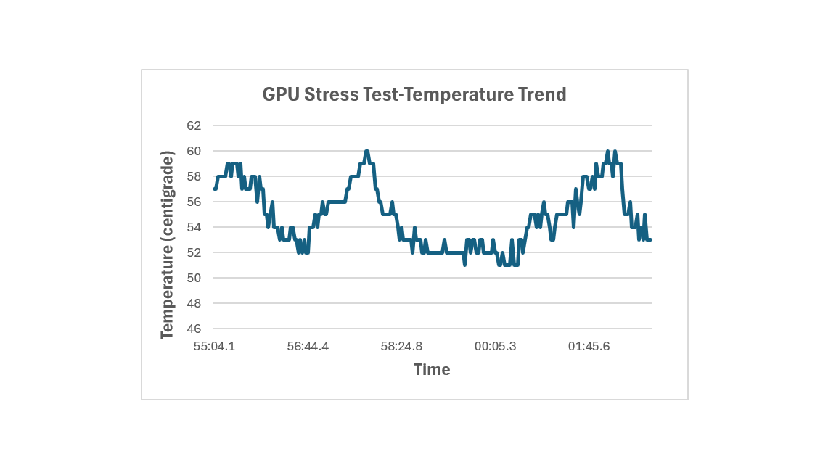
The integrated Intel UHD 620 reached 100% utilization, maintaining a safe temperature of 59°C.

Phase 6: Mixed Workload
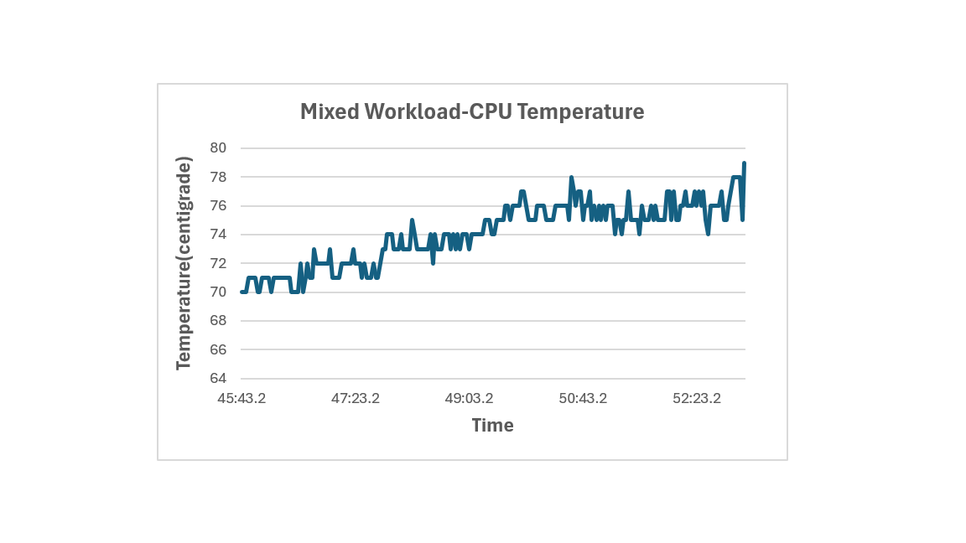The CPU handled multiple tasks, with temperatures stabilizing at 78°C.

Overall Comparison
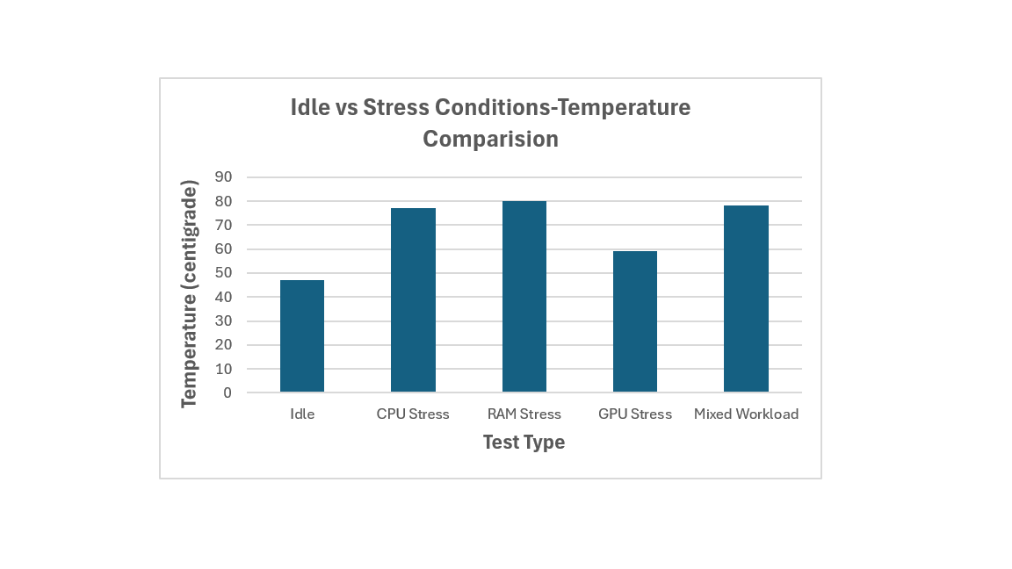The RAM stress test produced the highest temperature (80°C), slightly higher than the mixed workload, due to the CPU dedicating all power to a single task.

8. Detailed Analysis
· Utilization vs Performance: High utilization (100% CPU) does not always mean poor performance. During tests, the system remained stable.
· RAM Pressure: When physical memory reached 98%, the OS used the Page File (Virtual Memory) on the SSD to prevent crashes.
· Thermal Throttling: The HP EliteBook did not throttle during our 5-minute tests.

9. Limitations
· Integrated GPU: The Intel UHD 620 lacks a dedicated temperature sensor, so data was captured via the CPU package sensor.
· Single Machine: Results are specific to this HP EliteBook.

10. AI, Libraries and External Resources
· Tools: HWiNFO64, Prime95, CrystalDiskMark, WebGL Aquarium.
· AI Assistance: ChatGPT was used for troubleshooting tool configurations, guiding data logging, and structuring this report.

11. Individual Contributions
Member Name Contribution
[Javeria Rukhsar] Conducted CPU, RAM, and Storage stress tests, generated Excel graphs.
[Rehab Kaleem] Recorded machine specifications, conducted GPU and Mixed workload tests.
[Hafsa Hasan Siddique] Analyzed data, created the Architecture Diagram, and drafted the report.

