Autonomous AI Job Application Agent
Software Design Document



SUBMITTED BY AHMAD HASSAN
ROLL NO F23BDOC1M1089
SUBMITTED TO Dr. Muhammad Omar

BSCS Computer Science
Session 2023-2027

DEPARTMENT OF COMPUTER SCIENCE
The Islamia University of Bahawalpur
Revision History
Date | Description | Author | Comments
17 Oct 2026 | Version 1.0 (SRS) | Ahmad Hassan | The requirements this design answers
22 Oct 2026 | Version 1.0 (SDD) | Ahmad Hassan | First revision of the design document

Document Approval
The following Software Requirements Specification has been accepted and approved by the following:
Signature | Printed Name | Title | Date
 | Dr. Muhammad Omar | Supervisor, Department of Computer Science
 | Ahmad Hassan | Student, BSCS 2023-2027

ABSTRACT
This Software Design Document describes the design of the Autonomous AI Job Application Agent: a modular-monolith backend with a REST API, a React operator console, a relational database, a vector store and a per-account file tree. It states how the system is decomposed into layers and subsystems, how the parts exchange data, how each significant function runs, and how the design answers the requirements in the Software Requirements Specification.
The document gives the architecture, the data design, the component design, the human interface design with screen images taken from a running instance, and a requirements matrix that traces every functional requirement to the component that satisfies it. The pseudocode in section 5 names the real functions and the real data. Version 1.0 reflects the project on 22 October 2026, after workstream WS-15.
Table of Contents
1 INTRODUCTION 1
1.1 Purpose 1
1.2 Scope 1
1.3 Overview 1
1.4 Reference Material 2
1.5 Definitions and Acronyms 2
2 SYSTEM OVERVIEW 3
3 SYSTEM ARCHITECTURE 4
3.1 Architectural Design 4
3.2 Decomposition Description 6
3.3 Design Rationale 16
4 DATA DESIGN 18
4.1 Data Description 18
4.2 Data Dictionary 21
5 COMPONENT DESIGN 22
5.1 The Job Refresh 22
5.2 The Store-Only Search 23
5.3 The Match Engine 23
5.4 Resume Parsing 24
5.5 Tailoring and Factuality 24
5.6 The ATS Analysis 25
5.7 Rendering the Tailored Document 25
5.8 The Application Workflow 25
5.9 The Form Contract 26
5.10 The Scoped Data Access 27
5.11 Sessions 27
5.12 Retention and the Deletion Cascade 27
5.13 The Domain Allowlist 28
5.14 The Model Client 28
5.15 The Abuse Limits 28
5.16 The Operator Console 29
6 HUMAN INTERFACE DESIGN 31
6.1 Overview of User Interface 31
6.2 Screen Images 32
6.3 Screen Objects and Actions 42
7 REQUIREMENTS MATRIX 43
8 APPENDICES 44
8.1 Appendix A: The API Route Set 44
8.2 Appendix B: The Console's Routes 47
8.3 Appendix C: Where the Design Is Recorded 47

Table of Figures
Figure 1 The layers of the backend and the packages in each 5
Figure 2 The components and the calls they make on one another 6
Figure 3 The domain classes: the candidate, the job and the match 7
Figure 4 The classes the tailoring pipeline produces 8
Figure 5 The classes of the application workflow and of identity 9
Figure 6 The objects that exist at one moment, part way through a run 10
Figure 7 The job refresh, as a sequence 11
Figure 8 The job refresh, as an activity 12
Figure 9 Preparing, approving and submitting an application, as a sequence 13
Figure 10 The tailoring pipeline, as an activity 14
Figure 11 The lifecycle of a tracked application 15
Figure 12 The data flow between the external systems, the processes and the stores 16
Figure 13 The records an account owns 19
Figure 14 The shared corpus and the application lifecycle 20
Figure 15 The layout of the data directory and the per-account storage 21
Figure 16 Who uses the system, and for what 30
Figure 17 The console's screens and the navigation between them 31
Figure 18 The sign-in screen 32
Figure 19 The resume screen: the parsed profile and the document library 33
Figure 20 The matches screen before a search 34
Figure 21 The ranked matches, with the degraded-scoring notice 35
Figure 22 A close-up of the top result: the score, the disclosure and the action 35
Figure 23 A close-up of the parsed profile: the document library, the contact details, the skills and the experience 36
Figure 24 The job detail screen 37
Figure 25 The tailoring screen 38
Figure 26 The approvals screen: the payload a person is asked to approve 39
Figure 27 The tracker 40
Figure 28 The operations screen 41
Figure 29 The console on a narrow screen, where the navigation becomes a drawer 42

INTRODUCTION

Purpose
This Software Design Document describes the architecture and system design of the Autonomous AI Job Application Agent. It states how the system is decomposed, what each part is responsible for, how the parts exchange data, and how the design satisfies the requirements in the Software Requirements Specification, Version 2.0.
It is written for two readers. A maintainer who has to change the system uses it to find the module that owns a behaviour, the data it reads and writes, and the test that holds it in place. The supervisor uses it to check that the design answers every requirement and that the security decisions were made on purpose rather than by accident.

Scope
The document covers the whole system: the Python backend, its relational and vector stores, the browser automation that fills an employer's form, and the React operator console that a person drives. It covers the three flows that carry the product's value: refreshing the job corpus from public job-board APIs, ranking that corpus against a candidate's profile, and preparing, approving and submitting an application.
The design assumes the project goals in the plan: a modular monolith rather than a set of services, deterministic code rather than model reasoning wherever a rule can be written down, and a human approval step before anything irreversible. It does not describe the deployment topology beyond what the code already assumes, and it does not cover the fake applicant tracking system's internal pages, which exist only to exercise the browser layer.

Overview
Section 2 gives the system overview. Section 3 gives the architecture: the layers, the decomposition into subsystems, and the reasoning behind the choices. Section 4 gives the data design, both the relational tables and the files on disk. Section 5 gives the component design, one subsection per significant function, each with the algorithm it runs. Section 6 gives the human interface design, with screen images taken from a running instance. Section 7 gives the requirements matrix, which traces every functional requirement in the specification to the component that satisfies it and the test that proves it. Section 8 gives the appendices.

Reference Material
- Software Requirements Specification, Version 2.0, docs/SRS.docx. Project repository.
- Project plan, docs/PROJECT_PLAN.md. Project repository.
- Architecture document, docs/ARCHITECTURE.md. Project repository.
- Security model, threat model and control register, docs/SECURITY.md. Project repository.
- Implementation roadmap and the fifteen workstream documents, docs/implementation/. Project repository.
- Operator console guide, frontend/README.md. Project repository.
- Operations runbook, docs/RUNBOOK.md. Project repository.
- Evaluation baseline, docs/evaluations/report-2026-10-21.md. Project repository.
- IEEE Std 830-1998, Recommended Practice for Software Requirements Specifications. IEEE.
- Ian Sommerville, Software Engineering, Tenth Edition. Pearson.

Definitions and Acronyms
Term | Definition
Adapter | A module that maps one external source or site to a common interface.
Approval request | The stored record of a prepared application, its payload, and the human decision taken on it.
ATS | Applicant tracking system, the software an employer uses to receive applications.
Bounded | A limit the system enforces rather than assumes, such as a request size, a rate, a queue depth or a daily budget.
Cache miss | A text whose vector is not in the embedding cache. Only a miss costs an embedding.
Corpus | The set of job listings stored in the database.
CSRF | Cross-site request forgery, an attack that makes a browser send a state-changing request it did not intend.
Degraded mode | The state the system enters when a source of truth is unavailable, and it says so in the response.
Eviction | The removal of the listings a refresh has not seen for the longest, so that the corpus cap is a window and not a one-way door.
Factuality report | The record of everything the validator removed from a tailored resume, with the reason for each removal.
Fail closed | The rule that an ambiguous or unproven condition stops the run rather than lets it continue.
Fence | The marker that separates untrusted text inside a prompt from the instructions around it.
Neutral score | The value 70 that a component reports when neither side of the comparison stated the fact. It means unknown, not bad.
Owner scope | The authenticated principal together with the rules that decide which rows that principal may read.
Per-user storage | The directory layout that keeps one account's files under data/users/{account id}/.
Principal | The thing an action is attributed to, recorded as a kind and an identifier.
PII | Personally identifiable information.
Semantic channel | The comparison between the candidate's text vector and a listing's, contributed as one of six match components.
Session | A server-side row that records a signed-in account, so a session can be ended at once.
Store-only search | A search that reads the stored corpus and contacts no job source.
Tenant | One account and everything it owns.
Workstream | A numbered unit of delivery, WS-01 to WS-15, each with its own document.

SYSTEM OVERVIEW
The system is a Python service that turns a candidate's resume into a shortlist of jobs and, with a human's approval, into an application. It has four parts. The operator console is the person's side: a React application in its own package that shows what the agent has read, what it has decided, and what it needs a person to do next. The REST API is the machine's side: a FastAPI application that authenticates the caller, resolves what that caller may read, and hands the work to the domain modules. The domain modules do the actual thinking, and they do it in code: a refresh that collects and normalizes job listings, a matcher that scores them against a profile, a tailorer that writes a job-specific resume and then checks it, and a workflow that prepares an application, waits for a human, submits it and verifies what happened. The stores hold the state: a relational database for everything that belongs to a person, a vector store for the meaning of the job descriptions, and a directory tree for the files.
Two boundaries shape the design. The first is between the system and the web. Job listings and employer application pages are untrusted input. They arrive as data, they are never executed as instructions, and a text taken from them is fenced before it reaches a prompt. The second boundary is between accounts. Every row that belongs to a person carries the account that owns it, and the data layer is the only place that reads such a row, so a route cannot leak another account's data by forgetting a check.
The system reports what it did rather than what it intended to do. A refresh that lost a job board returns the board's name in the report. A search that could not reach the vector store returns a degraded flag and spreads the semantic weight over the other components. An application that could not be verified returns no success. Nothing in the product claims more than it can show.

SYSTEM ARCHITECTURE

Architectural Design
The backend is a modular monolith: one Python package, one process, one relational database. The separation that matters runs between the layers, because the layers have different reasons to change. The presentation layer is the console, the command-line scripts and the scheduler. The interface layer is the HTTP surface, the identity machinery and the workflow orchestration. The domain layer holds the behaviour that the product is actually for, and it is the only layer that knows what a job listing, a candidate profile or a match means. The infrastructure layer holds the things the domain layer asks for: the database, the vector store, the file system, the security controls and the logging.
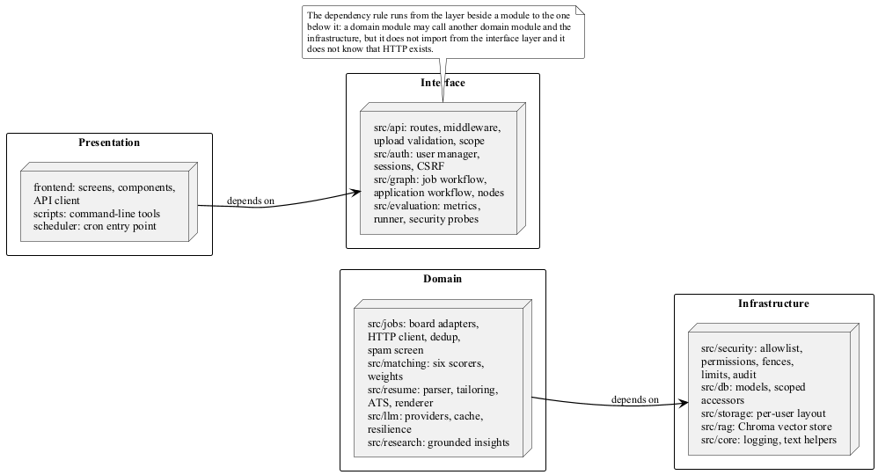
Figure 1 The layers of the backend and the packages in each
The dependency rule runs from a layer to the one beside it. A domain module may call another domain module and the infrastructure, but it may not import from the interface layer, and it may not know that HTTP exists. The interface layer may call the domain layer and the infrastructure layer; it may not contain business rules. The console knows only the API's shapes, and the API's shapes are generated from its OpenAPI description, so a change to a route that the console has not caught up with is a compile error rather than a surprise on screen.
The console is a separate package with its own toolchain. It is not part of the runtime process, and the backend was not restructured to suit it. The boundary between them is the API, and the API is the only thing both sides share.
Figure 2 is the same system drawn as components rather than as layers. Each box is a unit a caller talks to, and each line is a call one component makes on another. The three stores at the bottom hold the state that the whole system shares.
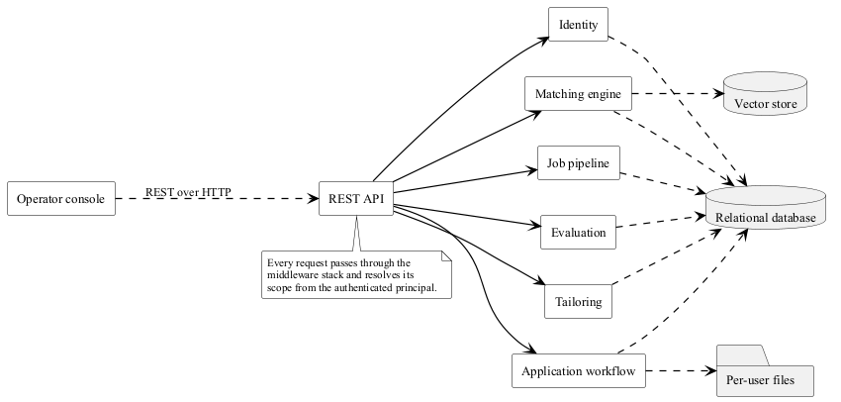
Figure 2 The components and the calls they make on one another

Decomposition Description
The system decomposes into the classes, the objects and the flows below. The class diagrams are the vocabulary the code is written in, the object diagram is one moment in time, and the sequence, activity and state diagrams are the behaviour.
Figure 3 holds the vocabulary of the first half of the product: the candidate, the job, and the match that joins them. The attributes are the fields of the Pydantic models, and the arrows are the composition and the dependency.
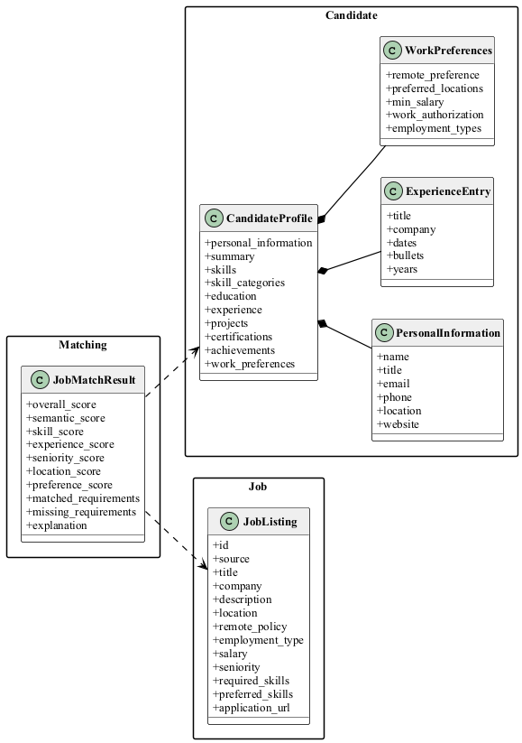
Figure 3 The domain classes: the candidate, the job and the match
Figure 4 holds the classes the tailoring pipeline produces. The factuality report is not a note on the tailored resume; it is the record of everything the validator took out of it, and it is what the console shows beside the resume.
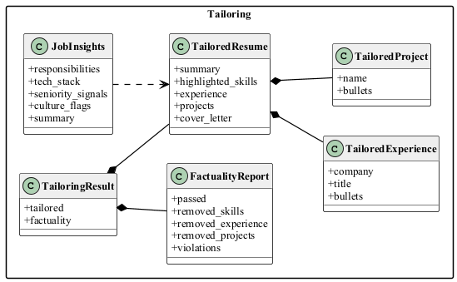
Figure 4 The classes the tailoring pipeline produces
Figure 5 holds the classes of the application workflow and of identity. The approval record is not drawn there, because it is a table rather than a value that travels through the code; it is in the entity-relationship diagram in section 4.
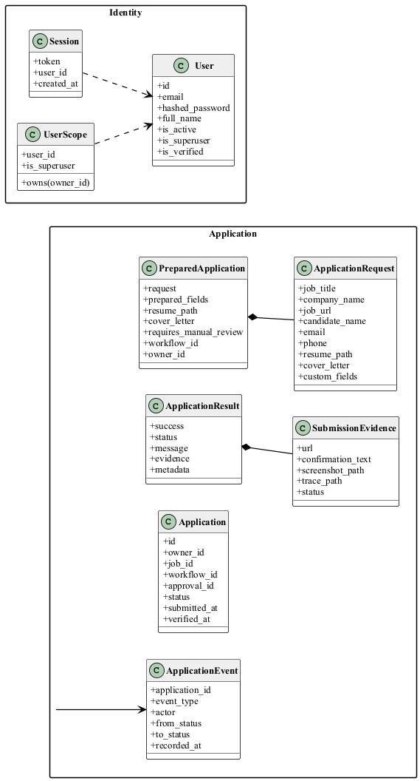
Figure 5 The classes of the application workflow and of identity
Figure 6 is the same vocabulary as a snapshot: one signed-in account, the profile parsed from its resume, a listing from the corpus with the match scored against that profile, a tailoring that was written and then checked, and the approval request waiting for a person. An object diagram shows values rather than types, so it answers the question a class diagram cannot: what the system actually holds at a given moment.
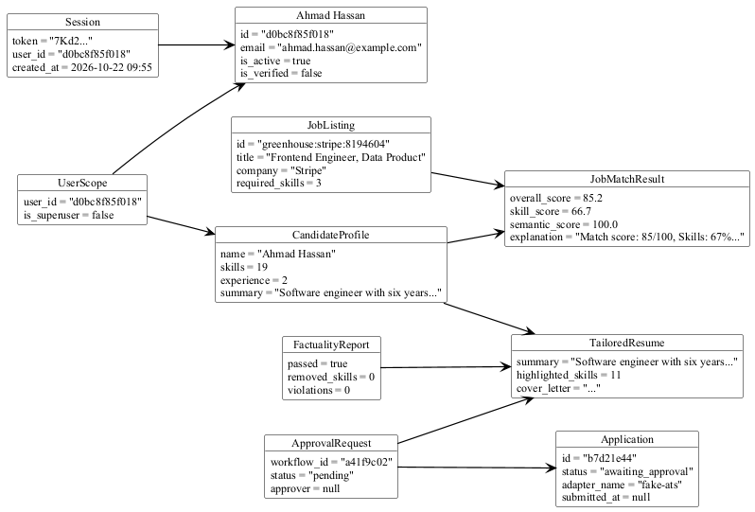
Figure 6 The objects that exist at one moment, part way through a run
The job refresh is the busiest flow. A scheduler or a person asks for it, the executor asks each board for everything it publishes, and the result is filtered, deduplicated, screened for machine-generated text, admitted within the configured limits, stored, and embedded. The embedding step costs money and time, so it only pays for the texts the cache does not already hold, and it stops at a daily budget with a resumable partial result.
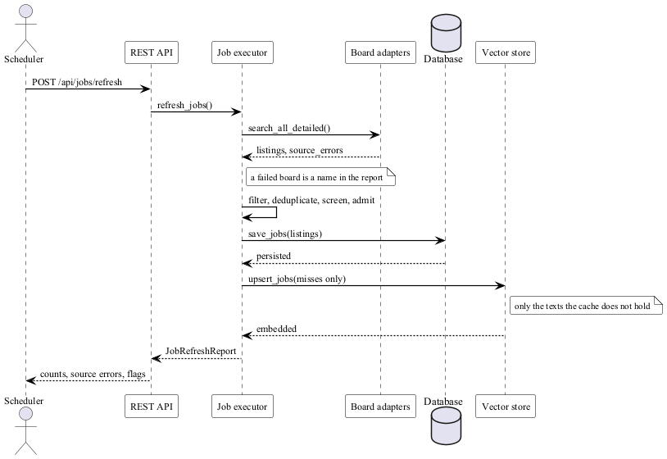
Figure 7 The job refresh, as a sequence
Figure 8 is the same flow as an activity, and it names the two gates that decide what a run costs: the corpus cap, which evicts the listings a refresh has not seen for the longest, and the embedding budget, which counts the texts the cache does not already hold.
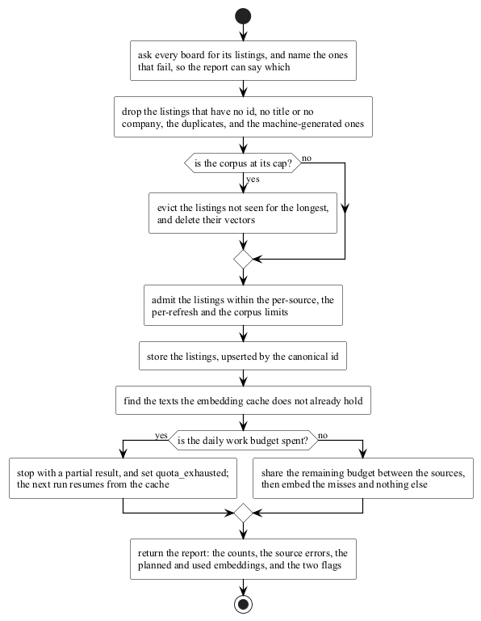
Figure 8 The job refresh, as an activity
The application flow is the one that carries the risk, so it is the one with the most steps. Preparing an application writes down exactly what would be sent and stops. A person reads it and decides. The decision is what the system then executes, which is why the approved payload is stored and submitted rather than rebuilt.
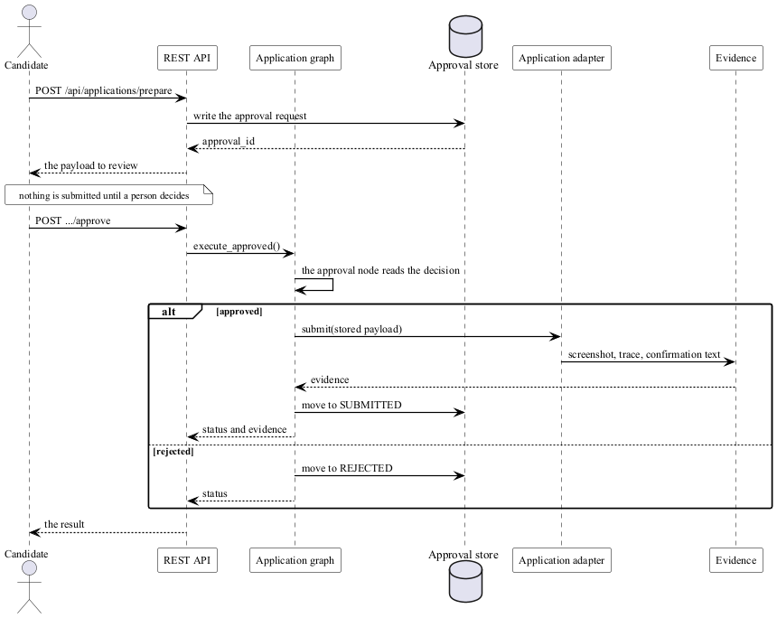
Figure 9 Preparing, approving and submitting an application, as a sequence
Figure 10 is the tailoring pipeline. The model writes the text and the validator decides what may stay. A violation is not an error: the run succeeds with the violation report attached, and the console shows both.
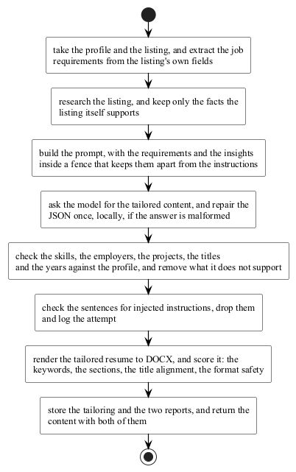
Figure 10 The tailoring pipeline, as an activity
The application workflow is a graph rather than a straight line, because a person and a browser can both go wrong. The approval node fails closed: with no recorded decision the run routes to reject, and it never reaches submit. Figure 11 is the lifecycle of a tracked application, and its transitions are the matrix that the API, the graph and the tests all read.
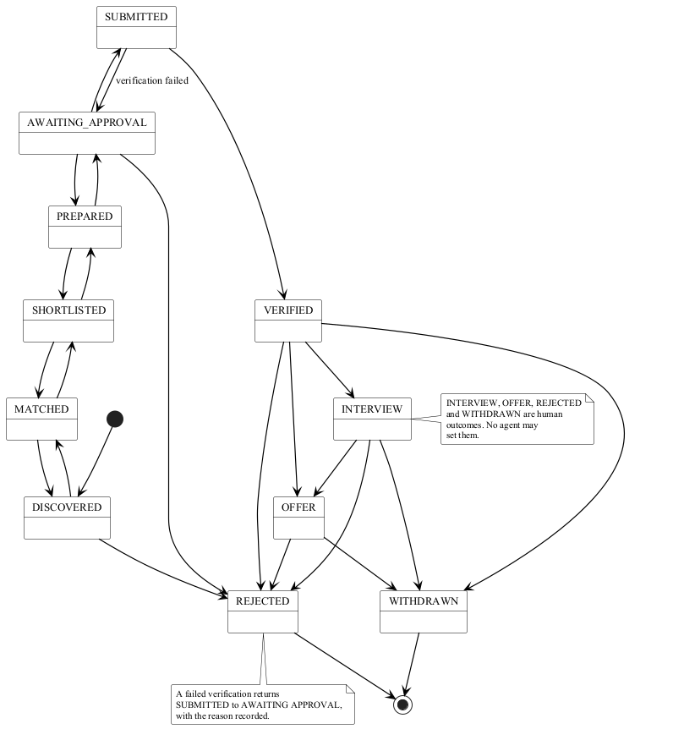
Figure 11 The lifecycle of a tracked application
The data flow in Figure 12 shows the same system from the data's point of view. The candidate supplies a resume; the job boards supply listings; the model provider supplies tailored text; the employer site receives one application. Between them sit the six processes, and two stores hold everything that must survive a restart.
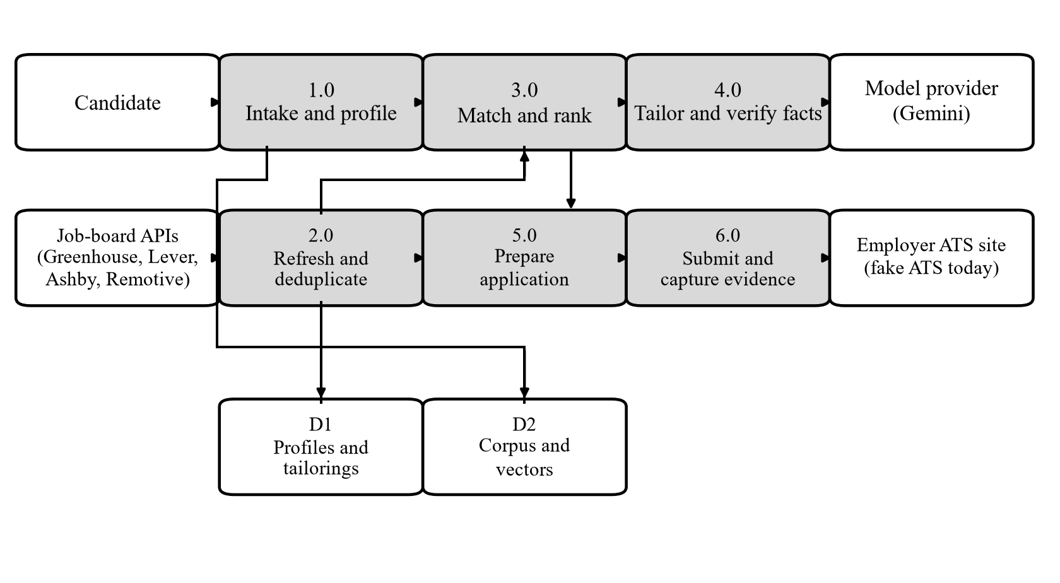
Figure 12 The data flow between the external systems, the processes and the stores
The data the system stores has three shapes. A relational database holds the records that belong to a person and the shared corpus of job listings. A vector store holds the meaning of the job descriptions, keyed by the model that produced it. A directory tree holds the files: the uploaded resumes, the rendered tailored documents, the screenshots and traces that prove a submission happened, and the outbound tokens.

Design Rationale
The plan fixed the architectural style before the code was written, and the code follows it. The project is a modular monolith, and the reasons are worth recording because they decided the shape of everything else.
A set of services was rejected because the work does not need one. The heavy operations are a daily refresh and a search over five thousand listings, and both finish inside a minute on one machine. Splitting the system would add a network hop to every call, a second deployment to keep alive, and a distributed failure mode that the project does not have the resources to diagnose. The one place a second process was wanted, the browser that fills an employer's form, is already a separate process because the browser is a separate program.
Business logic was kept in code rather than in prompts, and this is the decision with the widest consequences. A model is good at writing text and bad at counting, checking and remembering. So the model writes a tailored resume and a deterministic validator then checks every skill, employer, project and year claim against the profile and removes what the profile does not support. The same rule decides the rest of the system: the matcher is six arithmetic scorers, the ATS report is a weighted sum over four components, the form walker answers only questions it can ground in a fact, and the job refresh drops a listing that lacks an id, a title or a company. In each case the model is a source of text and the code is the authority.
A workflow library was adopted for the application flow and left out of the rest. The job search is a straight line of deterministic stages, so it is plain functions. The application flow has state, two branch points, an approval that a person fills in between two calls, and a browser that can fail, so it is a graph. The split follows the rule that the plan set: a graph earns its cost when there is state, branching, retries or a gate, and the application flow has all four while the refresh has none.
The database was chosen for the same reason the architecture was. SQLite is a file, so a student can copy the project directory and the history is with it. PostgreSQL serves a deployment, and both run the same nine Alembic revisions, so the schema does not fork between them.
Authorization was placed in the data layer rather than in the routes, and this is the one decision the live tests forced. A route that queries a user-scoped table directly is a route that has to remember to add a filter, and a mechanical check found five that did not. Moving the filter into the accessor means the route cannot get it wrong, because there is no way to ask for the row without it. The cost is that the scope must be resolved before the query is built, which is why every protected route takes the scope as a dependency and no route reads an account identifier from the request.
A foreign resource answers with 404 and a body identical to a missing one, rather than 403. A 403 tells the caller that the identifier exists and belongs to somebody else, which is an existence oracle over another account's records. The 404 costs a little more work at the call site and removes the oracle entirely.
The local embedding model is the default, and the API provider is the alternative, because the free tier allows twenty embedding requests a day and a refresh of thousands of listings needs more than that. The switch is a setting, and the provider interface is a seam, so the choice can be made per deployment.
The console was kept out of the runtime process. It has its own package, its own tests and its own build. This keeps the backend free of a second toolchain and lets the console be rebuilt and redeployed without touching the service.

DATA DESIGN

Data Description
The information domain splits into four kinds of record, and each is stored the way its own access pattern demands. The shared job corpus is a set of rows that every account may read, so it carries no owner. The candidate's own records, the profiles, the matches, the tailored resumes, the applications, the events, the evidence, the approvals and the audit rows all belong to one account and carry it. The sessions belong to the account that opened them. The vectors are not rows at all; they live in a separate store because they are searched by meaning rather than by key.
Every user-scoped table has the same three columns for the same three reasons. The owner_id column is not null, because a record with no owner cannot be read safely. It is indexed, because the only query that matters is the one that filters by it. And it is set by the accessor rather than by the caller, because a caller that sets it is a caller that can get it wrong. The constraint is enforced in the database as well as in the code, so a row inserted outside the accessor cannot exist without an owner.
The vectors are stored in Chroma, one collection, in cosine space. The model identity and the dimension are saved with the collection, because two embedding spaces cannot be compared, and opening the store with a different model raises an error that explains how to rebuild it rather than returning nonsense similarities.
The embedding cache is a separate SQLite file keyed by a hash of the model, the dimension and the text. It is the reason a second refresh over unchanged listings costs nothing. The cache holds corpus vectors only: a candidate's query vector is computed fresh and never written, because a cache hit on an identical profile would tell a second account that somebody else had submitted the same text.
The relational schema is shown in two figures, because eleven tables with their columns do not fit on one page at a size anyone can read. Figure 13 holds the records an account owns, and Figure 14 holds the shared corpus and the application lifecycle. The key columns are shown; the rest are elided.
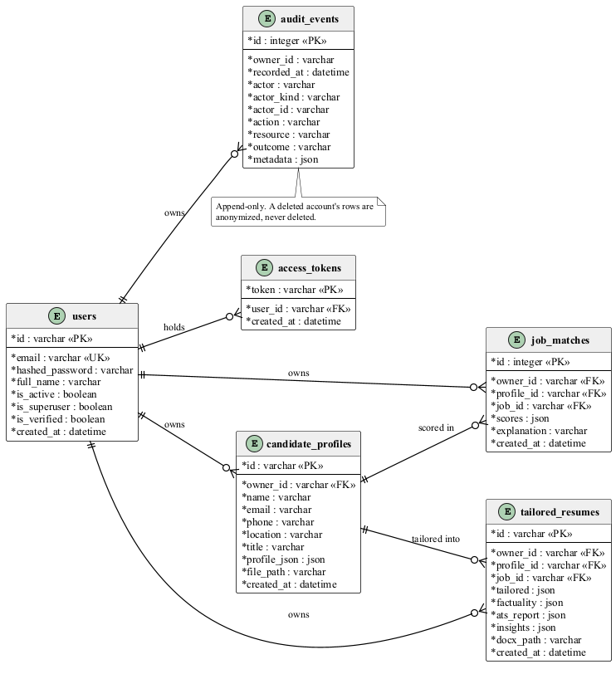
Figure 13 The records an account owns
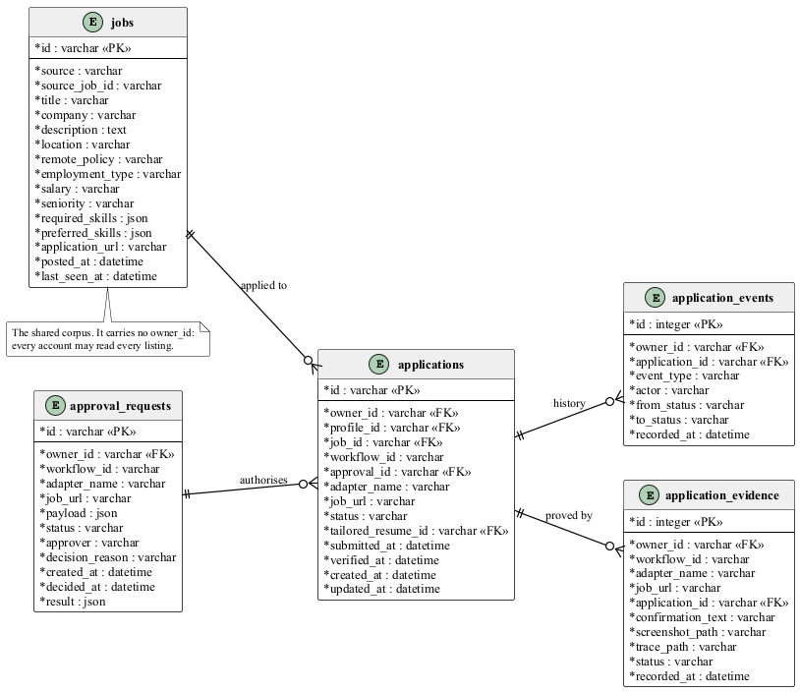
Figure 14 The shared corpus and the application lifecycle
The files follow the accounts. Every account's resumes, tailored documents and evidence live under data/users/{account id}/, and the containment check asks whether the resolved path is inside the caller's own directory. The check runs on the resolved path rather than the path as written, so a name that walks out of the directory is refused after resolution rather than before it.
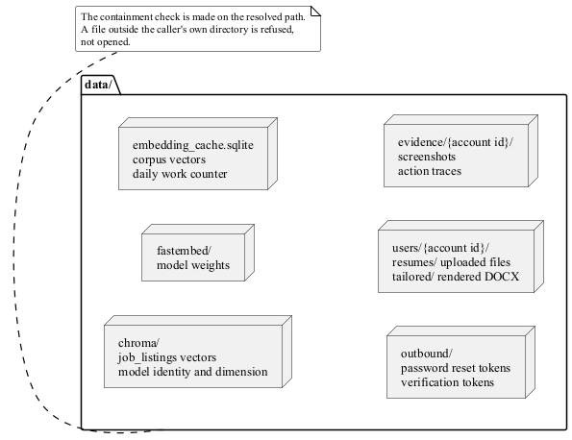
Figure 15 The layout of the data directory and the per-account storage

Data Dictionary
The tables below are the eleven the system uses. The nine migrations that create them are numbered in the order they were written, one per workstream, so each is independently reversible.
Entity | Type | Description
jobs | Relational table | The shared corpus of job listings, one row per canonical identifier. Holds the source, the company's details, the description, the structured skills, the salary, the seniority and the date the listing was last seen. The corpus cap is enforced here, and the last-seen date is what makes eviction possible.
users | Relational table | One account. Holds the e-mail address, the argon2 hash of the password, the display name and the three flags that decide what the account may do.
access_tokens | Relational table | One live session. The token is the primary key and the secret; the account it belongs to is indexed. A session is a row rather than a signed token, so ending it takes effect at once.
candidate_profiles | Relational table | The parsed profile of a resume, owned by the account that uploaded it. The structured profile and the path of the uploaded file are stored together, so the file and the record that describes it age out together.
job_matches | Relational table | One scored match between a profile and a listing. Holds the six component scores, the matched and missing requirements and the explanation.
tailored_resumes | Relational table | One tailoring run. Holds the tailored content, the factuality report, the ATS report, the grounded insights and the path of the rendered document.
approval_requests | Relational table | A prepared application waiting for a decision, or the decision taken. Holds the exact payload that was reviewed, the approver, the reason and the time.
applications | Relational table | One tracked application, with its status, the workflow that produced it and the times it was submitted and verified.
application_events | Relational table | The append-only history of an application. The auto-incrementing identifier is the order; the events are read in append order and never reordered by timestamp.
application_evidence | Relational table | What proves a submission happened: the confirmation text, the screenshot, the action trace and the status, linked to the application.
audit_events | Relational table | One recorded action. Holds the principal that acted, the action, the resource, the outcome and the metadata. The store is append-only, and a deleted account's rows are anonymized rather than removed.

The system also keeps state that is not relational. The Chroma collection holds one vector per corpus listing, with the model identity and dimension as collection metadata. The embedding cache holds the corpus vectors, keyed by a hash, together with a persistent counter of the work done today. The per-account directories hold the uploaded files, the rendered documents, the evidence artifacts and the outbound tokens. The vector store is a separate kind of state because it is queried by similarity and not by key, and the two stores are never allowed to disagree silently: the corpus row and the vector carry the same canonical identifier.

COMPONENT DESIGN
This section takes each significant function in turn and states the algorithm it runs. The pseudocode names the real functions and the real data. Where a function has a decision that matters, the decision is written out; where it does not, the line is left out.

The Job Refresh
The refresh is the one flow that touches every part of the system: the job sources, the normalizer, the deduplicator, the spam screen, the admission control, the database, the vector store and the embedding provider. Its contract is that it never raises. A source that fails, a store that fails or a quota that runs out lowers the report and lets the run finish.
workflow_id <- short random hex
for each registered source:
query <- empty query for that source
listings, source_errors <- search_all_detailed(queries)
# a failing source puts its message in source_errors and the run continues
kept, dropped <- filter listings that have an id, a title and a company
unique <- deduplicate(kept)
unique, spam_verdict <- screen_listings(unique) # drop machine-generated text
if the corpus is at its cap:
evict the listings not seen for the longest, and delete their vectors
admission <- admit_listings(unique, corpus_size) # per-source, per-refresh and corpus caps
unique <- admission.admitted
persisted <- save_jobs(unique) # upsert by the canonical id
# a failure here is logged; the rows stay unpersisted and the run continues
misses <- the listings whose text is NOT in the embedding cache
if the daily work budget is smaller than the misses:
misses <- the first misses that fit; quota_exhausted <- true
misses <- share the remaining budget round-robin between the sources
to_embed <- misses, then the cached listings that still fit
embedded <- store.upsert_jobs(to_embed) # only the misses cost an embedding
return the report: counts, source errors, planned and used embeddings,
quota_exhausted and degraded_embedding
Two properties of this design are worth stating. The budget is denominated in cache misses, not in listings, so a run over unchanged listings costs nothing and a flood at the front of a board cannot starve the listing behind it. And the corpus cap evicts rather than refuses, so a full corpus is a window over the most recent listings instead of a door that closes.

The Store-Only Search
rows <- read the jobs table, bounded by the corpus cap
if a query is given:
keep a job when ANY token of the query appears in its title or description
if a location is given:
keep a job when the location is a substring of its location
store <- open the vector store, or none
if there is a store:
similarities <- store.similarities_for_all(candidate_query_text(profile))
degraded <- true when some job has no vector
else:
degraded <- true when there is at least one job
for each job:
match <- calculate_match(job, profile, semantic_score = similarities.get(job.id))
rank the matches by the overall score, descending
return the top top_n matches, the counts and the degraded flag
The search never contacts a job source, which is why it has no source errors and no network failure path. A listing with no vector is scored with the semantic weight spread over the other five components, and the report says the scoring was degraded.

The Match Engine
weights <- validate_weights(weights or the configured weights)
# rejects an unknown component, a missing one, a non-positive one, or a
# total outside 1.0 +/- 0.01
if semantic_score is none:
weights <- redistribute the semantic weight over the other five
semantic <- 0; note 'degraded mode'
skill <- (required hits + 0.5 * preferred hits) / (required + 0.5 * preferred) * 100
# a job that states no skills scores 70: unknown, not bad
experience <- 100 - 25 for each year the candidate is short of
seniority <- 100 - 30 for each level between the job and the candidate
location <- 100 for a remote job or a preferred place;
25 when the job is on-site and the candidate wants otherwise;
70 when the candidate stated nothing
preference <- the mean of the employment-type and salary subscores, or 70
overall <- the weighted sum of the six components, clamped to 0..100
return the six scores, the matched and missing requirements, and the explanation
The engine never touches the vector store. The semantic score arrives as an argument, which keeps the arithmetic testable without a model and keeps the engine from depending on a store. The explanation is built from the same numbers as the score, so a reader can check the arithmetic by reading the sentence.

Resume Parsing
if the suffix is .docx: read the paragraphs and mark the list-styled ones
if the suffix is .txt or .md: read the lines and mark the ones that start with a bullet
otherwise: raise, the format is not supported
split the lines into a header and the sections
# a heading is a known heading and is NOT a bullet; a bullet that looks
# like a heading is content
skills, categories <- read the skills section; a 'Category: a, b, c' row splits
name, title, email, phone, location, website <- read the header
education, experience, projects <- read their sections
# a bullet under a section belongs to the entry above it
preferences <- read the work preferences
# labelled lines first, then phrases in the summary; the earliest phrase wins
return the profile
The parser never invents a value. A section that is missing yields an empty field and a deterministic warning, and the preferences are recorded only when the document actually states them.

Tailoring and Factuality
draft <- generate_structured(build_prompt(profile, job, insights), TailoredResume)
# the requirements and the insights go inside a fence; the profile copy
# that leaves the process has no e-mail, phone or website
removed_skills <- the draft skills the profile does not support
for each drafted experience entry:
if the company is not in the profile: drop the entry and record it
else if the title is not in the profile: blank the title and record it
for each bullet:
drop a sentence that claims more years than the profile shows
drop a sentence that carries an injected instruction
for each drafted project:
if the name is not in the profile: drop the project and record it
for each bullet: the same two removals
the summary and the cover letter: the same two removals
return the cleaned content and the factuality report
The report lists every removal and its reason, and the run still succeeds: a factuality violation is content, not an error. The two removals are separate on purpose. A claim about years is a fact that contradicts the profile, so the sentence goes. An injected instruction is an attack, so the sentence goes and the attempt is logged. The title check is an exact comparison while the company check accepts containment, because "Senior Staff Engineer" contains "Engineer" and a company name is often a suffix of another.

The ATS Analysis
coverage <- the required and preferred keywords the tailored text contains
# a keyword counts when EVERY content token of it is present
sections <- contact, summary, skills, experience and education; each present or not
alignment <- the overlap between the job title and the candidate's titles
risks <- inspect the rendered document: tables, text boxes, images,
missing standard headings, empty sections, too many fonts, no contact line
keyword_score <- 0.45 * coverage, where a required keyword weighs 1.0
and a preferred one weighs 0.5
section_score <- 0.20 * the proportion of the five sections that are present
alignment <- 0.20 * the title overlap
format_score <- 0.15 * (100 - 20 for each risk found)
score <- the weighted sum, clamped to 0..100
return the score, the four components, the risks and the notes
No model is involved. The report is a pure function of the tailored content, the profile, the listing and the rendered file, so two runs over the same inputs give the same number. A keyword that the profile does not support is reported as a note and is never inserted into the resume.

Rendering the Tailored Document
create a document
write the name as a title and the job title as a subtitle, when they exist
write the contact line, when any part of it exists
for each section that has content:
write the standard heading, then the content
# the headings are the ones the parser recognises, so the file reads
# back into the same facts
a skill line lists only the skills that are in BOTH the tailored content
and the profile
an experience line is 'Title | Company | Dates', the dates taken from the profile
save to out_path and return it
The renderer omits a field it does not have rather than completing it, and the file name is built from the profile and job identifiers, sanitized, with a hash appended when the sanitizing changed the identifier so that two identifiers cannot collide.

The Application Workflow
The workflow has five nodes. The two branch points between them are where a person and a browser get a say.
if the state already holds a prepared application: return it unchanged
prepared <- adapter.prepare(request)
store the prepared application and return the state
on an exception: record the error in the state and re-raise
approved <- (state.approval_status IS True)
return 'submit' if approved else 'reject'
# the test is identity with True, so None and False both reject
if the state holds an error: return 'end'
if there is no submission result: return 'end'
if the submission did not succeed: return 'end'
# a submission that failed has a reason of its own; verifying it would
# flatten the reason into a generic failure
return 'verify'
if there is no prepared application: raise
if the adapter is not registered for submit:
return a result with status 'permission_denied' and stop
# a refusal is a result, not an exception
result <- adapter.submit(prepared)
write the evidence row: confirmation text, screenshot, trace, status
# a failure to write the evidence is logged, and the submission still counts
if the result succeeded: move the application to SUBMITTED
append an event to the application's history
return the state
The verify node mirrors the submit node. It checks the permission, calls the adapter, and then downgrades the result to verification_failed when an artifact is missing. On success it moves the application to VERIFIED; on failure it moves it back to AWAITING_APPROVAL and records why.

The Form Contract
The browser layer finds the fields on the page and asks a pure contract what to put in them. The contract is free of the browser, which is what makes it testable.
normalize the label: collapse the space, strip the trailing '?' ':' '*', lower-case
if the exact label is in the field map: return its fact key
matches <- the mapped keys of at least 8 characters that the label contains
if there are no matches: return none
keep only the longest match; if two share the length: return none
# a tie is unknown, because a wrong answer cannot be recovered and an
# unknown question can be asked
key <- lookup_fact_key(question.label)
if there is no key: return none
value <- the first non-empty fact for that key, in the order the fact sources list
if the control is a select or a radio:
return the option that matches the value, or none
# choosing a different option would be a fabrication
if the control is a checkbox: return the value, or none when the token is neither
# true nor false
return the value
for each control on the page:
value <- answer_question(question, profile)
if the value is not none:
classification <- 'known'; record the answer
else if the label maps to no fact key:
classification <- 'unknown'; add it to the unresolved list
else if the field is required:
classification <- 'mappable'; add it to the unresolved list
else:
classification <- 'mappable'; add it to the skipped list
return the plan
A required field the system cannot ground is a question for a human, not a guess. The plan therefore separates the fields it answered from the fields it skipped and the fields it must ask about, and the browser layer stops on the last group with the status needs_human.

The Scoped Data Access
def _owned(statement, model, scope):
if scope.is_superuser:
return statement
return statement.where(model.owner_id == scope.user_id)
This is the whole authorization mechanism. An accessor builds its statement, passes it through the filter, and executes the result. The row is never materialized without the owner predicate, so a route cannot ask for another account's row even by accident. A row that belongs to somebody else comes back as nothing, and the route turns that into a 404 with a body identical to the one a missing row produces.
The scope comes from the authenticated principal. No route reads an account identifier from a body, a header, a query parameter or a path, so there is no value for a caller to change.

Sessions
token_from_request(request):
the session cookie first, then the Authorization: Bearer header
list_sessions(db, user_id):
the account's sessions, newest first; the route returns only the first
eight characters of each token
revoke_session(db, user_id, token):
delete where the token AND the account match; the account is part of the
filter so a caller can only end its own sessions
return whether a row went; the route turns false into 404
revoke_other_sessions(db, user_id, keep_token):
delete every session except the one the request is using
# this is what a password change does

Retention and the Deletion Cascade
for each kind of record, from the child to the parent:
find the rows older than the window for that kind
delete the files they point at
delete the rows
# the order matters: the evidence goes before the applications, the events
# before the applications, the applications before the profiles
if anything was removed: write an audit row naming the counts
delete the evidence, the events, the approvals, the applications, the tailored
documents, the profiles, the matches and the sessions, removing each file
anonymize the audit rows: the owner, the actor and the resource lose the
identity, and the action, the outcome and the time stay
delete the account row
remove the account's directory
write an audit row naming the counts
The purge is idempotent: every step deletes the rows that are still there and anonymizes the rows that are not anonymized yet, so running it twice changes nothing the second time. The audit rows are the deliberate exception, because a trail that can be rewritten is not a trail.

The Domain Allowlist
allow_local <- the environment is development
if the url is empty: raise
if the scheme is not http or https: raise
if there is no hostname: raise
if the host is a local address:
if allow_local: return
else: raise
if the host is an internal or metadata address: raise
if the host is not on the allowlist: raise
The match is exact or a sub-domain, so a host such as evil-greenhouse.io.attacker.com does not match greenhouse.io. An empty configuration means nothing is allowed. The only escape is the local host, and the environment decides whether it is granted, so a production deployment can never submit to a loopback address. The check is literal and does not resolve the name; resolving it is the HTTP client's job.

The Model Client
acquire a slot in the sliding-window limiter # it sleeps, it never refuses
call the provider with the request's timeout and temperature
on a rate-limit or availability error:
if the attempts are spent: raise
wait 1.0-1.5 seconds, then 4.0-4.5 seconds, and try again
# a daily quota is never retried; a daily budget does not reset in seconds
on success: record the token counts and the duration
on failure: record the error type and the duration
# the record holds counts only, never the prompt, the answer or the key
The temperature reaches the provider on every call, and both the client's retry layer and the SDK's own retry layer are switched off. The live run that found this was worth recording: the SDK honoured a Retry-After header of 50951 seconds and slept for fourteen hours inside a sixty-second timeout. The structured-output path validates the answer against the schema and, if it fails, repairs the JSON locally once, without spending another call.

The Abuse Limits
Five limits bound what one caller can cost the system, and each answers with a status that says what to do next.
Limit | Default | Refusal
Request body | 8 MiB | 413, whether or not the body declares its length
Requests per minute per address | 60 | 429, with a Retry-After header
Requests in flight | 64 | 503, after waiting five seconds for a slot
Heavy routes at once | 2 | 503, refused at once with no wait
Custom form fields per request | 50, and 2,000 characters each | 400

The heavy routes are the refresh, the search, the tailoring and the approval, because those are the ones that cost a browser, a model or a board. The rate limiter keys on the transport peer address and ignores any forwarded header, because a limit keyed on data the caller supplies is not a limit. The bucket table is bounded and evicts its least recently used entry.

The Operator Console
The console is a React application with a typed API client. The types are generated from the running API's OpenAPI description, so a route that changes shape breaks the console's build rather than its screen. There is one function per route in the client, and each carries a client-side timeout chosen from what the backend actually does: fifteen seconds for a search, two minutes for a tailoring run, five for a refresh.
Figure 16 is the console as the people who use it see it: the candidate, the scheduler that runs the refresh, and the maintainer who runs it by hand.
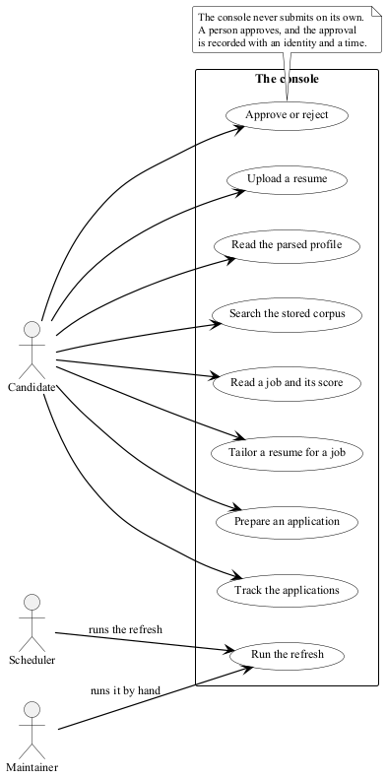
Figure 16 Who uses the system, and for what
Figure 17 is the console's screen map. The shell is the only place the navigation exists, so on a narrow screen the bar becomes a drawer and the two are never both in the document.
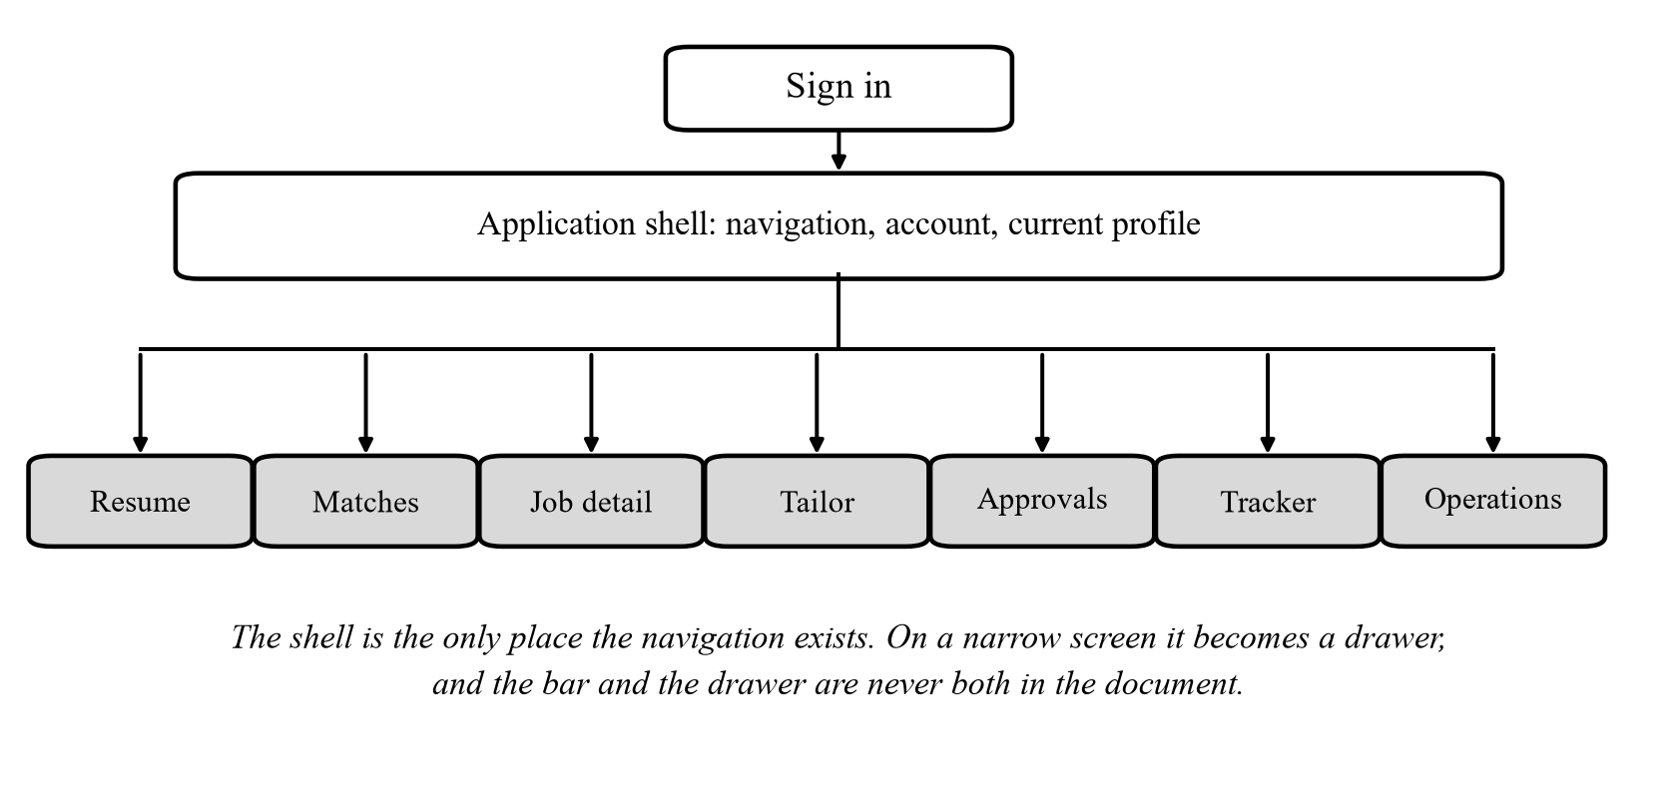
Figure 17 The console's screens and the navigation between them
The console holds no credential. It sends the session cookie the browser already has, and it echoes the CSRF cookie in a header on every unsafe request. It never updates a screen before the server has answered, so an approval that failed is never shown as approved. It renders backend text as plain text, and the lint rules forbid the routes that would not.

HUMAN INTERFACE DESIGN

Overview of User Interface
The console is the whole human interface. It has seven screens, and every one of them exists to answer a question a person asks: what did the agent read, what did it find, what does it want from me, and what happened to my applications.
- Sign in. The console asks the server who the caller is, and shows this screen when the answer is no.
- Resume. The uploaded resume, the document library, and the parsed profile section by section, including the parts the agent could not read.
- Matches. The filters, the ranked results with the six component scores, and the explanation behind each score.
- Job detail. One listing in full, with what the agent made of it and a way to tailor a resume for it.
- Tailor. The job, the document to tailor, and the result: the tailored content, the factuality report and the ATS report.
- Approvals. The applications waiting for a decision, the exact payload that would be sent, and the approve and reject actions.
- Tracker. Every application, its status, and the ordered history of what happened to it.
- Operations. The refresh, and the report that says exactly what it found, stored and embedded.
Two rules run through every screen. The console never shows a success the server did not return, and it never shows a status without saying what a person must do next: an application awaiting approval says so, an interview says who to prepare for. The colours follow the same rule. Lime marks what the agent did; clay marks what a person did.

Screen Images
The images below were captured from a running instance of the system: the backend on its own port, the console's development server, a real account and a real corpus of 5,855 listings.
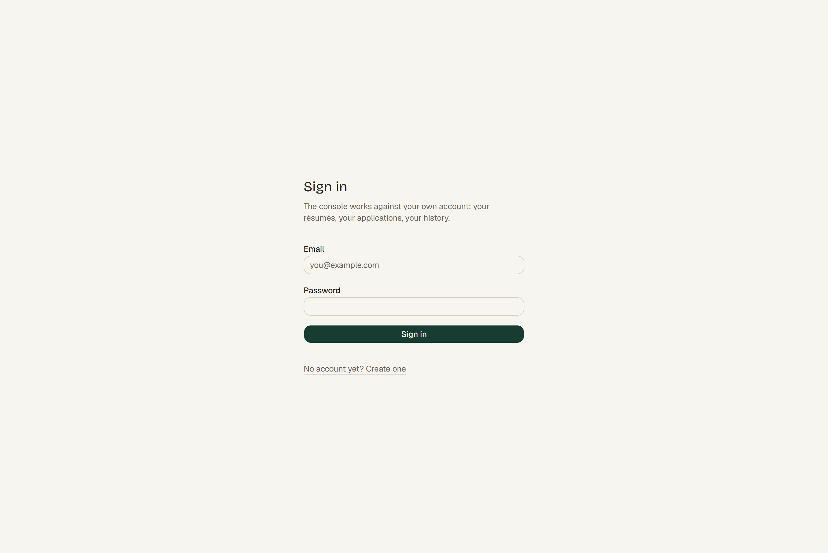
Figure 18 The sign-in screen
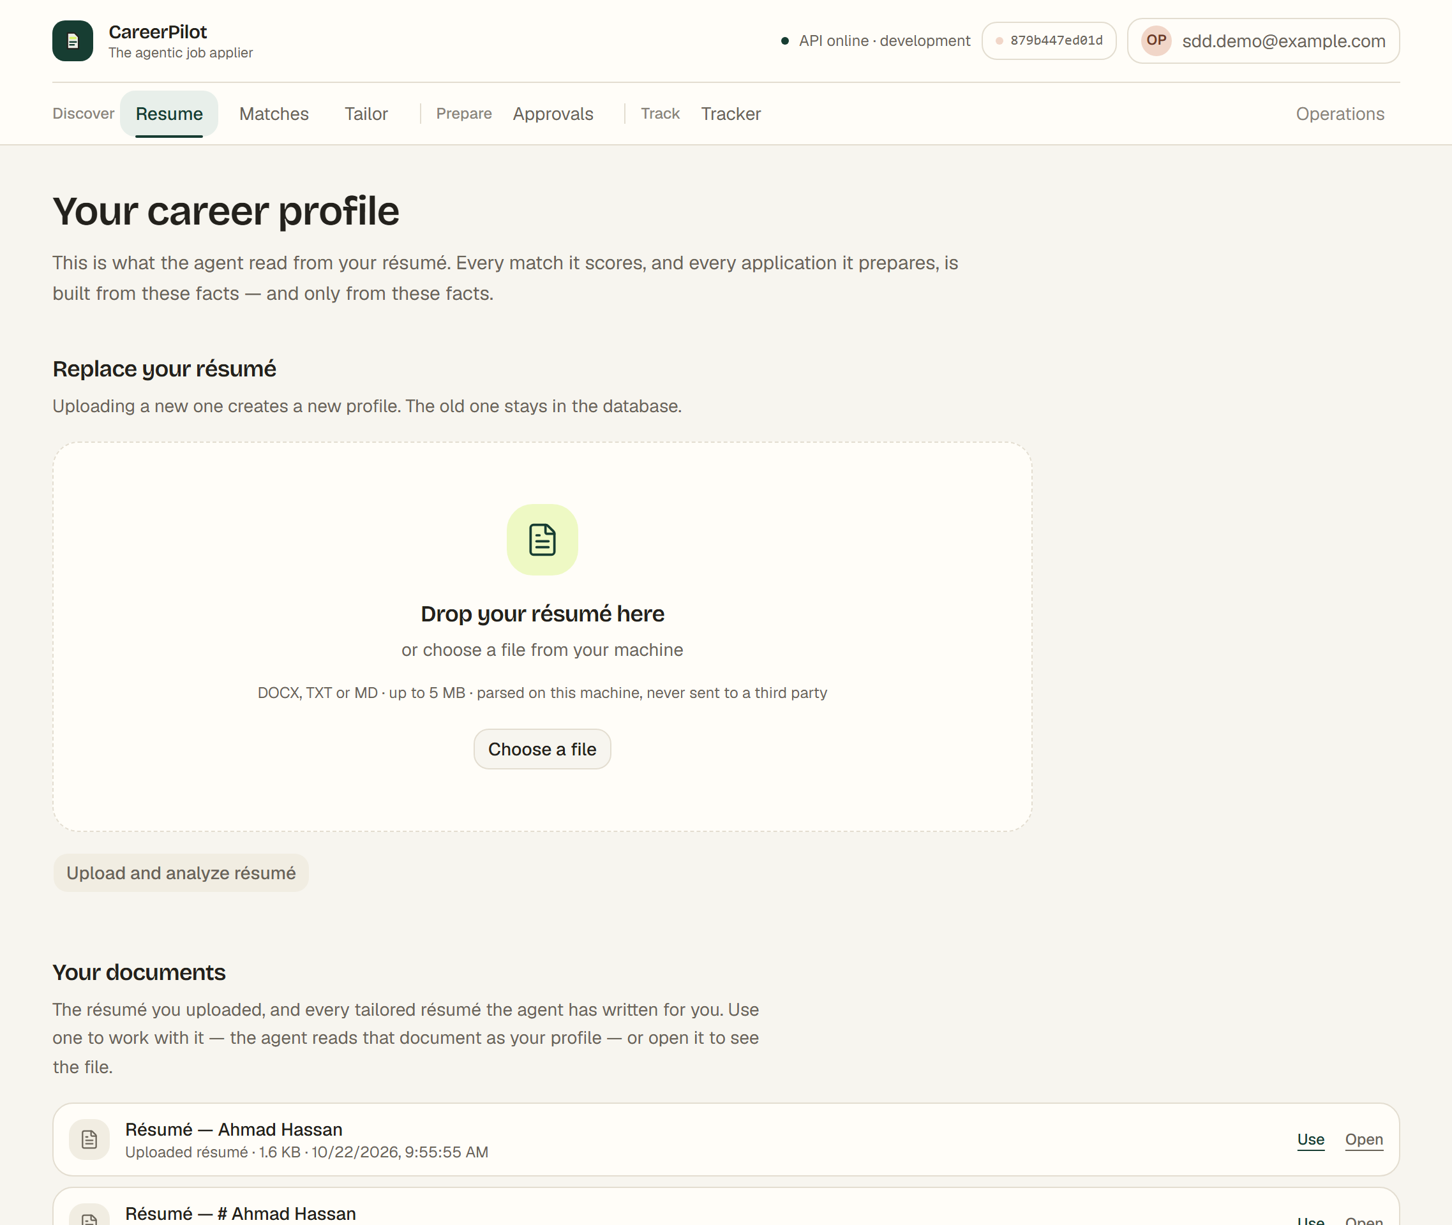
Figure 19 The resume screen: the parsed profile and the document library
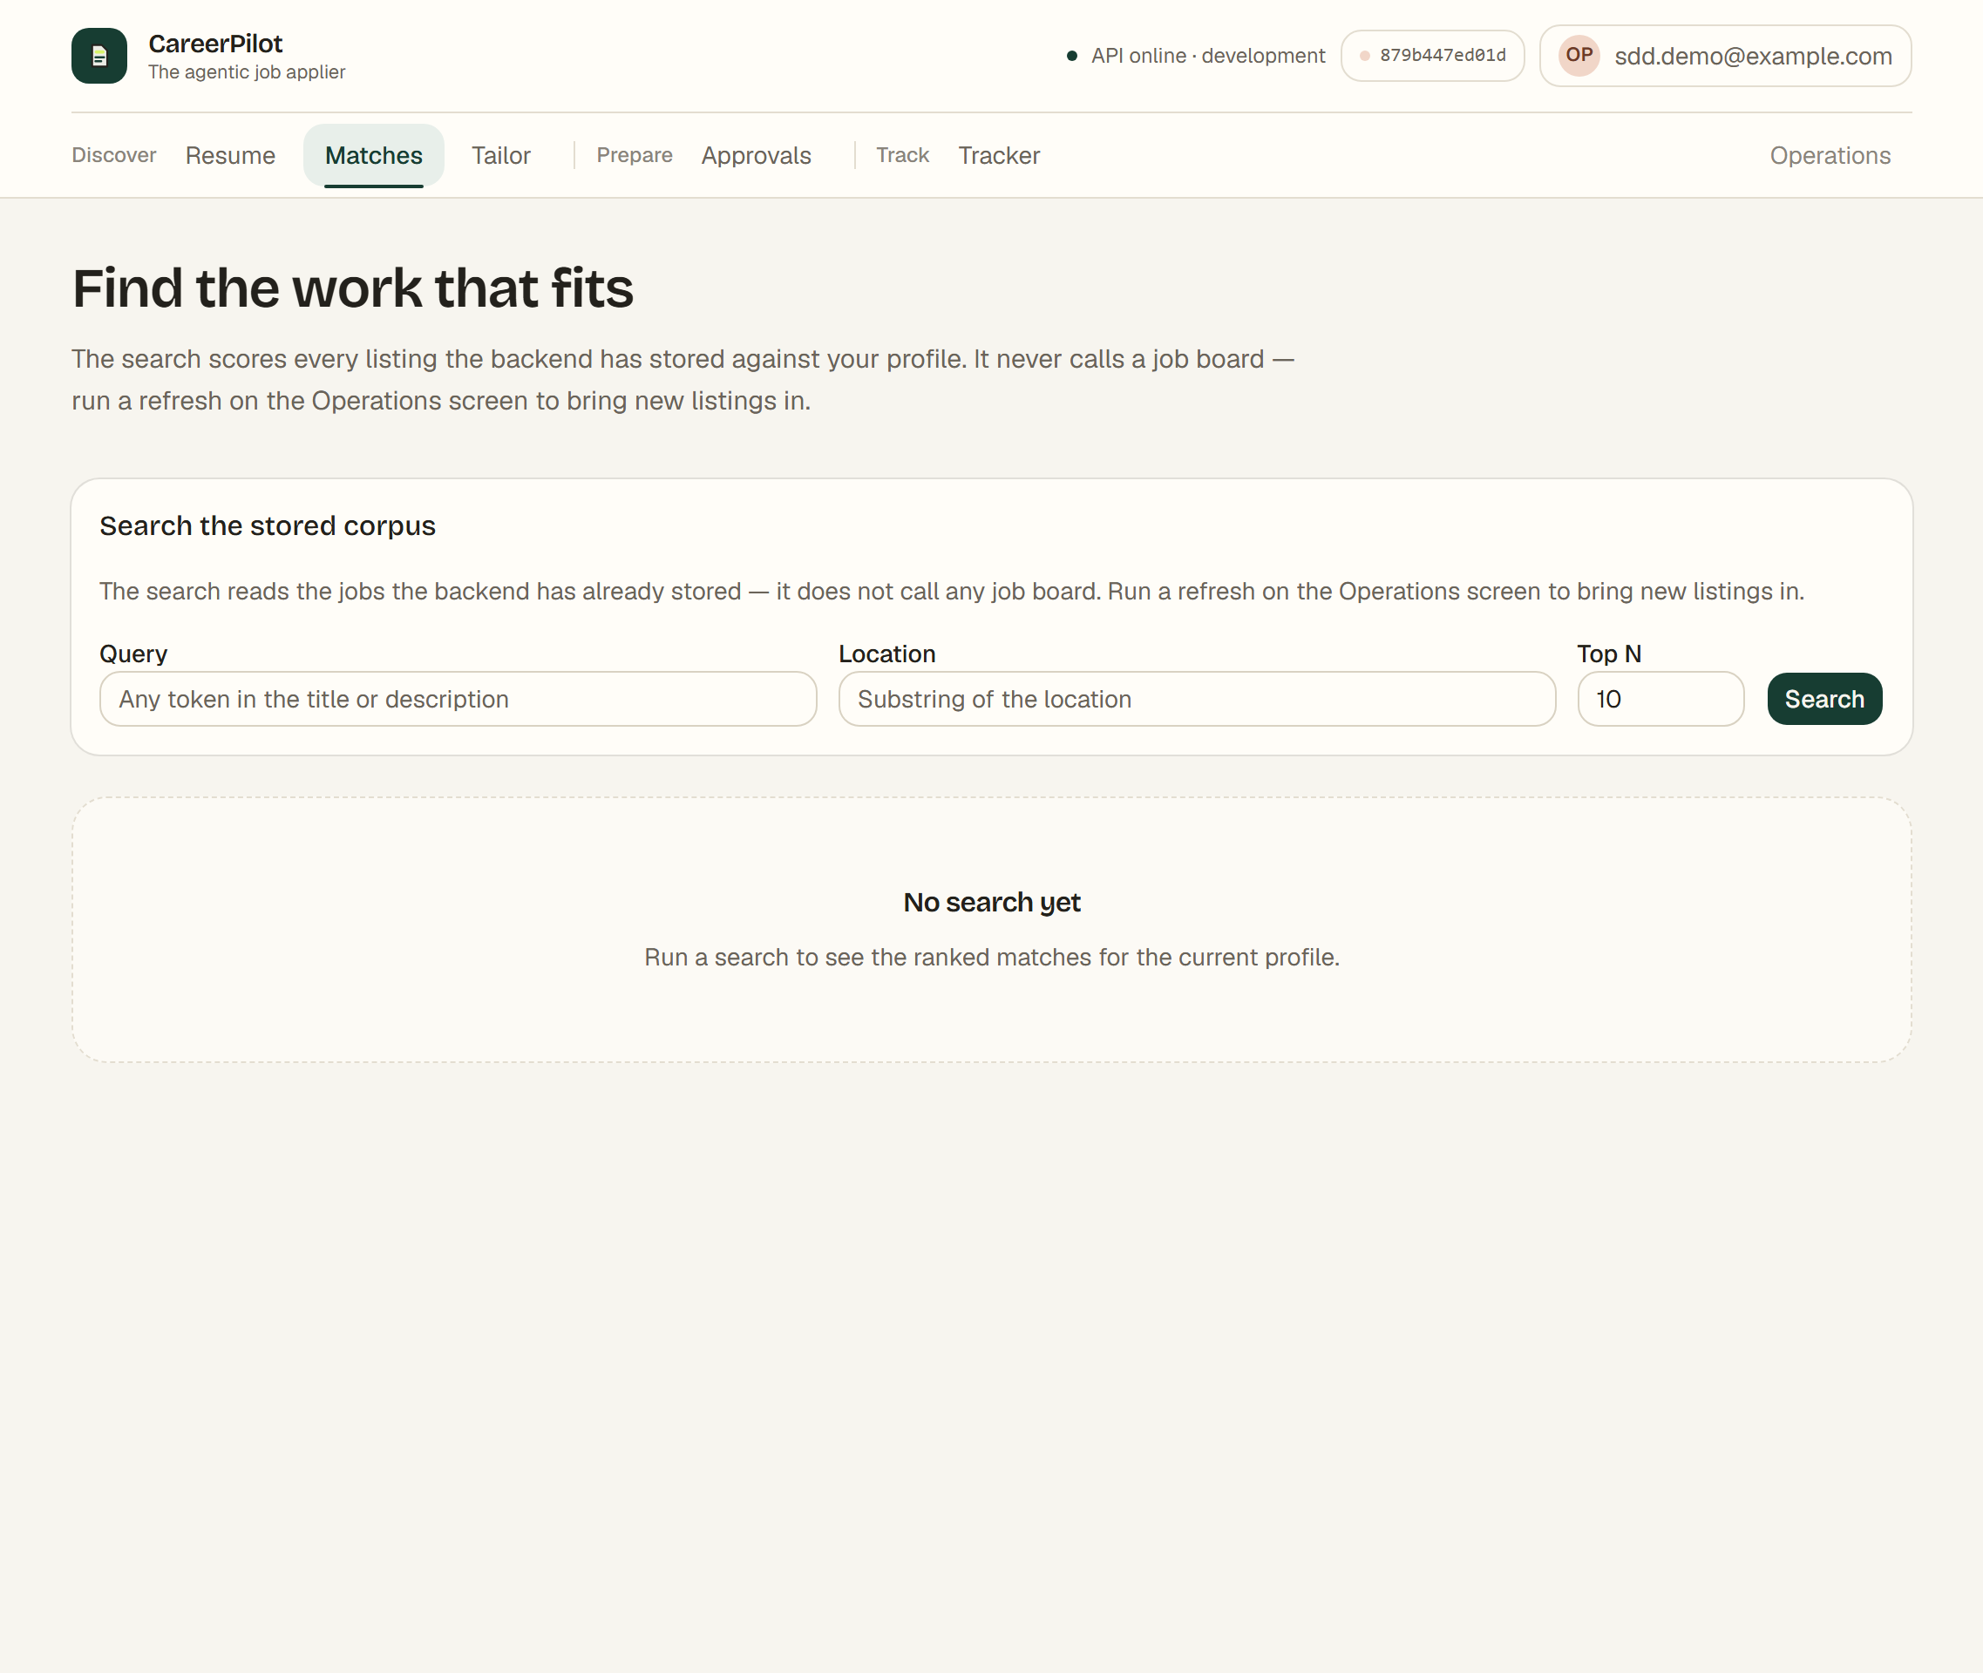
Figure 20 The matches screen before a search
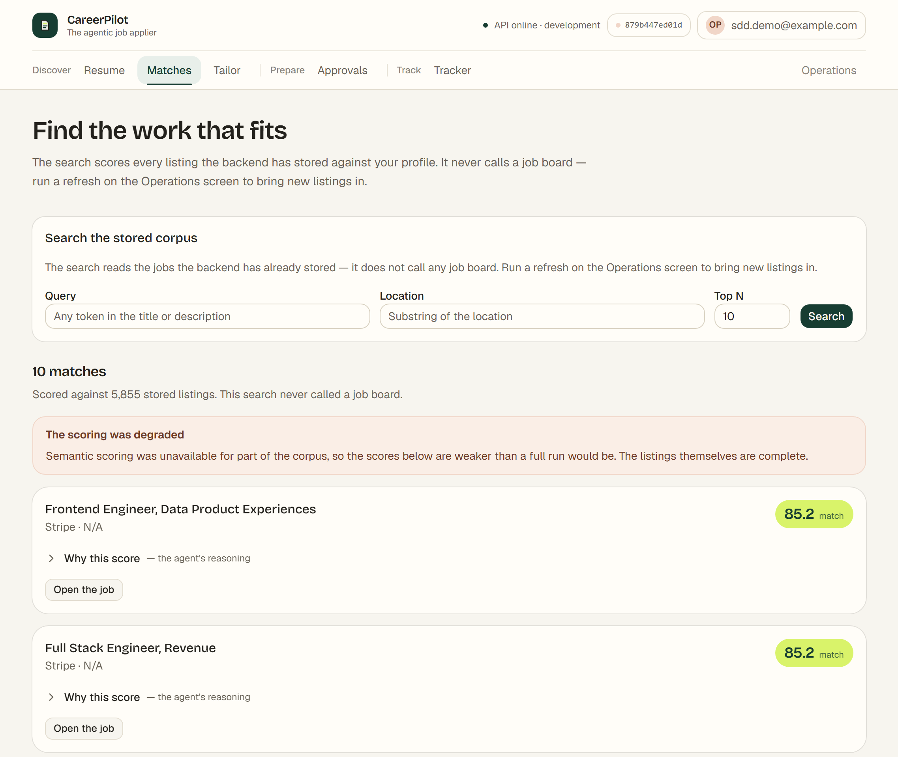
Figure 21 The ranked matches, with the degraded-scoring notice
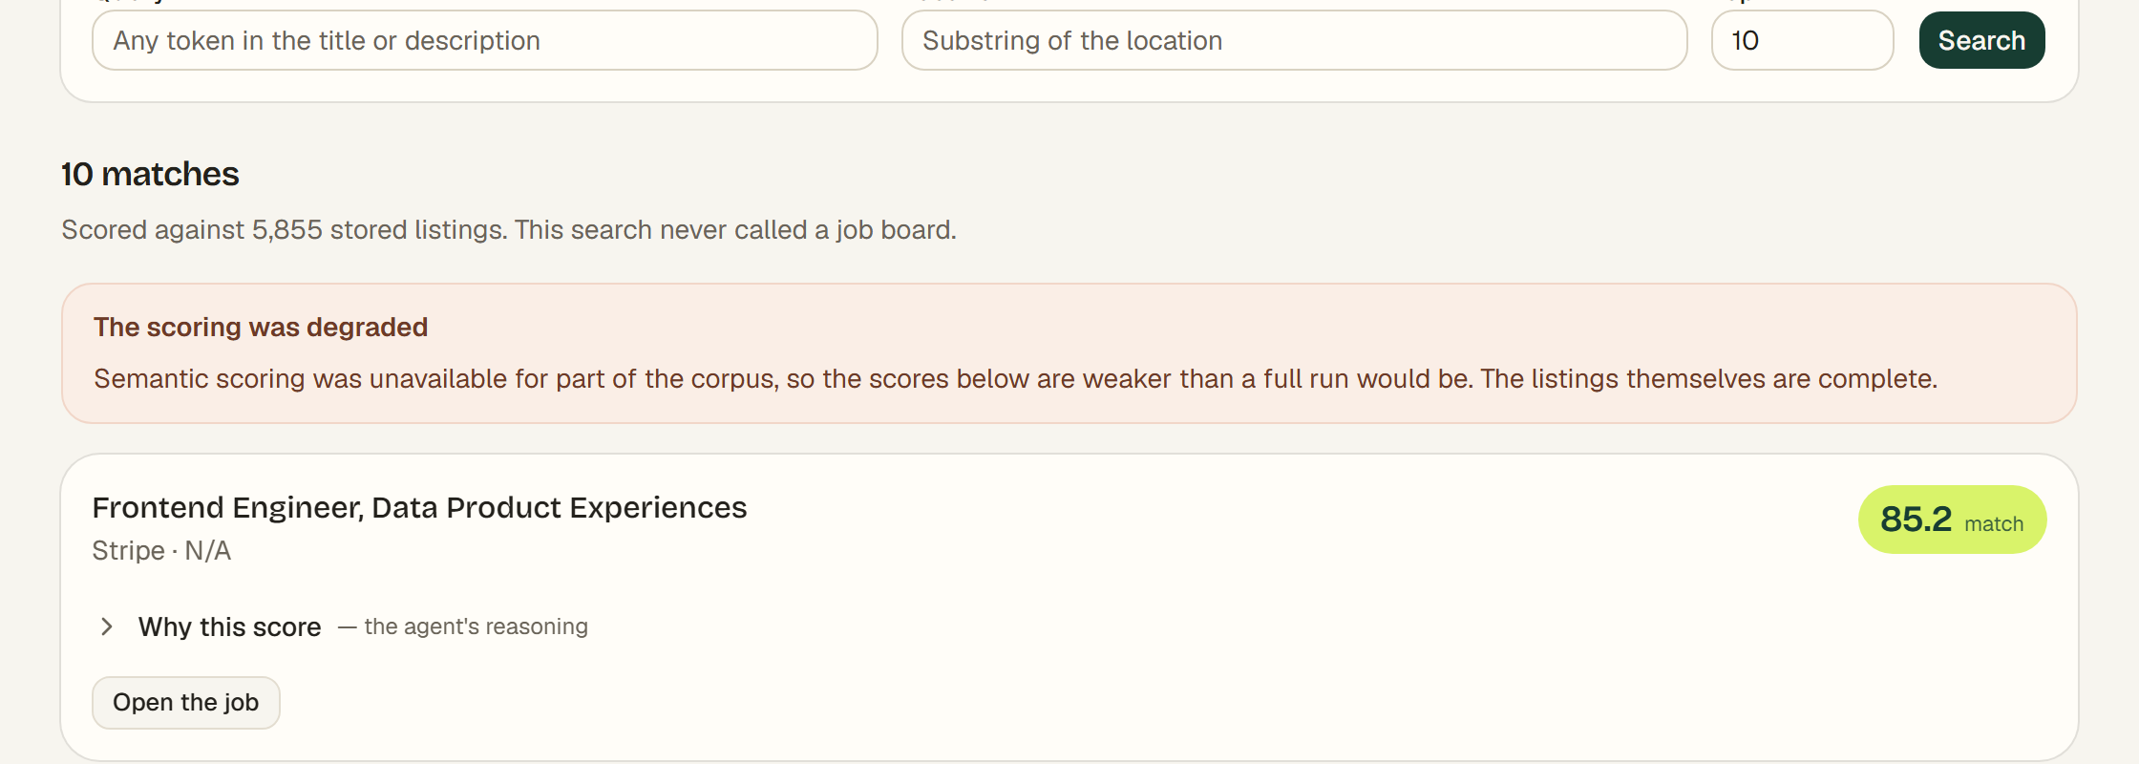
Figure 22 A close-up of the top result: the score, the disclosure and the action
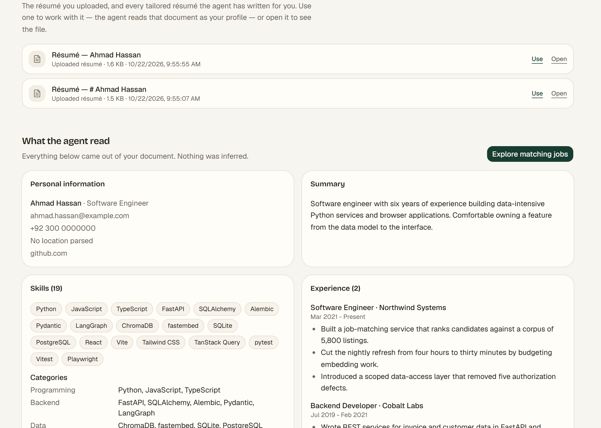
Figure 23 A close-up of the parsed profile: the document library, the contact details, the skills and the experience
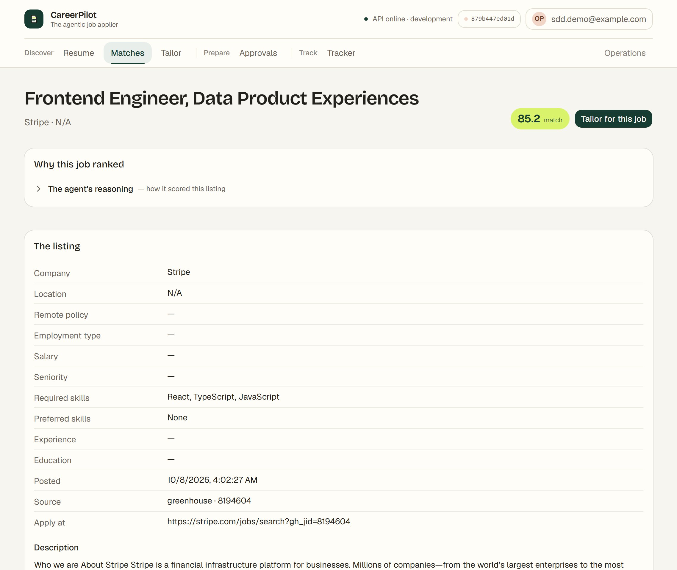
Figure 24 The job detail screen
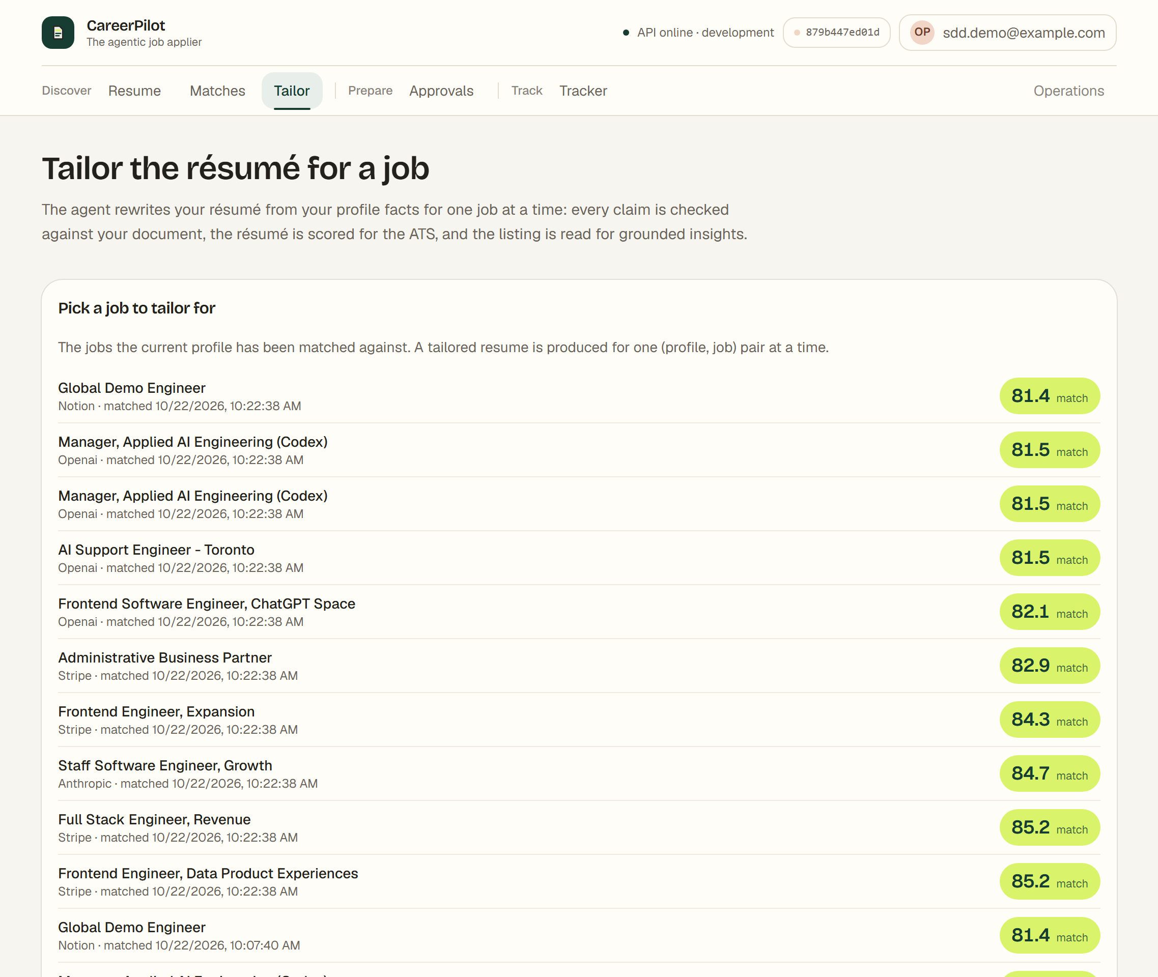
Figure 25 The tailoring screen
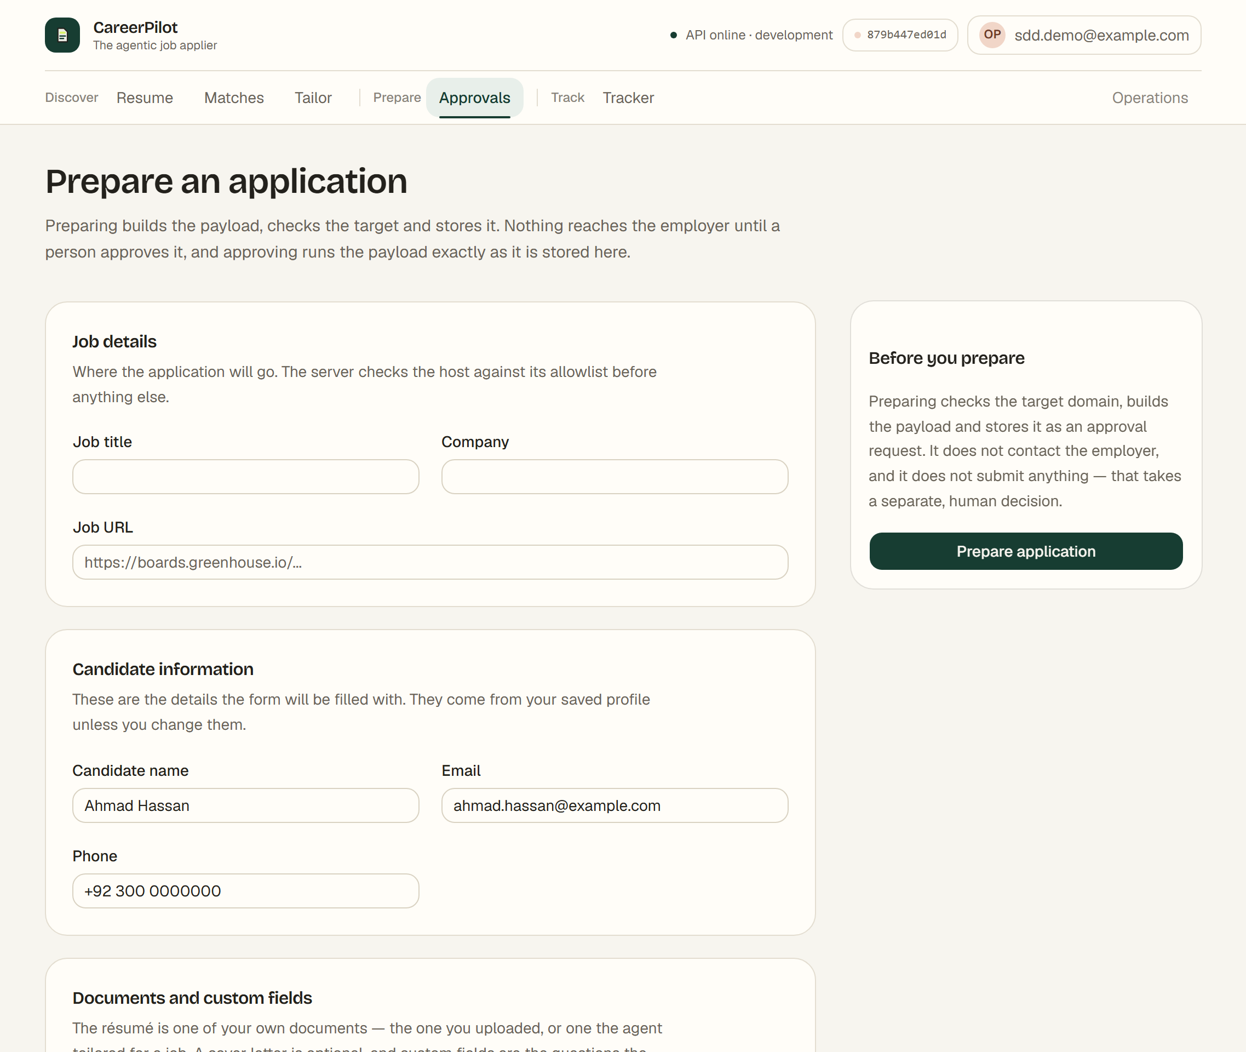
Figure 26 The approvals screen: the payload a person is asked to approve
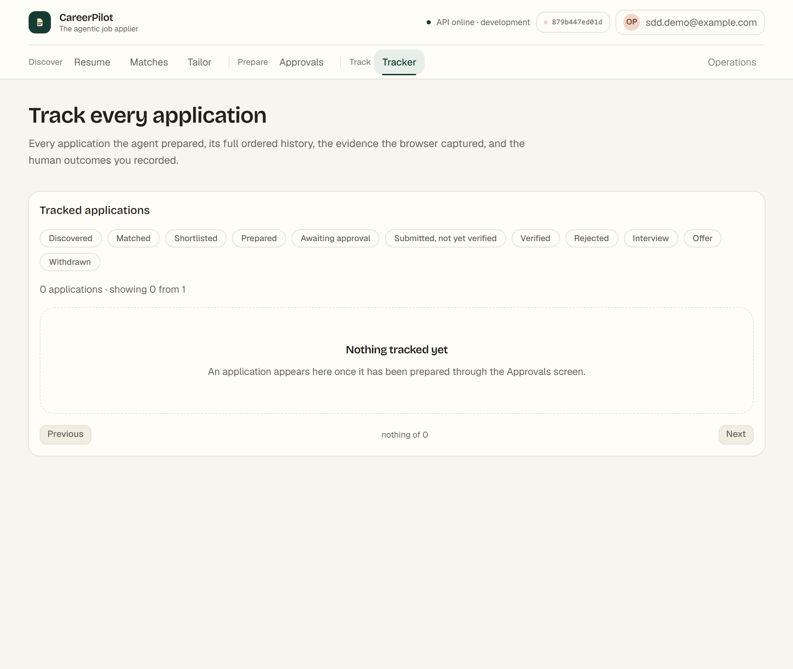
Figure 27 The tracker
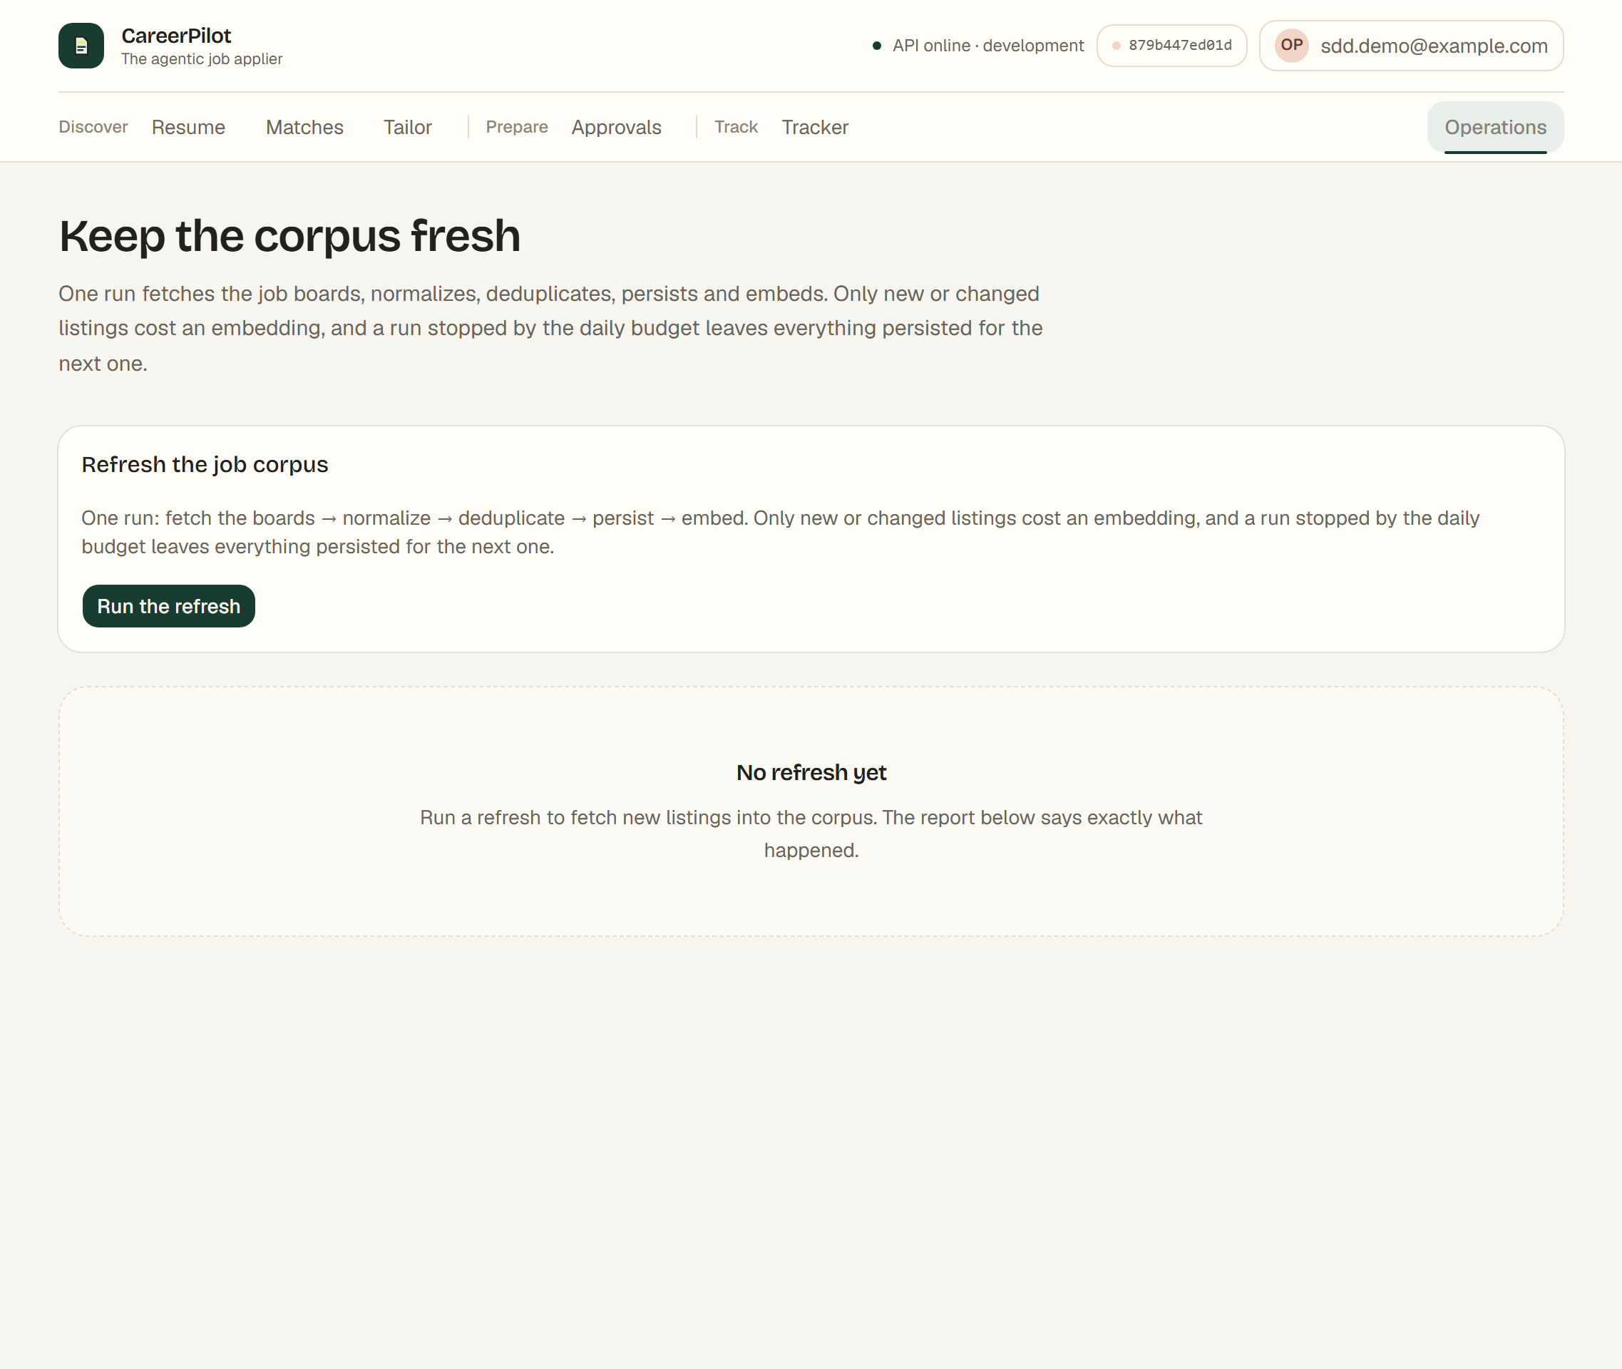
Figure 28 The operations screen
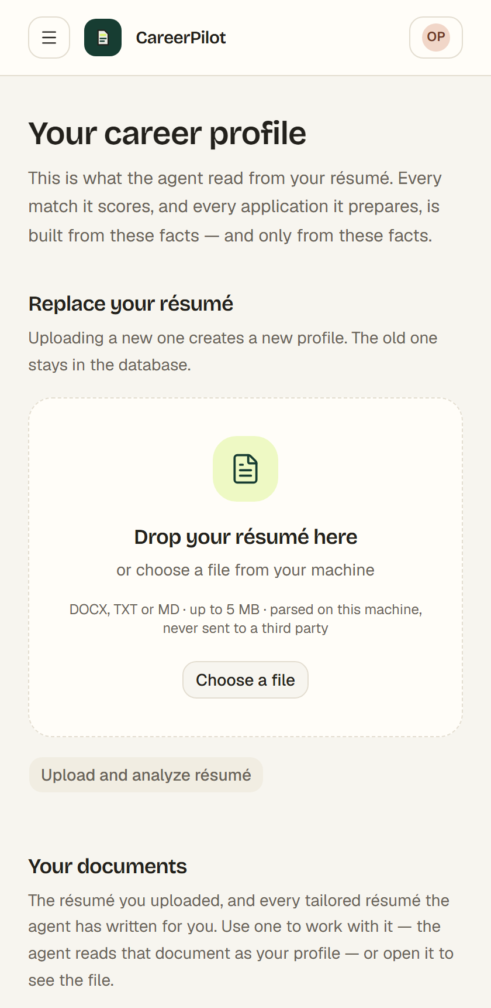
Figure 29 The console on a narrow screen, where the navigation becomes a drawer

Screen Objects and Actions
The table below names the objects a person interacts with, the action each one performs, and what the console shows afterwards.
Object | Action | Result
Email and password fields | Submit the sign-in form | The session cookie is set and the shell replaces the sign-in screen
Choose a file | Pick a .docx, .txt or .md file under 5 MB | The file is uploaded, parsed and stored; the parsed profile replaces the empty state
Your documents list | Choose a document, or open its file | The chosen document becomes the current profile, and every other screen works against it
Query, location and top N | Submit the search form | The ranked matches replace the empty state, with the count and the degraded notice
Why this score | Expand the disclosure | The agent's reasoning appears, with the matched and missing requirements
Open the job | Follow the link to a listing | The job detail screen opens with the listing and the component scores
Tailor for this job | Start a tailoring run | The run is reported as it happens and may be cancelled; the tailored content and the factuality report replace the form
Job details, candidate information and custom fields | Fill the prepare form | The payload is written down and the approval request appears in the approvals screen
Approve or reject, with a name and a reason | Record the decision | The decision is stored with the identity and the time; the approval leaves the pending list
Status filter and pagination | Filter the tracked applications | The list narrows, and the total stays scoped to the account
A status change with a name | Record an outcome | An event is appended to the application's history, and the history shows the actor
Run the refresh | Start the refresh and watch the timer | The report names what was found, dropped, screened, admitted, stored and embedded

REQUIREMENTS MATRIX
The matrix traces every functional requirement in the Software Requirements Specification to the component that satisfies it and the test that proves it. The requirement numbers are the ones in the specification, Version 2.0.
Requirement | Implementing component | Verification
FR-1.1 to FR-1.9 | src/api/routes/resumes.py, src/api/validation.py, src/resume/parser.py, src/resume/profile.py | tests/test_resumes_api.py, tests/test_resume_parser.py, tests/test_upload_validation.py
FR-2.1 to FR-2.15 | src/graph/job_executor.py, src/jobs/*, src/security/admission.py, src/security/html.py | tests/test_jobs.py, tests/test_refresh_and_stored_search.py, tests/test_ws12_hardening.py, tests/test_ws15_hardening.py
FR-3.1 to FR-3.11 | src/graph/job_executor.py, src/matching/engine.py, src/rag/chroma_store.py | tests/test_matching.py, tests/test_chroma_store.py, tests/test_jobs_api.py
FR-4.1 to FR-4.10 | src/resume/tailor.py, src/resume/ats.py, src/resume/render.py, src/research/engine.py, src/security/injection.py | tests/test_tailor.py, tests/test_ats.py, tests/test_render.py, tests/test_research.py
FR-5.1 to FR-5.17 | src/graph/nodes.py, src/graph/conditionals.py, src/applications/*, src/security/permissions.py, src/db/approval.py | tests/test_application_workflow.py, tests/test_approval_flow.py, tests/test_evidence.py, tests/test_browser_variants.py
FR-6.1 to FR-6.7 | src/applications/tracking.py, src/db/applications.py, src/api/routes/tracking.py | tests/test_tracking.py, tests/test_tracking_api.py
FR-7.1 to FR-7.5 | src/evaluation/*, scripts/run_eval.py | tests/test_eval_runner.py, tests/test_eval_metrics.py, scripts/verify_ws09.py
FR-8.1 to FR-8.12 | src/auth/*, src/config/settings.py | tests/test_auth.py, tests/test_user_storage.py, tests/test_production_posture.py
FR-9.1 to FR-9.8 | src/db/access.py, src/api/scope.py, src/security/audit.py | tests/test_tenant_isolation.py, tests/test_ws14_a0_verification.py, tests/test_audit_identity.py
FR-10.1 to FR-10.7 | src/storage/paths.py, src/retention.py, scripts/purge_expired.py | tests/test_retention.py, tests/test_user_storage.py
FR-11.1 to FR-11.12 | frontend/src/screens/*, frontend/src/lib/api/*, frontend/vite.config.ts | frontend/src/**/*.test.tsx, frontend/e2e/smoke.spec.ts
FR-12.1 to FR-12.12 | src/api/middleware.py, src/security/limits.py, src/security/html.py, src/security/paths.py, src/security/allowlist.py | tests/test_ws12_hardening.py, tests/test_ws15_hardening.py

The non-functional requirements are traced in the same way. The performance and reliability targets are measured by the evaluation harness in src/evaluation/, the security targets by src/evaluation/security.py, and the maintainability targets by the continuous integration job, which runs the lint, the test suite, the migration check and the dependency audit on every push.

APPENDICES
This section is optional. The appendices below give the reference material that a reader of this document is most likely to want beside it.

Appendix A: The API Route Set
Every route the service exposes, with the module that implements it. The table is checked against the running application by the test suite, so a route that is added without a row here fails the build.
Route | Purpose | Implemented by
GET / | Service status | src/main.py
GET /api/health | Service status | src/api/routes/health.py
POST /api/auth/register | Create an account | src/auth/routes.py (fastapi-users)
POST /api/auth/cookie/login | Sign in and set the session cookie | src/auth/routes.py (fastapi-users)
POST /api/auth/token/login | Sign in and return a bearer token | src/auth/routes.py (fastapi-users)
POST /api/auth/cookie/logout | End the cookie session | src/auth/routes.py (fastapi-users)
POST /api/auth/token/logout | End the bearer session | src/auth/routes.py (fastapi-users)
POST /api/auth/forgot-password | Request a password-reset token | src/auth/routes.py (fastapi-users)
POST /api/auth/reset-password | Set a new password with a reset token | src/auth/routes.py (fastapi-users)
POST /api/auth/request-verify-token | Request an e-mail verification token | src/auth/routes.py (fastapi-users)
POST /api/auth/verify | Verify the account with the verification token | src/auth/routes.py (fastapi-users)
GET /api/auth/me | The authenticated principal | src/auth/routes.py
PATCH /api/auth/me | Change the caller's own e-mail, password or name | src/auth/routes.py
DELETE /api/auth/me | Deactivate the account and end its sessions | src/auth/routes.py
GET /api/auth/sessions | The caller's live sessions, without their tokens | src/auth/routes.py
POST /api/auth/sessions/revoke | End every session of the caller | src/auth/routes.py
POST /api/auth/sessions/revoke-others | End every session except the current one | src/auth/routes.py
DELETE /api/auth/sessions/{token} | End one session of the caller | src/auth/routes.py
GET /api/audit | The caller's own audit trail | src/api/routes/audit.py
POST /api/resumes | Upload a resume and return a validated profile | src/api/routes/resumes.py
GET /api/resumes/{profile_id} | Read a stored profile | src/api/routes/resumes.py
GET /api/documents | The caller's document library | src/api/routes/documents.py
GET /api/documents/{document_id}/download | Download one of the caller's documents | src/api/routes/documents.py
POST /api/jobs/refresh | Fetch boards, normalize, deduplicate, persist and embed | src/api/routes/jobs.py
POST /api/jobs/search | Rank the stored corpus for a profile | src/api/routes/jobs.py
GET /api/jobs/{job_id} | Read one stored listing | src/api/routes/jobs.py
GET /api/profiles/{profile_id}/matches | Read the match history | src/api/routes/jobs.py
POST /api/tailor | Tailor a resume for a job, with a factuality report | src/api/routes/tailoring.py
GET /api/tailored/{tailoring_id} | Read a stored tailoring run | src/api/routes/tailoring.py
GET /api/tailored/{tailoring_id}/download | Download the rendered DOCX of a tailoring | src/api/routes/artifacts.py
POST /api/applications/prepare | Check the target, select the adapter, create an approval request | src/api/routes/applications.py
POST /api/applications/{approval_id}/approve | Record a human approval and execute | src/api/routes/applications.py
POST /api/applications/{approval_id}/reject | Record a human rejection | src/api/routes/applications.py
GET /api/applications/approvals/{approval_id} | Read the state of an approval request | src/api/routes/applications.py
GET /api/applications | List the tracked applications | src/api/routes/tracking.py
GET /api/applications/{application_id} | Read one application and its events | src/api/routes/tracking.py
PATCH /api/applications/{application_id}/status | Change an application status | src/api/routes/tracking.py
GET /api/applications/{application_id}/evidence | Read the evidence records of an application | src/api/routes/artifacts.py
GET /api/applications/{application_id}/evidence/{filename} | Download one evidence artifact | src/api/routes/artifacts.py

Appendix B: The Console's Routes
Route | Screen | Module
/resume | Your career profile | frontend/src/screens/resume-screen.tsx
/matches | Find the work that fits | frontend/src/screens/matches-screen.tsx
/matches/:jobId | One listing | frontend/src/screens/job-detail-screen.tsx
/tailor | Tailor a resume for a job | frontend/src/screens/tailor-screen.tsx
/tailor/:jobId | Tailor for one listing | frontend/src/screens/tailor-screen.tsx
/approvals | Prepare an application | frontend/src/screens/approvals-screen.tsx
/tracker | Track every application | frontend/src/screens/tracker-screen.tsx
/tracker/:applicationId | One application and its history | frontend/src/screens/tracker-screen.tsx
/operations | Keep the corpus fresh | frontend/src/screens/operations-screen.tsx

Appendix C: Where the Design Is Recorded
- The security model, the threat model and the control register are in docs/SECURITY.md. The register names each control, the threat it mitigates, where it is implemented and the test that proves it.
- The data model and the request flows are in docs/ARCHITECTURE.md.
- The workstream documents in docs/implementation/ hold the plan and the execution record for each of the fifteen workstreams.
- The operations runbook in docs/RUNBOOK.md holds the start-up, the backup and the recovery steps.
- The evaluation baseline in docs/evaluations/ holds the measured numbers the design is judged against.

