Autonomous AI Job Application Agent
Software Requirements Specification



SUBMITTED BY AHMAD HASSAN
ROLL NO F23BDOC1M1089
SUBMITTED TO Dr. Muhammad Omar

BSCS Computer Science
Session 2023-2027

DEPARTMENT OF COMPUTER SCIENCE
The Islamia University of Bahawalpur
Revision History
Date | Description | Author | Comments
17 Oct 2026 | Version 1.0 | Ahmad Hassan | First revision

Document Approval
The following Software Requirements Specification has been accepted and approved by the following:
Signature | Printed Name | Title | Date
 | Dr. Muhammad Omar | Supervisor, Department of Computer Science
 | Ahmad Hassan | Student, BSCS 2023-2027

ABSTRACT
This Software Requirements Specification describes the Autonomous AI Job Application Agent, a backend system that reads a candidate's resume, collects job listings from public job-board APIs, ranks them with an explained hybrid score, tailors the resume without inventing facts, and prepares applications for human approval.
The document defines the product context, user characteristics, constraints, external interfaces, functional requirements, use cases, data classes and measurable quality attributes. Each requirement has a unique identifier, a priority and a status, so a reader can see which requirements the current release meets and which remain planned. The specification reflects the project on 17 October 2026, after Milestone 1.
Table of Contents
1 INTRODUCTION 1
1.1 Purpose 1
1.2 Scope 1
1.3 Definitions, Acronyms, and Abbreviations 1
1.4 References 2
1.5 Overview 3
2 THE OVERALL DESCRIPTION 3
2.1 Product Perspective 3
2.1.1 Operations 4
2.1.2 Site Adaptation Requirements 5
2.2 Product Functions 5
2.3 User Characteristics 6
2.4 General Constraints 6
2.5 Assumptions and Dependencies 6
3 SPECIFIC REQUIREMENTS 7
3.1 External Interface Requirements 7
3.1.1 System Interfaces 7
3.1.2 Interfaces 7
3.1.3 Hardware Interfaces 8
3.1.4 Software Interfaces 8
3.1.5 Communications Interfaces 8
3.2 Functional Requirements 9
3.2.1 Resume Intake and Profile Extraction 9
3.2.2 Job Discovery and Refresh 10
3.2.3 Matching, Ranking and Search 11
3.2.4 Resume Tailoring and ATS Analysis 12
3.2.5 Application Preparation, Approval, Submission and Verification 13
3.2.6 Application Tracking 14
3.2.7 Evaluation 16
3.3 Use Cases 16
3.3.1 UC-1 Upload a Resume 16
3.3.2 UC-2 Refresh the Job Corpus 17
3.3.3 UC-3 Search Ranked Jobs 17
3.3.4 UC-4 Tailor a Resume for a Job 17
3.3.5 UC-5 Review and Approve an Application 18
3.3.6 UC-6 Record an Outcome 18
3.4 Classes / Objects 18
3.4.1 CandidateProfile 19
3.4.2 JobListing 19
3.4.3 JobMatchResult 19
3.4.4 TailoredResume and FactualityReport 20
3.4.5 Application request and result 20
3.4.6 Application and ApplicationEvent (planned) 20
3.5 Non-Functional Requirements 20
3.5.1 Performance 21
3.5.2 Reliability 21
3.5.3 Availability 21
3.5.4 Security 21
3.5.5 Maintainability 22
3.5.6 Portability 22
3.6 Inverse Requirements 22
3.7 Logical Database Requirements 22
3.8 Design Constraints 23
3.8.1 Standards Compliance 23
Table of Figures
Figure 1 System context of the Autonomous AI Job Application Agent 4
Figure 2 Major functions and their implementation status 5
Figure 3 Application status lifecycle 15

INTRODUCTION
This document specifies what the Autonomous AI Job Application Agent must do. It describes requirements and avoids design. The design lives in the architecture document and the workstream documents listed in the references.

Purpose
This SRS defines the requirements for the Autonomous AI Job Application Agent. It serves two readers: the project supervisor, who reviews and approves the requirements, and the developer, who designs, builds and tests against them. Version 1.0 reflects the project on 17 October 2026, after Milestone 1. Each requirement carries a status (Done, Partial or Planned) so the reader can separate what the current release meets from what remains.

Scope
The product is the Autonomous AI Job Application Agent, a backend service with a REST API. It will read a candidate's resume, collect job listings from public job-board APIs, rank them with an explained score, tailor the resume without inventing facts, and prepare applications for human approval. After approval it will submit through controlled browser automation, verify the result with evidence, and track each application.
The product will not scrape web pages, use LinkedIn, bypass CAPTCHA or multi-factor authentication, or submit an application without recorded approval. It has no graphical interface in this release. Submission targets a local fake ATS until the security preconditions in the security model pass.
The goals are to cut the effort of finding and applying to suitable jobs, keep every claim in a tailored resume traceable to the candidate's own profile, and keep every external action auditable.

Definitions, Acronyms, and Abbreviations
Term | Definition
Adapter | A module that maps one external source or site to a common interface.
ATS | Applicant tracking system, the software an employer uses to receive applications. "ATS analysis" estimates how well a resume passes keyword screening.
Alembic | The database migration tool used by the project.
CAPTCHA | A challenge meant to separate people from automated clients.
CandidateProfile | The structured, validated record of a candidate produced from a resume.
Chroma | The embedded vector database that stores listing embeddings.
Corpus | The set of job listings stored in the database.
Embedding | A numeric vector that represents the meaning of a text.
Evidence | Artifacts that show a submission happened: URL, confirmation text, screenshot and trace.
Factuality validation | A deterministic check that removes tailored content the profile does not support.
Fake ATS | A local test site that imitates an employer's application form.
FU, WS | Follow-up item and workstream, the labels used in the implementation documents.
Hybrid match | A score that combines semantic similarity with rule-based component scores.
JobListing | The canonical record for a job from any source.
LangGraph | The library that runs the application workflow as a state graph.
LLM | Large language model.
MFA | Multi-factor authentication.
PII | Personally identifiable information.
Refresh | The job that fetches boards, stores listings and embeds new text.
SRS | Software Requirements Specification.
SSRF | Server-side request forgery, an attack that makes a server call internal addresses.
Store-only search | A search that reads the stored corpus and contacts no job source.

References
- IEEE Std 830-1998, Recommended Practice for Software Requirements Specifications. IEEE.
- Project plan, docs/PROJECT_PLAN.md. Project repository.
- Architecture document, docs/ARCHITECTURE.md. Project repository.
- Security model and control register, docs/SECURITY.md, section 14. Project repository.
- Implementation roadmap, docs/implementation/00-OVERVIEW.md and workstream documents 01 to 11. Project repository.
- Greenhouse Job Board API. Greenhouse Software. https://developers.greenhouse.io/job-board.html
- Lever Postings API. Lever. https://github.com/lever/postings-api
- Ashby public job posting API. Ashby. https://developers.ashbyhq.com/docs/public-job-posting-api
- Remotive API documentation and terms. Remotive. https://remotive.com/api-documentation
- EmbeddingGemma model card. Google. https://ai.google.dev/gemma/docs/embeddinggemma/model_card_2
- Gemini API documentation. Google. https://ai.google.dev/gemini-api/docs
- FastAPI documentation. https://fastapi.tiangolo.com
- LangGraph documentation. LangChain. https://langchain-ai.github.io/langgraph/
- Chroma documentation. https://docs.trychroma.com
- Playwright for Python documentation. Microsoft. https://playwright.dev/python/

Overview
Section 2 describes the product in plain language and suits the supervisor and the candidate. Section 3 holds the numbered requirements and suits the developer and tester. Requirement identifiers use the prefix FR for functional and NFR for non-functional requirements, and each functional feature names the workstream documents and tests that trace to it.

THE OVERALL DESCRIPTION
This section gives the background for the requirements in section 3. It states no testable requirement.

Product Perspective
The product is an independent backend service. It talks to job-board APIs, a language model API, a database, a local vector store and, in later releases, employer application sites. The candidate drives it through HTTP calls and a scheduled command.
Commercial tools such as Simplify, Teal and LazyApply autofill forms, track applications or send applications in bulk. This product differs in three ways. It collects jobs only from documented public APIs. It checks every tailored claim against the candidate's profile. It requires recorded human approval and evidence before it reports a submission.
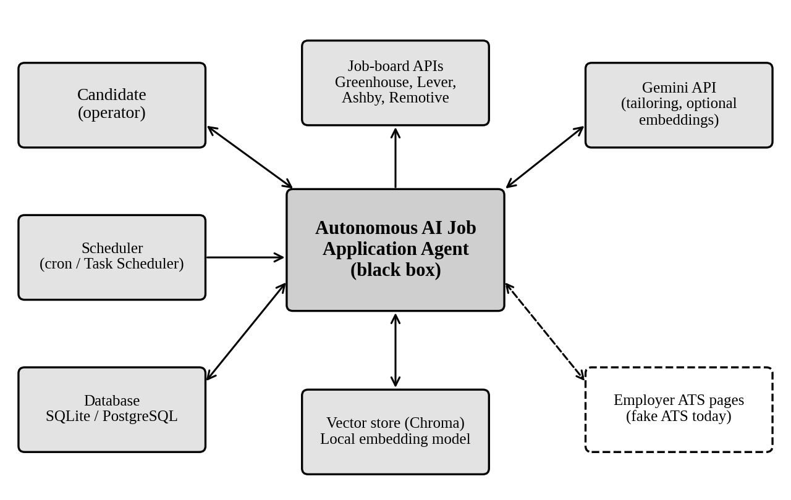
Figure 1 System context of the Autonomous AI Job Application Agent

Operations
- Interactive operation. The candidate calls the API to upload a resume, search and review results.
- Unattended operation. A scheduler runs the refresh command once a day. Remotive asks API users to fetch at most about four times a day.
- Data processing. The refresh embeds listings in chunks of 100 texts so that an interrupted run keeps completed chunks.
- Backup and recovery. The candidate backs up the database and the data/ directory. The vector store can be rebuilt by deleting its directory and running the refresh.

Site Adaptation Requirements
Before first use the operator must install Python 3.13, install the Chromium browser for Playwright, copy .env.example to .env and set the board lists, and run the database migrations. The first refresh downloads about 300 MiB of embedding model weights. Tailoring needs a Gemini API key. A PostgreSQL deployment needs a database created and its URL set in DATABASE_URL.

Product Functions
- Resume intake: parse a resume into a validated profile and store it.
- Job discovery: collect listings from four public sources, normalize, deduplicate and index them.
- Matching and search: rank stored listings for a profile with an explained score.
- Tailoring and ATS analysis: draft a job-specific resume and cover letter from profile facts, validate them and score keyword coverage.
- Application workflow: prepare an application, wait for approval, submit, verify and record evidence.
- Application tracking: record each status change as an event.
- Evaluation: measure extraction, ranking and factuality against golden datasets.
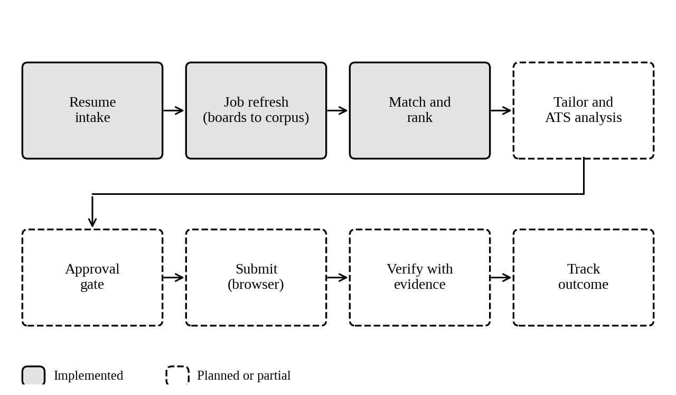
Figure 2 Major functions and their implementation status

User Characteristics
The main user is the candidate, a technical user who is comfortable with REST tools and a command line. The release has no graphical interface, so every capability must work through documented HTTP endpoints and scripts with readable error messages. In early versions the candidate also acts as the approver, which makes the approval step a deliberate pause instead of a formality. A maintainer extends adapters and scorers and needs clear module boundaries and a test suite that runs without a network.

General Constraints
- Terms of service. Only documented, key-less public job-board APIs may supply listings. Remotive requires credit and a link back to the original listing.
- Safety. Submission is irreversible. Approval, evidence and fail-closed behavior are mandatory before any real-site use.
- Security and privacy. Web content is untrusted data. Secrets and PII stay out of prompts and logs. Language model calls disable provider-side storage.
- Audit. Every external action must leave a record.
- Language and libraries. The runtime is Python 3.13 with FastAPI, Pydantic, LangGraph, SQLAlchemy and Playwright.
- Free-tier quotas. The free Gemini embedding tier allows 20 requests a day. The local embedder replaces it by default.
- Memory. Local embedding batches stay at 8 texts because larger batches exhausted memory in testing.
- Scope of automation. The system may not bypass CAPTCHA, MFA or anti-bot controls.

Assumptions and Dependencies
- The listed job-board endpoints keep their current response shapes. A change requires an adapter update.
- The operator curates the boards to watch. The product does not discover companies.
- The candidate supplies a resume in DOCX, TXT or MD format.
- The embedding model weights download once and stay cached.
- A Gemini API key is available for tailoring. Search and resume features work without it.
- SQLite serves development and PostgreSQL serves deployment, both through the same migrations.
- The operator runs one instance for one candidate. Multi-user access control is out of scope.

SPECIFIC REQUIREMENTS
Every requirement below has a unique identifier, a priority (High, Medium or Low) and a status (Done, Partial or Planned). Each requirement can be tested. Workstream (WS) and follow-up (FU) labels point to the implementation documents.

External Interface Requirements

System Interfaces
System | Interface used by the product
Greenhouse | GET boards-api.greenhouse.io/v1/boards/{token}/jobs, with content=true or per-job fetch. JSON.
Lever | GET api.lever.co/v0/postings/{company}?mode=json. JSON list.
Ashby | GET api.ashbyhq.com/posting-api/job-board/{org}. JSON.
Remotive | GET remotive.com/api/remote-jobs?search={query}. JSON.
Gemini API | google-genai Interactions API for structured tailoring output, with store=False. Optional embedding calls.
Employer ATS sites | Browser sessions through Playwright, limited to allowlisted domains. Only the local fake ATS is supported today.

Interfaces
The product exposes a REST API with JSON bodies and generated OpenAPI documentation at /docs. It has no graphical interface. Errors return an HTTP status and a detail message. Scheduled and one-off jobs run as command-line scripts.
Endpoint | Purpose
GET /, GET /api/health | Service status.
POST /api/resumes, GET /api/resumes/{id} | Upload and read a profile.
POST /api/jobs/refresh | Run the refresh.
POST /api/jobs/search | Rank the stored corpus for a profile.
GET /api/jobs/{id}, GET /api/profiles/{id}/matches | Read a listing and match history.
POST /api/applications/submit | Run the application workflow.
POST /api/tailor, GET /api/tailored/{id} | Planned (WS-05).
/api/applications approval and tracking routes | Planned (WS-06, WS-07).

Hardware Interfaces
The system has no hardware interface requirements.

Software Interfaces
The project plan fixes the following components. Version numbers are the minimums declared in pyproject.toml.
Name | Minimum version | Purpose
Python | 3.13 | Runtime.
FastAPI, Pydantic | 0.141.1, 2.13.5 | REST API and data models.
LangGraph | 1.2.11 | Application and job-search workflows.
SQLAlchemy, Alembic | 2.0.52, 1.16.0 | Persistence and migrations. SQLite for development, PostgreSQL for deployment.
ChromaDB | 1.0 | Vector store, cosine space.
fastembed | 0.9.0 | Local EmbeddingGemma-2 int8 embedding.
google-genai | 2.25.0 | Gemini client.
httpx | 0.28.1 | Job-source HTTP client.
Playwright | 1.51.0 | Browser automation.
python-docx | 1.1.0 | Resume parsing and rendering.

Communications Interfaces
The product calls job-board and Gemini endpoints over HTTPS. It sends GET requests to job boards, does not follow redirects, and sets a User-Agent that identifies the agent. Its own API uses HTTP with JSON. Cross-origin access follows an explicit CORS_ORIGINS list. The product defines no custom protocol.

Functional Requirements

Resume Intake and Profile Extraction

Introduction
Turns an uploaded resume into a validated CandidateProfile. Traces to WS-04, UC-1, tests/test_resumes_api.py, tests/test_resume_parser.py, tests/test_profile_preferences.py.

Inputs
A multipart file with extension .docx, .txt or .md, at most 5 MB. A profile identifier for retrieval.

Processing
ID | Requirement | Priority | Status
FR-1.1 | The system shall accept .docx, .txt and .md files and reject other types with HTTP 400. | High | Done
FR-1.2 | The system shall reject files larger than 5 MB, empty files and unparseable files with HTTP 400 and the cause. | High | Done
FR-1.3 | The system shall extract name, title, contact details, summary, skills with categories, education, experience, projects, certifications and achievements verbatim from the document. | High | Done
FR-1.4 | The system shall record work preferences (remote mode, locations, minimum salary, work authorization, employment types) only when the resume states them. | High | Done
FR-1.5 | The system shall return deterministic warnings for a missing name, email, skills, summary or experience. | Medium | Done
FR-1.6 | The system shall persist the profile and return an identifier that retrieves the same profile later. | High | Done
FR-1.7 | The system shall confirm that a .docx is a valid ZIP package, that text files decode as UTF-8, and shall sanitize file names. | Medium | Planned
FR-1.8 | The system shall parse PDF resumes. | Low | Planned

Outputs
profile_id, warnings and the full profile as JSON.

Error Handling
Validation failures return HTTP 400 with a message. An unknown identifier returns HTTP 404. Logs record sizes and counts, never resume content.

Job Discovery and Refresh

Introduction
Collects listings from public APIs into one stored corpus and its vector index. Traces to WS-02, FU-1, FU-2, FU-3, FU-4, FU-7, UC-2, tests/test_jobs.py, tests/test_http_client.py, tests/test_refresh_and_stored_search.py.

Inputs
Board lists in GREENHOUSE_BOARDS, LEVER_COMPANIES and ASHBY_ORGS. A refresh trigger through POST /api/jobs/refresh or scripts/refresh_jobs.py.

Processing
ID | Requirement | Priority | Status
FR-2.1 | The system shall take listings only from the Greenhouse, Lever, Ashby and Remotive public APIs and shall not scrape pages. | High | Done
FR-2.2 | The system shall request only URLs built from an adapter's host constant and a validated board identifier. | High | Done
FR-2.3 | The system shall refuse, before any request, URLs that use a non-HTTP(S) scheme or whose host resolves to a loopback, private, link-local or reserved address. | High | Done
FR-2.4 | The system shall space requests to one host at least 1 second apart by default, retry transport errors, HTTP 429 and 5xx at most twice with exponential backoff, and fail other 4xx responses and redirects at once. | High | Done
FR-2.5 | The system shall normalize each listing to a JobListing with a canonical id and skip listings that lack an id, title or company. | High | Done
FR-2.6 | The system shall extract skills from listing text with a fixed lexicon and report only skills that appear in the text. | Medium | Done
FR-2.7 | The system shall remove duplicates and upsert listings by canonical id so a repeated run leaves the row count unchanged. | High | Done
FR-2.8 | The system shall embed only new or changed texts and stop with a partial, resumable result when an embedding quota runs out. | High | Done
FR-2.9 | The system shall continue when a source fails and report each failed source by name. | High | Done
FR-2.10 | The system shall leave the LinkedIn adapter unregistered. | High | Done

Outputs
A refresh report with counts for found, dropped, deduplicated, persisted and embedded listings, a map of source errors, planned and used embedding requests, and the flags quota_exhausted and degraded_embedding.

Error Handling
A failing source, vector store or quota limit lowers the result and never raises an error to the caller. The report names the cause so the next run can resume.

Matching, Ranking and Search

Introduction
Ranks stored listings for a profile and explains each score. Traces to WS-03, WS-04, FU-1, UC-3, tests/test_matching.py, tests/test_chroma_store.py, tests/test_jobs_api.py.

Inputs
A profile_id, an optional query, an optional location and top_n (default 10, maximum 50).

Processing
ID | Requirement | Priority | Status
FR-3.1 | The system shall search the stored corpus and shall not contact any job source during a search. | High | Done
FR-3.2 | The system shall score semantic similarity, skills, experience, seniority, location and preference from 0 to 100, with default weights 0.2, 0.3, 0.2, 0.1, 0.1 and 0.1. | High | Done
FR-3.3 | The system shall accept weight overrides that name all six components, are positive and sum to 1.0 within 0.01, and shall refuse invalid overrides at startup. | Medium | Done
FR-3.4 | The system shall score a component 70 when either side lacks the data and 25 on a hard conflict. | Medium | Done
FR-3.5 | The system shall derive semantic similarity from the cosine distance between the candidate text vector and each listing vector. | High | Done
FR-3.6 | When embeddings are unavailable the system shall spread the semantic weight over the other components and mark the report degraded. | High | Done
FR-3.7 | The system shall return, for each result, the component scores, matched skills, missing skills and a readable explanation. | High | Done
FR-3.8 | The system shall filter by query tokens (any token in title or description) and by location substring, ignoring case. | Medium | Done
FR-3.9 | The system shall rank by overall score in descending order, return the top results and save one match row for each. | High | Done
FR-3.10 | The system shall return a stored listing by id and a profile's match history, oldest first. | Medium | Done
FR-3.11 | The system shall prevent a listing without stated skills from outranking listings with real partial skill matches. | Medium | Planned

Outputs
Ranked job and match pairs, stats, source_errors (empty for a store-only search) and the degraded flag.

Error Handling
An unknown profile returns HTTP 404. Missing vectors or a vector store failure return HTTP 200 with degraded set.

Resume Tailoring and ATS Analysis

Introduction
Drafts job-specific resume content from profile facts and checks it. Traces to WS-05, WS-10, UC-4, tests/test_tailor.py, tests/test_requirements.py.

Inputs
A profile and a listing, selected by profile_id and job_id in the planned API.

Processing
ID | Requirement | Priority | Status
FR-4.1 | The system shall extract job requirements from structured listing fields and from skill mentions in the description without using a language model. | High | Done
FR-4.2 | The system shall request tailored content from the language model as structured output limited to profile facts, with provider-side storage disabled. | High | Done
FR-4.3 | The system shall remove any skill, employer, project or claim of more years than the profile supports, and report each removal. | High | Done
FR-4.4 | The system shall return the cleaned content with a violation report when removals occur, and shall not raise an error. | High | Done
FR-4.5 | The system shall extract job insights (responsibilities, technologies, seniority signals, culture statements) using only the listing text. | Medium | Planned
FR-4.6 | The system shall compute a deterministic ATS report: keyword coverage (required 1.0, preferred 0.5), section completeness, format risks, title alignment and a weighted score. | High | Planned
FR-4.7 | The system shall suggest missing keywords only as notes and shall never insert a keyword the profile does not support. | High | Planned
FR-4.8 | The system shall render the tailored resume to DOCX that the resume parser reads back with the same names, companies and bullets. | High | Planned
FR-4.9 | The system shall persist tailoring results and expose them through POST /api/tailor and GET /api/tailored/{id}. | Medium | Planned

Outputs
Tailored summary, highlighted skills, experience, projects, cover letter, the factuality report and, when planned work lands, the ATS report and a DOCX path.

Error Handling
The client classifies model failures as configuration, rate limit, unavailable or invalid output. A missing API key fails at once with an actionable message and never echoes the key.

Application Preparation, Approval, Submission and Verification

Introduction
Runs a LangGraph workflow of prepare, approval, submit and verify. Only the local fake ATS is supported. Traces to WS-06, WS-08, UC-5, tests/test_application_workflow.py, tests/test_workflow_e2e.py, tests/test_graph_executor.py.

Inputs
An application request (job title, company, job URL, candidate name, email, phone, resume path, cover letter, custom fields) and an approval decision.

Processing
ID | Requirement | Priority | Status
FR-5.1 | The system shall select the adapter that supports the job URL and return HTTP 400 when none does. | High | Done
FR-5.2 | The system shall run prepare, approval, submit and verify as separate graph nodes and reach submit only after approval. | High | Done
FR-5.3 | The system shall reject an application when no approval decision exists. | High | Done
FR-5.4 | The system shall report success only after the confirmation page text shows a submission. | High | Done
FR-5.5 | The system shall store an evidence row (URL, confirmation text, status, metadata) for each submission. | High | Done
FR-5.6 | The system shall use two phases: prepare stores a pending approval request, and a separate approve or reject call records the approver, reason and UTC time. | High | Planned
FR-5.7 | The system shall support the policies PREPARE_ONLY, REQUIRE_APPROVAL (default) and AUTO_SUBMIT, and shall refuse AUTO_SUBMIT. | High | Planned
FR-5.8 | The system shall accept only job URLs whose host equals an allowlisted domain or is a subdomain of one, check the page URL after every navigation and stop on an unexpected redirect. | High | Planned
FR-5.9 | The system shall allow submission only for adapters registered with the submit capability. | High | Planned
FR-5.10 | The system shall capture a screenshot, a navigation trace and the confirmation text for each submission and treat missing artifacts as failed verification. | High | Planned
FR-5.11 | The system shall stop with status blocked_human_review on a CAPTCHA or MFA challenge and shall not interact with it. | High | Planned
FR-5.12 | The system shall pause with status needs_human on a form question the profile cannot answer and shall not guess. | High | Planned
FR-5.13 | The system shall write an append-only audit event, with secrets and PII removed, for every prepare, approve, reject, submit and verify. | High | Planned
FR-5.14 | The system shall locate form fields by accessible labels and roles. | Medium | Planned
FR-5.15 | The Greenhouse and Lever application adapters shall raise an error on submit until they gain the submit capability. | High | Planned

Outputs
workflow_id, adapter_name, success, status, message and evidence.

Error Handling
An unexpected exception ends the workflow with status workflow_error and a message. A rejection ends with status rejected. The system never reports a submission it cannot verify.

Application Tracking

Introduction
Records the lifecycle of each application as events. Traces to WS-07, UC-6.
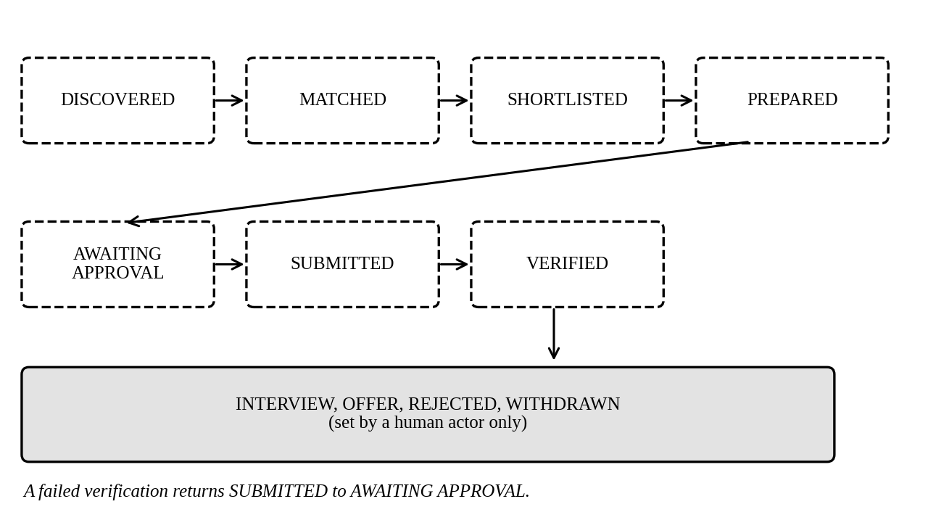
Figure 3 Application status lifecycle

Inputs
A status change request with the target status, the actor and optional notes.

Processing
ID | Requirement | Priority | Status
FR-6.1 | The system shall store each application with its profile, job, workflow, status and timestamps. | High | Planned
FR-6.2 | The system shall allow only the transitions defined in the lifecycle and reject others with HTTP 409. | High | Planned
FR-6.3 | The system shall append one event for each transition with actor and metadata and shall never update or delete an event. | High | Planned
FR-6.4 | The system shall let only a human actor set INTERVIEW, OFFER, REJECTED after submission, or WITHDRAWN. | High | Planned
FR-6.5 | The system shall list applications with a status filter and pagination, and return one application with its ordered events. | Medium | Planned
FR-6.6 | The system shall link every evidence row to an application. | Medium | Planned

Outputs
Application records with status and ordered event history.

Error Handling
An illegal transition returns HTTP 409. An unknown application returns HTTP 404. A terminal outcome from a non-human actor is refused.

Evaluation

Introduction
Measures quality so the project can support claims with numbers. Traces to WS-09.

Inputs
Golden datasets: four labeled resumes, about 25 labeled listings with duplicate groups, and six tailoring pairs.

Processing
ID | Requirement | Priority | Status
FR-7.1 | The system shall compute extraction field accuracy, skills F1, dedup precision and recall, nDCG@10, precision@5, factuality agreement and ATS coverage change. | High | Planned
FR-7.2 | The system shall run offline with canned model responses and give identical numbers on repeated runs. | High | Planned
FR-7.3 | The system shall write a report that records the dataset hash and run configuration. | Medium | Planned
FR-7.4 | The system shall exit with an error when a metric falls below its stored threshold. | Medium | Planned

Outputs
A dated Markdown report and a JSON file with the same numbers.

Error Handling
A missing dataset or canned response stops the run with a message that names the file.

Use Cases
Each use case lists the actor, preconditions, main flow, exceptions and the requirements it covers.

UC-1 Upload a Resume
Item | Description
Actor | Candidate
Precondition | The API runs and the database is migrated.
Main flow | 1. The candidate sends a resume file.  2. The system checks type, size and content.  3. The system parses and validates the profile.  4. The system stores it and returns the identifier, warnings and profile.
Exceptions | Unsupported type, oversize, empty or corrupt file: HTTP 400 with the cause.
Postcondition | The profile is retrievable by identifier.
Covers | FR-1.1 to FR-1.6

UC-2 Refresh the Job Corpus
Item | Description
Actor | Scheduler or candidate
Precondition | Boards are configured and the embedding provider is ready.
Main flow | 1. The actor starts a refresh.  2. The system queries each configured source.  3. The system drops incomplete listings and removes duplicates.  4. The system upserts listings and embeds new text.  5. The system returns the report.
Exceptions | Source failure: recorded, others continue. Quota exhausted: partial report with quota_exhausted. Vector store failure: rows kept, degraded_embedding set.
Postcondition | The corpus and vectors reflect the sources.
Covers | FR-2.1 to FR-2.10

UC-3 Search Ranked Jobs
Item | Description
Actor | Candidate
Precondition | A profile exists and the corpus holds listings.
Main flow | 1. The candidate sends a profile identifier and optional filters.  2. The system loads and filters stored listings.  3. The system reads similarities from the vector store and scores each listing.  4. The system ranks, saves match rows and returns the top results with explanations.
Exceptions | Unknown profile: HTTP 404. Missing vectors: results return with degraded set.
Postcondition | Match history holds the returned results.
Covers | FR-3.1 to FR-3.10

UC-4 Tailor a Resume for a Job
Item | Description
Actor | Candidate
Precondition | A profile and a listing exist and an LLM key is set.
Main flow | 1. The system extracts job requirements.  2. The system asks the model for tailored content from profile facts.  3. The validator removes unsupported content.  4. The system returns the content and the factuality report. Planned: ATS report and DOCX.
Exceptions | Model error: classified failure. Violations: removed and reported.
Postcondition | The candidate holds content that matches the profile.
Covers | FR-4.1 to FR-4.9

UC-5 Review and Approve an Application
Item | Description
Actor | Candidate as approver
Precondition | Tailored content exists and the job URL is allowlisted.
Main flow | 1. The system prepares the application and stores a pending approval request.  2. The approver reviews the summary and approves.  3. The system submits through the adapter.  4. The system verifies the confirmation and stores evidence.  5. The system sets the status.
Exceptions | Rejection: status REJECTED. CAPTCHA or MFA: blocked_human_review. Unknown question: needs_human. Failed verification: no success reported.
Postcondition | Evidence and an audit trail exist.
Covers | FR-5.1 to FR-5.15

UC-6 Record an Outcome
Item | Description
Actor | Candidate
Precondition | The application has status VERIFIED or later.
Main flow | 1. The candidate sends the new status.  2. The system checks the transition and the actor.  3. The system updates the status and appends an event.
Exceptions | Illegal transition: HTTP 409. Non-human actor on an outcome: refused.
Postcondition | The event history is current.
Covers | FR-6.1 to FR-6.6

Classes / Objects
This section lists the major data classes. Each reference names the requirements that use the class.

CandidateProfile

Attributes
personal_information (name, title, email, phone, location, website), summary, skills, skill_categories, education, experience (title, company, dates, bullets, years), projects, certifications, achievements, work_preferences.

Functions
parse_resume(path) builds it. validate_candidate_profile(profile) returns warnings. Reference: FR-1.1 to FR-1.6, UC-1.

JobListing

Attributes
id, source, source_job_id, title, company, description, location, remote_policy, employment_type, salary, currency, seniority, required_skills, preferred_skills, experience_requirements, education_requirements, application_url, company_url, posted_at, metadata.

Functions
Adapters implement search(query, location) and get_job(id). deduplicate() and save_jobs() act on lists of listings. Reference: FR-2.1 to FR-2.10, UC-2.

JobMatchResult

Attributes
overall_score, semantic_score, skill_score, experience_score, seniority_score, location_score, preference_score (each 0 to 100), matched_requirements, missing_requirements, explanation.

Functions
calculate_match(job, profile, semantic_score, weights) builds it. validate_weights() checks overrides. Reference: FR-3.2 to FR-3.7, UC-3.

TailoredResume and FactualityReport

Attributes
TailoredResume: summary, highlighted_skills, experience, projects, cover_letter. FactualityReport: passed, removed_skills, removed_experience, removed_projects, violations.

Functions
tailor_resume(profile, job, generate) returns both. extract_requirements(job, skills) supplies the requirements. Reference: FR-4.1 to FR-4.4, UC-4.

Application request and result

Attributes
ApplicationRequest, PreparedApplication, SubmissionEvidence (URL, confirmation text, screenshot path, trace path, status) and ApplicationResult (success, status, message, evidence, metadata).

Functions
An adapter implements supports_url, prepare, submit and verify. Reference: FR-5.1 to FR-5.15, UC-5.

Application and ApplicationEvent (planned)

Attributes
Application: id, profile_id, job_id, workflow_id, status, submitted_at, verified_at, notes. ApplicationEvent: application_id, event_type, actor, from_status, to_status, metadata, recorded_at.

Functions
transition(app, to, actor, db, metadata) validates the move and appends an event. Reference: FR-6.1 to FR-6.6, UC-6.

Non-Functional Requirements
Targets below apply to a single-user installation on a development laptop.

Performance
ID | Requirement | Status
NFR-P1 | At least 95% of store-only searches over 5,000 listings shall finish within 10 seconds. | Planned
NFR-P2 | A search shall send at most one embedding request. | Done
NFR-P3 | A refresh over unchanged listings shall send zero embedding requests. | Done
NFR-P4 | Local embedding shall use batches of at most 8 texts. | Done

Reliability
ID | Requirement | Status
NFR-R1 | One failed job source shall not fail a search or refresh, and the result shall name it. | Done
NFR-R2 | A vector store or embedding failure shall return ranked results with degraded set. | Done
NFR-R3 | A refresh stopped by quota shall resume without re-embedding finished texts. | Done
NFR-R4 | Language model calls shall make up to three attempts on rate-limit and server errors with backoff, apply the configured temperature and record token counts without prompt text. | Planned

Availability
The product runs as a local service with no uptime target. Resume upload, search and match history shall work without network access once the model weights and the first refresh exist. Job refresh needs the job boards, and tailoring needs the Gemini API.

Security
ID | Requirement | Status
NFR-S1 | Secrets shall live in the environment and never appear in prompts, logs or exceptions. | Done
NFR-S2 | A production start shall fail when CORS_ORIGINS is unset or *. | Done
NFR-S3 | Outbound requests shall pass the SSRF guard. | Done
NFR-S4 | Text from web pages and listings shall reach the system as data only, and no tool choice, navigation target or form field shall come from it. | Partial
NFR-S5 | Uploads shall pass type, size and content validation. | Partial
NFR-S6 | Logs shall omit PII and secrets. | Partial
NFR-S7 | Submission shall require an adapter with the submit capability, an allowlisted host and recorded approval. | Planned

Maintainability
ID | Requirement | Status
NFR-M1 | The test suite shall run offline with no API key or database server. | Done
NFR-M2 | Code shall pass ruff with line length 100. | Done
NFR-M3 | Each workstream shall add its own Alembic revision. | Done
NFR-M4 | A new dependency shall come with a written justification. | Done

Portability
The product shall run on Python 3.13 on Windows and Linux. It shall use the same migrations on SQLite and PostgreSQL and store JSON columns in a portable form. The embedding model shall run on CPU.

Inverse Requirements
- The system shall not submit an application without a recorded approval decision.
- The system shall not add a skill, employer, title, date, degree or metric that the profile lacks.
- The system shall not scrape web pages or call LinkedIn.
- The system shall not attempt to solve or bypass CAPTCHA or MFA.
- The system shall not send credentials, cookies or API keys to a language model.
- The system shall not reach AUTO_SUBMIT in this release.
- The system shall not report a submission without evidence.

Logical Database Requirements
The relational database uses Alembic migrations. The vector store holds one Chroma collection, job_listings, in cosine space, with the embedding model and dimension saved as metadata. Opening it with a different model or dimension shall raise an error that explains how to rebuild. An SQLite cache keyed by sha256(model|dimension|text) stores Gemini vectors and a daily request counter.
Table | Key fields | Status
jobs | id (canonical), source, company, listing fields, JSON skill lists | Done
candidate_profiles | id, personal columns, profile_json, file_path, created_at | Done
job_matches | id, profile_id, job_id, scores, explanation, created_at | Done
application_evidence | id, workflow_id, adapter_name, job_url, status, screenshot_path, trace_path | Done
tailored_resumes | id, profile_id, job_id, tailored, factuality, ats_report, docx_path | Planned
approval_requests | workflow_id, adapter_name, payload, status, approver, decision time | Planned
audit_events | id, recorded_at, actor, action, resource, outcome, metadata | Planned
applications | id, profile_id, job_id, status, timestamps | Planned
application_events | id, application_id, event_type, actor, from_status, to_status | Planned

Design Constraints

Standards Compliance
- Python code follows PEP 8 as enforced by ruff, with line length 100 and target version 3.13.
- The API follows HTTP semantics and publishes an OpenAPI description.
- Timestamps use ISO 8601 in UTC.
- Text files use UTF-8.
- Security controls follow the register in docs/SECURITY.md, and the submission preconditions in its section 14 gate any real-site use.
- Embedding use follows the model card, which forbids the fp16 variant.

