Address Decoding

Memory Space |  |  | A[11] | A[10] | A[9] | A[8] | CS_ROM | CS_RAM
 |  |  | A | B | C | D
ROM | 0x000 |  | 0 | 0 | 0 | 0 | 0 | 1
 | 0xBFF |  | 1 | 0 | 1 | 1 | 0 | 1
RAM | 0xC00 |  | 1 | 1 | 0 | 0 | 1 | 0
 | 0xEFF |  | 1 | 1 | 1 | 0 | 1 | 0
MMIO | 0xF00 |  | 1 | 1 | 1 | 1 | 1 | 1
 | 0xFFF |  | 1 | 1 | 1 | 1 | 1 | 1

For ROM: CS = 0 on 0000 to 1011, All Others: CS = 1
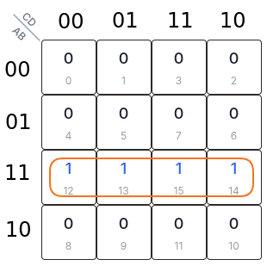

ROM_CS = A·B

To do this with nand only we can nand A, B then take the output and feed it into both inputs of another nand gate to act like an inverter, creating an AND

For RAM: CS = 0 on 1100 to 1110, All Others: CS = 1
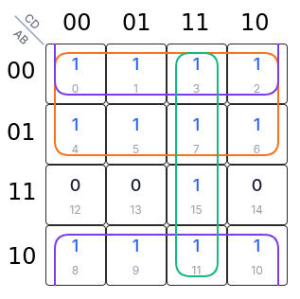
RAM_CS = A`+ B`+ CD

To do this with nand, we first apply DeMorgan’s

RAM_CS = (A·B·(C·D)’)’

(C·D)’ is the same as nand; i.e. nand(C,D)
while A·B = ROM_CS lets reuse it…

RAM_CS = (ROM_CS·(C·D)’)’ = nand(ROM_CS,nand(C,D)

ROM_CS = A[11]·A[10] RAM_CS = (ROM_CS·(A[11]·A[10])’)’
Note: 74LVC00

Propagation Delay = 4.1ns

Worst Case for 3 Gate Path
Total = 3(4.1ns) = 12.3ns
