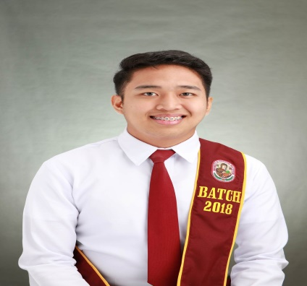

Image result for icon for seminarRelated image

*Infection Control Committee Nurse*

*San Juan De Dios Hospital – Pasay*

*+69394265129*

**Divino Emmanuel Ong, R.N., M.A.N**

*Head, College of Computer Studies*

*Olivarez College Paranaque*

826-07-50 Local(114)

*Secretary*

*Post-Office – Pasay*

*+69666845227*

**Raffy Ortega**

**Dennis Quinto**

**REFERENCE**

* Disaster Preparedness
* Personal Development
* Data Privacy Act on Social Media
* 3D Object

**SEMINARS/TRAININGS ATTENDEDED**

* Learning Support Aide (LSA)

**EXPERIENCE**

* Certificate of completion:
  + Responsive Web Design Certificate – freeCodeCamp
  + Javascript Algorithm and Data Structures Certificate – freeCodeCamp
  + Front End Libraries - freeCodeCamp
  + Javascript course completion – SoloLearn
  + SQL course completion – SoloLearn
  + Introduction to Cyber security – Cisco Network Academy

**COMMENDATIONS/AWARDS**

* HTML
* CSS, Bootstrap and SASS frameworks
* Javascript
* SQL Database
* JQuery and React frameworks

JEREMY OPRIASA

*Applicant*

*University of Perpetual Help – Las Pinas*

*2016-2018*

**Bachelor of Science in**

**Information Technology**

**Objective**

*Olivarez College Paranaque*

*2018-2020*

**Opriasa, Jeremy D.**

Passion, consistency and being productive day by day help me to reach my goal. Excited to be part of the team to build impressive project for business.

**Information, Communication and**

**Technology(ICT)**

**Camp Claudio Elementary School**

13th E. Masipag St., Sarikap Homes,

Fortunata Village, San Isidro,

Paranaque City

**CONTACT**

*Tambo, Paranaque City*

*2006-2012*

**EDUCATION**

engr.opriasa@gmail.com

+639267758198

**SKILLS**