

Software Requirements Specification

for

Project Ki

Version <1.0>

Prepared by

Group Name: The Super Saiyans

|  |  |  |
| --- | --- | --- |
| Ritta Gladchuk | <student #> | Ritta.kftw@gmail.com |
| Kyle Smith | <student #> | <e-mail> |
| <name> | <student #> | <e-mail> |
| <name> | <student #> | <e-mail> |
| <name> | <student #> | <e-mail> |

|  |  |
| --- | --- |
|  |  |
| Date: | 11/06/2020 |
|  |  |
|  |  |
|  |  |

Content

Revisions iii

1 Introduction 1

1.1 Document Purpose 1

1.2 Product Scope 1

1.3 Intended Audience and Document Overview 1

1.4 Definitions, Acronyms and Abbreviations 1

1.5 Document Conventions 1

1.6 References and Acknowledgments 2

2 Overall Description 3

2.1 Product Perspective 3

2.2 Product Functionality 3

2.3 Users and Characteristics 3

2.4 Operating Environment 3

2.5 Design and Implementation Constraints 4

2.6 User Documentation 4

2.7 Assumptions and Dependencies 4

3 Specific Requirements 5

3.1 External Interface Requirements 5

3.2 Functional Requirements 6

3.3 Behavior Requirements 6

4 Other Non-functional Requirements 7

4.1 Performance Requirements 7

4.2 Safety and Security Requirements 7

4.3 Software Quality Attributes 7

5 Other Requirements 8

Appendix A – Data Dictionary 9

Appendix B - Group Log 10

Revisions

| Version | Primary Author(s) | Description of Version | Date Completed |
| --- | --- | --- | --- |
| Initial SRS Version 1.0 | Ritta Gladchuk, Kyle Smith | Initial SRS for the project prior to any work being initiated. | 11/06/2020 |

# Introduction

## Document Purpose

This document goes over the specification requirements for Project Ki, it is an engineering project bill of materials (BOM) and purchase order (PO) generator. The two major functionalities of the system are data entry by the user, which adds entries to the database maintained by the system. And regular system use, in which BOMs and POs, which are filled by options selected from the system database, are generated per project. This document includes detailed information on what data is to be collected from the user for the database entries as well as what interactions the user should be able to have with the system during regular operation.

## Product Scope

The product will allow the user to generate POs and BOMs for engineering projects using a list of components, suppliers, and manufacturers. This will save a lot of time as this information is often shared from project to project (for example same supplier, using some of the same components, etc.) It’s convenient to be able to fill out paperwork from a database of this information and will reduce potential for effort, since the user will not have to manually enter this information for every project that requires a BOM or PO.

## Intended Audience and Document Overview

The intended audience for this document include the user and the professor.

The user of this document is intended to be a person starting working on an engineering project. The user will want to know the general layout of the software and how to interact with it. It is recommended that they proceed to section 1.4 for a brief overview of the pertinent definitions and abbreviations used throughout this document and then move on to section 2.1 to read the product perspective and view the system overview diagram provided in that section. Finally, they will find section 3.3 useful for a general understanding of how the system is used.

The professor can also benefit by reading the same sections, perhaps also including [sections that will help him understand the work put in on the project, not just how to use it.]

## Definitions, Acronyms and Abbreviations

**BOM:** Bill of Materials, a list of all materials/parts required for a project.

**PO:** Purchase Order, a list of parts to be purchased from a specific supplier.

**Project Ki:** The project management software described by this document.

## Document Conventions

IEEE Formatting requirements are followed: Arial font size 11, single spaced, 1” margins. Section and subsection titles as seen in the SRS Template provided by WSU Vancouver.

## References and Acknowledgments

<List any other documents or Web addresses to which this SRS refers. These may include user interface style guides, contracts, standards, system requirements specifications, use case documents, or a vision and scope document.

TO DO: Use the standard IEEE citation guide (attached) for this section.>

# Overall Description

## Product Perspective

The Project Ki is a self-contained product. It will enable the user to store information about manufacturers, suppliers, and parts. Then to select parts and suppliers from this database of information to generate a BOM for the project and issue POs for the necessary parts.

The first and primary functionality of the product is as a database. The user will be able to enter and edit data in the database. There will be three primary databanks, parts, suppliers, and BOMS. Whenever a new supplier becomes available to the company, the supplier information (linked to which parts they provide) will be entered into the database. Parts can also be entered individually and lists of each (suppliers or parts) can be browsed. Finally, upon the creation and saving of a new BOM, it will be added to the database of BOMs for future reference.

The primary use of the product will be to generate BOMs and POs from these databases per project. The user will start a new project and then enter basic information about it. Next the user will select parts necessary for the project along with quantities and which supplier will be used. Finally, the project will be saved and the BOM and POs can be generated.

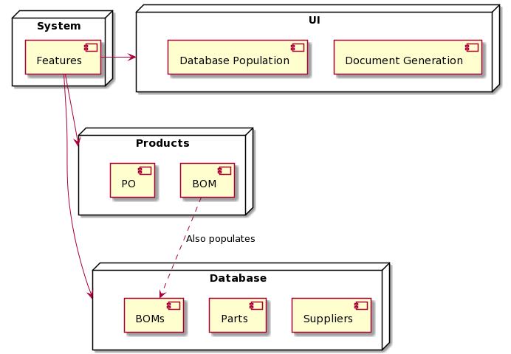

## Product Functionality

* From landing page, allow user to create a new project
* Take project information from user (title, company project is for, date, etc.)
* Allow user to add parts from list
* Select quantity of parts and supplier if more than one supplier carried the part
* Save this list of parts and project information to the BOM database
* Generate BOM document with project information
* Generate individual POs per supplier for all parts with project information

## Users and Characteristics

The primary intended user of Project Ki is an engineer, drafter, technician, or any other member of a small technical team managing the parts and pieces of an engineering project. Most likely, these primary users would include mechanical, electrical, process control and project engineers and their managers. From the software's perspective, there is only one user-type, as there are no functions of the software that need to be different from one user to the next.

In practice, different users may be responsible for different tasks in using the software. For example, a management or accounting person may have the responsibility of populating the vendor and supplier database tables, an electrical drafter may then generate a Bill of Materials for their current project, and then a purchasing manager may generate and distribute the Purchase Orders. The tool is generally used to generate business and logistics documents, so the secondary user is the recipient of the generated documentation.

- The recipients of Bills of Materials are intended to include:

* Engineers and drafters responsible for reviewing the final parts lists against project drawings.
* Project managers responsible for approving expenditures.
* Shipping and receiving staff to check-list project shelving.

- The recipients of the Purchase Orders are expected to be:

* Internal purchasing agents and departments.
* External suppliers/vendors.

## Operating Environment

Project Ki is intended to reside within a small internal company network as a tool which is quickly accessible to employees onsite in the same subnet. Much of the engineering and manufacturing world is dominated by Microsoft, so it is most likely that this tool would be hosted on a network attached Windows box:

* The operating system should be Microsoft Server 2003 or higher.
* At least Dual Core 3.6 MHz CPU.
* At least 1 gigabyte of storage.
  + Microsoft Access is limited to a 1 gigabyte database size and Project Ki is a potential Access alternative, so requires a 1 gigabyte minimum to match.
* 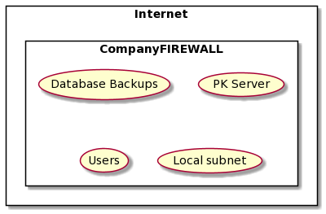Local installation of Microsoft SQL Server.

## Design and Implementation Constraints

**Developer Inexperience:** The largest constraint on this project is the general inexperience of the development team.

**Time Limitation:** The second largest constraint on the project is designing to fit development time within the latter half of one semester.

**Programming Language Constraint:** The class project requires Project Ki to be a website built on HTML, CSS, and JavaScript.

## User Documentation

The user documentation for Project Ki consists of three parts:

* 1. The primary documentation will be the landing page of the website, which will have an embedded mini-guide on how to use the system.
  2. The secondary documentation will be tooltips populated for every pushbutton and static page element.
  3. The third and most detailed documentation will be the software user manual. This manual will provide screenshots of each page and an enumerated description pointing to each element on that page. The manual will also detail the valid values for each user entry and a description for each system error that can occur.

## Assumptions and Dependencies

**Assumptions:**

- Each BOM can only select one price per unique part, even with multiple of the same part.

- Each unique part is made by only one manufacturer.

- Manufacturers do not duplicate their own part numbers.

- Each supplier has only one relevant contact and address.

- Each purchase order is generated from only one BOM.

- Each purchase order is for only one supplier.

- Each supplier requires one purchase order per BOM.

**Dependencies:**

- Users have web-browsers capable of interacting with javascript, html, and css.

- Microsoft SQL Server will host a database to interact with.

# Specific Requirements

## External Interface Requirements

### User Interfaces

The user interface for Project Ki consists of four pages. At the top of each of these pages will be navigation buttons to the other three.

* **Landing Page**

The landing page will present a mini-tutorial in a central window with buttons on either side for scrolling through the tutorial graphics.

* **Suppliers Entry**

The suppliers entry page will be split into two halves. The top half will display the currently selected supplier, or an empty entry, with the following editable fields either populated or blank:

* + Supplier ID
  + Supplier Name
  + Supplier Abbreviation
  + Account Number
  + Contact Name
  + Contact Title
  + Address
  + City
  + State
  + Postal Code
  + Phone Number
  + Notes

Below the editable fields, there will be pushbuttons for Accepting, Cancelling, Previous Entry, Next Entry, and New Entry. Lastly, the bottom half of the page will display a sortable tabulated list of existing supplier entries which can be selected from. When an entry is selected, it is pulled up into the top half of the screen for editing.

* **Parts Entry**

The parts entry page will be very similar to the suppliers entry page. The top half will display the currently selected part, or an empty entry. For each part, the editable fields are:

* + Part ID
  + Part Number
  + Description
  + Manufacturer
  + Supplier and Supplier Unit Price

Each part can have multiple suppliers, so additional Supplier and Price fields are generated as needed. Again below the editable fields there will be pushbuttons for Accepting, Cancelling, Previous Entry, Next Entry, and New Entry. The bottome half will display a sortable tabulated list of existing part entries, which can also be selected from for editing.

* **Project Page**

The project page is where parts are collected into a Bill of Materials. The page initially starts blank with a prompt and buttons for either selecting an exisiting BOM project or starting a new one. After making a selection, either an existing BOM is populated on screen or a blank one is started. Once a project is open, the page will have three main sections. At the top section are editable data fields that apply to the project as a whole:

* + BOM ID
  + Job Number
  + Date
  + Customer Name
  + Project Name
  + BOM Description

Also in the top section will be two pushbuttons, one for generating a BOM document and one for generating a Purchase Order document.

The second section of the project page is an interactive area for adding parts to the BOM. The first field is a searchable drop-down selection from the parts list, ordered by manufacturer and then by part number. After selecting a part, the second field will show a drop-down selection of possible suppliers for that part. After selecting both the part number and then supplier, a final field will display a quantity to add, next to a pushbutton to accept the entry.

The third section of the project page is a sortable list of all parts already added to the BOM. Next to each part is a button for deleting the part and a button for editing the part, which will cause its details to automatically populate the second page section for adding parts. Each part entry on the BOM page will show its associated:

- Part Number

- Part Description

- Manufacturer

- Supplier

- Quantity

- Unit Price

- Line Total

### Hardware Interfaces

The anticipated hardware for using Project Ki is just a basic monitor, keyboard, and mouse peripheral setup on any website-capable computer. Even though many other devices including cell phones and tablets can access an internet browser to reach the Project Ki webpage, the data-entry nature of Project Ki strongly suggests using a keyboard. A separate mobile-ready webpage will not be created. The Project Ki website application and database will be on the same network as user-accessible computers.

### Software Interfaces

The Project Ki program will need to interface with a database for storing project data. Interaction with the database will be with SQL commands, specifically transact-SQL for Microsoft SQL Server. Web-browsers used to access Project Ki will probably be limited to Windows installations of either Edge, Chrome, or Firefox.

### Communications Interfaces

Because Project Ki is intended to be contained within a trusted network, basic Ethernet/IP connectivity over HTTP to a static IP address should suffice.

## Functional Requirements

**Project Creation:**

* Landing page will allow the user to either open an existing project or to create a new project. Once a project is open, it can be edited. This will include:

1. Entering and editing project information such as which company the project is for, the date, the project name, etc.
2. Selecting parts and suppliers: This will include selecting parts from a dropdown menu and specifying the quantity of parts needed for the project.
3. Saving the project: The project will be saved by the system as a current project for later editing and use.

**Database Population:**

* The user is able to add parts and suppliers to the database as they become available. This will make them available for selection in the project creation/edit page. The software will retain these databases and their entries between projects.

**Document Generation:**

* Once the project is created and saved the BOM and POs can be generated. The system will use the project information to generate a BOM document which will include the project information, all the parts needed for the project and their quantities, and the suppliers of these parts.
* Next the POs can be generated. The number of POs generated will depend on the number of unique parts suppliers for the project. One PO per individual supplier will be generated. The PO will also include pertinent project information as well as which parts are to be purchased and how many of each.
* Once a BOM is generated, it will be saved to a BOM database for future reference and retrieval.

## Behavior Requirements

### Use Case View The typical user for this software is an engineer or project manager working on a project. The user will generally interact with the software in three ways. One, is to open and existing project for editing and two is to start a new project entry. Both of these lead to the user editing the project which can include selecting parts, selecting suppliers, selecting quantities or changing any of these values on an existing project. From the project view the user can also save the project and generate BOMs and POs. The third way in which the user will interact with the project is by editing the database of parts and suppliers. When new part and/or supplier information becomes available, it can be added to the database, expanding the functionality of the product.

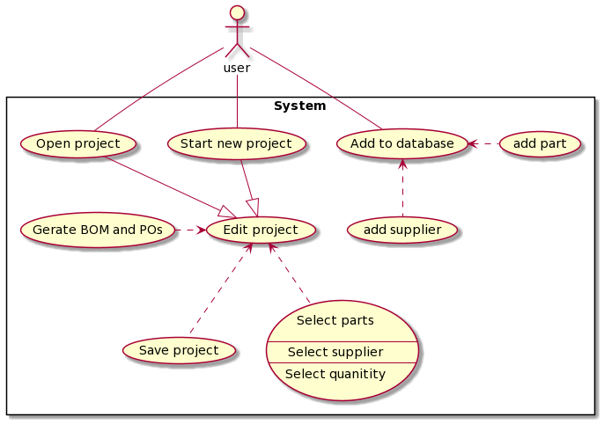

# Other Non-functional Requirements

## Performance Requirements

- Project Ki would ideally be a drop-in replacement for similar custom Microsoft Access applications, and because Access is just a local application and database, it feels very snappy relative to internet webpages.

- Local hosting of the Project Ki database server will allow for nearly-as-fast interaction.

## Safety and Security Requirements

Project Ki does not carry implications for possible loss, damage, or harm. However, it would be best administrative practice to automatically save a backup of the database every work day and save a copy of any issued BOMs and POs in order to maintain a record.

Once populated, the Project Ki database will likely contain sensitive business information, ranging from privately negotiated vendor prices to engineering designs protected by Non-Disclosure Agreements. For the purposes of demo, Project Ki will be hosted on a public domain website, but end-user installation of the software is expected to be restricted to an existing local subnet whose security is already maintained by an administrator and hidden behind firewall. The software itself does not provide additional security measures.

## Software Quality Attributes

**Lean Design:** Project Ki consists of only a handful of pages, but each page should have links to every other page, and those links should be supplemented with a paired shortcut key.

**Flexible Quantities and Prices:**

-All quantities fields need to able to handle fractional amounts (for example 3.25 is a valid number to specify quantity of 10' cable lengths.)

- All prices fields need to be able to handle fractional pennies (for example $0.015 is a valid price for individual terminal separators)

**Printable Deliverables:**

- Generated PO's and BOM's must format to print nicely on 8.5" by 11" standard printer paper as well as 11" by 17" drawing paper.

Appendix A – Data Dictionary

*<Data dictionary is used to track all the different variables, states and functional requirements that you described in your document. Make sure to include the complete list of all constants, state variables (and their possible states), inputs and outputs in a table. In the table, include the description of these items as well as all related operations and requirements.>*

|  |  |
| --- | --- |
|  |  |
|  |  |
|  |  |
|  |  |
|  |  |
|  |  |
|  |  |
|  |  |

Appendix B - Group Log

<Please include here all the minutes from your group meetings, your group activities, and any other relevant information that will assist the Teaching Assistant to determine the effort put forth to produce this document>