

Software Requirements Specification

for

The Project Ki

Version <1.0>

Prepared by

Group Name: The Super Saiyans

|  |  |  |
| --- | --- | --- |
| Ritta Gladchuk | <student #> | Ritta.kftw@gmail.com |
| Kyle Smith | <student #> | <e-mail> |
| <name> | <student #> | <e-mail> |
| <name> | <student #> | <e-mail> |
| <name> | <student #> | <e-mail> |

|  |  |
| --- | --- |
|  |  |
| Date: | 11/06/2020 |
|  |  |
|  |  |
|  |  |

Content

Revisions iii

1 Introduction 1

1.1 Document Purpose 1

1.2 Product Scope 1

1.3 Intended Audience and Document Overview 1

1.4 Definitions, Acronyms and Abbreviations 1

1.5 Document Conventions 1

1.6 References and Acknowledgments 2

2 Overall Description 3

2.1 Product Perspective 3

2.2 Product Functionality 3

2.3 Users and Characteristics 3

2.4 Operating Environment 3

2.5 Design and Implementation Constraints 4

2.6 User Documentation 4

2.7 Assumptions and Dependencies 4

3 Specific Requirements 5

3.1 External Interface Requirements 5

3.2 Functional Requirements 6

3.3 Behavior Requirements 6

4 Other Non-functional Requirements 7

4.1 Performance Requirements 7

4.2 Safety and Security Requirements 7

4.3 Software Quality Attributes 7

5 Other Requirements 8

Appendix A – Data Dictionary 9

Appendix B - Group Log 10

Revisions

| Version | Primary Author(s) | Description of Version | Date Completed |
| --- | --- | --- | --- |
| Initial SRS Version 1.0 | Ritta Gladchuk, Kyle Smith | Initial SRS for the project prior to any work being initiated. | 11/06/2020 |

# *<In this template you will find text bounded by the “<>” symbols. This text appears in italics and is intended to provide explanations and guide you through the document. There are two types of comments in this document. The comments that are in black are intended specifically for the course. The comments that are in blue are more general and apply to any SRS. Please make sure to delete all of the comments before submitting the documen**t.**>*

# Introduction

*<TO DO: Please provide a brief introduction to your project and a brief overview of what the reader will find in this section.> This document covers the specification requirements for the Project Ki web application including all its functionalities and features.*

## Document Purpose

<Identify the product whose software requirements are specified in this document, including the revision or release number. Describe the scope of the product that is covered by this SRS, particularly if this SRS describes only part of the system or a single subsystem.

TO DO: Write 1-2 paragraphs describing the purpose of this document as explained above.>

This document goes over the specification requirements for Project Ki, it is an engineering project bill of materials (BOM) and purchase order (PO) generator. The two major functionalities of the system are data entry by the user, which adds entries to the database maintained by the system. And regular system use, in which BOMs and POs, which are filled by options selected from the system database, are generated per project. This document includes detailed information on what data is to be collected from the user for the database entries as well as what interactions the user should be able to have with the system during regular operation.

## Product Scope

<Provide a short description of the software being specified and its purpose, including relevant benefits, objectives, and goals.

TO DO: 1-2 paragraphs describing the scope of the product. Make sure to describe the benefits associated with the product.>

The product will allow the user to generate POs and BOMs for engineering projects using a list of components, suppliers, and manufacturers. This will save a lot of time as this information is often shared from project to project (for example same supplier, using some of the same components, etc.) It’s convenient to be able to fill out paperwork from a database of this information and will reduce potential for effort, since the user will not have to manually enter this information for every project that requires a BOM or PO.

## Intended Audience and Document Overview

<Describe the different types of reader that the document is intended for, such as developers, project managers, marketing staff, users, testers, and documentation writers (In your case it would probably be the “client” and the professor). Describe what the rest of this SRS contains and how it is organized. Suggest a sequence for reading the document, beginning with the overview sections and proceeding through the sections that are most pertinent to each reader type.>

The intended audience for this document include the user and the professor.

The user of this document is intended to be a person starting working on an engineering project. The user will want to know the general layout of the software and how to interact with it. It is recommended that they proceed to section 1.4 for a brief overview of the pertinent definitions and abbreviations used throughout this document and then move on to section 2.1 to read the product perspective and view the system overview diagram provided in that section. Finally, they will find section 3.3 useful for a general understanding of how the system is used.

The professor can also benefit by reading the same sections, perhaps also including [sections that will help him understand the work put in on the project, not just how to use it.]

## Definitions, Acronyms and Abbreviations

<Define all the terms necessary to properly interpret the SRS, including acronyms and abbreviations. You may wish to build a separate glossary that spans multiple projects or the entire organization, and just include terms specific to a single project in each SRS.

TO DO: Please provide a list of all abbreviations and acronyms used in this document sorted in alphabetical order.>

BOM: Bill of Materials, a list of all materials/parts required for a project.

PO: Purchase Order, a list of parts to be purchased from a specific supplier.

Project Ki: The project management software described by this document.

## Document Conventions

<In general this document follows the IEEE formatting requirements. Use Arial font size 11, or 12 throughout the document for text. Use italics for comments. Document text should be single spaced and maintain the 1” margins found in this template. For Section and Subsection titles please follow the template.

TO DO: Describe any standards or typographical conventions that were followed when writing this SRS, such as fonts or highlighting that have special significance. Sometimes, it is useful to divide this section to several sections, e.g., Formatting Conventions, Naming Conventions, etc.>

## References and Acknowledgments

<List any other documents or Web addresses to which this SRS refers. These may include user interface style guides, contracts, standards, system requirements specifications, use case documents, or a vision and scope document.

TO DO: Use the standard IEEE citation guide (attached) for this section.>

# Overall Description

## Product Perspective

<Describe the context and origin of the product being specified in this SRS. For example, state whether this product is a follow-on member of a product family, a replacement for certain existing systems, or a new, self-contained product. If the SRS defines a component of a larger system, relate the requirements of the larger system to the functionality of this software and identify interfaces between the two. In this part, make sure to include a simple diagram that shows the major components of the overall system, subsystem interconnections, and external interface. In this section it is crucial that you will be creative and provide as much information as possible.

TO DO: Provide at least one paragraph describing product perspective. Provide a general diagram that will illustrate how your product interacts with the environment and in what context it is being used, i.e., context diagram.>

The Project Ki is a self-contained product. It will enable the user to store information about manufacturers, suppliers, and parts. Then to select parts and suppliers from this database of information to generate a BOM for the project and issue POs for the necessary parts.

The first and primary functionality of the product is as a database. The user will be able to enter and edit data in the database. There will be three primary databanks, parts, suppliers, and BOMS. Whenever a new supplier becomes available to the company, the supplier information (linked to which parts they provide) will be entered into the database. Parts can also be entered individually and lists of each (suppliers or parts) can be browsed. Finally, upon the creation and saving of a new BOM, it will be added to the database of BOMs for future reference.

The primary use of the product will be to generate BOMs and POs from these databases per project. The user will start a new project and then enter basic information about it. Next the user will select parts necessary for the project along with quantities and which supplier will be used. Finally, the project will be saved and the BOM and POs can be generated.

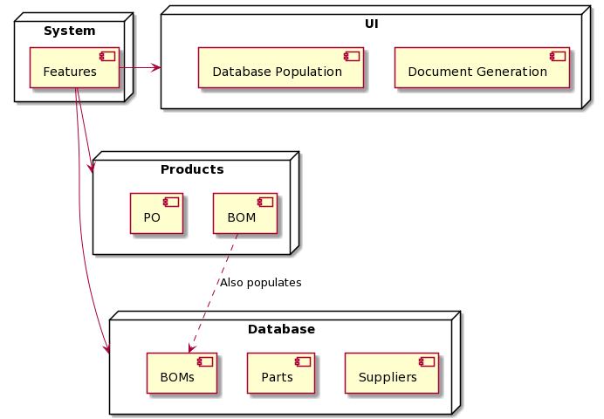

## Product Functionality

<Summarize the major functions the product must perform or must let the user perform. Details will be provided in Section 3, so only a high level summary is needed here. Organize the functions to make them understandable to any reader of the SRS. A picture of the major groups of related requirements and how they relate, such as a top level data flow diagram or object class diagram, will be effective.

TO DO:

1. Provide a bulleted list of all the major functions of the system

2. **(Optional)** Provide a Data Flow Diagram of the system to show how these functions relate to each other. This is useful when there is a clear sequence for the functions being performed.>

* From landing page, allow user to create a new project
* Take project information from user (title, company project is for, date, etc.)
* Allow user to add parts from list
* Select quantity of parts and supplier if more than one supplier carried the part
* Save this list of parts and project information to the BOM database
* Generate BOM document with project information
* Generate individual POs per supplier for all parts with project information

## Users and Characteristics

<Identify the various users that you anticipate will use this product. Users may be differentiated based on frequency of use, subset of product functions used, technical expertise, security or privilege levels, educational level, or experience.

TO DO:

1. Describe the pertinent characteristics of each user. Certain requirements may pertain only to certain users.

3. Distinguish the most important users for this product from those who are less important to satisfy.>

## Operating Environment

<Describe the environment in which the software will operate, including the hardware platform, operating system and versions, and any other software components or applications with which it must peacefully coexist. In this part, make sure to include a simple diagram that shows the major components of the overall system, subsystem interconnections, and external interface

TO DO: As stated above, in at least one paragraph, describe the environment your system will have to operate in. Make sure to include the minimum platform requirements for your system. >

## Design and Implementation Constraints

<Describe any items or issues that will limit the options available to the developers. These might include: hardware limitations (timing requirements, memory requirements); interfaces to other applications; specific technologies, tools, and databases to be used; parallel operations; language requirements; communications protocols; security considerations; design conventions or programming standards (for example, if the customer’s organization will be responsible for maintaining the delivered software).

TO DO: In this section you need to consider all of the information you gathered so far, analyze it and correctly identify relevant constraints.>

## User Documentation

<List the user documentation components (such as user manuals, on-line help, and tutorials) that will be delivered along with the software. Identify any known user documentation delivery formats or standards.

TO DO: You will not actually develop any user-manuals, but you need to describe what kind of manuals and what kind of help is needed for the software you will be developing. One paragraph should be sufficient for this section.>

## Assumptions and Dependencies

<List any assumed factors (as opposed to known facts) that could affect the requirements stated in the SRS. These could include third-party or commercial components that you plan to use, issues around the development or operating environment, or constraints. The project could be affected if these assumptions are incorrect, are not shared, or change. Also identify any dependencies the project has on external factors, such as software components that you intend to reuse from another project.

TO DO: Provide a short list of some major assumptions that might significantly affect your design. For example, you can assume that your client will have 1, 2 or at most 50 Automated Banking Machines. Every number has a significant effect on the design of your system.

# Specific Requirements

## External Interface Requirements

### User Interfaces

<Describe the logical characteristics of each interface between the software product and the users. This may include sample screen images, any GUI standards or product family style guides that are to be followed, screen layout constraints, standard buttons and functions (e.g., Cancel) that will appear on every screen, error message display standards, and so on. Define the software components for which a user interface is needed.

TO DO: The least you can do for this section is to describe in words the different User Interfaces and the different screens that will be available to the user. Optional: You may also provide an initial Graphical User Interface design (does not have to be final).>

### Hardware Interfaces

<Describe the logical and physical characteristics of each interface between the software product and the hardware components of the system. This may include the supported device types, the nature of the data and control interactions between the software and the hardware. You are not required to specify what protocols you will be using to communicate with the hardware, but it will be usually included in this part as well.

TO DO: Please provide a short description of the different hardware interfaces. If you will be using some special libraries to communicate with your software mention them here. In case you have more than one hardware interface divide this section into subsections.>

### Software Interfaces

<Describe the connections between this product and other specific software components (name and version), including databases, operating systems (Windows? Linux? Etc…), tools, libraries, and integrated commercial components. Identify the data items or messages coming into the system and going out and describe the purpose of each. Describe the services needed and the nature of communications. Identify data that will be shared across software components. If the data sharing mechanism must be implemented in a specific way (for example, use of a global data area in a multitasking operating system), specify this as an implementation constraint.

TO DO: The previous part illustrates some of the information you would usually include in this part of the SRS document. To make things simpler, you are only required to describe the specific interface with the operating system.>

### Communications Interfaces

<Describe the requirements associated with any communications functions required by this product, including e-mail, web browser, network server communications protocols, electronic forms, and so on. Define any pertinent message formatting. Identify any communication standards that will be used, such as FTP or HTTP. Specify any communication security or encryption issues, data transfer rates, and synchronization mechanisms.

TO DO: Do not go into too much detail, but provide 1-2 paragraphs were you will outline the major communication standards. For example, if you decide to use encryption there is no need to specify the exact encryption standards, but rather, specify the fact that the data will be encrypted and name what standards you consider using. >

## Functional Requirements

*< Functional requirements capture the intended behavior of the system. This behavior may be expressed as services, tasks or functions the system is required to perform. This section is the direct continuation of section 2.2 where you have specified the general functional requirements. Here, you should list in detail the different product functions with specific explanations regarding every function.*

*TO DO: Break the functional requirements to several functional areas and divide this section into subsections accordingly. Provide a detailed list of all product operations related to these functional areas.>*

## Behavior Requirements

### Use Case View

<A use case defines a goal-oriented set of interactions between external actors and the system under consideration.

TO DO: Provide a use case diagram which shows the entire system and all possible actors. Do not include detailed use case descriptions (these will be needed when you will be working on the Test Plan), but make sure to include a short description of what every use-case is, who are the actors in your diagram.>

*The typical user for this software is an engineer or project manager working on a new project. The user will generally interact with the software in three ways. One, is to open and existing project for editing and two is to start a new project entry. Both of these lead to the user editing the project which can include selecting parts, selecting suppliers, selecting quantities or changing any of these values on an existing project. From the project view the user can also save the project and generate BOMs and POs. The third way in which the user will interact with the project is by editing the database of parts and suppliers. When new part and/or supplier information becomes available, it can be added to the database, expanding the functionality of the product.*

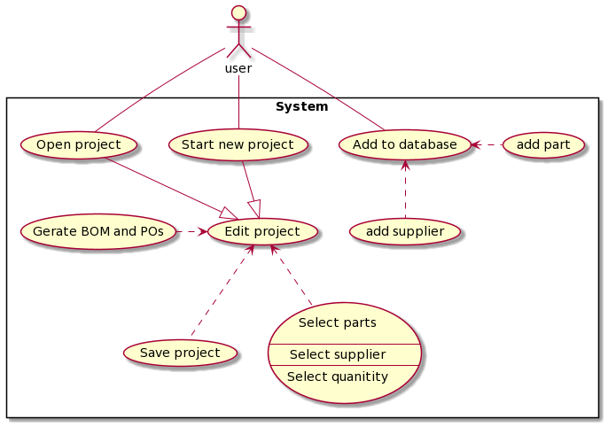

# Other Non-functional Requirements

## Performance Requirements

<If there are performance requirements for the product under various circumstances, state them here and explain their rationale, to help the developers understand the intent and make suitable design choices. Specify the timing relationships for real time systems. Make such requirements as specific as possible. You may need to state performance requirements for individual functional requirements or features.

TODO: Provide relevant performance requirements based on the information you collected from the client. For example you can say “1. Any transaction will not take more than 10 seconds, etc…>

## Safety and Security Requirements

<Specify those requirements that are concerned with possible loss, damage, or harm that could result from the use of the product. Define any safeguards or actions that must be taken, as well as actions that must be prevented. Refer to any external policies or regulations that state safety issues that affect the product’s design or use. Define any safety certifications that must be satisfied. Specify any requirements regarding security or privacy issues surrounding use of the product or protection of the data used or created by the product. Define any user identity authentication requirements.

TODO:

* Provide relevant safety requirements based on your interview with the client or, on your expectation for the product.
* Describe briefly what level of security is expected from this product by your client and provide a bulleted (or numbered) list of the major security requirements.>

## Software Quality Attributes

<Specify any additional quality characteristics for the product that will be important to either the customers or the developers. Some to consider are: adaptability, availability, correctness, flexibility, interoperability, maintainability, portability, reliability, reusability, robustness, testability, and usability. Write these to be specific, quantitative, and verifiable when possible. At the least, clarify the relative preferences for various attributes, such as ease of use over ease of learning.

TODO: Use subsections (e.g., 4.3.1 Reliability, 4.3.2 Portability, etc…) provide requirements related to the different software quality attributes. Base the information you include in these subsections on the material you have learned in the class. Make sure, that you do not just write “This software shall be maintainable…” Indicate how you plan to achieve it, etc.>

# Other Requirements

<This section is **Optional.** Define any other requirements not covered elsewhere in the SRS. This might include database requirements, internationalization requirements, legal requirements, reuse objectives for the project, and so on. Add any new sections that are pertinent to the project.>

Appendix A – Data Dictionary

*<Data dictionary is used to track all the different variables, states and functional requirements that you described in your document. Make sure to include the complete list of all constants, state variables (and their possible states), inputs and outputs in a table. In the table, include the description of these items as well as all related operations and requirements.>*

|  |  |
| --- | --- |
|  |  |
|  |  |
|  |  |
|  |  |
|  |  |
|  |  |
|  |  |
|  |  |

Appendix B - Group Log

<Please include here all the minutes from your group meetings, your group activities, and any other relevant information that will assist the Teaching Assistant to determine the effort put forth to produce this document>