**Dengue fever** is a mosquito-borne tropical disease caused by the dengue virus. Symptoms typically begin three to fourteen days after infection. This may include a high fever, headache, vomiting, muscle and joint pains, and a characteristic skin rash. Recovery generally takes less than two to seven days. In a small proportion of cases, the disease develops into the life-threatening **dengue hemorrhagic fever**, resulting in bleeding, low levels of blood platelets and blood plasma leakage, or into **dengue shock syndrome**, where dangerously low blood pressure occurs.

Dengue is spread by several species of mosquito of the *Aedes* type, principally *A. aegypti*.

 Prevention is by reducing mosquito habitat and limiting exposure to bites. This may be done by getting rid of or covering standing water and wearing clothing that covers much of the body. Treatment of acute dengue is supportive and includes giving fluid either by mouth or intravenously for mild or moderate disease. For more severe cases blood transfusion may be required. About half a million people require admission to hospital a year. Nonsteroidal anti-inflammatory drug (NSAIDs) such as ibuprofen should not be used.

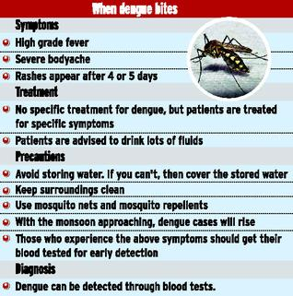

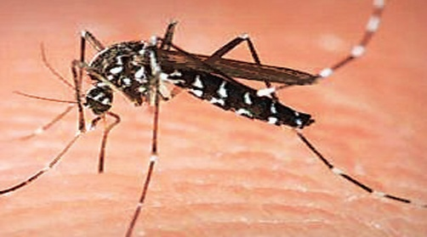

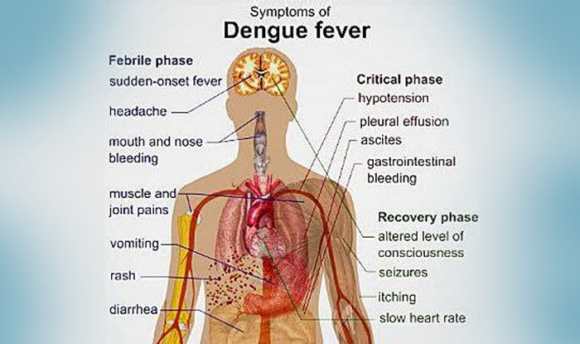

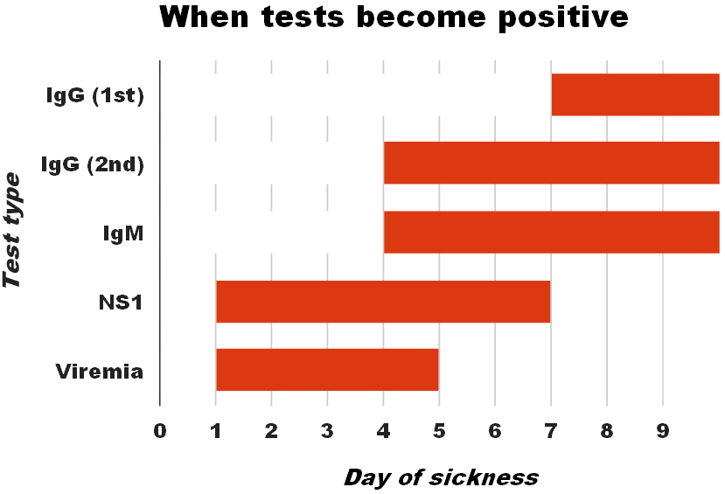

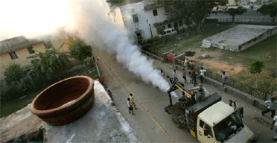

**Malaria…**

**Malaria** is a mosquito-borne infectious disease of humans and other animals caused by parasitic protozoans (a group of single-celled microorganisms) belonging to the *Plasmodium* type. Malaria causes symptoms that typically include fever, fatigue, vomiting, and headaches. In severe cases it can cause yellow skin, seizures, coma, or death. Symptoms usually begin ten to fifteen days after being bitten. If not properly treated, people may have recurrences of the disease months later, The disease is most commonly transmitted by an infected female *Anopheles* mosquito. The mosquito bite introduces the parasites from the mosquito's saliva into a person's blood. The parasites travel to the liver where they mature and reproduce. Five species of *Plasmodium* can infect and be spread by humans. Most deaths are caused by *P. falciparum* because *P. vivax*, *P. ovale*, and *P. malariae* generally cause a milder form of malaria Malaria is typically diagnosed by the microscopic examination of blood using blood films, or with antigen-based rapid diagnostic tests.

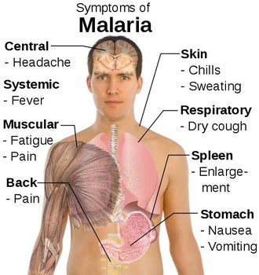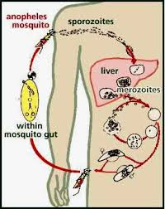

**Mosquito Control**   
Source reduction involves preventing development of mosquito larvae. The female anopheles mosquito lays eggs in collections of clean water. Each female anopheles mosquito lays millions of eggs in its lifetime of 4–8 weeks. The eggs hatch into larvae which then develop into pupae and adults in a span of 7–10 days. The best method of mosquito control is preventing the development of the eggs into adult mosquitoes. These anti larval measures are not only simple and cost effective, but also environment friendly.

