**PROPOSAL FOR ONLINE FOOD ODERING SYSTEM  
USING MYSQL AND PHP ADMIN**

**BY**

**HASSAN AMINU  
DBI/NID/CSE/KN/2019/142**

**UNDER THE SUPERVISOR  
JA’AFAR ALIYU**

**AT**

**DIGITAL BRIDGE INSTITUTE KANO COMPUS CENTER FOR EXCELLENT**

**DEPARTMENT OF COMPUTER SOFTWARE ENGINEERING {CSE}**

**ON**

**APRIL 14/2022**

# DECLARATION

I …………………………………………………………………………..

, hereby declare that everything proposed in this project proposal is based on my own knowledge and research carried out with exception to printed or electronic content and has not been submitted to any institution of learning for any academic awards.

SIGNATURE………………………………………DATE ……………………………

# APPROVAL

This project proposal has been presented for examination with my approval as the supervisor: Mr. Ja,afar Aliyu

SIGNATURE………………………………………DATE …………………………........

# DEDICATION

This project proposal is dedicated with profound admiration and appreciation to ALMIGHTY GOD for giving me strength and breathe and my beloved Father and my mother for their moral support. Great appreciation also goes to my supervisor Mr. Ja,afar Aliyu and all my Instructors, classmates and who made it a success through their constant support supervision, encouragement and moral support.

# ACKNOWLEDGEMENT

Most importantly, I sincerely thank the Almighty God for giving me strength and breathe throughout the preparation of this project proposal. I also wish to extend my sincere and heartfelt gratitude to my loving mum for the financial, moral and emotional support, my classmates and friends who helped in various ways for the successful completion of this project proposal. Finally, it is a great pleasure for me to also acknowledge the assistance and support of all the people who helped me to start and finish this project proposal successfully especially Mr. Ja’afar Aliyu who has been a great supervisor during this period. I would like to give my special thanks to Digital Bridge Institute Kano campus for giving me enough knowledge and skills that made me to innovatively and successfully research and compile this project proposal

# ABSTRACT:

A fast-food restaurant also known as quick service restaurant (QSR) within the food service industry is a specific type of restaurant characterized both by its fast-food cuisine and by minimal table service. Food served in fast food restaurants is offered from a limited menu, cooked in bulk in advance and kept hot, is finished and packaged for order and is usually available ready for pickup or to be delivered though seating may also be provided. The customers presently spend an average of 60 minutes per day going to the restaurant, selecting their meals and paying. Some restaurants have the provision of customers making a call to the restaurant in advance to order a meal to be ready for them for pick or to be delivered to them.

Some of the customers don’t always get the selection they want because the restaurants run out of certain items or because there is no provision of ordering custom meals. This project is aimed at developing a complete online ordering system for use in the foodservice industry which will allow the restaurants to quickly and easily manage an online menu which customer can browse and use to place orders with just a few clicks. The customers will have to choose whether they want the food to be delivered to them or it will be packaged for pick up and the payment method will be upon delivery or pick up. There will be a system administrator who will have the right to add and manage user accounts, a manager who will be managing product and orders and last but not least a meal deliverer who will be dealing specifically with pending deliveries. The customer will be in a position to view the products, register and place an order. There will be a confirmation receipt for each and every order made by the customer which can be printed. The development of this system will be based on SDLC with PHP and HTML as the programming languages while MySQL server as the database of the system. HTML language is advantageous due to its easy to use and learn validation properties while MySQL has better advanced features and properties, has good security, is open source and has cross platform operability. The advantages of using PHP programming language in developing this system include:

* It is a stable open-source language development and maintained by a large group of PHP developer which a creating a support community abundant extension library.
* It's easy and quick to learn and use
* Can be run on many platforms thus easy for user to find hosting service.
* It has built-in database module which make it easy to connect to the database.

On the other hand, the disadvantage of PHP programming language is security since it's open source, so people see the source and if there are bugs in the source code, it can be used by people to explore the weakness of PHP.

# TABLE CONTENT

Contents

DECLARATION 2

APPROVAL 3

DEDICATION 4

ACKNOWLEDGEMENT 5

ABSTRACT: 6

TABLE CONTENT 8

CHAPTER ONE 9

1.0: INTRODUCTION 9

1.1 Problem statement 10

1.2.1 Objectives 10

1.2.2 Specific objectives 10

1.3 Justification 11

1.4 Project scope 11

**1.5 Limitation of the system** 12

CHEPTER TWO 13

2.0: LITERATURE REVIEW 13

CHAPTER THREE 13

3.0: METHODOLOGY 13

CHAPTER FOUR 15

4.0: OVERALL DESCRIPTION 15

4.1 weaknesses of the current system 15

4.2 merits of the proposed system 15

4.3 Feasibility study 15

4.3.1 technical feasibility 16

4.3.2 operational feasibility 16

4.3.3 Economic feasibility 17

CHAPTER FIVE 19

5.0: ANALYSIS AND DESIGN 19

5.1 context diagram 19

**5.2 DATA FLOW DIAGRAM** 20

5.3 user requirements 21

5.3.1 functional requirements 22

**5.3.2 non-functional requirements** 22

5.3.3 system requirements 23

5.3.4 software requirements 23

CONCLUSION 24

REFRENCE 25

# **CHAPTER ONE**

# 1.0: INTRODUCTION

The online food ordering system is one of the latest servicers most fast-food restaurants in the western world are adopting. With this method, food is ordered online and delivered to the customer. So, the system designed in this project will enable customers go online and place order for their food. Due to the great increase in the awareness of internet and the technologies associated with it, several opportunities are coming up on the web. So many businesses and companies now venture into their business with ease because of the internet. One of such business that the internet introduced is an online food ordering system. In today’s age of fast food and take out, many restaurants have chosen to focus on quick preparation and speedy delivery of orders rather than offering a rich dining experience. Until recently, most of this delivery orders were placed over the phone, but there are many disadvantages to this system. It is possible for anybody to order any goods via the internet and have the goods delivered at his/her doorsteps. But while trying to discuss the transfer method of the goods and services, attention is focused on the payment mode. In other words, how possible is it to pay for goods and services via the internet? This then leads to the discussion of the economic consequences of digital cash. What are the implementations from the view point of economic? Since the world is fast becoming a global village, the necessary tool for this process is communication of which telecommunication is a key player. A major breakthrough is the wireless 2 telephone system which comes in either fixed wireless telephone lines or the Global System of Mobile communication (GSM). What I propose is an online ordering system originally designed for use in college cafeterias, but just as applicable in any food delivery industry. The main advantage of this system is that it greatly simplifies the ordering process for both the customer and the restaurant. The system also greatly lightens the load on the restaurants end, as the entire process of taking orders is automated. Once an order is placed on the webpage that will be designed, it is placed into the database and then retrieved, in pretty much real-time, by a desktop application on the restaurants end. Within this application, all items in the order are displayed, along with their corresponding options and delivery details, in a concise and easy to read manner. This allows the restaurant employees to quickly go through the orders as they are placed and produce the necessary items with minimal delay and confusion. The greatest advantage of this system is its FLEXIBILITY.

# 1.1 Problem statement

The challenges encountered by the existing system serve as a major drawback to the realization of efficiency and customer satisfaction. The experience of ordering in most fast-food restaurants is not pleasant for the customers. Customers will have to make long queues before placing their orders especially during peak hours and then the ordering staff will record customer orders. Having placed their order, the customer must then wait near the counter until their order is ready for collection. The other problem in the food service industry is that restaurants are not realizing the efficiencies that would result from better application of technology in their daily operations. Fast food business in a very competitive business and one way to stand out from competitors is through improving the business process where business process automation can assist business improvement. The other problem with the current system is that the customers are not able to see the ingredients of the meals before they place their order and also, they only have to pay for an order online.

# 1.2.1 Objectives

* Increase efficiency and improve services provided to the customers through better application of technology in daily operations.
* be able to stand out from competitors in the food service industry1.2.2

# 1.2.2 Specific objectives

1. To enable customers to order custom meals that aren’t in the menu
2. To enable customers to have a visual confirmation that the order was placed correctly
3. To enable customers to know food ingredients before ordering
4. To reduce restaurant’s food wastage
5. To ensure correct placement of orders through visual confirmation
6. Improve efficiency of restaurant’s staff
7. Eliminate paper work and increase level of accuracy
8. Increase speed of service, sales volume and customer satisfaction.

# 1.3 Justification

* To increase efficiency by shortening the purchasing time and eliminating paper work like receipts through online transaction
* To be able to stand out from competitors by automating daily operations which will give food service providers the opportunity to increase sales
* To reduce restaurants food wastage and increasing efficiency of the restaurants staff by enabling the restaurants staff to know what food items the customers wanting advance.
* increase customer satisfaction by speeding up food delivery
* To reduce time wasting by eliminating long queues

# 1.4 Project scope

Online ordering system will be a web-based application whose main language of programming will be PHP. Its main aim is to simplify and improve the efficiency of the ordering process for both customer and restaurant, minimize manual data entry and ensure data accuracy and security during order placement process. Customers will also be able to view product menu sand their ingredients and be able to have a visual confirmation that the order was place correctly.1.5

# 

# **1.5 Limitation of the system**

* Internet connection and also the user must be computer literate.
* Set back of the system is that the customers targeted are adults with access to computer systems while the minors might have to go physically to the restaurant to purchase the food that they want or order food the food with the help of an adult.
* Other limitation is that the system will only be convenient to people with a small geographical region, basically just around the restaurant i.e., can only help a small area.

# **CHEPTER TWO**

# 2.0: LITERATURE REVIEW

An ordering system is referred to as a set of detail methods that is being used in handling the ordering process. Food ordering can be computerized or done manually. Those help customer to order their food themselves which is known as the customer self-ordering system.

The customer self-ordering system can be defined as a computerized system that is being used by customer to place their own orders in the restaurant and allow the order to be tracked. In order to prepare and deliver the food to the computers.

# 

# **CHAPTER THREE**

# 3.0: METHODOLOGY

Research methodology has many research dimension and methods. The scope of research methodology is wider than research method. This is mainly adopted by the researcher in undertaking this research. Methodology is the underlying principles and that govern a system method, on the other hand it’s a systematic procedure for a set of activities. Thus, from this definition a methodology encompasses the method used within a study.

A waterfall model under the software development life cycle (SDLC) is the methodology used to procedure the online food ordering system and the customer self-ordering system. It is used by system developers to produce or alter information system or software.

It divides the development process in to several stage or processes. After the completion of one stage, it will logically move to another stage. Sometimes moving back to the previous stage is necessary due to failure that occurs in current stages.

System design method are a discipline within the software development industry which seek to provide a framework for activity and the capture, storage, transformation and dissemination of information so as to enable the economic development of computer system that are fit purpose.

# **CHAPTER FOUR**

# 4.0: OVERALL DESCRIPTION

# 4.1 weaknesses of the current system

* Inconvenience of customer needing to have a physical copy of the menu
* Time consuming
* Lack of visual confirmation that the order was placed correctly
* Necessity for restaurant to have an employee answering the phone and taking orders
* in tracking customers past history
* Manual work and consumes large volumes of data
* Lack of data security4.2

# 4.2 merits of the proposed system

* Security of data. Data are well protected for personal use.
* data accuracy during order placement process
* Minimized manual data entry
* Greater efficiency since data processing is very fast
* User friendly and interactive interface with provision for customer to view menu sand have a visual confirmation that the order was place correctly.
* time requirement during the order placement process
* Greatly simplifies the ordering process for both customer and restaurant.4.3

# 4.3 Feasibility study

This is an evaluation and analysis of the potential of the proposed project which is based on extensive investigation and research to support the process of decision making. [1] It assesses the operational, technical and economic merits of the proposed project. The feasibility study is intended to be a preliminary review of the facts to see if it is worthy of proceeding to the analysis phase. From the systems analyst perspective, the feasibility analysis is the primary tool for recommending whether to proceed to the next phase or to discontinue the project.

# 4.3.1 technical feasibility

This assessment is focused on gaining an understanding of the present technical resources of the organization and their applicability to the expected needs of the proposed system. Evaluation of the hardware and software and how it meets the needs of the proposed system. The systems project is considered technically feasible if the internal technical capability is sufficient to support the project requirements. The essential questions that help in testing the technical feasibility of a system include the following:

* Is the project feasible within the limits of current technology?
* Does the technology exist at all?
* Is it available within given resource constraints?
* Is it a practical proposition?
* Is there enough manpower- programmers, testers & debuggers?
* Do the required software and hardware exist?
* Are the current technical resources sufficient for the new system?
* Can they be upgraded to provide the level of technology necessary for the new system?
* Do we possess the necessary technical expertise, and is the schedule reasonable?
* Can the technology be easily applied to current problems?
* Does the technology have the capacity to handle the solution?
* Do we currently possess the necessary technology?

# 4.3.2 operational feasibility

Operational feasibility is the measure of how well the project will support the customer and the service provider during the operational phase.

It is dependent on human resources available for the project and involves projecting whether the system will be used if it is developed and implemented.

The essential questions that help in testing the technical feasibility of a system include the following:

* Is the project feasible to operate or not?
* Does current mode of operation provide adequate throughput and response time?
* Could there be a reduction in cost and or an increase in benefits?
* Does current mode of operation offer effective controls to protect against fraud and to guarantee accuracy and security of data and information?
* Does current mode of operation make maximum use of available resources, including people, time, and flow of forms?
* Are the current work practices and procedures adequate to support the new system?
* If the system is developed, will it be used?
* Does it agree with the government regulations?
* Will the proposed system really benefit the organization?
* Will the system affect the customers in considerable way?
* Do the end-users feel about their role in the new system?
* How will the working environment of the end-user change?4.3.3

# 4.3.3 Economic feasibility

This assessment aims to determine the positive economic benefits to the organization that

The proposed system will provide. It typically involves a cost/ benefits analysis and it’s the most

Frequently used method for evaluating the effectiveness of a new proposed system. Possible questions raised in economic analysis are:

* Is the system cost effective?
* Do benefits outweigh costs?
* The cost of doing full system study
* The cost of business employee time
* Estimated cost of hardware
* Estimated cost of software/software development
* Is the project possible, given the resource constraints?
* What are the savings that will result from the system?
* Cost of employees' time for study
* Cost of packaged software/software development
* Selection among alternative financing arrangements (rent/lease/purchase)

# **CHAPTER FIVE**

# 5.0: ANALYSIS AND DESIGN

Development of computerized systems requires analysis of the process to be digitized in order to enable a correct system, a system that functions as required and to assist the potential users of the system understand the general functionality of the system. The analysis specifies the system's objectives and constraints to which designers have to comply. The purpose of doing

Analysis is to transform the system’s major inputs into structured specification.

# 5.1 context diagram

This is a brief structure which depicts the environment in which a software system and helps in communicating about what lies outside the system boundary.

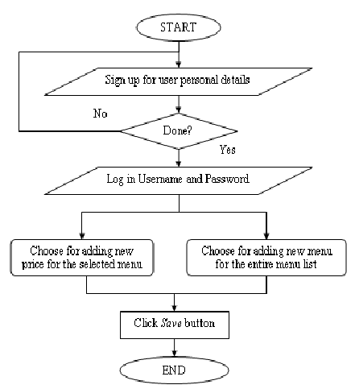

# **5.2 DATA FLOW DIAGRAM**

It is a two-dimensional diagram that explains how data is processed and transferred in a system. The graphical depiction identifies each source of data and how it interacts with other data sources to reach a common output.

Administrator module:

Functionalities provided:

* Create usernames and passwords
* View/ edit / delete user accounts

Customer module

Functionalities provided:

* View product’s list
* Register
* Place orders

21

Main Menu

About Us

Fast Food

Login

Home

Contact us

Manager module

Functionalities provided:

* Create product categories and functionalities
* Edit / delete product categories and descriptions
* View and manage orders and sales report

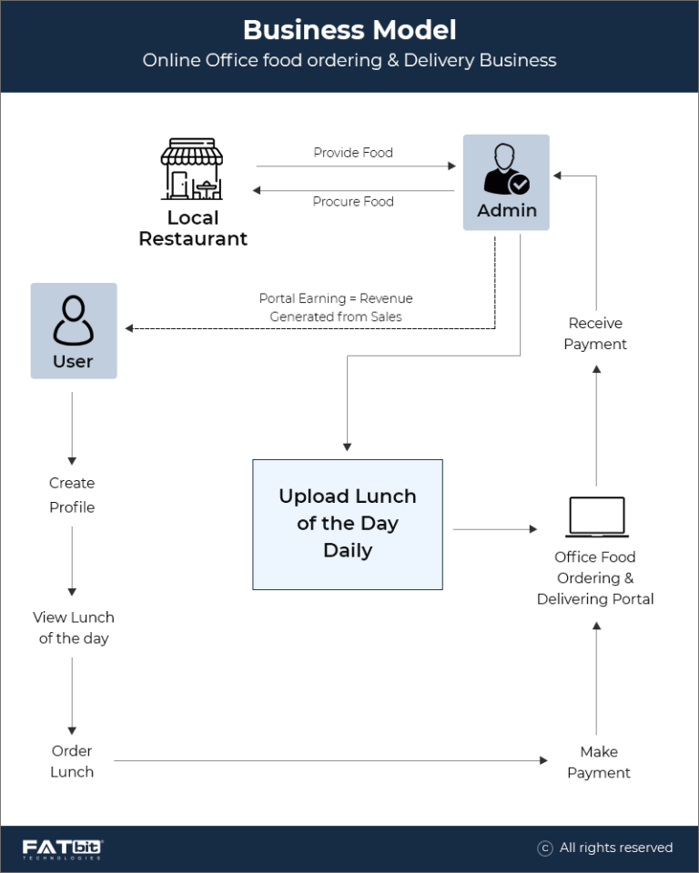

Meal delivers module

Functionalities provided:

* View pending orders and delivery details
* Confirm order deliveries

# 5.3 user requirements

The system will be designed to be user friendly. The user friendly and interactive interfaces design helps to achieve this by enabling customers to easily browse through the menus place orders with just a few clicks and also allows restaurant employees to quickly go through the orders as they are placed and produce the necessary items with minimal delay and confusion. The system will be simple to use.

# 5.3.1 functional requirements

Functional requirements define the capabilities and functions that a system must be able to perform successfully. The functional requirements of this online ordering system include:

* The system shall enable the customer to view the products menu, create an account, login to the system and place an order.
* customer shall specify whether the order is to be picked up or delivered.
* system shall display the food items ordered, the individual food item price sand the payment amount calculated.
* system shall prompt customer to confirm the meal order.
* system shall provide visual confirmation of the order place me
* The system shall enable the manager to view, create, edit and delete food category and descriptions
* The system shall allow confirmation of pending orders.
* system shall allow generation of sales report for the orders made.
* system shall allow the manager to update additional information (description, photo, ingredients etc.) for a given food item.
* system shall allow the manager to update price for a given food item.5.3.2

# 

# **5.3.2 non-functional requirements**

A non-functional requirement is a requirement that specifies criteria that can be used to judge the operation of a system, rather than specific behaviors. Some of the non-functional requirements include:

* They should be sufficient network bandwidth
* Backup- provision for data backup
* Maintainability- easy to maintain
* Performance/ response time- fast response
* Usability by target user community- easy to use
* Expandability- needs to be future proof or upgradable
* Safety- should be safe to use5.4

# 5.3.3 system requirements

Computer system is made up of units that are put together to work as one in order to achieve a common goal. The requirements for the implementation of the new system are:

* The Hardware
* The Software

# 5.3.4 software requirements

* Operating system: Windows XP / windows 7
* : My SQL
* Tool: Dreamweaver
* Antivirus software
* Backup & Data Recovery software

# 5.4.2 Hardware requirements

* Processor: Intel dual core or above
* Processor Speed:1.0GHZ or above
* RAM:1 GB RAM or above
* Hard Disk: 20 GB hard disk or above
* Printer for printing reports
* Uninterruptible power supply to ensure a constant access of data.
* flash disk (At least 2GB)

# **CONCLUSION**

The development of online food ordering system involved many phases. The approach used is a top-down one concentrating on what first, then how and moving to successive levels of details. The first phase started with a detailed study of the problems and prospects of ordering Foods, r. In the course of this study, many problems were discovered to have hindered the effectiveness of the existing manual system. These problems, information needs and activities were documented and later used as the basis for system design, which immediately followed the first phase. The design phase was concerned primarily with the specification of the system elements in manner that best met the organization’s business needs. 31 During this phase, strict adherence was made on proven software engineering principles and practices. To implement this design, a computer program was then written and tested in php My admin environment. It is hoped that effective implementation of this software product would eliminate many problems discovered during systems investigation.

# 

# **REFRENCE**

* Anderson, R.G. (1978), “Data processing and Management Information Systems” McDonald and Evans Ltd
* De Leon, E. (2008, August 23). Best Online Food Ordering System. Restaurant Checklist.
* Purname, J., & Wibowo, A.Y. (2007). Wireless Application for Ordering Management System in a Restaurant.
* Gan, C.C. (2002). Online Fast-Food Restaurant Ordering Systems.
* Hobbs, N. (2004, march 26). Restaurant Customer Ordering
* [www.academia/digital](http://www.academia/digital) food ordering system