Roboter Application

Problem Statement
We want a simple differential robot simulator.

Objectives
A small , clean, extensible simulator where robot moves, publish datas, receives commands and everything is observable, loggable and replayable.

Requirements
- A user must be able to spawn one or more robot models on the scene using GUI interface.
- The user must be able to commands the robot direction, position, orientation, and simulation process( pause, reset, step,…)
- The user must be able to visualizes on the plotting window, the results of robot’s datas(speed, position, time).
- The application must log all simulation datas in a record file and use these to review the simulation visually.
- The application must implement different options for robotics simulation as path tracing, path planning, obstacles avoidance, robots coordination.
- The user must be able to create a world and this world for simulation and mapping.
- The application loop rate must be modifiable by the user and performs in a real time like behaviour.
- The loading for simulation must follow within 5 seconds maximum.
- The application must be cross-platform.

Tools
Language: C++
Build system: Cmake, Ninja/Make
Graphics: Sfml
GUI: Tgui
physcis library: Box2D
ECS: Flecs
Plotting library: PlotGenCpp.
Version control: Git/Github.

Components

Message Bus
The communication system like a ROS topic, which:
- Enables modularity.
- Allows logging, replays visualization.
- Make the system scalable.

Simulator loop
Real time loop that thicks at a fixed frequency(10 Hz, 20 Hz, …).
- Updates robot physics
- Publishes Odometry,
- Processes commands.
- Drives the whole system.

Differential Models(Differential drive)
Simple physic models
- left / right wheels velocities.
- position updates
- orientation updates

Recorder (Single writer logging thread)
Robust login system
- logs every message.
- No corruption of data.
- replayable
- timestamped

History System
stores messages inmemory for
- debugging
- visualization
- replay

Roadmap

Phase 1: Core engine
- message bus
- simulator loop
- robot model
- logging
- history

Phase 2: Tools
- replay system
- gui log viewer
- real time plots
- simulation controls(pause, step, reset)

Phase 3: Visualization
- 2D robots view
- path tracing
- sensor visualization(laser scan, …)

Phase 4: Robotics features
- controllers
- path planning
- obstacle avoidance
- mapping
- multi robots coordination

Phase 5: Advanced
- scripting (python, lua)
- networked simulation
- plugin system
- integration with ROS.

Use Case diagram
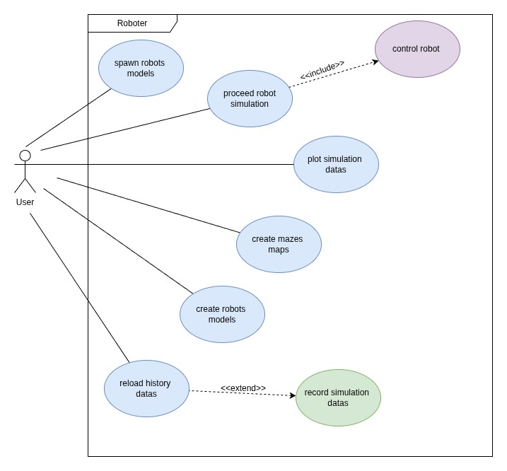
Image: use case diagram of the application

Use Case description

Spawn robot models

- Goal add one or many robot(s) model on the graphic scene.
- Summary of the use case The user choose a robot models on the catalog and enters some default parameters like name, position, orientation, step rate, then choose a given world to load in the robot model.
- Actors The application user
- Preconditions Robots models are already loaded into the catalog,
- Trigger The user use presses the “Add” button.
- Primary action sequence
- The application operates the robot parameter , the step rate and the world.
- The robot model is loaded with the given parameters on the graphic scene.
- Alternate action sequence The parameters are incorrect or out of scope
- Highlight the incorrect form field
- Display explanatory message
- The user corrects the erroneous form field.
- Return to primary sequence
- Post-condition The user sees the spawned model
- Nonfunctional requirements
- The robot must be spawned within 2 seconds.
- The application must be usable by a any user.

Proceed robot simulation
- Goal performs robots simulation .

