|  |  |
| --- | --- |
| **Name** | Engy Ayman Hanfy |
| **B.N** | 223 |
| **Date** | 1-6-2020 |
| **Topic** | Programming Languages |
| **Github link** |  |
| **Github page** |  |

**Application brief**

A program is a set of instructions written in a language (such as BASIC) understandable by the computer to perform a particular function on the computer. A well written program could be parceled well to form an application package customized for solving specific type of problem on the computer system. A computer programmer is computer scientist (a professional) skilled in using constructs of programming languages to develop executable and acceptable computer programs. A software developer is a programmer. Programmers often work hand in hand with system analysts on large projects. Programming languages are artificial notational languages created or developed to be used in preparing coded instructions on the computer for later execution by the computer. They are usually composed of series of usage rules (syntax) that determine the meaning (semantics) of expressions written in the language. Each programming language comes handy with its own translator i.e interpreter or compiler as the case may be. Programming is the art of developing computer programs with the aid of selected programming language by a computer programmer. It is a special skill whose quality is tested by the quality of the resulting program or software. In programming, programming stages must be properly followed, i.e from problem definition to maintenance.[1]

**Screenshots**

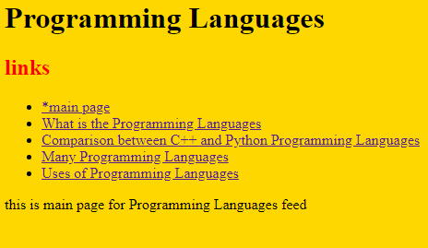

**1**

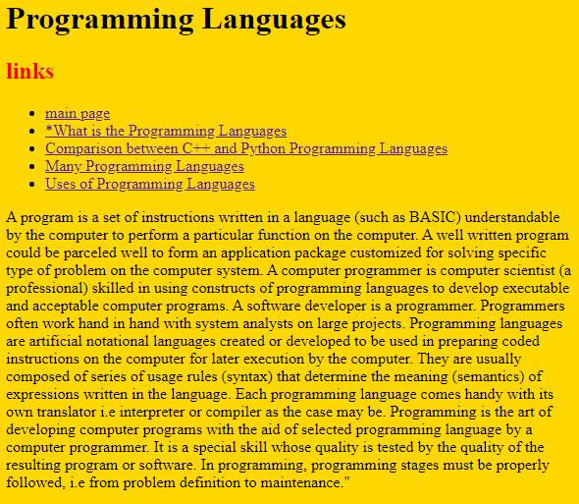

**2**

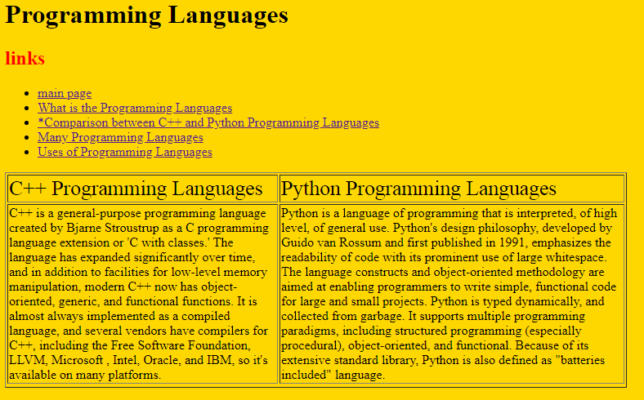

**3**

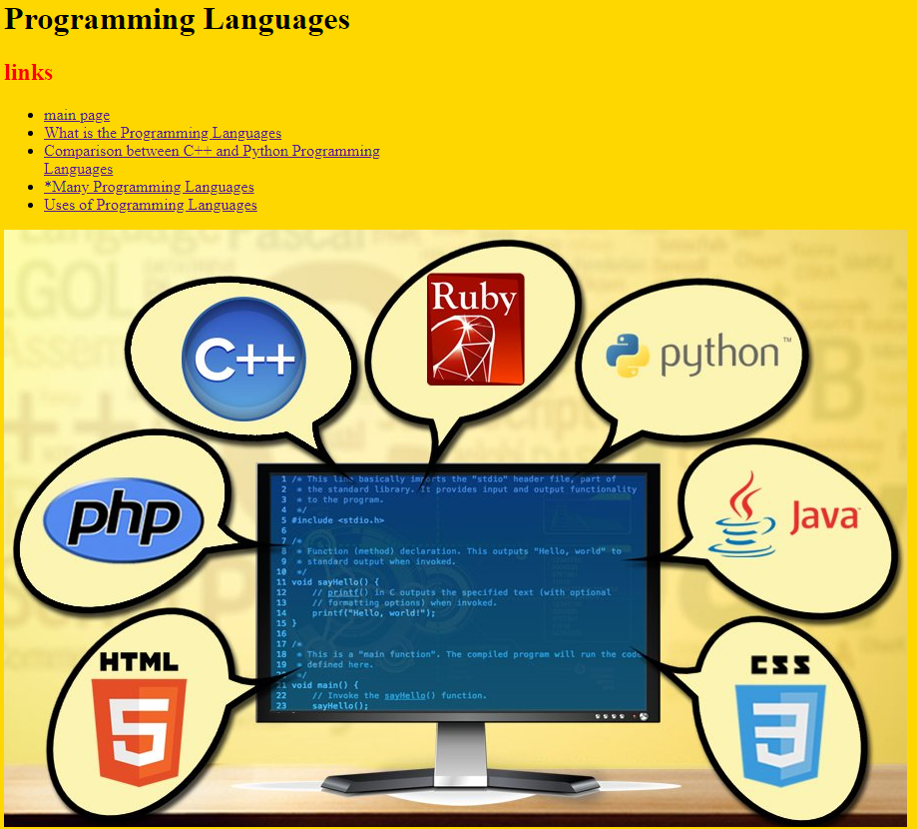

**4**

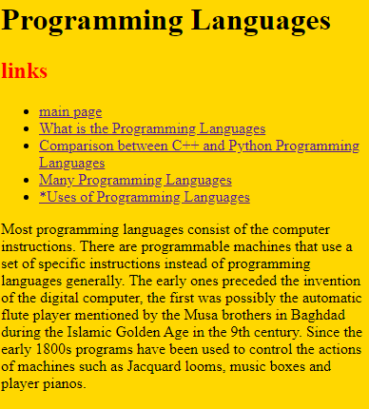

**5**

**Source code**

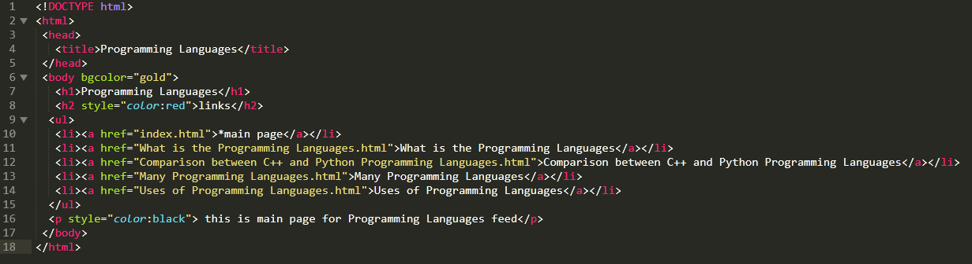

**Code of 1**

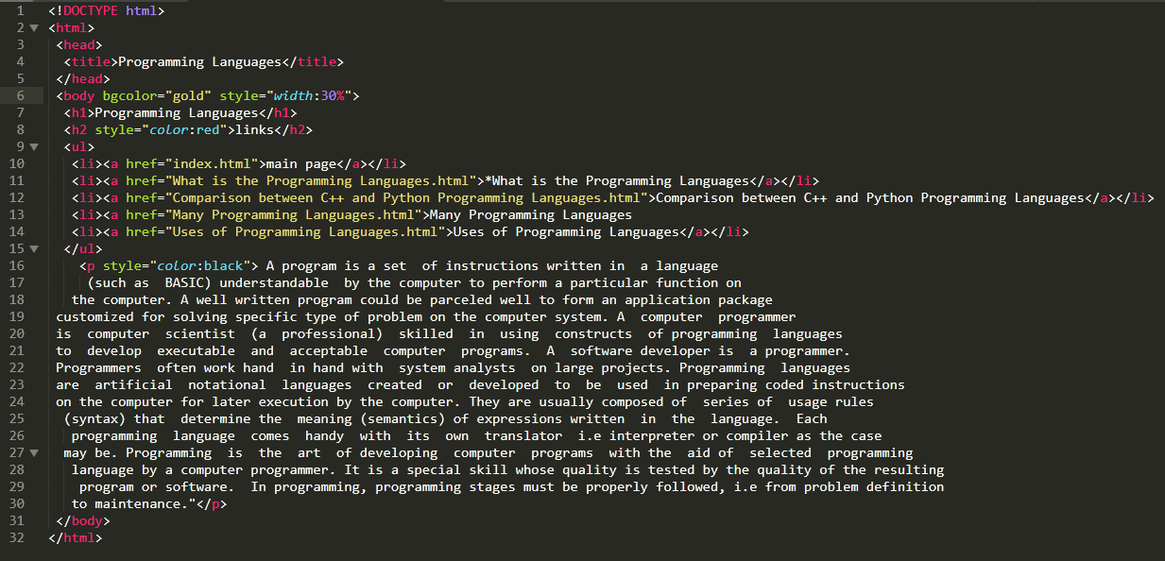

**Code of 2**

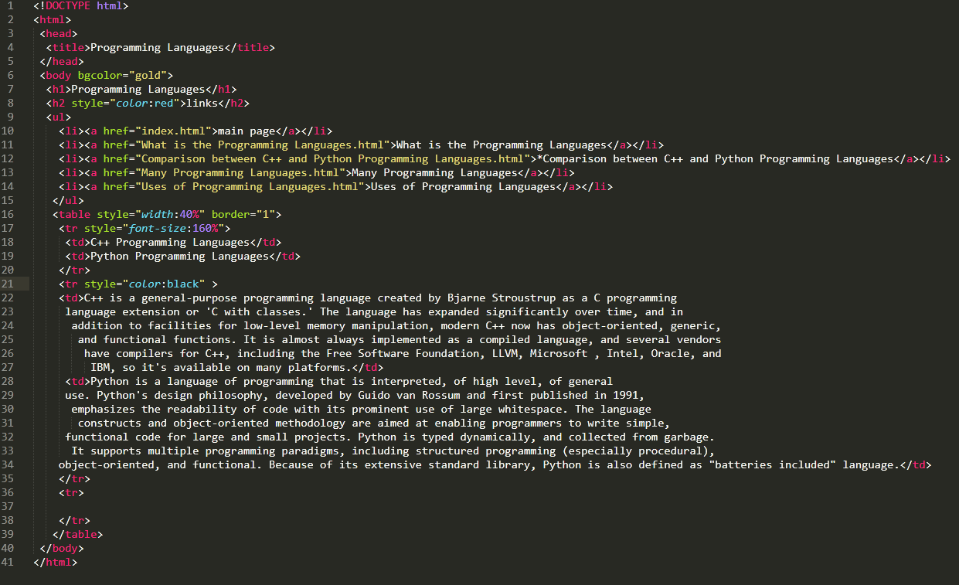

**Code of 3**

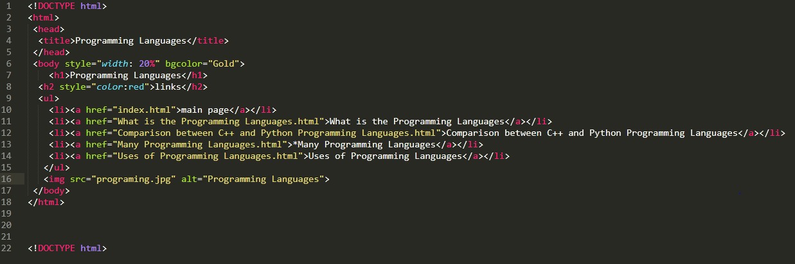

**Code of 4**

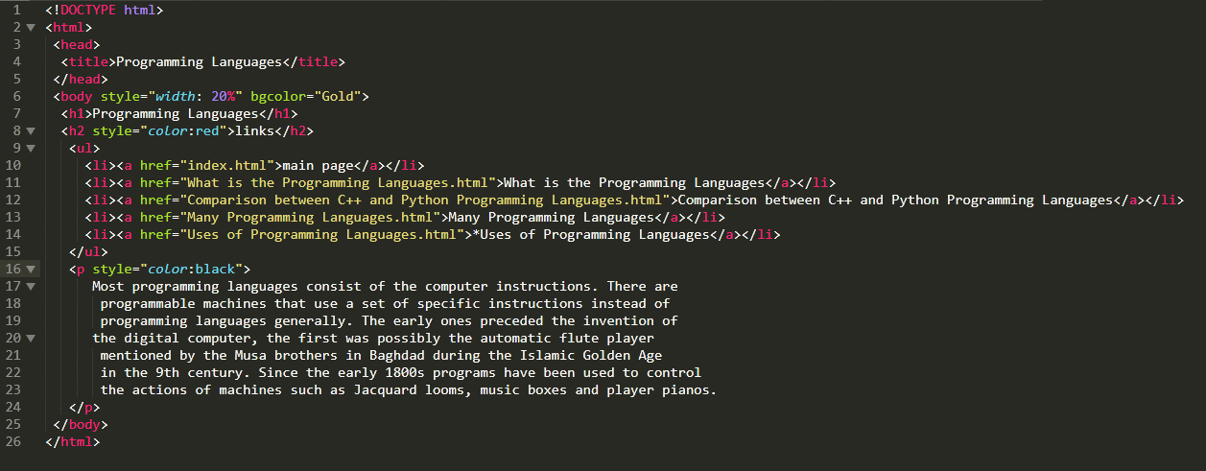

**Code of 5**

**Reference**

1. <https://www.computerscience.org/resources/computer-programming-languages/>