# Term 1-2

###### Relationship

↑ P : ↓ Qd ↑ Qs //LoD && LoS

Other factors : Δ DS

↑ D : ↑ Pe ↑ Qt ↑ TR

↑ S : ↓ Pe ↑ Qt / TR //varies with elasticity

↑ Ceiling : ↑ P ↑ Q ↑ TR

↑ Floor : ↑ P ↓ Q / TR

↑ Quota : ↓ P ↑ Q /TR ↓ S //bent

###### Chapter 1

Opportunity Cost : Highest valued option forgone

Positive statements : Refutable by facts

Normative statements : Not refutable by facts

###### Chapter 2

**To produce**

1. What : type, quantity
2. How : method, location, resource
3. For whom : consumer

Market-oriented economy : guided by price signal | private individuals //resource allocation, economic decision

Command economy : govt cmd | govt decision

**★ Private property rights**

1. Exclusive right to use
2. Exclusive right to receive income
3. Right to transfer

###### Chapter 3

Gov departments : government

Public corporations : NGO

* sole proprietorship
* partnership
* private limited company
* public limited company

|  |  |  |
| --- | --- | --- |
| Legal status  Tax rate  Setup procedure  Transferring ownership  Disclosure of accounting info  share/bond power | rate of return  Shareholder’s meeting voting rights to influence company decisions  Maturity date | Obligation to pay  Obligation to redeem  Diluted control of existing shareholder |
| **Limited liability means if there is a loss, the owners' liability is confined to the amount of investments to the firm** | | |

###### Chapter 8

|  |
| --- |
| CP VV  Given ↑ P of goods caused by Quota  RP of HPG in terms of LPG ↓  People would consume > HPG :: LPG  The proportion of HPG consumed ↑  The average quality would ↑ |

###### Demand and supplies + Measures

**★ Price Functions**

1. Rationing : #Goods# were distributed to consumers who were willing to pay the market price //consumers
2. Allocative : Resources are allocated according to Δ in relative price //producers
3. Signal : Prices help transmit info about consumer's demand of good :: producer's supply

|  |  |
| --- | --- |
| Related goods | Income : ↑ Dn ↓ Di |
| Competitive D | P : ↑ Dr |
| Joint D | P : ↓ Dr |
| Derived D | Dp : Di //product, input |
| Competitive S | P : ↓ Sr |
| Joint S | P : ↑ Sr |
| Factors of production: | Pi : ↓ Sp //input, product |

**★ Elasticity**

* Calc = %ΔQ/%ΔP
* Arc = ΔQ/ΔP * P1+P2/Q1+Q2

Elastic: %ΔQ > %ΔP > 1

Unitary: %ΔQ = %ΔP = 1

Inelastic: %ΔQ < %ΔP < 1

Perfectly E: ΔP = ∞ΔQ = ∞

Perfectly inE: ΔP = 0ΔQ = 0

|  |  |
| --- | --- |
| **Factors ↑ Ed Es**  Substitutes D  Proportion of income D  Durability D  Time for adjusting D S  Flexibility of production S  Ease of entry S | **Factors ↓ Ed Es**  Necessity D  Habit forming goods D  Capital intensiveness S |

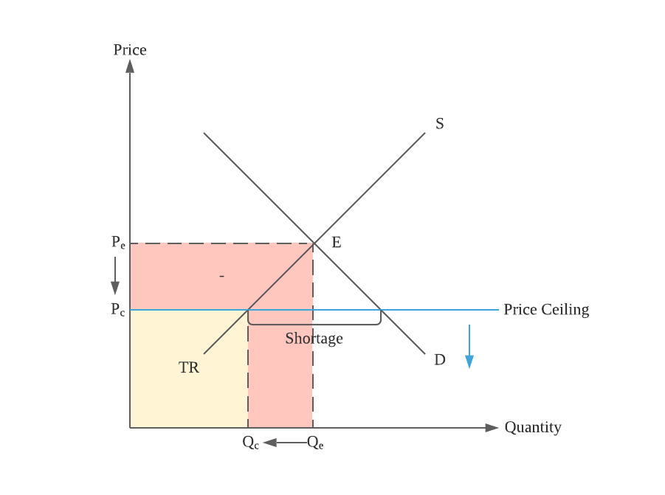**Price ceiling**

< E: Effective

Δ in TR = Δ in ceiling

Examples: rent control

Producers: non-price competition

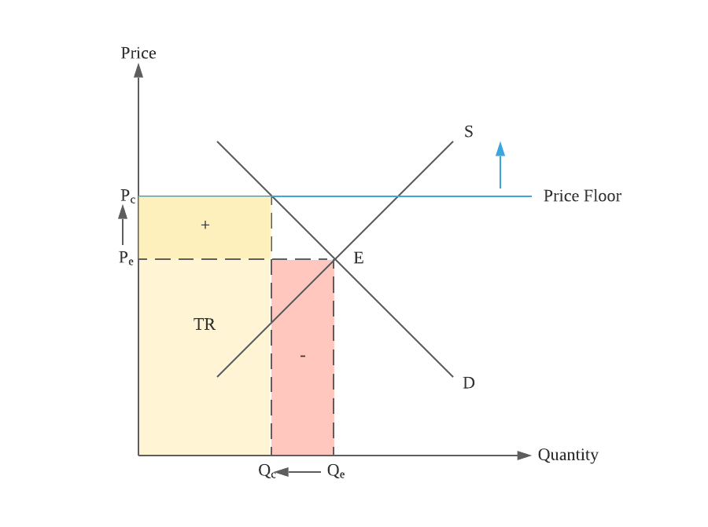

**Price floor**

> E: Effective

Floor: Price, !Quantity

Δ in TR depends on elasticity

Examples: minimum wage

Producers: non-price competition

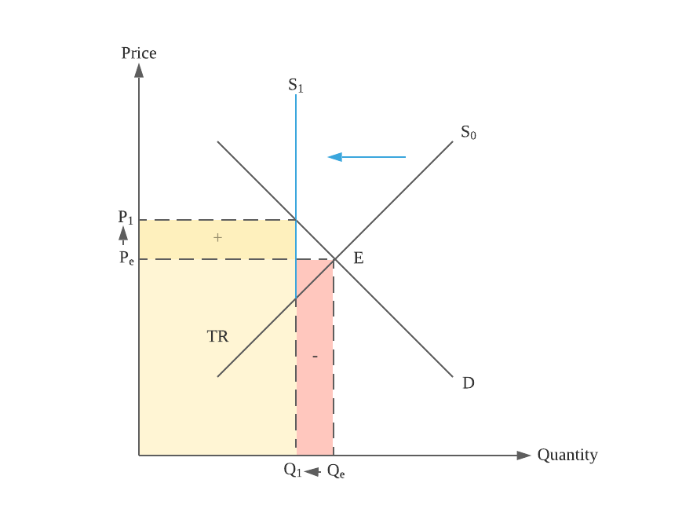**Quota (Quantity)**

Quota kinks the supply curve

< E: Effective

Quota: Quantity !Price

Δ in TR depends on elasticity

|  |  |
| --- | --- |
| Supply and Demand(3) | Supply and Demand(4) |
| **Per-unit tax**  P ^ Q v  Ed > 1 : TR increase  Ed < 1 : TR decrease  Ed = 1 : TR unchanged  Total revenue net of tax decrease  Consumer’s burden  -------------  Producer’s burden | **Subsidy**  P v Q ^  Ed > 1 : TR decrease  Ed < 1 : TR increase  Ed = 1 : TR unchanged  Total revenue increase  Producer’s benefit  -------------  Consumer’s benefit |
| Ed > Es : P > C  Ed < Es : P < C  Ed = Es : P = C  Ed = 0 : C | P  Ed = Inf: P | C $$\frac{P}{C}=\frac{E_{d}}{E_{s}}$$ $$\frac{\%∆Q}{\%∆P}$$ | |

# Production

### Inputs

* Land - natural resources used in production, gift of nature | R = rent
  + No cost of production / Cost for consumption / Human effort → capital
  + Can’t be increased by human effort
* Capital - man-made resources used in production | R = interest
  + Used to raise productivity
  + ↑ capital → present consumption is forgone for exchange more future consumption
  + Can be increased by human effort
    - Capital formation - production of capital goods, ↑ capital stock
    - Capital consumption - reduction of capital goods, ↓ capital stock
    - Δ in capital stock = capital formation / capital consumption, ↑ = capital accumulation
* Labour - human effort (mental, physical) used in production | R = wage
  + Factors affecting Q of labour (Workers * Working Hours):
    - Size of population
    - Proportion of working population
    - Number of working hours
    - Future prospects
  + Factors affecting labour productivity (Unit / Labour Hour):
    - Education & training
    - Working environment
    - Rewards & benefits to workers
    - Management
    - Mechanization & technology
  + Wage payment system
    - Time rate - according to working hours
    - Piece rate - according to output

|  |  |  |  |  |  |
| --- | --- | --- | --- | --- | --- |
|  | Basic |  | Commission | |  |
|  | Time | Piece | Profit sharing | Tips | Basic + Commission |
| Labor productivity | ✖ | ✓ | ✓ |  | ✓ |
| Cost > wage | ✓ | ✖ | ✖ | ✖ | ✖ |
| Cost > shirk | ✖ | ✓ | ✓ | ✓ | ✓ |
| Shared business risk |  |  | ✖ | ✖ |  |
|  |  |  |  |  |  |
| Wage stability | ✓ | ✖ | ✖ | ✖ | ✓ |
| Increase income by working harder |  |  | ✖ | ✖ |  |
| Shared business risk | ✖ | ✓ | ✓ | ✓ | ✓ |

* Entrepreneurship - human efforts make decisions & bear business risks in production | R = profit
  + Risk bearing : Face risks & bear loss from business
  + Decision making : Make major decisions regarding operation & management
  + Coordinating & managing production : Production → factors of production

### Factors of production

* Mobility
  + Occupational - Ability & willingness to Δ from one occupation to another
  + Geographical - Ability & willingness to move from place to place

|  |  |  |  |  |
| --- | --- | --- | --- | --- |
|  | Land | Captial | Labour | Entrepreneurship |
| Occupational | ✓ | ✓ | ✓ | ✓ |
| Geographical | ✖ | ✓ | ✓ | ✓ |

* Internal affecting: Ability & Willingness
* External factors affecting ↓
  + Geographical
* Transportation cost
* Immigration and emigration policies
* Labour market information
* Economic and political conditions
  + Occupational
* Monetary and non-monetary rewards
* Skill requirements
* Labour market information
* Entry barriers and professional body restrictions
* Retraining programmes
* Hong Kong
  + Land
    - Insufficient for development
    - Superior harbour
  + Capital
    - Well-developed infrastructure
    - Doesn’t have foreign exchange control
  + Human resources
    - Well-educated workforce
    - Entrepreneurs have good business sense and extensive network

### Types (Hong Kong)

* **All of them are interdependent**
* Primary production - extraction / direct use resources of nature : raw materials
  + Insignificant ∵lacks natural resource, urbanized
* Secondary production - turn raw materials : finished products // producer goods
  + Less significant ∵ relocation of factories → mainland
* Tertiary production - activities providing : services
  + Most important ∵shift from a manufacturing center → knowledge-based economy

### Process

* Division of labour
  + Simple - worker specialize producing a good
  + Complex - worker specialize in stage of production of good
  + Regional - district / region specialize producing / stage in production
* Disadvantages
* Work → monotonous / boring ∵repeated
* ↑ risk of unemployment ∵ skills are limited
* Excessive standardization
* Advantages
  + - Practice makes perfect
    - Save time on training and job rotation
  + Improving standard of living
  + Economy in the use of capital
* Limitations
  + Not necessary in small markets
  + Products with high degree of uniqueness → hard to practice

### Output

* Goods - Tangible
  + Consumer, for final consumption → directly satisfy human wants
  + Producer, in production → produce other goods : !satisfy
  + Classification
* Rivalry in consumption, consumption reduce the amount available to others
* Excludability in consumption, possible to prevent others use good at affordable cost
  + Private = 2
  + Pure public = 0 (consumed by all people @ same time)
  + Impure public = 1 (consumed by many but not all people @ same time)
* Services - intangible

# Production and costs

### Concepts

* Runs
  + Short : > 1 factor = fixFactor
  + Long : * factor = varFactor

## Short Run

###### Input-output relationship

* Factors:
  + Variable : Factors of production Δ : value Δ
    - When output ↑, Q varFactor ↑
  + Fixed : Factor of production Δ : value unchanged
    - When output ↑, Q fixFactor unchanged

Products (.P)

|  |  |  |  |
| --- | --- | --- | --- |
| Total | Total Q of output | Q * AP | Σ of MP |
| Average | Q of output per varFactor | TP / Q |  |
| Marginal | Δ in total product by + in varFactor | Δ TP by + in factor | |
| **If there is total product: can find other products** | | | |

###### Law of diminishing marginal returns

|  |
| --- |
| In the short run | holding technology constant  When more varFactor + → given Q of fixFactor //added to a  MP → eventually ↓ |

**★ Answering:**

|  |
| --- |
| The production is a short run production with #fixFactor# as fixFactor and #varFactor# as the varFactor.  The above production illustrates the law because the law applies when the #unit#th unit of #varFactor# is employed, the MP drops from [#Value1] →[#Value2] |

###### Cost-output relationship

* Cost
  + Variable: Output Δ : cost Δ, produce = 0 = cost
  + Fixed: Output Δ : cost unchanged, long run fixed cost = 0

Cost

|  |  |  |  |
| --- | --- | --- | --- |
| Total | Total fixCost unit of output | Q * AC | Σ of MC |
| Average | C per output | TC / Q |  |
| AverageVar | varCost per output | Σ MC / Q | TvC / Q |
| AverageFix | fixCost per output | TfC / Q | |
| Marginal | Δ in total cost by + unit of output | Δ TP by + factor | |

## LR | Economies of scale

↑ in production scale : ↓ in average cost

**★ Reasons**

1. Larger discounts are given to bulk purchase of production inputs
2. Better credibility results in a lower interest rate
3. Marketing expenses are spread over increase output

# Market Structure

Exist without physical location

Market:

* Product : transaction : goods and services
* Factor : transaction : factors of production

Exchange:

* Barter : goods are exchanged for goods
* Monetary : money used as medium of exchange for goods & services

## Distinguishing between market structures

* Homogeneous // Completely identical
* Heterogeneous // Different

###### Reasons why a market isn’t perfect competition

**★ Reasons**

1. Imperfect information
2. Sellers provided heterogeneous services
3. Non-price competition exists

* Remember to give examples for trailing marks

###### Structure: Monopoly

**★ Features**

1. Sellers are price searchers
2. There is only one seller
3. Entry to market is restricted

* ✖ direct ✓ indirect competition
* Sellers in other market provide substitutes
* Compete with monopolist for inputs like labour / capital
* May be potential competitors entering market
* Power may come from gov