# 16 – Redox equilibria

Oxidation - e- #o - agents are Reduced to Oxidize other molecules

Reduction - e- #o - agents are Oxidized to Reduce other molecules

Standard conditions - 100kPa, 298K, 1 mol dm-3

## Electrical chemical cell

Standard electrode potential - Potentials measured against standard hydrogen electrode (0.00 V)

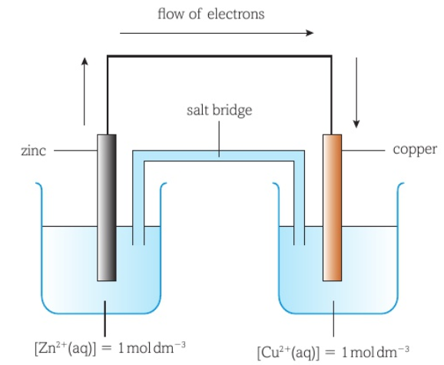

Largerreduced, smaller oxidized

Largerstronger oxidizing / weaker reducing

(Zn oxidized, Cu reduced)

Electrolytes (aqueous substance in beaker) must be **soluble**.

### Electro-cell diagram

e- flows from smaller larger

Left oxidized, right reduced.

### Shorthand display

Example:

### Measuring

The standard hydrogen electrode is used to measure:

Half equation:

### Feasibility

reaction is feasible (spontaneous)

## Hydrogen-Oxygen Fuel cells

Both sides overall equations are the same:

The membrane separates H2 and O2 gases

Electrodes are coated in Pt as catalyst

### Acidic electrolytes

Anode (-):

Cathode (+):

### Alkaline electrolytes

Anode:

Cathode:

### Advantages & disadvantages

|  |  |
| --- | --- |
| * Environmentally friendly * No harmful product pollutants * Alternative to use of fossil fuels | * H2(g) is a flammable gas * H2(g) is not renewable * Storage of H2(g) has hazards * Storage of H2(g) is costly |

# 17 – Transitional metals

Transitional metals - Metals that can form > 0 stable ions with partially filled d subshell

Scope of the exam:

## Electronic configuration

If moving 4s e- to 3d, d is d5 / d10, there is more stability for half-filled subshells, so e- would leave 4s.

When forming ions, 4s e- leaves first.

## Introduction to complexes

Ligands - Species with lone pair of e- that can form dative bond to t.m. ion

Co-ordinate bonds (c.o. bonds) - Dative covalent bond from ligands

Co-ordination number (c.o. num) - Number of c.o. bonds

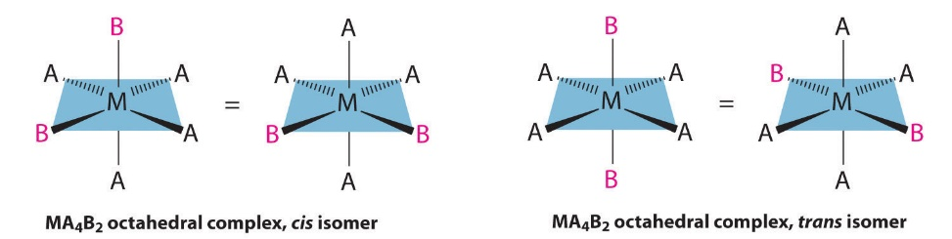

### Shapes

Large ligands (Cl-) 4 bonds: Tetrahedral 109.5°

Small ligands (H2O / NH3) forms 6 bonds: Octahedral 90°

*Number of ligands around metal:*

* Ligands repel each other as far as possible
* Giving shape with bond angles of X°

### Naming

H2O aqua | NH3 ammine | X- halo | OH- hydroxo (All negatives end with -o)

### Multidentate ligands

Multidentate ligands - Ligands that has > 1 lone pair of e- that can bond to t.m. ion

Names of multidentate is related to number of c.o. bonds formed.

### Ligand isomerism

Optical isomerism: only 3 bidentate ligands

Cis-trans geometric isomerism: quad-bi octahedral ligands / bi-bi square planar ligands

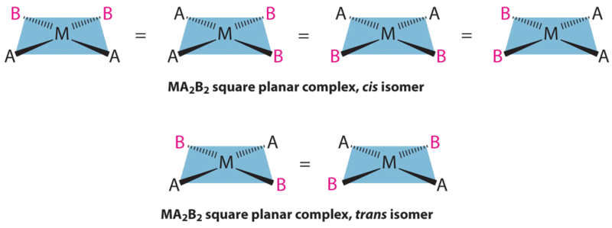Cis - same side | Trans - opposite side

## Complex reactions & color

### Cause of colors – 3d Energy levels

1. Partially filled d-orbital
2. Ligands cause d-d splitting
3. Visible spectrum radiation absorbed
4. Light causes d-d transitions
5. 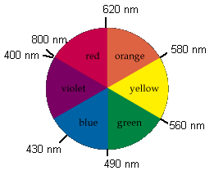Complementary color observed

### Reactions

1. Deprotonation Ligands ± H+
2. Ligand exchange Ligands replaced
3. Redox Oxidation number
4. C.o. number change Number of ligands in complex

## Summary of reactions

|  |  |  |  |  |
| --- | --- | --- | --- | --- |
| **Type** | **Ligand** | **Formula** | **Exception** | **Metals** |
| D | OH- |  |  | All |
| D | OH- (Excess) |  |  | **Cr Zn** |
| D | NH3 |  |  | All |
| L | NH3 (Excess) |  |  | **Cu Co Cr Ni Zn** |
| C | Cl- |  |  | **Cu Co** |

|  |  |  |  |  |  |  |  |  |  |  |  |
| --- | --- | --- | --- | --- | --- | --- | --- | --- | --- | --- | --- |
| **T.M.** | **Oxi.** | **Color** | | | **OH-** *p.p.* | | **Excess OH-** *sol.* | **NH3** *p.p.* | | **Excess NH3***sol.* | **Cl-** |
| Cu | 2 | B | | | B | |  | B | | B | dBr |
| Co | 2 | P | | | B | | B | | Br | B |
| Cr* | 2, 3, 6 | B | G | O | G | | G | G | | G |  |
| Ni | 2 | G | | | G | |  | G | | B |
| Zn | 2 | c | | | W | | c | W | | c |
| Fe | 2, 3 | pG | Y | | dG | Br |  | dG | Br |  |
| Mn | 2 | pP | | | W | | W | |

### Chromate reactions

# References

## Solubility rules

|  |  |  |  |  |  |
| --- | --- | --- | --- | --- | --- |
| **Soluble** | | | | | **Exceptions** |
| Nitrate | Ammonium | Potassium | Sodium |  | - |
| Chlorine | Iodine |  |  |  | Pb2+ Hg22+ Ag+ (PHAg) |
| Sulphate |  |  |  |  | Pb2+ Hg22+ Ag+ Ca2+ Ba2+ Sr2+ (Castro bear) |
| **Insoluble** | | | | |  |
| Carbonate | Phosphate |  |  |  | Group 1, NH4+ |
| Hydroxide |  |  |  |  | Group 1, NH4+ Ca2+ Ba2+ Sr2+ (Castro bear) |