# Prove by contradiction

## Steps

1. Assume opposite is true
2. Write series of logical step proving opposite is false
3. State the contradiction & conclude

## Techniques

|  |  |
| --- | --- |
| Proving number irrational | Let where:   1. have no common factors   Perform operations on both sides to show have common factors:  Power both sides 🡪 factor for a, sub a as factor 🡪 factor for b |
| Proving infinite primes | 1. List all prime numbers 2. Let number with product of all prime numbers + 1 3. Divide by any prime numberRemainder = 1 4. N must be prime |
| Proving even / odd | Let or then substitute to show final expression does not match even / odd |

# Partial fractions

For

, sub

For

# Parametric equations

Change subject:

1. To t
2. To trigonometric functions of t, then sub

* Domain = range f(t) [x]
* Range = range g(t) [y]

# Binominal expansion

### Compound expressions / partial fractions expansion

1. Break the expression down into binomial expansions
2. Expand each binomial individually
3. Collect the expansions together and simplify
4. Check the validity of each binomial expansion

# Differentiation

|  |  |  |
| --- | --- | --- |
|  |  |  |
| *Not given rules* | | |
|  |  |  |
|  |  |  |
|  |  |  |
|  |  |  |
|  |  |  |
|  |  |  |
| *Given rules* | | |
|  |  |  |
|  |  |  |
|  |  |  |
|  |  |  |

**Implicit**: “Differentiate all xy, add behind all differentiations of y”

Chain rule substitution: “ etc.”

# Integration

Rotating about x-axis & y-intercept

## Solving differential equations

### Methods

By **substitution**: “sub find and replace all functions of with ”

By **part**:

By **joining recurring parts**:

Try **partial fractions**:

Try **trigo identities**:

Try **multiplying fractions by one**:

# Vectors

## Basics

Position vectors: Vectors originating from a point

Unit vectors: Vectors with magnitude of 1

Column vector:

Resultant vectors (head to tail):

Resultant vector of position vectors:

**Use resultant vectors to solve “prove” problems!**

## Magnitude & direction

For :

**3D vectors**

For

Magnitude =

Unit vector =

## Solving vector problems

To find unknown vector’s expression (e.g. )

Expressions for unknown vectors can be found by tracing different paths from the 2 vector points.

## Lines of vectors

Passing throughparallel to:

Passing through :

* Different values of represent different points on line. The equation of the line represents all possible points on the line

Check if point **P** on line:

Check if lines have intersection:

Point of intersection:

## Vector properties

* Vectors are parallel if one is a scalar multiple of the other
* Vectors are skew if they don’t intersect
* Vectors are collinear if there’s a common point for parallel vectors

For

If **:**

## Scalar product, angles & areas

Angle between vectors:

Angle between vectors:

For

Lines make angle:

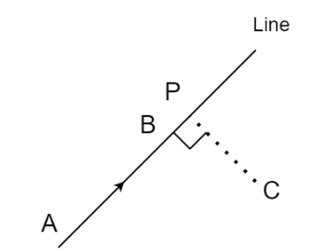

Prove perpendicular:

Find shortest distance to other line:

Area:

Cosine rule: /