# Topic 5 – Further mechanics

## Further momentum

Elastic collision: KE conserved

Inelastic collision: KE not conserved

$$p=mv$$

Impulse is the change in momentum: $∆p=F×∆t$

So average force during collision: $F=\frac{Δp}{Δt}$

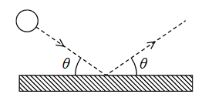Bounce collision

* Force acts opposite direction to initial movement

$F_{on ball}=\frac{Δp}{Δt}=\frac{-2p\sin{θ}}{t}$

$F_{on wall}=-F_{on ball}$

Solving collision momentum problems

* Draw a vector diagram and use Pythagoras theorem to solve the problems
* Use trigonometry to find angles
* Draw scaled vector diagram to check your answers

Why can a scaled vector diagram demonstrate conservation of momentum?

* Sum of momentum before and after collision is the same
* As the mass is the same, sum of velocity before and after collision is the same

## Circular motion

Angular velocity: $w=\frac{∆θ}{∆t}=\frac{2πr}{t}$

Instantaneous velocity: $v=rw$

Centripetal force acts 90 degrees to the direction of motion

Why does an object move with circular motion

* Resultant force by other forces which acts perpendicularly to the direction of motion

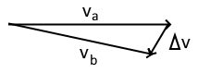Derive $a=\frac{v^{2}}{r}$

1. 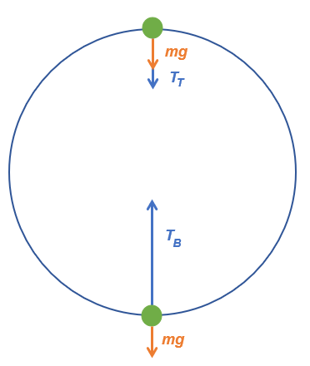Draw vector diagram (RHS)

$as θ→0, Δθ=\frac{Δv}{v}$

$Δθ=wΔt$

$\frac{Δv}{Δt}=\frac{v^{2}}{R}$

### Vertical circular motion

$$cF_{top}=T+W$$

$$cF_{bottom}=T-W$$

Centripetal force is the resultant force of T and W.

### Horizontal circular motion

$$\tan{θ}=\frac{v^{2}}{rg}$$

Derived by: $\frac{T\sin{θ}}{T\cos{θ}}$

# Topic 6 - Electric and magnetic fields

## Electric fields

Electric field - force field in which charged particles experience a force

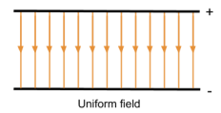

To draw field lines:

1. Current +ve → -ve terminal

2. Straight parallel lines

3. Evenly spaced lines

$$E_{k}=VQ$$

$$E=\frac{F}{Q} E=Electric field strength (NC^{-1})$$

### Uniform fields

$$E=\frac{V}{d} d=distance between parallel plates$$

### Radial fields

To explain the direction of the electric field at a point:

$$Using example of A positive B negative, referring to diagram$$

1. Due to A being +ve, e-field is exerted away from A: $\vec{AX}$
2. Due to B being -ve, e-field is exerted towards B: $\vec{XB}$
3. $\vec{AX}+\vec{XB}=\vec{AB}$ (as vertical component cancelled out)

### Coulomb’s law

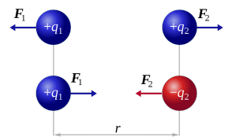If charges have the same sign, F ≥ 0 and hence the force will be repulsive, else it will be attractive

$$F=k\frac{Q_{1}Q_{2}}{r^{2}} r=distance between charges k=\frac{1}{4πε_{0}}$$

$$Energy per particle from a distance V=k\frac{Q}{r}$$

### Equipotentials

Join points with equal potential in an electric field together to create surfaces of equipotentials

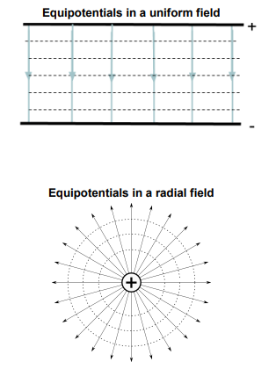

### Thermionic emission

e- in heated metal gain energy and leave surface

**Electron guns**

1. hot metal surface causes emission of e-
2. anode +ve charge accelerates e-

### Earth’s magnetic field

Distance from poles ↓ Magnetic field strength ↑

## Capacitors

* 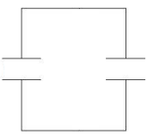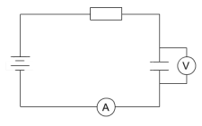Stores energy
* Total charge = 0
* Separates charge

$$C=\frac{Q}{V}=\frac{It}{IR} C=capacitance \left(F farads\right)$$

$${For capacitors in parallel: C}_{total}=∑C$$

To explain charging capacitor with e- flow

* e- move from one plate to another through external circuit
* As capacitors charge, rate of flow of e- ↓
* When fully charged, equal amounts of e- stored on each plate

### Charging and discharging properties

$$τ=RC τ=time constant R=total resistance$$

$$* = *_{0}e^{-t / RC} * =Q \left| V \right| I *_{0}=initial value of*$$

$$\%=e^{-t / RC} \%=the percentage of*_{0}@ t$$

$$When time=τ→I,Q,V @ 37\% X_{0} \\ For discharge, t=τ→Q,V @ 63\% X_{0}$$

|  |  |
| --- | --- |
| Charging | Discharging |
|  |  |

To find the time constant with *-t graph:

1. Locate the initial value for Q | V | I
2. Calculate value at 37% if charging, 63% if discharging
3. 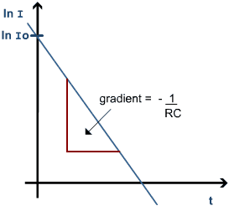Use the graph to find corresponding time

To find time constant with straight-line graph

1. Natural log both sides → $\ln{I}=\frac{-1}{RC}×t+\ln{I_{0}}$
2. Re-arrange variables to make $y=mx+c where x=t, y=\ln{I}$

$∇ =\frac{-1}{RC} {int}_{y}=\ln{I_{0}}$

### Energy

Energy charged / discharged by capacitor is the energy dissipated / gained by other components.

## How Magnets WorkMagnetic fields

Magnetic poles always exist with both North and South poles, N → S, S → N if at the center

### Magnetic flux

Uniform magnetic fields - constant magnetic flux density

Magnetic flux density (B, Unit Testa (T)) is a measure of the strength of the field

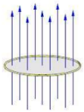Magnetic flux ($Φ$, Unit Weber (Wb)) describes magnetic field lines cutting through a given area:

$Φ=B\sin{θ}A θ=angle from⊥line of B$

When $θ=0$, there are no field lines cutting through A

Magnetic flux linkage: $ΦN=BAN N=number of turns of a coil$

### Directions of vectors

⨀: Out of paper F: Magnetic force

⊗︀: Into paper iL: Induced current

|  |  |  |
| --- | --- | --- |
| Force direction: LHR | Induced current direction: RHR | Magnetic field direction: Grip rule |
|  | Electromagnetism Resource | Right-hand rule - Wikipedia |

To explain directions of vectors:

* State “Using LHR”, or state $\vec{X} acts at a right angle to the direction of \vec{Y}$

To think of questions with magnet on a weigh:

* Note that the reason for the increasing reading is due to the reaction force experienced by magnet when it exerts an **upward** force onto the conducting material, which by 3rd law, it exerts a **downwards reaction** force onto the magnet
* Directions of forces should reference LHR

### Charged particles in magnetic fields

A force acts on charged particles moving in a magnetic field

­Magnetic Force on wires: $F=BIL\sin{θ} θ=angle of I from magnetic field L=length of wire in field$

Magnetic Force on particles: $F=BQv\sin{θ} θ=angle of movement from magnetic field$

As force acts $⊥$ to motion of charged particles (LHR), particle motion is circular:

Radius of circular path of particles: $r=\frac{p}{BQ} p=momentum of charged particle derived from\frac{mv^{2}}{r}=BQv$

Use $r=\frac{p}{BQ}, E=\frac{p^{2}}{2m}$ to find variables of particle in magnetic field.

For a negative charge, the current will be flowing in the opposite direction relative to its movement

### Electromagnetic induction

Lines of magnetic field cut through coil → emf is induced.

Coil forms a complete circuit → Current is induced.

Lenz’s law: Direction of induced current is such as to oppose the motion causing it

Lenz’s law can be applied to explain direction of movement. Also can think of as “minimizing” motion causing it

Faraday’s law: $ε=\frac{-ΔBAN}{Δt}$ definition

Average induced emf: $time =\frac{period}{4}$ (maximum amplitude of V)

## Applications of magnetic fields

### Demonstrating Lenz’s law induction

$$for magnet falling through coil of wire: t_{coil}>t_{freefall}$$

$as magnet approaches coil, ΔΦ through coil→induced ε \& I (complete circuit)$

1. Due to Lenz’s law, **direction of induced $ε$ is such as to oppose the motion** of the magnet  
   **Same pole** is induced to the pole of the magnet **approaching** coil, causing magnet to slow down due to **repulsion** force
$as magnetic passing through coil, ΔΦ=0→no ε induced$

$as magnet leaves coil, ΔΦ→induces ε \& I (complete circuit)$

2. Due to Lenz’s law, **direction of induced $ε$ is such as to oppose the motion** of the magnet  
   **Opposite pole** is induced to the pole of the magnet **leaving** coil, causing magnet to slow down due to **attraction** force

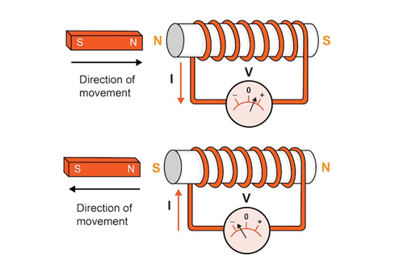 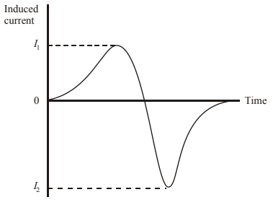

“Induced current flows in a direction such that it opposes the change which produces it”

Note that the magnitude of the second peak is greater ∵magnet at higher velocity ∴rate of change of flux greater

Work done due to Lenz’s law:

* $W=Fd$, therefore the movement caused by Lenz’s law does work

### How does a transformer increase the pd?

1. AC provides alternating current
2. AC produces varying magnetic field in core (T)
$ΔΦ through 2^{nd}coil→induced ε \& I in capacitor circuit (complete circuit)$

3. Diode converts AC to DC

### Generators & motors

|  |  |
| --- | --- |
| **AC Generator** | **DC Motor** |
| * The coil is rotated mechanically * F and B 🡪 induces emf & current onto coil (RHR) * Current alternates (AC) as coil cuts max and no field lines when rotating, inducing max and 0 emf | Draw a labelled diagram of an electric motor. Explain its principle and  working. What is the function of a split ring in an electric motor?   * Current is supplied to the system * I and B 🡪 exerts magnetic force onto coil (LHR) * Coil rotates by resultant force |
| Animation: [Click me](https://www.youtube.com/watch?v=gOB4OmwK7yc) | Animation: [Click me](https://www.youtube.com/watch?v=0q5bARctt7M) |

# Topic 7 – Particle physics

## What is Atomic Structure? | Definition from Seneca LearningAtomic model

${}_{\left(atomic\right) p=Z}^{\left(mass\right) p+n=A}X α: {}_{2}^{4}{{He}^{+}}$

### Nuclear model of an atom

*Evidenced by α-scattering Disproving plum-pudding model*

1. Most α no deflection 🡪 Atom is mostly empty ✖ As pp model atom matter spread out
2. Small amounts α deflected 🡪 Center is charged (+ / -) ✔ pp model doesn’t have high conc. charge
3. Very small amounts α deflected > 90° 🡪 Center is very dense ✔ pp model doesn’t have high conc. mass

*Alpha scattering uses a lead box: Lead absorbs e- travelling in directions other than towards the foil*

### Charge of particles

All particles have a charge relative to e (1.6x10-19)

## Particle accelerators

### Accelerating potential

Accelerating pd is used to accelerate particles.

Find momentum of particle / number of passes in LINACs

$E_{field}=\frac{V}{d}→V=E_{field}×d$

$E_{J}=VQ→E_{J}=E_{field}×d×Q$

$VQ=\frac{p^{2}}{2m}$

* Remember if a particle passes through $n$ tubes, the energy gained by particle is only $\left(n-1\right)V$

### Types of accelerators

Both uses E field to accelerate particles, time spent in each dee and tube is constant

|  |  |
| --- | --- |
| **Linear accelerators**: E field only, tubes get longer  Explanation key points   1. Particles in tubes pd reverses 2. Adj tubes have opposite pds   Why gaps & tube must increase in length further down LINAC   1. Electric field accelerate particle across gap 2. Particle speed constant in tube 3. pd oscillate at constant intervals, so time for particle staying in gaps & tubes is constant 4. Particle enters gap & tube with increasing speeds, s=vt, so gaps & tubes must increase in length | **Cyclotron**: E + M fields, radius gets larger  Explanation key points   1. Particles in dees pd reverses $M field⊥cyclotron→exert centrip. F_{M}→circlar motion$  Why only t is needed to time acceleration of particles   1. Speed of particle has no relationship to the time 2. Since time for particles staying in dees is constant 3. So pd oscillate at constant intervals 4. As pd across gap is in correct direction to accelerate particles each time they pass |

Why high energy particles required to investigate structure of nucleons

$E=\frac{p^{2}}{2m} E↑p↑$

$λ=\frac{h}{p} p↑λ↓$

* Wavelength needs to be comparable to nucleon size

Stationary collisions & Opposite collisions

* Explain using ideas of conservation of momentum.
* Stationary $p_{net}>0$, opposite collisions $p_{net}=0$, $E_{k}→E_{k}+E_{mc^{2}}$, $E∝m$

## Mass and energy

$$E=mc^{2} m=\frac{E}{c^{2}} so 1MeV/c^{2}=1×{10}^{6}×1.6∙{10}^{-19}÷{\left(3∙{10}^{8}\right)}^{2}$$

### Time dilation & relativistic lifetime

Time dilation - Time travels slower for faster moving objects.

1. Initial distance $∝$ speed
2. $v→c$, velocity almost unchanged, lifetime observed stationarily > predicted lifetime due to relativistic increase
3. 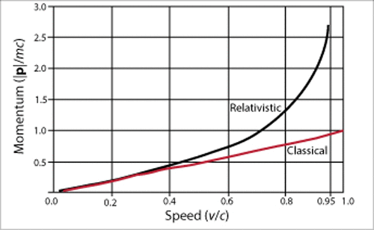 $s=vt$, Particle travels further as lifetime extended

## Standard model of elementary particles

Hadrons - Formed of quarks

Leptons - Fundemental particles

Quarks - Makes up leptons. Fundemental particles

Fundemental - Cannot be broken down further

### Quarks & leptons

You’ll need to memorize particle charges for exams: $up \left| charm↔strange \right| top \frac{2}{3}-\frac{1}{3} eμτ \left(-1\right) υ_{X} neutrino, photon \left(0\right)$

Antiparticle: Equal mass, equal and opposite charge & baryon / lepton number

|  |  |  |  |
| --- | --- | --- | --- |
| Quark | | | Charge |
| 1st | 2st | 3rd | Gen |
| u | c | t | $$2/3$$ |
| d | s | b | $${-1}/3$$ |
| Leptons | | |  |
| $$e$$ | $$μ Muon$$ | $$τ Tau$$ | -1 |
| $$ν_{e}$$ | $$ν_{μ}$$ | $$ν_{τ}$$ | 0 |
| Charge: (+ve) n charge of e- | | | |

### Hadron particles – Baryons

Formed by 3 quarks, with sum of charge being integer. (can’t be same 3 quark)

$$uud→p^{+}$$

$$udd→n$$

$usd→δ^{0}$

### Hadron particles – Mesons

Formed by quark & antiquark, with sum of charge being integer

$$\overline{d}u→π^{+} (pion)$$

$$\overline{u}u→π^{0} (pion)$$

$$\overline{s}d→K^{0} (Kaon)$$

### Electromagnetic force

Particles pass photons back and forth between each other

### Particle interactions

Finding momentum of particles after interaction

* $E=mc^{2}$, most energy converted to mass
* Leftover energy will be converted to $E_{k}=\frac{p^{2}}{2m}$

Interaction can only occur if all properties below are conserved

1. E, Q & p **Use vector diagram when explaining p**
2. Baryon number (is: 1, anti: -1, not: 0)
3. Lepton number (is: 1, anti: -1, not: 0)
4. Strangeness (is: -1, anti: 1, not: 0)

### Bubble chamber tracks

Tracks are created by ionization of **charged** particles. Magnetic field acts perpendicular to the page.

For pair production tracks, momentum of tracked particles = momentum of initial particle

Explanation of shape symmetrical tracks

1. Same shape: Same mass
2. Spiral opp. dir.: Opposite charge
3. Circular motion: Magnetic field exert centripetal magnetic force
4. Radius decrease: $Ionisation→E_{k}↓, E=\frac{p^{2}}{2m}, r=\frac{p}{BQ}, E↓r↓$

# Notes

### SI Base units

|  |  |  |  |
| --- | --- | --- | --- |
| Unit | Name | Quantity | Symbol |
| s | seconds | time | t |
| m | meter | length | l,x,d |
| kg | kilogram | mass | m |
| A | ampere | electric current | I |
| K | kelvin | temperature | T |
| mol | mole | amount of substance | n |
| cd | candela | luminous intensity | Iv |

### Personal notes: During exams…

* Make sure all squares in the formula are applied
* Draw vector diagrams
* If stuck, read question again for hidden details
* When explaining variable change be as precise as possible