# Topic 8 – Heat

Specific heat capacity (c) - E required to raise t of 1 kg substance by 1 K

Specific latent heat (L) - E required to change state of 1 kg substance at constant t

## Molecule speeds

mean of sum of squares of speeds of individual molecules

* The equation shows that for **same T**, the **average KE per molecule** is the same for any molecules (so heavier = slower)
* Potential energy changes during change of state. **T is constant** for this state
* Internal energy =
* **Rate of E transfer to surroundings** affect **T-t** curve

Why does increasing temperature increase the pressure?

1. Atoms moves faster
2. More frequent collisions
3. State variables that are unchanged
4. is greater
5. Larger force on walls

## Ideal gas equation

Internal energy of the gas:

* Use to answer MC questions

**Assumption that molecules behave as ideal gas such that:**

1. Negligible size
2. Identical
3. Exert no force on each other except during collisions
4. Random motion

* **Molecules in ideal gas has no PE**

# Topic 9 – Nuclear physics

## Particle interactions

|  |  |  |  |
| --- | --- | --- | --- |
| **Particle** | **General equation** | **Trend of prop.** | **Penetrating power** |
| Alpha |  | 1. Ionization 2. Range 3. Penetrating power | Stopped by paper |
| Beta |  | Stopped by few mm Aluminum |
| Gamma |  | Reduced by few mm Lead |

Activity - The rate of decay of (unstable) nuclei

Random decay - We cannot predict which nucleus will decay next

Half life - The average time taken for the activity to halve

Binding energy - E required to split the nucleus up into its separate nucleons

Show half-life equals…

* Read from graph at least 2 half-lives

Why can’t use activity to determine age

* Time scale too long
* Activity

### Measuring count rates

Count rates is the number of particles that reach the detector per time

* Background radiation increases reading

*Measure background radiation for subtraction before source in position for long durations of time*

* Longer time reduces uncertainy of decay’s random nature

## Fusion & fission

Why does fission release energy?

* mass of products less than initial mass

Why does the fragments of a fission move away from each other?

* Initial momentum is 0
* Momentum must be conserved

### Binding energy

### Binding energy per nucleon graph

Fe is the most stable element as smallest

Why nuclear fission is only possible for massive nuclei?

* Splitting of massive nucleus
* Splitting of light nucleus requires energy as

Why does fission of massive nuclei release large amounts of energy?

* Splitting of massive nucleus
* Large number of nucleons from fragments means large overall energy release

### Fusion as power supply

**Advantages**

1. Unlimited fuel supply
2. Hardly any radioactive waste

**Disadvantages / facts**

* High temperatures (essential) are needed to give nuclei enough KE to overcome the electrostatic repulsion to come near
* High densities needed to give a high enough collision rate (for continued only)
* The reaction must be contained securely along with a strong magnetic field
* If material touches container, the temperature decreases
* *Stars are ideal for fusion as great gravitational forces promote required conditions*

# Topic 10 – Simple harmonic motion (SHM)

**Conditions:**

1. F is acting towards eq position
2. Fdisplacement from eq position

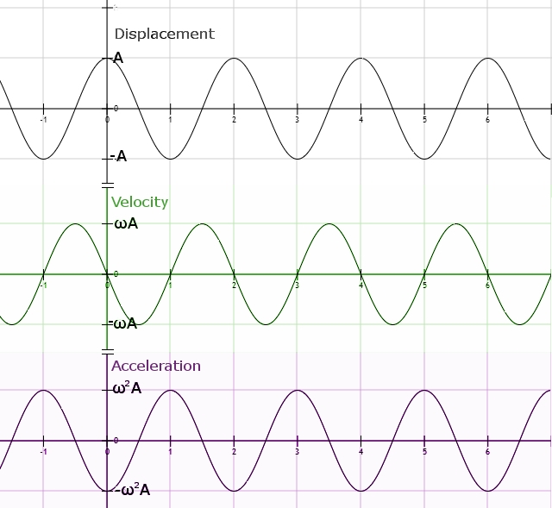Assuming :

### Graphs

## Conservation of energy

Free oscillations have all E conserved.

## Terminologies

### Resonance

System forced into oscillation at natural frequency resulting in maximum energy transfer

### Damping

Reduction in energy from an oscillation due to resistive forces on the oscillating system leading to decrease in amplitude

* Plastic materials are necessary for energy dissipation to be effective

They change shape and doesn’t return to original shape, so energy is not returned to system

**Types of damping:**

1. Light / under:
2. Critical:
3. Heavy / over:

# Topic 11 – Gravity and space

## Gravitational forces

Gravity is always attractive

## Starshine

Black body radiation - Object that completely absorbs all radiation that lands on it

Standard candle - Object of known luminosity

Wien’s law:

## Star classifications

Main sequence stars - Star that fuses H2 in core

White dwarf stars - Small surface area, high T and emit white light

### H-R diagram

* to relate to size
* Determining cluster age:

Lack of giants = very young

White dwarfs = very old

### Star formation

* Dust & gas clump together by gravityprotostar
* Star undergoes nuclear fusion
* Binding E diffrelease E as EM radiationheat star
* Gravitational collapse prevented by pressure of vibration of particles

### Star properties

* Large gravitational forces size

Sizegravitational forcesrate of fusion

* High densities & temperatures

### Life cycles

**Low-mass stars (~1x Sun)**

## Distance to stars

Parallax - Change in position relative to background

Inverse square law:

Determine distance by parallax

1. Object viewed at opposite ends of earth
2. Change in angular positions of star against background measured
3. Trigonometry used

Determine distance by standard candle

1. Standard candle – object of known luminosity
2. Identify object standard candle and measured
3. Inverse square law used

## Calculation of the age of the universe

Approaching Distancing

Why wavelength of light detected from orbiting bodies change?

* Doppler shift
* Object moving towards and away from observer
* Approaching Distancing

Determine distance to distant galaxies

1. Measureof line in spectrum by distant galaxy
2. Determine difference ofof same line in lab
3. Use velocity of galaxy
4. Hubble’s lawdistance

## Theories of the fate of everything

Critical density - Density of matter in the Universe, below which universe will expand forever

### Dark matter

* It explains why stars orbit galaxies even if the centripetal force by the mass of stars is lower than needed.
* Gravitational lenses verify existence of dark matter, as masses deform space-time which bends light. This bending effect is observed in photographs of deep space

What is concluded from the observation of difference in values of observed mass & actual mass?

* 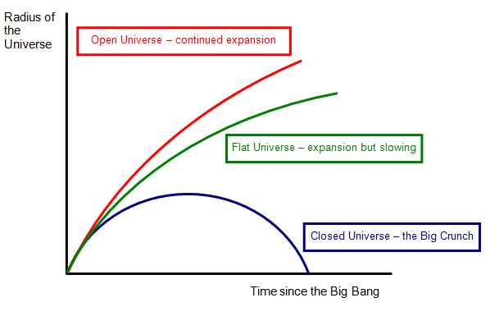There must matter that doesn’t emit or absorb electromagnetic radiation
* So dark matter must be present

How does dark matter relate to the fate of the universe?

* Dark matter increases density
* Fate depends upon density, compared with a critical density value