How to Use Wireless Pedal Controller Fiwmware Flasher :

1. Make Sure youre Computer is already installed Python 3 inscluding Python3-pip
2. Donwloads Flasher files from <https://github.com/EnigmaElec/Wireless-Pedal-Controller-Flash-Firmware>
3. Extract the Files and put in Desktop

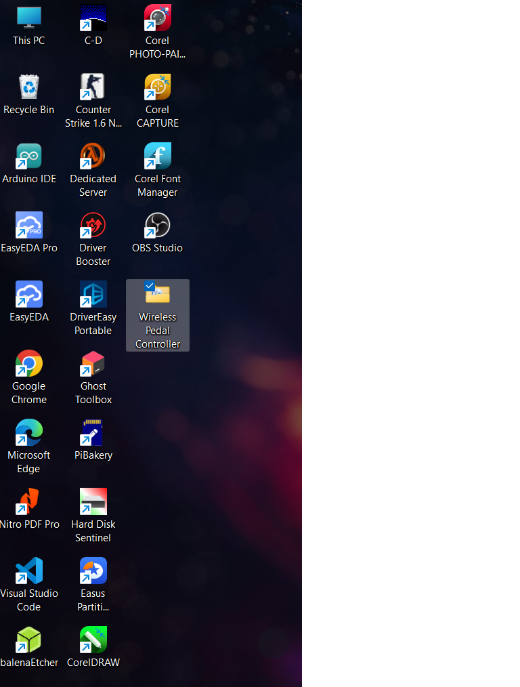

1. Here is the File content Original_Flasher.exe is for Original firmware in the Pedal_RX_original Directory, and WPC.exe is for updating Firmware

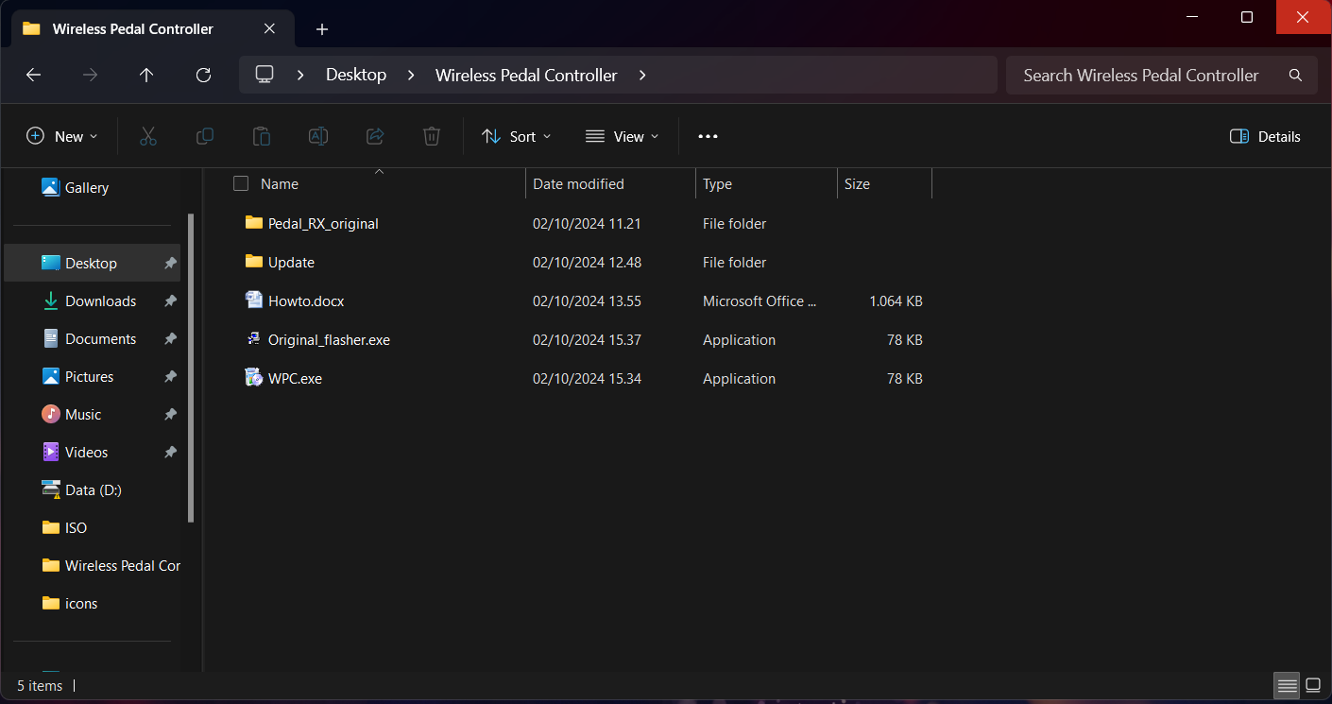

1. There is Pedal_RX_original firmware that contains 3 Binary firmware just like this

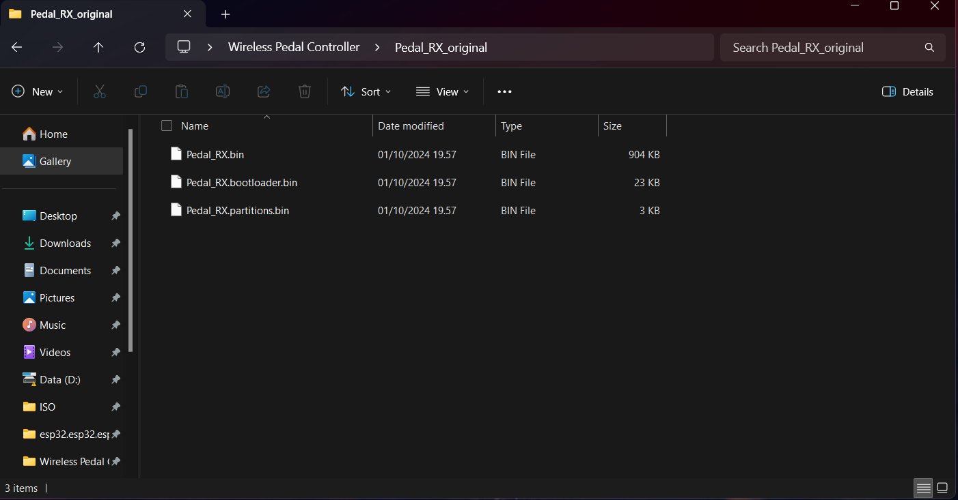

1. Flashing Default Original firmware just double click on Original_Flasher.exe, this will upload 3 bin files in Pedal_RX_original Directory as shown in green box

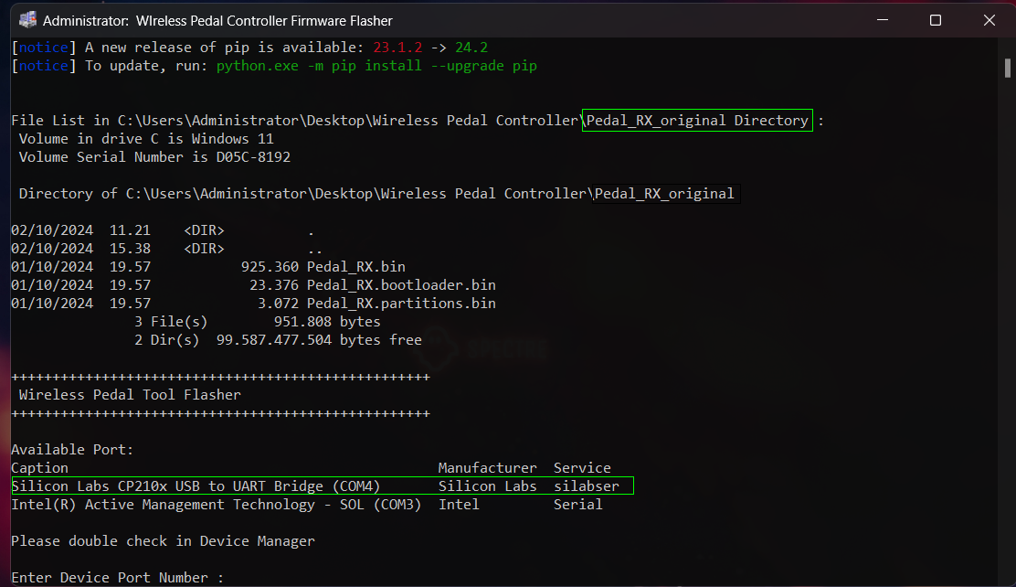

1. Choose Available Com port ***Silicon Labs CP210X USB to UART Bridge*** in this case is COM4 it can be diff in youre computer dont forget to double check in device manager This Port can’t be empty or missed type or apps get err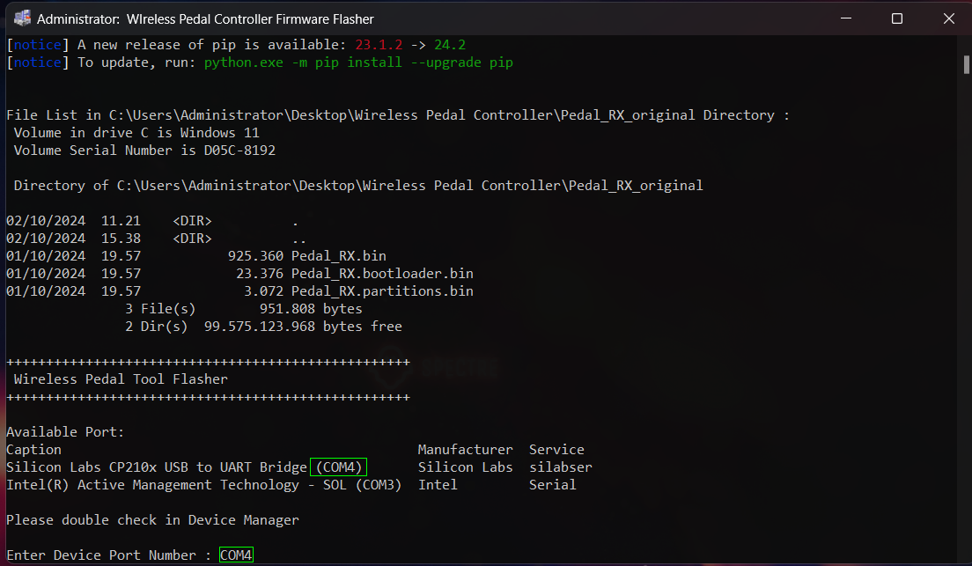
2. Default BaudRate is 921600 but you can chage it ex 115200 or 9600

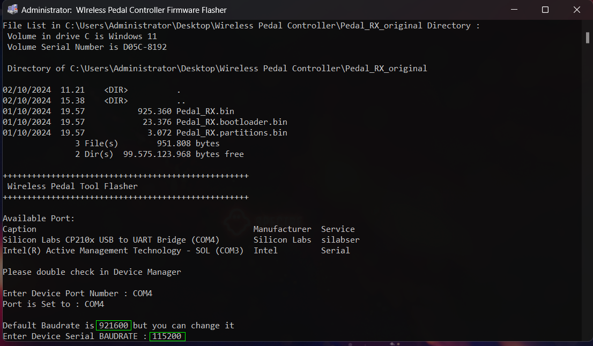

1. Wait until Firmware Flashing Complete

