**Report for CSCI 585 Homework 1**

**Name: Hao Wu**

**USC ID: 1699530173**

I use VISIO 2016 as tool to design the database. There are something I need to explain. First, every table’s primary key attribute is mandatory but some trivial information can be optional. Such like the description for an assignment and student’s age. There is no multi-valued attribute in the database because I think that it is hard to manage and distinguish from multi-valued record.

Because I want my database be easy to manage, so I choose to use weak relationship to connect each table. Although I have to assign a new primary key attribute for each table, I can make the management of the database more flexible.

To make it easier for database administrator to manage and organize data, I create some extra table to store some arbitrary data. For example, instead of just add an attribute for a table to store uploading file, I make a File table to specially store all the data uploaded by users. Though it will affect the performance of database, every data will be arranged in perfect order.

Some trivial attributes are omitted or are substituted with “content” field.

**Table: Course**

**Description: This table is used to store different course information.**

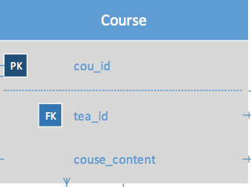

|  |  |  |  |
| --- | --- | --- | --- |
| Table1 Name | Table2 Name | Relationship | Reason |
| Course | Couse_Staff | 1:M | Every course has multiple staff and every record in the Course_Staff means a certain person plays a certain role in a certain course |
| Course | Assignment | 1:M | Every course has many assignments and every assignment only can belong to one Course |
| Course | Material | 1:M | Every course has many materials and every material only can belong to one Course |
| Course | Course_Time_Management | M:M |  |
| Course | Teacher | M:1 | One course can be created by one teacher, one teacher can create many courses |
| Course | Course_Management | 1:M | One course has many management record to distinguish the permission assigned to different person |
| Course | Register | 1:M | One course has many register record correspond to one student in a certain course. |
| Course | Lecture | 1:M | Same reason as assignment table. |
| Course | Category | 1:M | One course can only belong to on category, one category can have many courses |

**Table: Category**

**Description: This table is used to record the different category. Each category contains many courses, but one course only has a certain category. The attribute “cat_name” and “cat_description” are meaning the name and description of a category**

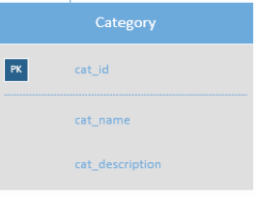

**Table: Course_Time_Management**

**Description: The Course_Time_Management table is used to satisfy the requirement that “A course should start and end at certain time”. The field “isAvaliable” means that this course is opened and the correspond schedule time is fields “start_time” and “end_time”**

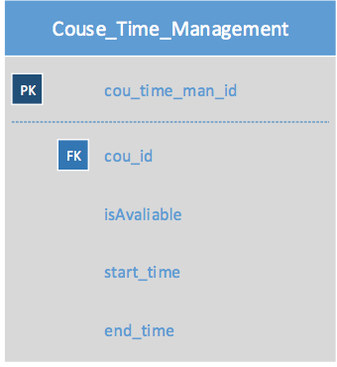

**Table: Lecture**

**Description: This table is used to store the lecture information from a certain class.**

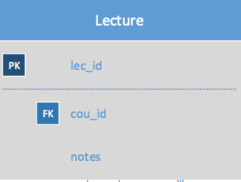

|  |  |  |  |
| --- | --- | --- | --- |
| Table1 Name | Table2 Name | Relationship | Reason |
| Lecture | Lecture_Video | 1:M | One lecture can have many video resources |
| Lecutre | Lecture_Note | 1:M | One lecture can have many notes |
| Lecture | Material | 1:1 | One lecture can be assigned as a certain material |
| Lecture | Lecture_Material | 1:M | One lecture can have many general material |
| Lecture | Comments | 1:M | One lecture can have many comments but one comment is specify for a lecture |

**Table: Lecture_Video**

**Description: This table is used to store videos for each lecture. Every record in the table means a video content for a lecture.**

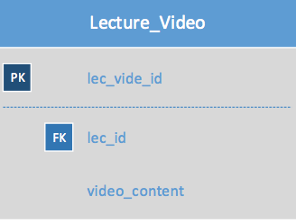

**Table: Lecture_Note**

**Description: This table is used to store lecture note for a certain lecture.**

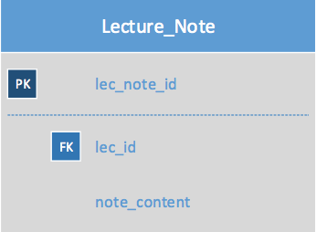

**Table: Material**

**Description: The material table store all the course material information. Every record contains a syllabus information and a textbook for corresponding course.**

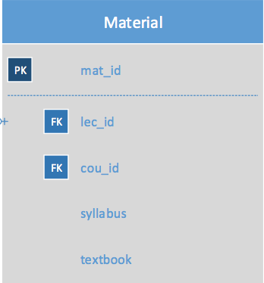

**Table: Couse_Staff**

**Description: This table stores every staff’s information and each staff can only be responsible for one course.**

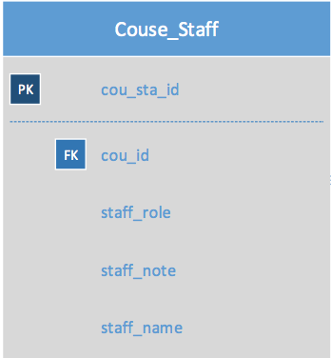

**Table: Lecture_Material**

**Description: This table stores the information of each lecture’s material (different from the material showed up)**

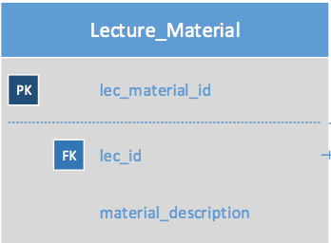

|  |  |  |  |
| --- | --- | --- | --- |
| Table1 Name | Table2 Name | Relationship | Reason |
| Lecture_Material | File | 1:M | One lecture material contains several files and these files can only be assigned to on lecture material |
| Lecture_Material | Link | 1:M | One lecture material contains several links and these links can only be assigned to on lecture material |

**Table: File**

**Description: This table stores file’s information for lecture material or assignment.**

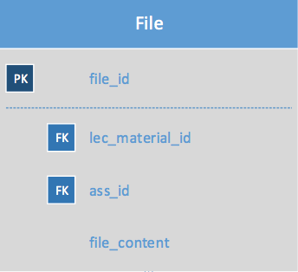

**Table: Link**

**Description: This table stores link’s information for lecture material.**

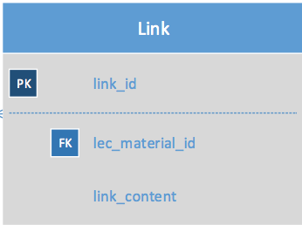

**Table: Assignment**

**Description: This table stores assignments for each courses. Each assignment has to be assigned to a course and has a deadline.**

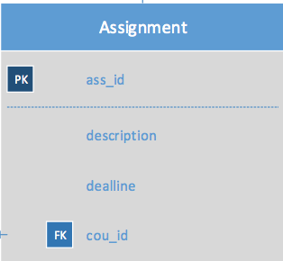

|  |  |  |  |
| --- | --- | --- | --- |
| Table1 Name | Table2 Name | Relationship | Reason |
| Assignment | File | 1:M | One assignment has many files. File can only be assigned to one |
| Assignment | Comments | 1:M | One assignment has many comments. Comment can only be assigned to one |
| Assignment | Grade | 1:M | One assignment has many grade for every student who finished this assignment |

**Table: Grade**

**Description: This table stores the information of the grade for each student’s one assignment.**

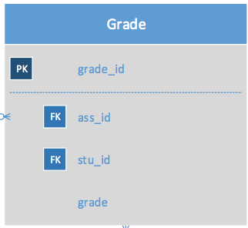

**Table: Comments**

**Description: Comments table stores the comment posted by students and teachers for a certain assignment or a lecture.**

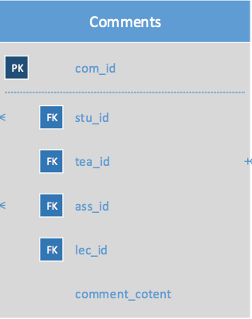

**Table: Student**

**Description: This table stores every student’s information like their name, age.**

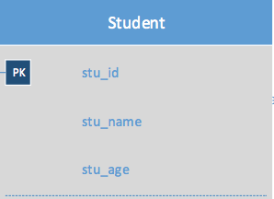

|  |  |  |  |
| --- | --- | --- | --- |
| Table1 Name | Table2 Name | Relationship | Reason |
| Student | Comments | 1:M | One student can post many comments |
| Student | Grade | 1:M | One student has different grade for different courses and assignments |
| Student | Register | 1:M | One student can register many courses |

**Table: Teacher**

**Description: This table stores every teacher’s information.**

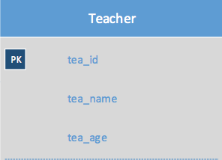

|  |  |  |  |
| --- | --- | --- | --- |
| Table1 Name | Table2 Name | Relationship | Reason |
| Teacher | Comments | 1:M | One teacher can post many comments |
| Teacher | Course_Management | 1:M |  |

**Table: Course_Management**

**Description: This table is used to assign different permission and role to each teachers which were involved in a course.**

**Table: Register:**

**Description: This table record every student’s course enrolling information. What’s more, student’s rate about the course will be recorded in this table.**

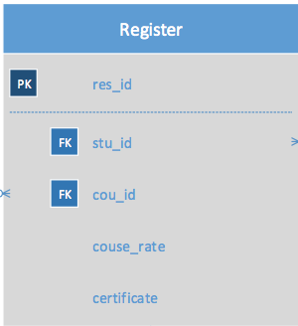

|  |  |  |  |
| --- | --- | --- | --- |
| Table1 Name | Table2 Name | Relationship | Reason |
| Register | Course_Grade | 1:M | One student in one course has many grade in different items. |
| Register | Payment | 1:M | Different student may use different payment way because of different price. |

**Table: Payment**

**Description: This table stores every payment record generated by students. The field pay_price means the price that student pays for a certain course and the payment_type is the payment method that student choosen.**

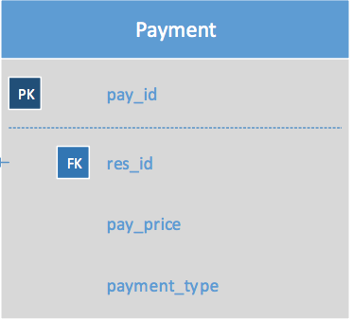

**绘图2.pdf**

**Please zoom in to see the details.**