ENIGMA OCTOPUS WHITEPAPER

[WWW.ENIGMA-OCTOPUS.COM](http://WWW.ENIGMA-OCTOPUS.COM)

**INTRODUCTION**

LAUNCHED AND WAS BORN THIS YEAR 2022, ENIGMA OCTOPUS WAS CREATED TO BE THE FIRST PROJECT AND BECOME THE FIRST DECODE TO EARN GAME ON BINANCE SMART CHAIN NETWORK, THE GOAL OF THE PROJECT IS TO INPUT HIDDEN MESSAGES ON DIFFERENT TASK TO BE GIVEN TO THE PARTICIPANTS AND THEY SHOULD DECODE IT INORDER TO PROCEED TO THE NEXT LEVEL OF THE GAME UNTIL IT LAST.­

ENIGMA OCTOPUS WAS INSPIRED BY THE FAMOUS MYSTERIOUS ONLINE PUZZLE THAT GOES VIRAL ON THE INTERNET, ON WHICH IS THE “CICADA 3301*”* ON JANUARY 04, 2012, THAT EVERYTHING GOES CRAZY TRYING TO UNDERSTAND WHAT IS THE REASON BEHIND OF POSTING DIFFERENT PUZZLES, WHO ARE THEY AND WHAT IS THEIR GOAL.

ENIGMA OCTOPUS WANTS TO HAVE THE SAME IDEA, BUT THE ONLY DIFFERENCE IS TOKEN WILL BE USED AS A PAYMENT FOR ENTRANCE TICKET TO JOIN AND PARTICIPATE ON THE GAME, ONCE THEY HAVE GOT AN ACCESS TO THE CHALLENGE, THEY CAN START DECODING AND LEARNING WHAT IS MESSAGE BEHIND THE GIVEN TASK.

WE DO NOT ADVISE TO RISK ALL YOUR MONEY WITH THE PROJECT, WE ARE NOT FINANCIAL ADVISOR OR ANY FORM, BUT WE ARE SAYING ONLY INVEST WHAT YOU CAN AFFORD TO LOSE.

**WHY BINANCE SMART CHAIN NETWORK?**

ENIGMA OCTOPUS CHOOSE BINANCE SMART CHAIN NETWORK AS A PRIMARY NETWORK TO RUN THE PROJECT IS BECAUSE BSC NETWORK GAS FEE IS MUCH CHEAPER AND MUCH MORE ACCESSIBLE TO ANYONE WHO WOULD LIKE TO PARTICIPATE AND INVEST IN THE PROJECT.

BY BUYING, CLAIMING AND SENDING TOKENS TO PRIZE WALLET ADDRESS REQUIRES A TRANSACTION FEE FOR EACH, WE DO NOT WANT ANYONE TO SPEND SO MUCH GAS FEE JUST TO PARTICIPATE IN THE GAME AND FOR SMALL INVESTOR, WE DO NOT WANT THEM TO SPEND MORE GAS FEE RATHER THAN THEIR INVESTMENT.

BINANCE SMART CHAIN IS EASILY ACCESSIBLE TO ANYONE, THEY CAN BUY BNB FROM BINANCE OFFICIAL WEBSITE, SEND IT TO DIFFERENT DIGITAL WALLET THAT SUPPORT BSC NETWORK AND THEY CAN JOIN ENIGMA OCTOPUS PROJECT.

**THE TOKENOMICS OF ENIGMA OCTOPUS**

THE MAIN TOKEN OF ENIGMA OCTOPUS IS BEP20 TOKEN, SINCE IT BASED ON BINANCE SMART CHAIN NETWORK, THE PROJECT’S TOTAL TOKEN SUPPLY IS ONLY 100,000,000,000 (100B) AND THE 45% OF IT WILL GO TO OUR PUBLIC PRESALE AND THE REST OF THE DETAILS ARE LISTED BELOW.

WE WILL ADD 12% AFTER THE PRESALE IS CONCLUDED TO THE PRIZE WALLET AND THE 15% OF TOTAL TOKEN SUPPLY WILL BE BURNED AUTOMATICALLY ONCE THE PRICE OF TOKEN IS ESTABLISHED.

**WHY IS ENIGMA OCTOPUS DOING THIS?**

ENIGMA OCTOPUS WANT TO MAKE SOMETHING NEW TO BINANCE SMART CHAIN NETWORK TYPE OF PROJECT, THIS DECODE TO EARN IDEA IS QUITE NEW, AND WE PROJECTED THAT THE IDEA MIGHT CAUGHT THE ATTENTION OF MANY WITHOUT DOING SO MUCH EFFORT TO LET THE PROJECT MAKE NOISE.

THE FOUNDER AS AN INVESTOR SEE DIFFERENT TYPE OF PROJECT BUT DID NOT ENCOUNTER THIS IDEA BEFORE, THE FOUNDER CONNECTS US ALL TO MAKE THIS THING HAPPEN.

NOW ENIGMA OCTOPUS WANT TO SEE IF THERE IS REALLY INTELLIGENT PERSON AND DESERVING WINNER OF THE PRIZE THAT WE PREPARED, WE WANT TO CHALLENGE ANYONE AND PROVE THAT SHOULD BE THE ONE WE ARE LOOKING FOR.

IF WE WANT TO MAKE SOMETHING NEW IN LIFE IT SHOULD START WITH QUESTIONS AND OUR SUBCONSIOUS WILL START TO MAKE A WAY TO FIND AN ANSWER TO THAT QUESTION.

THIS IS THE MAIN IDEA OF ENIGMA OCTOPUS, LET YOURSELF DO THE WORK AND ACHIEVE THE GREATEST ACHIEVEMENT OF YOUR LIFE, WE ARE JUST HERE WAITING FOR YOU TO REACH US OUT ON THE OTHER SIDE.

**LIQUIDITY POOL**

TO ENSURE THE SAFETY OF INVESTORS AND PARTICIPANTS, WE WILL LOCKED UP THE LIQUIDITY POOL TOKEN OR PANCAKESWAP-LP TOKENS FOR 1337 YEARS, SO WE CAN AVOID RUGPULL ISSUE, ENIGMA OCTOPUS WANTED TO HAVE A LONG-TERM PROJECT, THIS LOCKED UP TIME CAN HELP THE TEAM TO THINK OF NEW IDEA ONCE THE CHALLENGE IS FINISHED.

**CHALLENGES**

EACH CHALLENGES GIVEN TO PARTICIPANTS CONTAINS HIDDEN MESSAGES THAT CAN HELP TO LET THEM PROCEED TO NEXT LEVEL OF THE GAME, PARTICIPANTS CAN BRAINSTORMED ABOUT WHAT MIGHT BE THE ANSWER TO OUR CHALLENGES BUT ONLY THE EARLIEST PERSON WHO CAN DECODE THE GAME WILL WIN THE PRICE, WE DO NOT HAVE CONTROL ABOUT THE PRIZE WALLET, ONLY THE WINNER CAN GET THEM AND UNLOCK THEM.

**PRIZE POOL WALLET**

ONCE THE GAME IS CONCLUDED, THE WINNER OF THE GAME WILL BE ANNOUNCED ON OUR WEBSITE AND WILL RECEIVED AN NFT AS A BADGE FOR COMPLETING THE CHALLENGE. ONLY THE WINNER OF THIS GAME AND ACCESS THE PRIZE POOL WALLET, IT IS UP TO THE WINNER TO SELL THEM ALL AND HOLD THEM UNTIL THE TEAM CREATED A NEW CHALLENGE.

**THE TEAM BEHIND ENIGMA OCTOPUS**

**THE FOUNDER OF ENIGMA OCTOPUS**

THE FOUNDER CONNECTS US ALL THE GOLDEN, HE PLANNED THE IDEA OF CREATING THE GAME THAT WILL CHALLENGE AND WAKE UP THE SKILL THE INVESTOR HAVE, TO PROVE AS WELL THAT THEY ARE THE DESERVING WINENR OF THE PRIZE WE PREPARED.

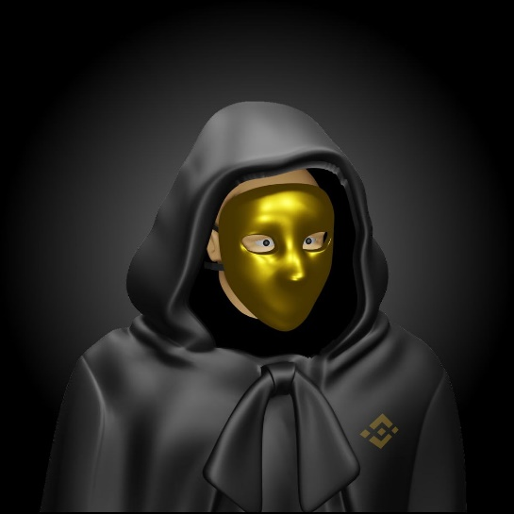**THE GOLDEN MASK**

ALWAYS FANTASIZE HOW DID INVESTIGATIVE AND PUZZLE PIECE LIKE MOVIE WAS CREATED, WITH BEING INSPIRED BY DIFFERENT MOVIE, WE CHOOSE MASK TO BE THE BRAIN FOR THE CHALLENGES THAT THE PARTICIPANT WILL DECODE.

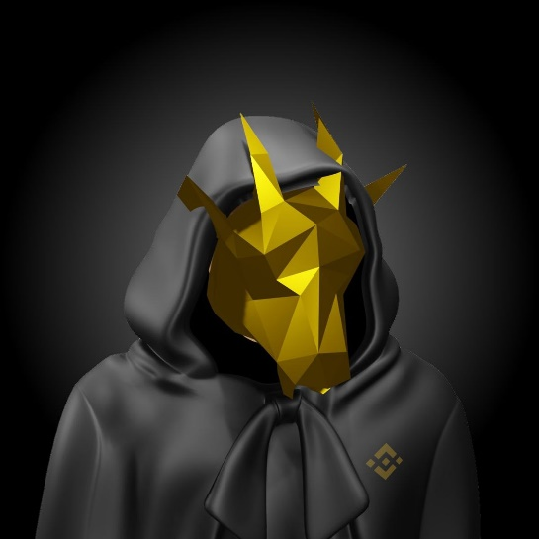**THE GOLDEN GOAT**

LEAD DEVELOPER OF ENIGMA OCTOPUS WEBSITE AND SOCIAL LINKS, WITH EXPERIENCE FOR BEING A DEVELOPER FOR 2 YEARS AND BEING INTO CRYPTO IS THE FASHION OF GOLDEN GOAT.

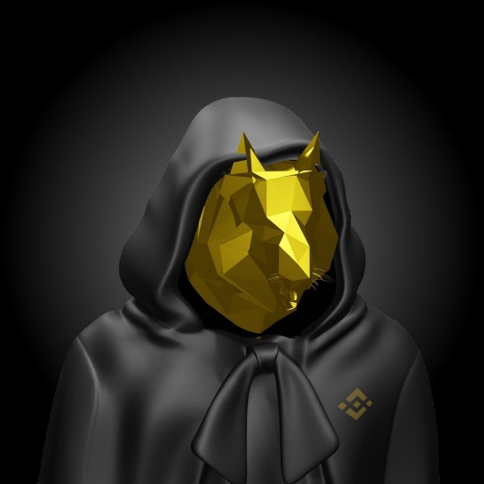

**THE GOLDEN TIGER**

RESPONSIBLE FOR VISUAL TASK, SUCH AS IMAGES THAT HAS BEEN USED FOR THE VISUAL OF OUR WEBSITE, SOCIAL MEDIA POSTS AND INPUT ON OUR CHALLENGES FOR THE PARTICIPANTS, TIGER IS OUR WELL-EXPERIENCED VISUAL AND GRAPHIC EDITOR.

ALL OF US DO NOT HAVE A PLAN TO GET DOXXED UNTIL FURTHER INSTRUCTION FROM OUR HEAD FOUNDER, WE WILL JUST CONTINUE WHAT WE STARTED AND CONTINUTE TO FIND SOMEONE THAT DESERVES THE PRIZE, ANYONE CAN PARTICIPATE BUT ONLY ONE WILL BE CHOSEN.

ENIGMA OCTOPUS IS NOT A FINANCIAL ADVICE, WE DO NOT RECOMMEND YOU TO RISK ALL WHAT YOU HAVE, ONLY BUY WHAT YOU CAN AFFORD TO LOSE.

GOOD LUCK TO ALL THE PARTCIPANT OF THE GAME, THIS IS THE END OF THE   
WHITEPAPER BUT YOUR JOURNEY WILL START HERE.

WSWNv+jaL1tyAGS2anBr8/eGyLWgGEyUl7jA5upm3oerp5n+dxTfxEI7YKaNvn3CRq2r1qU3LMQuxV1rcxmWSg==

THE END

www.enigma-octopus.com