**美国国会投票记录实验报告**

17030140014 张笑天

1. 实验内容

对于美国国会他投票记录数据，使用Apriori算法，支持度设为30%，置信度为90%，挖掘高置信度的规则。

1. 分析与设计

参考：<https://zhuanlan.zhihu.com/p/39918644>

利用第三包。

1. 详细实现

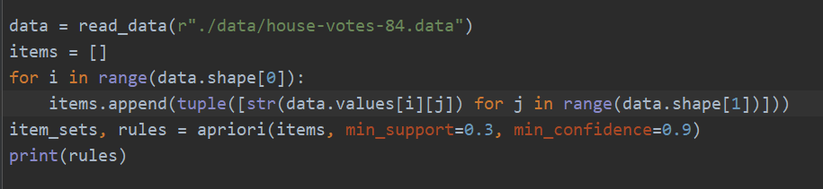

1. 实验结果

{0} -> {-1} (conf: 0.990, supp: 0.462, lift: 0.995, conv: 0.467)

{1} -> {-1} (conf: 0.998, supp: 0.995, lift: 1.002, conv: 1.995)

{-1} -> {1} (conf: 1.000, supp: 0.995, lift: 1.002, conv: 2298850.575)

{republican} -> {-1} (conf: 0.994, supp: 0.384, lift: 0.999, conv: 0.772)

{0} -> {1} (conf: 0.995, supp: 0.464, lift: 0.997, conv: 0.467)

{republican} -> {1} (conf: 0.994, supp: 0.384, lift: 0.996, conv: 0.386)

{democrat} -> {-1} (conf: 0.996, supp: 0.611, lift: 1.001, conv: 1.228)

{democrat} -> {1} (conf: 1.000, supp: 0.614, lift: 1.002, conv: 2298850.575)

{0, 1} -> {-1} (conf: 0.995, supp: 0.462, lift: 1.000, conv: 0.929)

{-1, 0} -> {1} (conf: 1.000, supp: 0.462, lift: 1.002, conv: 2298850.575)

{0} -> {-1, 1} (conf: 0.990, supp: 0.462, lift: 0.995, conv: 0.467)

{1, republican} -> {-1} (conf: 1.000, supp: 0.384, lift: 1.005, conv: 4597701.149)

{-1, republican} -> {1} (conf: 1.000, supp: 0.384, lift: 1.002, conv: 2298850.575)

{republican} -> {-1, 1} (conf: 0.994, supp: 0.384, lift: 0.999, conv: 0.772)

{0, democrat} -> {-1} (conf: 0.993, supp: 0.326, lift: 0.998, conv: 0.657)

{1, democrat} -> {-1} (conf: 0.996, supp: 0.611, lift: 1.001, conv: 1.228)

{-1, democrat} -> {1} (conf: 1.000, supp: 0.611, lift: 1.002, conv: 2298850.575)

{democrat} -> {-1, 1} (conf: 0.996, supp: 0.611, lift: 1.001, conv: 1.228)

{0, democrat} -> {1} (conf: 1.000, supp: 0.329, lift: 1.002, conv: 2298850.575)

{0, 1, democrat} -> {-1} (conf: 0.993, supp: 0.326, lift: 0.998, conv: 0.657)

{-1, 0, democrat} -> {1} (conf: 1.000, supp: 0.326, lift: 1.002, conv: 2298850.575)

{0, democrat} -> {-1, 1} (conf: 0.993, supp: 0.326, lift: 0.998, conv: 0.657)

1. 心得体会

使用了包，因此实验没有什么难度。之后或许会考虑自己实现。