## Assignment 1: QuestionsWereAsked

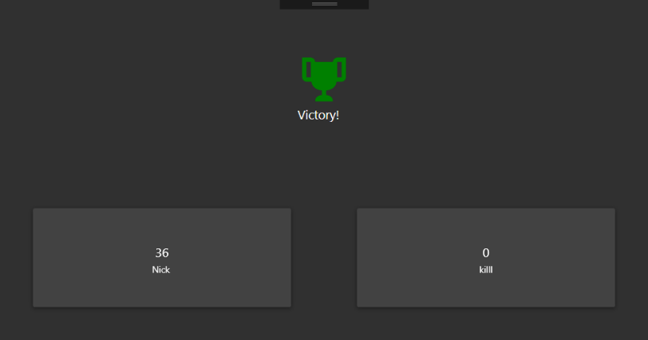A question-answer war between two players. Login with host and a nickname, port is preconfigured. Answer questions within 10 seconds and get points.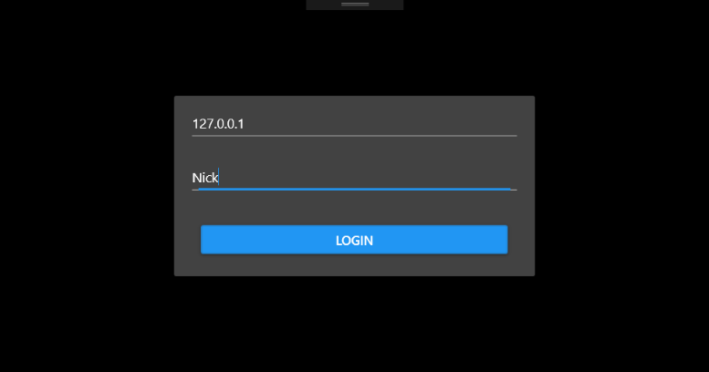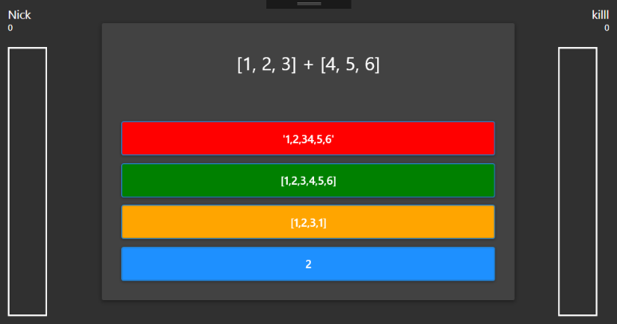

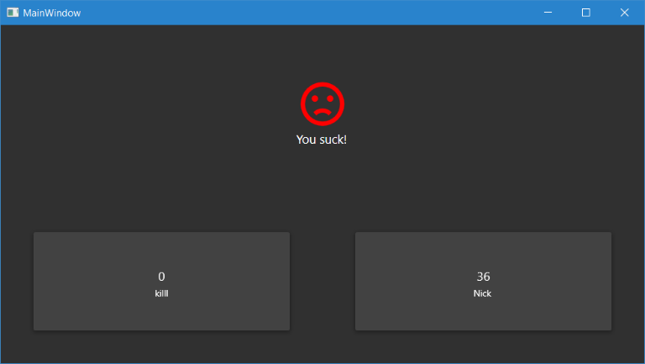Server:

.NET Core, C#

Client:

C#, WPF, Material Design

There is encryption between the server and client. On initial connect, server sends non-private RSA asymmetric key to client. Client uses this to encrypt a symmetric key (TripleDES) as a message and send it over it to the server. All the rest of the messages use this symmetric encryption (asymmetric encryption has restrictions on message size).