Costumer System Requirements:

1.

|  |  |
| --- | --- |
| UC Name | SignIn |
| Summary | Customers use their credentials to sign into their bank account. |
| Dependency | N/A |
| Actors | Primary Customer |
| Preconditions | The customer must have already created an account with the bank. |
| Description of the Main Sequence | The customer accesses the login page.  The customer inputs their username and password.  The system verifies the credentials and grants access. |
| Description of the Alternative Sequence | N/A |
| Non functional requirements | The sign-in process must be secured with encryption, and the system must be capable of handling high volumes of simultaneous login requests. |
| Postconditions | The customer is logged into their account. |

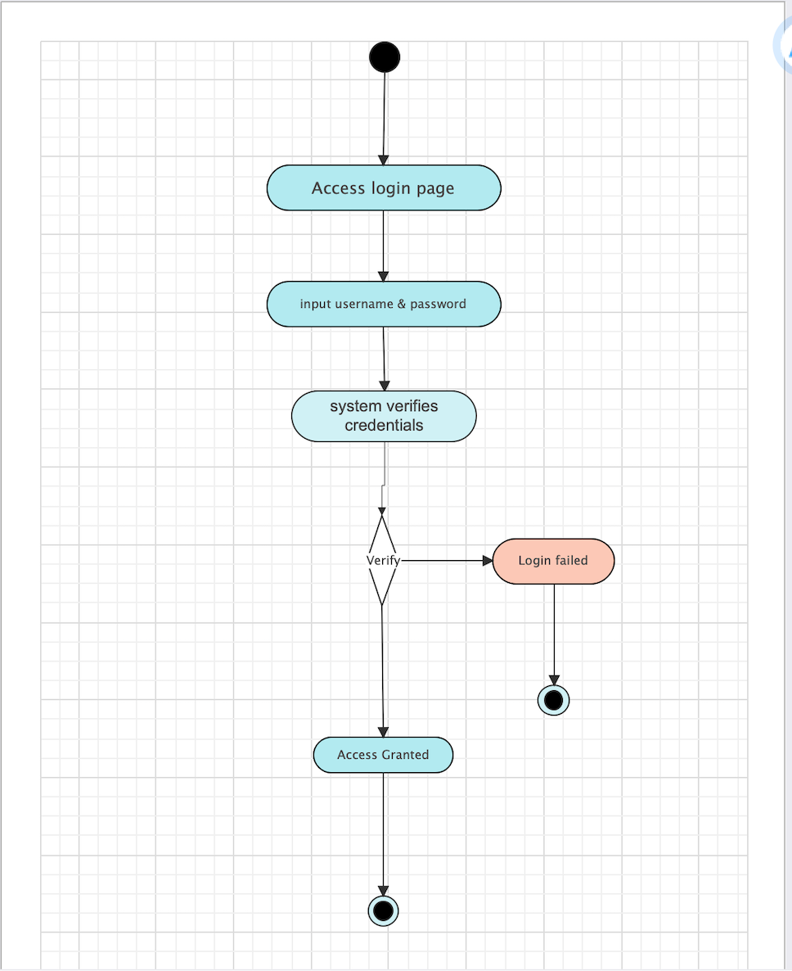

2.

|  |  |
| --- | --- |
| UC Name | UpdatePassword |
| Summary | Customers securely update their account password. |
| Dependency | CustomerSignIn |
| Actors | Primary Customer |
| Preconditions | The customer is logged into their account. |
| Description of the Main Sequence | The customer navigates to the account settings.  The customer selects the option to change their password.  The customer inputs their current password and then the new password.  The system verifies and updates the password. |
| Description of the Alternative Sequence | N/A |
| Non functional requirements | Password changes must comply with security policies, including complexity requirements and secure transmission. |
| Postconditions | The customer’s password is updated. |

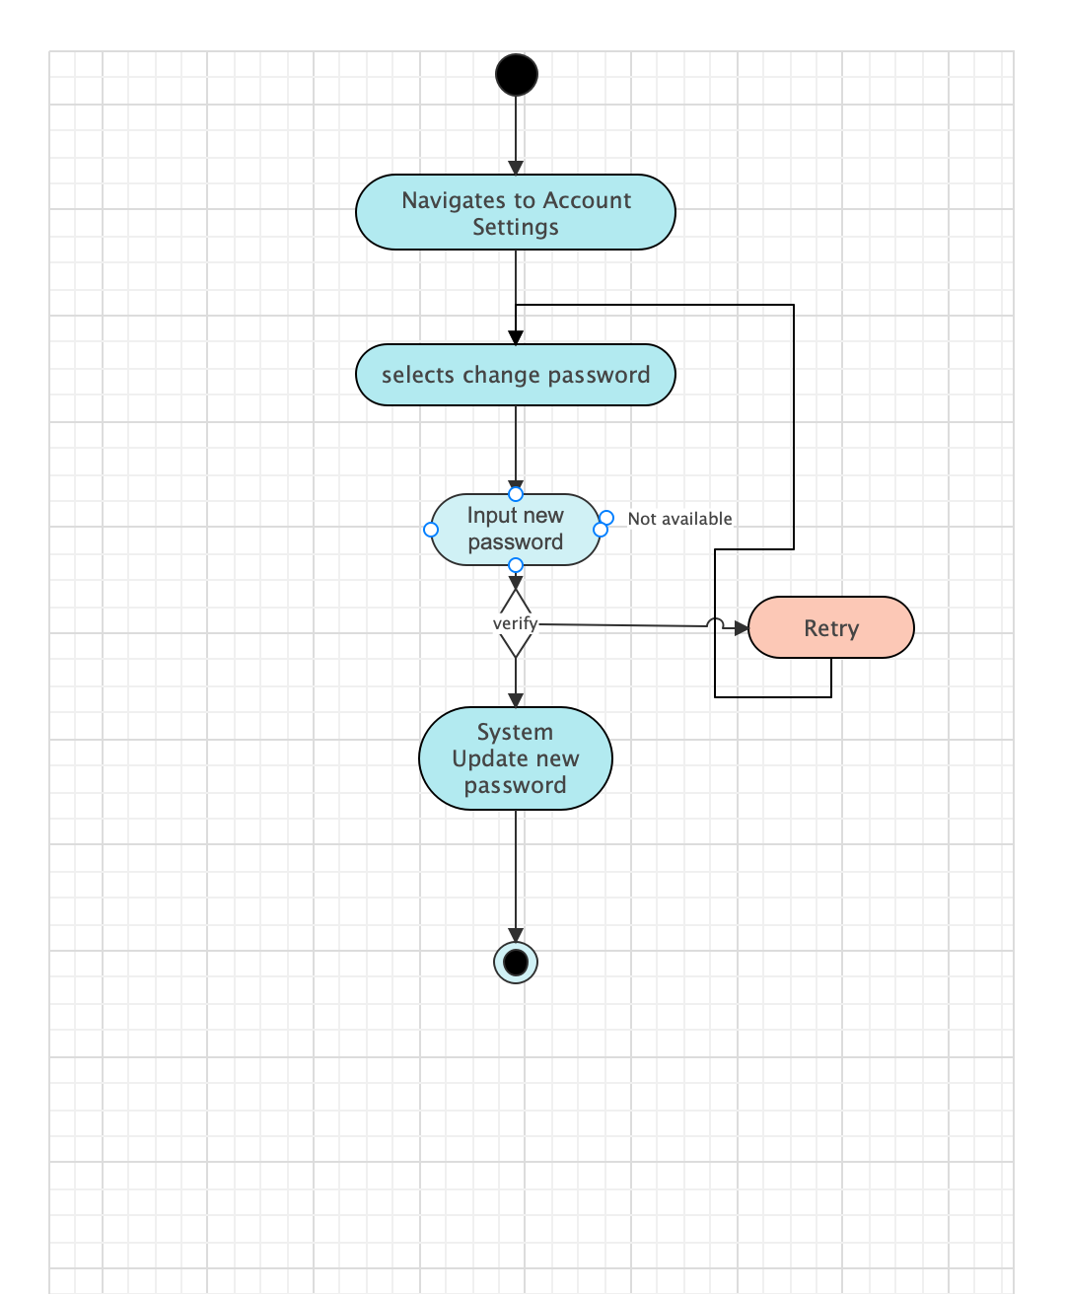

3.

|  |  |
| --- | --- |
| UC Name | ViewBalance |
| Summary | Customers check the balance of their accounts. |
| Dependency | CustomerSignIn |
| Actors | Primary Customer |
| Preconditions | The customer is logged into their account. |
| Description of the Main Sequence | The customer selects the account they wish to view.  The system displays the current balance of the selected account. |
| Description of the Alternative Sequence | N/A |
| Non functional requirements | Account balance displays must be real-time and accurate. |
| Postconditions | The customer has viewed their account balance. |

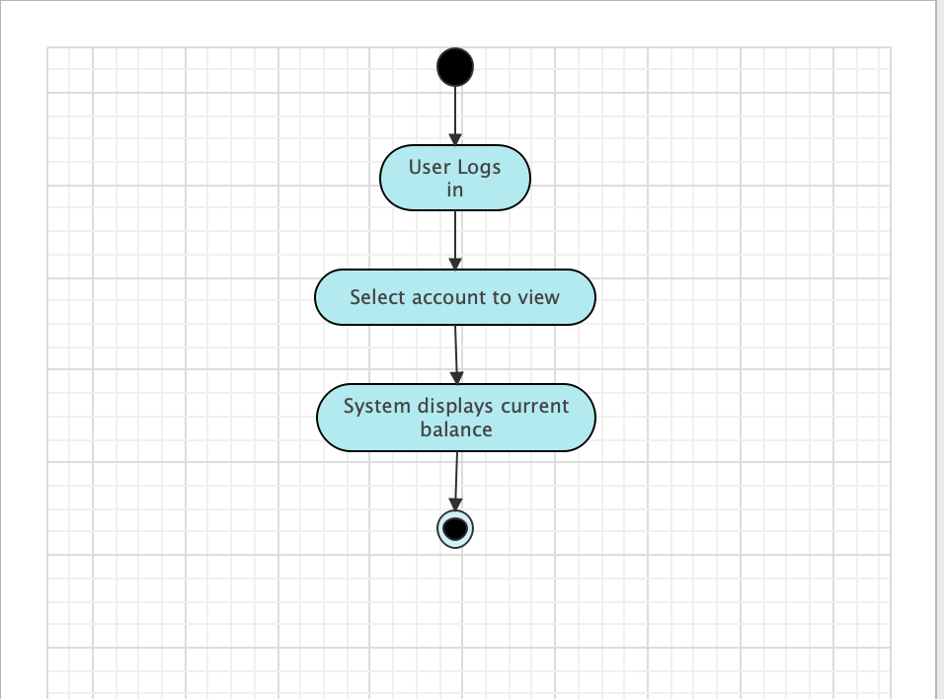

4.

|  |  |
| --- | --- |
| UC Name | ReviewHistory |
| Summary | Customers review the transaction history of their accounts. |
| Dependency | CustomerSignIn |
| Actors | Primary Customer |
| Preconditions | The customer is logged into their account. |
| Description of the Main Sequence | The customer selects 'Transaction History' from the account menu.  The system displays a list of recent transactions. |
| Description of the Alternative Sequence | N/A |
| Non functional requirements | Transaction history must be presented in a clear, chronological order, and the system should allow filtering and searching of transactions. |
| Postconditions | The customer has accessed their transaction history. |

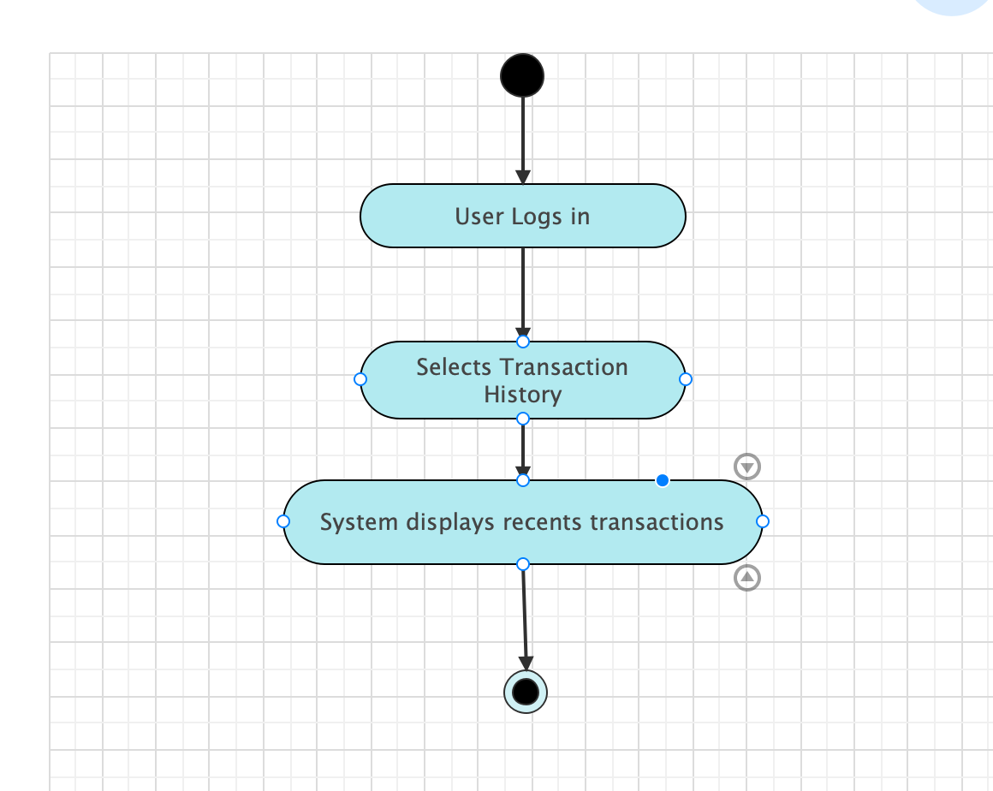

5.

|  |  |
| --- | --- |
| UC Name | DepositFunds |
| Summary | Customers deposit funds into their account. |
| Dependency | CustomerSignIn |
| Actors | Primary Customer |
| Preconditions | The customer is logged in and has a valid method for deposit. |
| Description of the Main Sequence | The customer initiates a deposit transaction.  The customer selects an account and enters the amount to deposit.  The system processes the deposit and updates the account balance. |
| Description of the Alternative Sequence | If the deposit is made at an ATM, the customer must insert cash or checks. |
| Non functional requirements | Deposits must be processed in a timely manner, and the system must provide immediate confirmation to the customer. |
| Postconditions | The deposit is reflected in the customer’s account balance. |

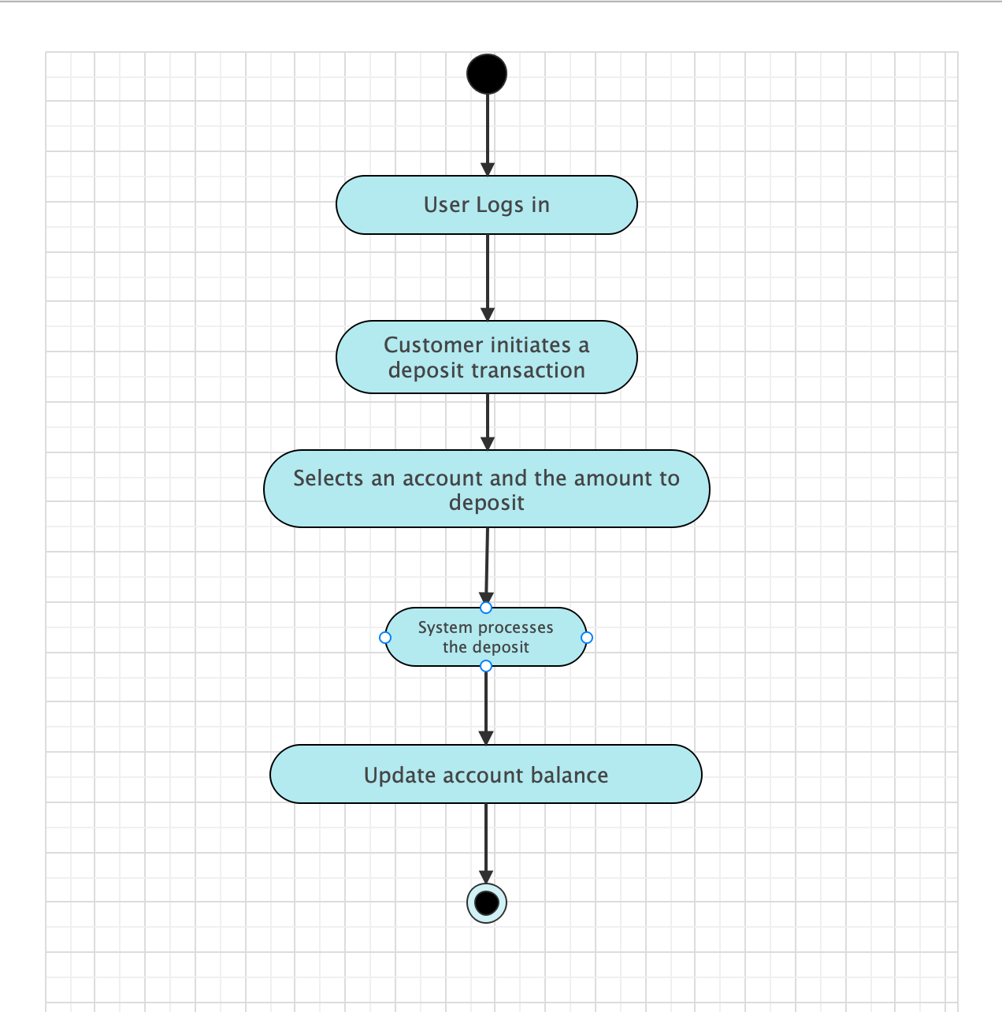

6.

|  |  |
| --- | --- |
| UC Name | WithdrawFunds |
| Summary | Customers withdraw funds from their account. |
| Dependency | CustomerSignIn |
| Actors | Primar Customer |
| Preconditions | The customer is logged in and has sufficient funds available. |
| Description of the Main Sequence | The customer requests a withdrawal.  The customer selects an account and specifies the amount.  The system processes the withdrawal and dispenses funds if at an ATM or confirms the transaction online. |
| Description of the Alternative Sequence | If a customer uses a teller for the withdrawal, the teller processes the transaction. |
| Non functional requirements | The system must securely process the withdrawal and have anti-fraud measures in place. |
| Postconditions | The withdrawal amount is deducted from the customer’s account balance. |

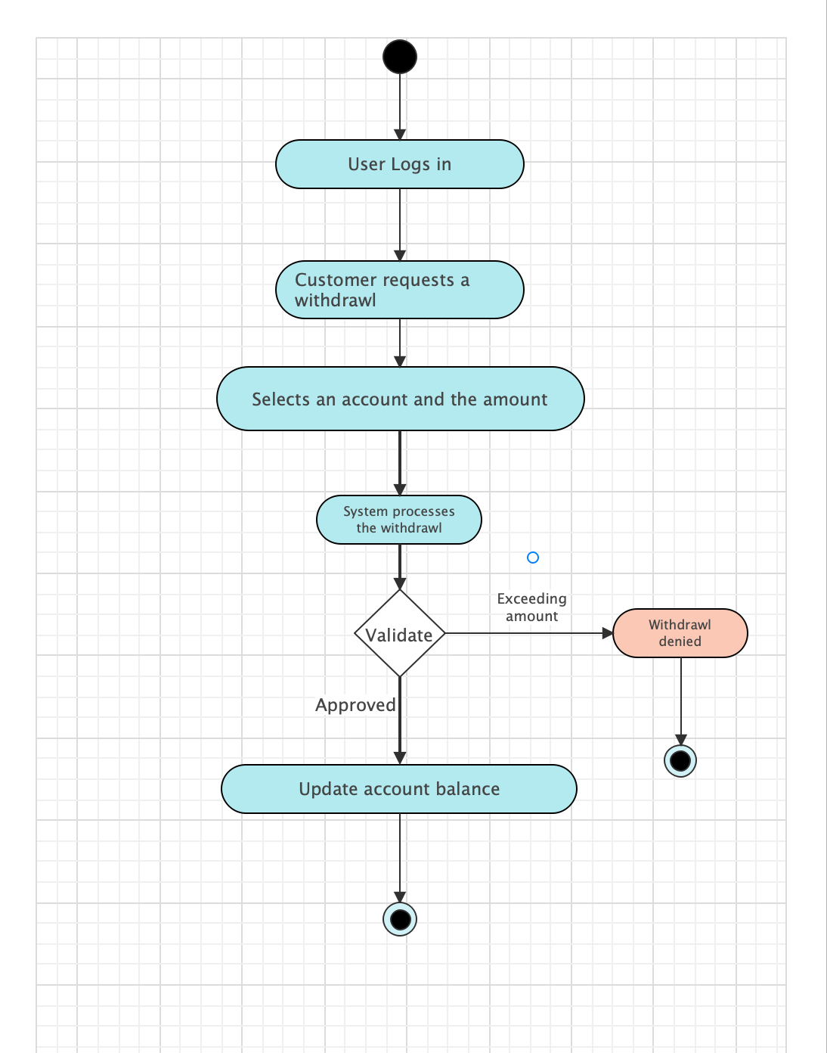

7.

|  |  |
| --- | --- |
| UC Name | TransferMoney |
| Summary | Customers transfer money between their own accounts. |
| Dependency | CustomerSignIn |
| Actors | Primary Customer |
| Preconditions | The customer is logged in and owns multiple accounts with the bank. |
| Description of the Main Sequence | The customer initiates a transfer between accounts.  The customer selects the source and destination accounts and enters the transfer amount.  The system processes the transfer and updates both account balances. |
| Description of the Alternative Sequence | N/A |
| Non functional requirements | The system must handle transfers instantly and securely, with all necessary fraud prevention checks. |
| Postconditions | The transferred funds are deducted from one account and added to another. |

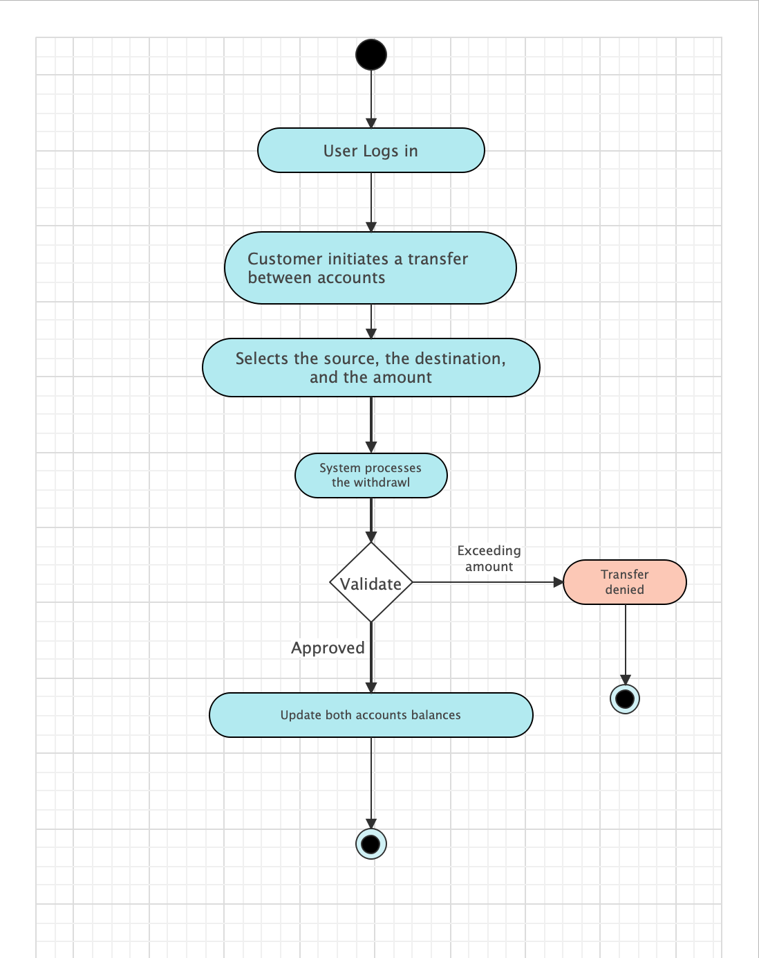

8.

|  |  |
| --- | --- |
| UC Name | RequestLoan |
| Summary | Customers requests for a loan. |
| Dependency | CustomerSignIn |
| Actors | Primary Customer |
| Preconditions | The customer is logged into their account. |
| Description of the Main Sequence | The customer initiates a loan request.  The customer selects the amount and the time period.  The system processes the loan payment and the interest rate. |
| Description of the Alternative Sequence | N/A |
| Non functional requirements | The system provides the loan details (payments, interest rate, and approval of loan). |
| Postconditions | The customer's loan requests is approved. |

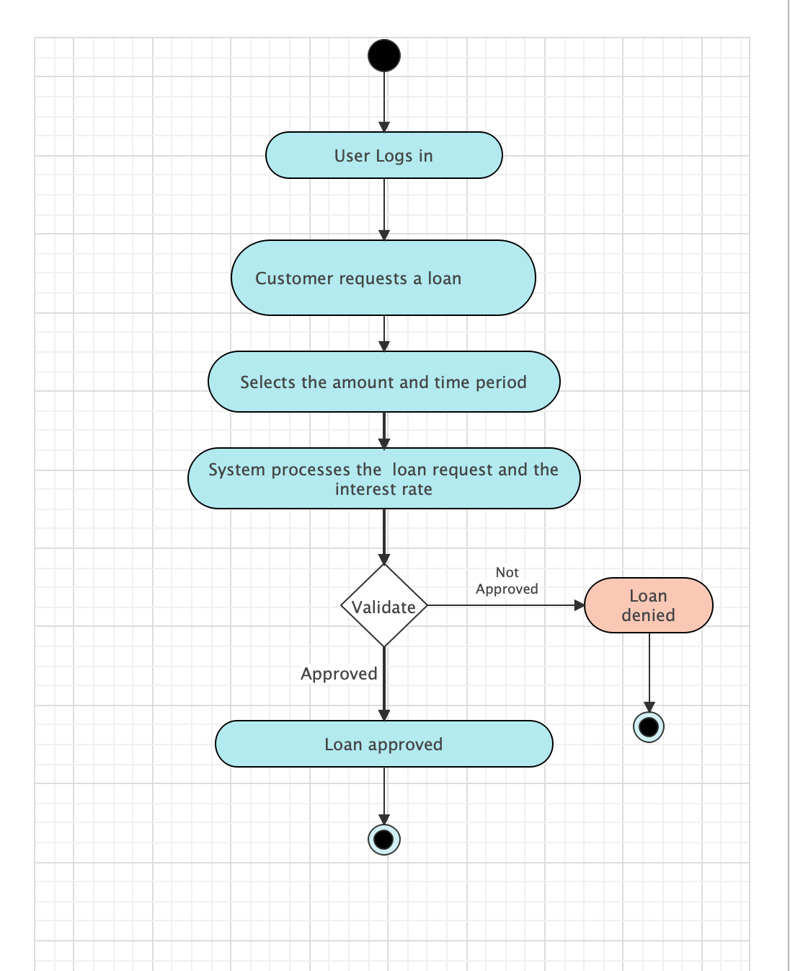

9.

|  |  |
| --- | --- |
| UC Name | ReportIssues |
| Summary | Customers report issues or flag unauthorized transactions for review. |
| Dependency | CustomerSignIn |
| Actors | Primary: Customer |
| Preconditions | The customer has identified a potential issue or unauthorized transaction. |
| Description of the Main Sequence | The customer navigates to the 'Help' or 'Support' section.  The customer selects the option to report an issue or flag a transaction.  The customer provides details of the issue or identifies the specific transaction.  The system logs the issue and provides the customer with a tracking number or confirmation. |
| Description of the Alternative Sequence | N/A |
| Non functional requirements | The reporting feature must be easily accessible and secure, ensuring the customer's information is protected. |
| Postconditions | The reported issue is registered in the system and queued for review by bank staff. |

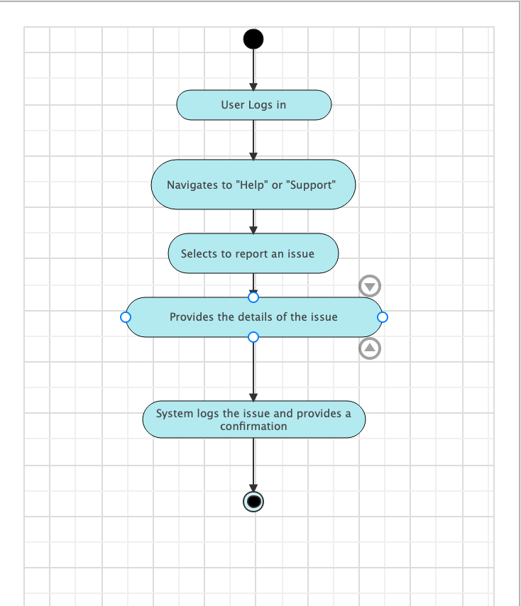

10.

|  |  |
| --- | --- |
| UC Name | AccessSupportServices |
| Summary | Customers access various support services provided by the bank. |
| Dependency | CustomerSignIn |
| Actors | Primary Customer |
| Preconditions | The customer requires assistance with a bank product or service. |
| Description of the Main Sequence | The customer selects the 'Contact Us' or 'Support' option.  The customer chooses the type of support needed (e.g., live chat, email, phone).  The system connects the customer with the appropriate support channel. |
| Description of the Alternative Sequence | If initial support channels are not available, the customer is provided with options to schedule a call or leave a message. |
| Non functional requirements | Support services must be accessible 24/7, and the system must maintain a high level of service quality and response time. |
| Postconditions | The customer has been assisted, and their inquiry or issue has been addressed. |

