Documentation: Temperature Converter

1. Introduction:

The Converter project aims to create a user-friendly web application for temperature conversion. Its purpose is to provide a convenient tool for users to convert temperatures between Celsius, Fahrenheit, and Kelvin scales. The application allows users to input a temperature value in one scale and instantly see the equivalent values in the other two scales. By offering a simple and intuitive interface, the Converter project seeks to facilitate quick and accurate temperature conversions, catering to the needs of individuals in various fields such as science, engineering, and everyday life.

The main objectives of the Converter project are as follows:

* Develop a user-friendly web application: The project aims to create an intuitive and easy-to-use tool that allows users to convert temperatures effortlessly. The user interface will be designed to provide a seamless experience, enabling users to input temperature values and obtain the equivalent conversions with minimal effort.
* Support multiple temperature scales: The Converter will support conversions between the three most commonly used temperature scales: Celsius, Fahrenheit, and Kelvin. Users will have the flexibility to enter temperatures in any of these scales and obtain accurate conversions to the other scales.
* Ensure accuracy and reliability: The project will focus on implementing precise conversion algorithms and logic to ensure that the converted temperature values are accurate. Extensive testing will be conducted to validate the correctness of the conversion results and to handle any potential edge cases or exceptions.
* Handle positive and negative temperatures: The Converter will be designed to handle both positive and negative temperature values. It will account for the different conventions and formulas used in converting temperatures in different scales, taking into consideration the specific characteristics and ranges of each scale.
* Provide a responsive and visually appealing user interface: The project will focus on creating a visually appealing user interface that adapts well to different screen sizes and devices. The Converter will be designed using modern web technologies and responsive design principles to ensure optimal user experience across desktop and mobile platforms.
* Promote maintainability and extensibility: The source code of the project will be structured and documented in a way that promotes maintainability and extensibility. Clear and concise comments will be added to facilitate understanding and future modifications or enhancements to the application.

By achieving these objectives, the Converter project aims to deliver a user-friendly temperature conversion tool that meets the needs of its users and provides accurate and convenient temperature conversions across different scales.

1. User Manuals:

* Open the Converter Application: Launch the web browser and navigate to the URL where the Converter application is hosted.
* Input Temperature Value: Locate the input field labeled "Celcius" and enter the temperature value you want to convert. You can input both positive and negative temperature values.
* Select Conversion Unit: Choose the desired conversion unit by entering the temperature in either "Fahrenheit" or "Kelvin." You can leave the input fields for the units you don't want to convert empty.
* View Converted Temperatures: As you enter the temperature value and select the conversion unit, the application will automatically calculate and display the converted temperature values in the remaining input fields. The conversions will be performed in real-time.
* Repeat the Process: You can repeat the above steps to convert additional temperature values. Simply enter a new temperature in the input field you want to convert, and the application will update the corresponding conversion results.
* Error Handling: If you enter an invalid input, such as a non-numeric value or an unsupported character, the application will not display any value. Make sure to enter valid numeric values for temperature conversions.
* Reset or Clear Values: To reset the application and start fresh, you can delete with backspace(or delete) button or, you can refresh the web page or click on a Reset button if provided. This will clear all input fields and allow you to enter new temperature values.

By following these step-by-step instructions, you can easily input temperature values, select the desired conversion units, and view the corresponding converted temperatures using the Converter application. Enjoy the convenience of quick and accurate temperature conversions!

1. Source Code Documentation:

The HTML, CSS, and JavaScript files work together to create the Converter application. Here's an explanation of their purpose and how they interact:

HTML:

* The HTML file provides the structure and content of the Converter application.
* It includes input fields for Celcius, Fahrenheit, and Kelvin temperatures, along with their respective IDs and placeholders.
* The HTML file also includes a reference to the CSS file (**style.css**) for styling and a reference to the JavaScript file (**main.js**) for functionality.
* The input fields are wrapped in a **<section>** element with the class "inputs" for styling purposes.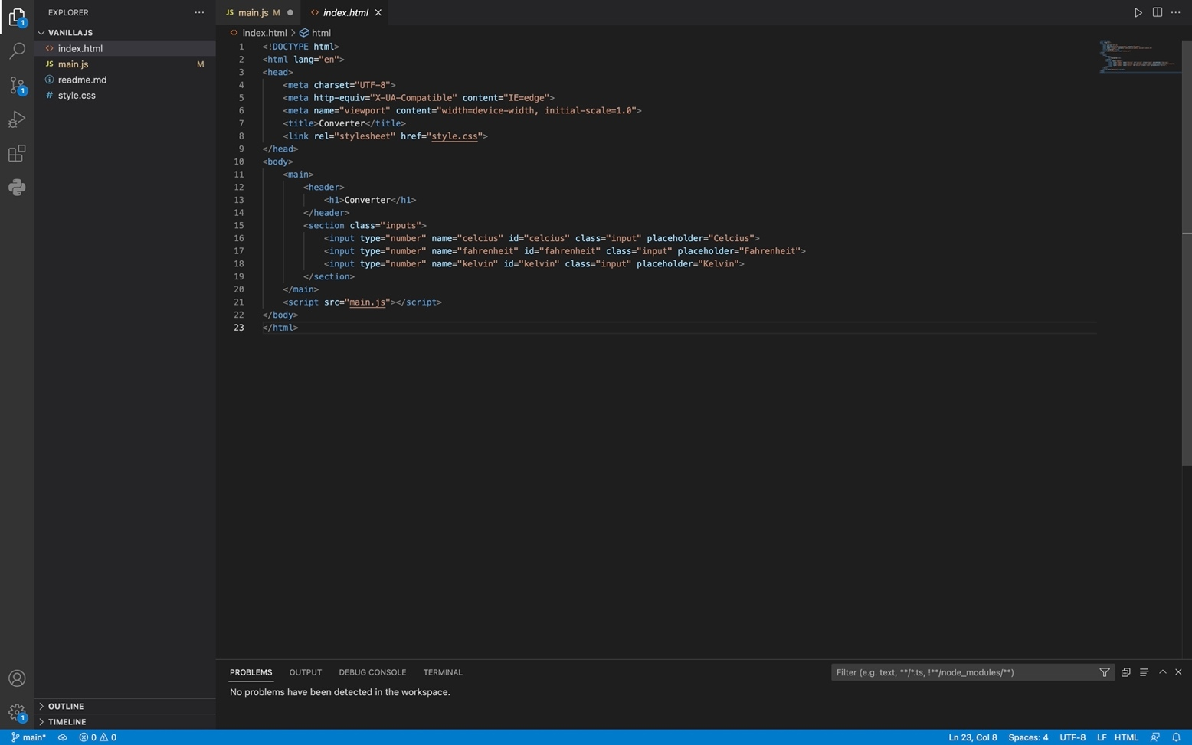

CSS:

* The CSS file (**style.css**) is responsible for styling the Converter application.
* It sets the styles for the main container (**main**), the header (**header**), and the input fields (**input**).
* It also defines the appearance and transitions for the input fields, such as background color, border radius, and box shadow.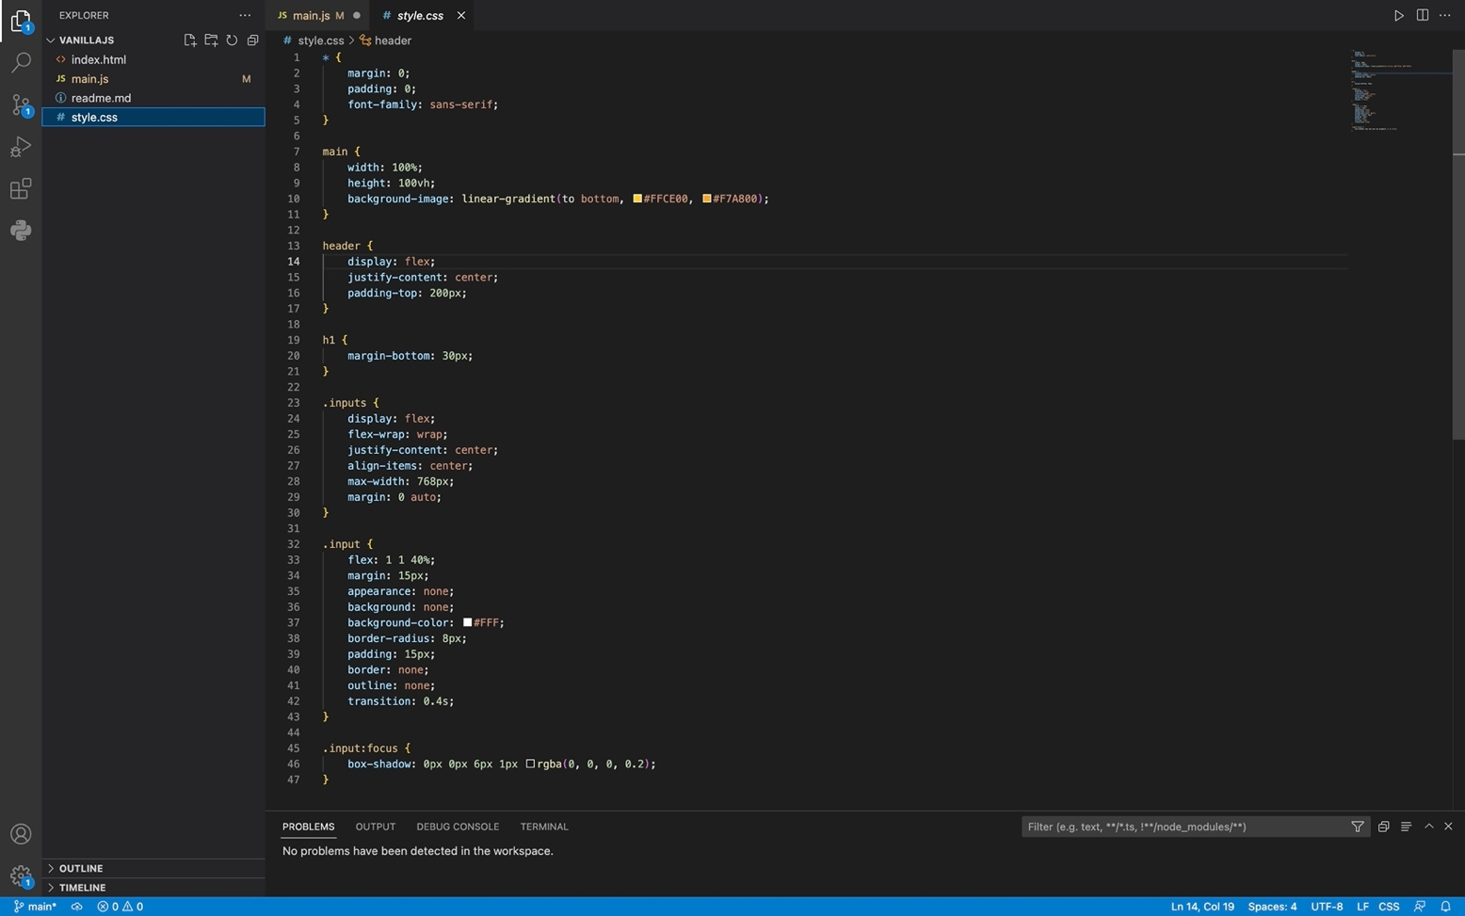

JavaScript:

* The JavaScript file (**main.js**) contains the logic and functionality of the Converter application.
* It retrieves references to the input elements using their IDs and stores them in variables (**celciusInput**, **fahrenheitInput**, **kelvinInput**).
* It attaches event listeners to the input elements, specifically listening for the "input" event.
* When the user enters a value in an input field, the event listener function is triggered.
* The event listener function performs the temperature conversion calculations based on the input field's name ("celcius", "fahrenheit", or "kelvin").
* The calculated values are then assigned to the respective input fields.
* The **isNumeric** and **isMinusSign** functions are helper functions used for input validation.
* The JavaScript code allows for real-time temperature conversion as the user inputs values in the input fields.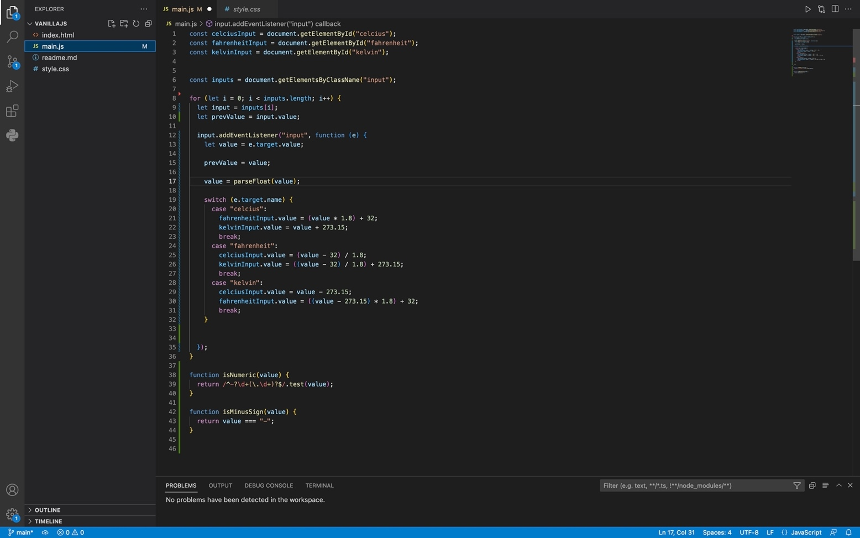

Overall, the HTML file provides the structure and content, the CSS file styles the application, and the JavaScript file adds interactivity and functionality to the Converter application.

1. Project Report:

Project Report: Temperature Converter

1. Project Requirements The project requirements were as follows:

* Support for temperature conversion between Celsius, Fahrenheit, and Kelvin scales.
* User-friendly interface with input fields for each temperature scale.
* Real-time conversion and display of converted temperatures.
* Input validation to ensure valid numeric input and handle invalid entries.
* Clear and responsive error solution.
* Proper styling and layout to enhance the user experience.

1. Conversion Logic The temperature conversion logic implemented in the project is as follows:

* When a user enters a value in any of the input fields, an event listener is triggered to capture the input.
* The input value is validated to ensure it is a valid numeric input using the **isNumeric** helper function.
* If the input is invalid (contains non-numeric characters other than "-"), the previous valid value is restored, and no value is displayed.
* If the input is valid, the conversion calculations are performed based on the input field's name ("celcius", "fahrenheit", or "kelvin").
* The calculated values are then assigned to the respective input fields using the appropriate conversion formulas.
* The conversions are updated in real-time as the user enters values, providing instant feedback.

1. Project Outcomes :

The Temperature Converter project successfully achieved its objectives by delivering a user-friendly tool for temperature conversion. The application provides a simple and intuitive interface for users to input temperature values, select the desired conversion units, and view the converted temperatures. Real-time conversion and error handling enhance the user experience, ensuring accurate results and informative feedback.

1. Conclusion :

The Temperature Converter project demonstrated the successful implementation of a web-based temperature conversion tool. The project met the specified requirements and delivered a functional and user-friendly application. The use of HTML, CSS, and JavaScript allowed for the creation of an interactive and responsive interface, enabling users to effortlessly convert temperatures between Celsius, Fahrenheit, and Kelvin scales. The project's development process highlighted the importance of proper input validation, error handling, and real-time updates for a seamless user experience.

In future iterations of the project, enhancements such as additional temperature scales, customizable themes, and support for complex conversions could be considered to further improve the application's versatility and usefulness.

