MENTORNESS ARTICLE

TASK 1

**INTRODUCTION TO POWER BI: GETTING STARTED WITH DATA VISUALIZATION**

**By OGUNRIN KALIFAT ENIOLA**

MIP-DA-04 Batch

**INTRODUCTION**

The capacity to efficiently visualize and analyze data is an essential talent for workers in a variety of businesses in today's data-driven world. Microsoft's robust business analytics product, Power BI, enables users to share smart visualizations of raw data with stakeholders. For those who are new to the world of Power BI data visualization, this article acts as an introduction.

**What is Power Bi?**

A set of business analytics tools called Power BI allows users to visualize data, connect to a variety of data sources, and share findings with other members of their organization. It offers a complete platform for data analysis, including interactive reporting, dashboard building, and data preparation.

Getting started with Power Bi:

**• Installation and Setup:**The free desktop program Power BI Desktop, which is the main interface for creating reports and visualizations, should be downloaded and installed first. After installation, open the program and log in using your organizational or Microsoft account.  
  
**• Data Connectivity:**  
Many data sources, such business databases, Excel spreadsheets, internet applications, and cloud computing platforms like Azure and Google Analytics, can be connected to using Power BI. Start by utilizing the "Get Data" option in Power BI Desktop to import your data. From there, you can select from a list of compatible data sources or use ODBC or OLE DB to connect to a custom source.

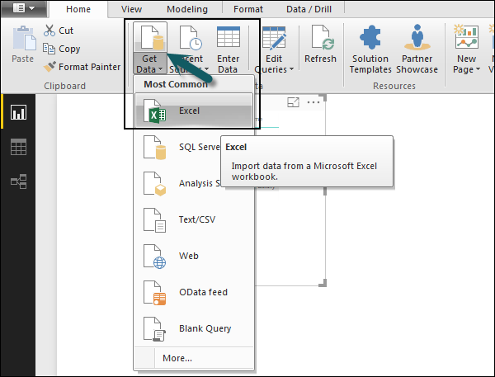

**• Data Transformation:**To clean, filter, and rearrange your data for analysis after connecting to your data source, you might need to carry out data transformation procedures. A variety of data transformation tools are available in Power BI Desktop, such as DAX (Data Analysis Expressions) formulas, data modelling, and query modification.

**• Visualization:**  
  
After your data is ready, you can begin utilizing it to tell a story and extract insights by visualizing it. Numerous visualization choices are available with Power BI, such as graphs, charts, maps, and bespoke visuals from the Power BI store. To create visualizations, drag and drop fields onto the canvas. You can also add interactive elements and formatting options to personalize your visualizations.

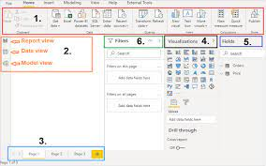

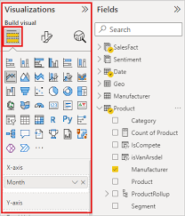

**• Creating a Dashboard:**With Power BI dashboards, you can combine many reports and visualizations into a dynamic, one canvas. Visualizations from various reports can be pinned to a dashboard and arranged to tell a coherent story. Dashboards can be published to the Power BI service for wider access or shared with other members of your organization.

Example of a Dashboard

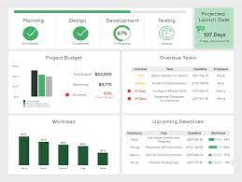

**• Cooperation and Sharing:**  
  
Users can share insights and work together with others using Power BI's comprehensive sharing and collaboration features. You can manage access rights, work together in real time with tools like comments and annotations, and share reports and dashboards with particular people or groups.

**• Conclusion**

Power BI is a powerful tool for data visualization and analysis, offering a user-friendly interface, robust connectivity options, and advanced visualization capabilities. By following the steps outlined in this article, beginners can quickly get started with Power BI and unlock the potential of their data to drive informed decision-making and business growth.

This article provides an introductory overview of Power BI and serves as a starting point for beginners looking to explore data visualization using this powerful tool. From installation and data connectivity to visualization and collaboration, Power BI offers a comprehensive platform for transforming raw data into actionable insights.