ISCS 539 – Data Analytics

Assignment #2

1. (5 points) Present the absolute and relative frequencies and respective cumulative frequencies for the attribute “Weight” in Table 1.

Table 1. Friends data set

|  |  |  |  |  |  |  |
| --- | --- | --- | --- | --- | --- | --- |
| **Friend** | **Max temp** | **Weight** | **Height** | **Years** | **Gender** | **Company** |
| Andrew | 25 | 77 | 175 | 10 | M | Good |
| Bernhard | 31 | 110 | 195 | 12 | M | Good |
| Carolina | 15 | 70 | 172 | 2 | F | Bad |
| Dennis | 20 | 85 | 180 | 16 | M | Good |
| Eve | 10 | 65 | 168 | 0 | F | Bad |
| Fred | 12 | 75 | 173 | 6 | M | Good |
| Gwyneth | 16 | 75 | 180 | 3 | F | Bad |
| Hayden | 26 | 63 | 165 | 2 | F | Bad |
| Irene | 15 | 55 | 158 | 5 | F | Bad |
| James | 21 | 66 | 163 | 14 | M | Good |
| Kevin | 30 | 95 | 190 | 1 | M | Bad |
| Lea | 13 | 72 | 172 | 11 | F | Good |
| Marcus | 8 | 83 | 185 | 3 | F | Bad |
| Nigel | 12 | 115 | 192 | 15 | M | Good |

Note: The file, named “Friends”, with the data set given in Table 1 is attached.

1. (5 points) Plot a histogram for the “height” attribute in Table 1.
2. (5 points) Classify the type of relation between the two attributes in the scatter plot shown in Figure 1.

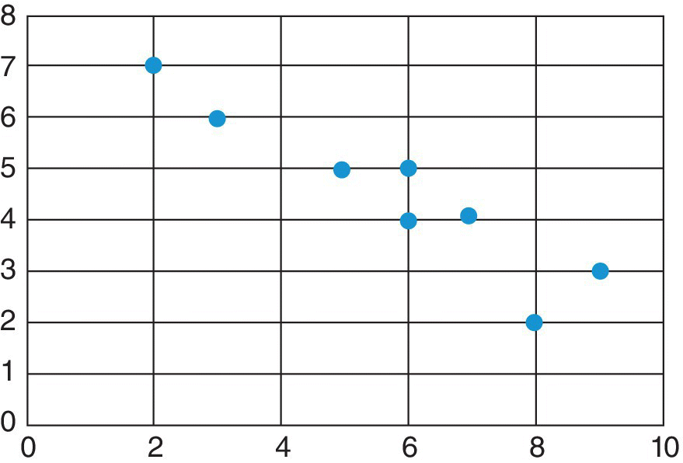

Figure 1. Scatter plot

1. (5 points) Create the contingency table for the attributes “gender” and “company” in Table 1.
2. (5 points) Create a box plot for the attribute “Years” in Table 1.
3. (5 points) Create a pie plot for the attribute “Company” in Table 1.
4. (5 points) Create a stacked bar plot for the attributes “Gender” and “Company” in Table 1.
5. (5 points) Create a mosaic plot for the attribute “Years” in Table 1.
6. (5 points) Create a scatter plot for the attributes “Max temp” and “weight” in Table 1.

Note: Each plot should have a plot title, axis labels and axis titles.