文章标题：Percussion Pro V3 （小字： A Real-Time Feedback App for Conga Learning）
作者：TED HUANG
时间：SEPTEMBER 2025
字数：N/A

Abstract: N/A（附上github链接）

Dedication and acknowledgements：
Dedicated to my supervisor, Prof. Oliver Ray, Peter Bennett and Nathalie Alexandra for providing me with much guidance and inspiration throughout this project.
Dedicated to colleagues who participated in the research for my Evaluation section.
Dedicated to my family and friends for supporting me during this academic year at the University of Bristol.

Author’s Declaration（signed and date）

Table of Contents（包括List of Tables（性能测试，用户反馈）, List of Figures（背景部分配图，截图，时序图，类图）, List of Listing etc.
Introduction, Background, Development Work, Evaluation, Further Work, Conclusion）

Chapter 1
Introduction
  - Motivation
Cuban music—distinguished by a highly recognizable rhythmic vocabulary centered on the clave—rose to global prominence in the twentieth century and has profoundly shaped the sound world of American jazz and popular music worldwide[1]. Its core aesthetic rests on a deep fusion of rhythmically intricate African patterns with Western/Spanish melodic and harmonic frameworks, exemplified by genres such as son, rumba, and danzón.[2] Within this cross-cultural formula, the percussion battery functions as the time-line and groove engine; in particular, the clave (both the organizing pattern and the pair of sticks), bongó, conga (tumbadora), and timbales form the signature timbral and rhythmic foundation of the son conjunto and Latin jazz[3].
[1] Manuel P. Rhythmic Structures in Latin American and Caribbean Music. In: Hartenberger R, McClelland R, eds. The Cambridge Companion to Rhythm. Cambridge Companions to Music. Cambridge University Press; 2020:283-297.
[2] Carpentier, Alejo. Music in Cuba. Vol. 5. U of Minnesota Press, 2001.
[3] Fernandez, Raul A. From Afro-Cuban Rhythms to Latin Jazz. Vol. 10. Univ of California Press, 2006.

The conga (conga / tumbadora) emerged within Afro-Cuban communities, taking shape at the intersection of Bantu-derived drums (e.g., makuta, yuka) and Cuba’s urbanization, and it subsequently became one of the most emblematic hand drums in Latin American and global music.[4] Owing to its timbral richness and rhythmic expressivity, the conga has drawn large numbers of learners and produced many renowned artists. For example, Mongo Santamaría absorbed rumba practice informally in Havana’s neighborhoods before bringing the conga into the mainstream in the United States with works such as “Watermelon Man”;[5] Chano Pozo moved from comparsa and rumba settings in Havana to New York, where his collaboration with Dizzy Gillespie helped establish cu-bop / Latin jazz; Cándido Camero is widely credited with systematizing the conga within jazz; and, in more recent decades, Giovanni Hidalgo has set contemporary benchmarks through technical innovation—trajectories that were largely rooted in apprenticeship, oral transmission, and stage practice.[6-9]
Unlike the earlier era when study depended primarily on in-person mentorship, today’s online resources for conga (videos and method books) are abundant. However, the lack of immediate, individualized performance feedback and formative error correction has repeatedly been shown in music-education research to diminish learning effectiveness—for instance, online formats often cannot promptly correct hand shape, posture, tone quality, or timing deviations.[10]This gap is especially consequential for percussion instruments such as the conga, where temporal control is central: without real-time feedback during practice, both novices and experienced players may be unaware of performance issues, reinforcing errors into habits that impede progress. Consequently, robust feedback mechanisms are particularly needed across the broad community of conga learners.[11]
[4] Warden, Nolan. "A History of the Conga Drum." Percussive Notes 43.1 (2005): 8-15.
[5] C. Gerard. Music from Cuba: Mongo Santamar´ıa, Chocolate Armenteros, and Cuban Musicians in the United States. 2001.
[6] Garcia, David. "“We Both Speak African”: A Dialogic Study of Afro-Cuban Jazz." Journal of the Society for American Music 5.2 (2011): 195-233.
[7] The John F. Kennedy Center for the Performing Arts. Candido Camero. Accessed 28/08/2025. URL: https://www.kennedy-center.org/artists/c/ca-cn/candido-camero/
[8]JazzTimes. Giovanni Hidalgo (Artist Profile). Accessed 28/08/2025. URL: https://jazztimes.com/artists/giovanni-hidalgo/
[9] Modern Drummer. Concert to Benefit Legendary Conga Player Giovanni Hidalgo. Accessed 28/08/2025. URL: https://www.moderndrummer.com/2017/08/concert-benefit-legendary-conga-player-giovanni-hidalgo/
[10] Váradi, Judit, et al. "Lessons from the COVID pandemic in music education the advantages and disadvantages of online music education." Heliyon 10.15 (2024).
[11] Sadakata, Makiko, et al. "Real-time visual feedback for learning to perform short rhythms with expressive variations in timing and loudness." Journal of New Music Research 37.3 (2008): 207-220.

Most self-learning apps for conga and other percussion still center on videos/tutorials and play-along tracks, lacking mechanisms for real-time, individualized assessment of timing, dynamics, and hand posture; as a result, they offer limited error correction. Research in both academia and industry shows that augmented or real-time feedback—via visualization or sonification—can significantly improve timing accuracy, coordination, and practice efficiency, and this has been validated in percussion contexts (e.g., mixed-reality and wearable-sensor drum-training systems, rhythmic/motor-learning sonification studies). These findings suggest that a learning tool with cross-device consistency (desktop and mobile), timely feedback, and strong UI/UX is more likely to increase immersion and learning outcomes[12-14].
[12] O'Leary, Emmett. "Music education on YouTube and the challenges of platformization." (2023).
[13] Pinkl, James, Julián Villegas, and Michael Cohen. "Multimodal Drumming Education Tool in Mixed Reality." Multimodal Technologies and Interaction 8.8 (2024): 70.
[14] Şimşekli, Umut, et al. "Real-time recognition of percussive sounds by a model-based method." EURASIP Journal on Advances in Signal Processing 2011.1 (2010): 291860.

Furthermore, evidence linking cross-platform consistency and highly usable interfaces to user engagement and retention—along with reviews of music/education apps recommending consistent interactions and actionable real-time feedback across devices—supports the product and experience design choices proposed here. In short, combining multi-platform availability with high-quality immediate feedback and an aesthetically refined, easy-to-use interface is a key pathway to deeper immersion and better learning results for this class of applications.[15][16]
[15] Venkova, Jelizaveta, and Essien Nkpoikanna. "Optimizing User Experience Across Platforms: A Study on Enhancing music-streaming Applications' Cross-device Unification." (2024).
[16] Bitrián, Paula, Isabel Buil, and Sara Catalán. "Enhancing user engagement: The role of gamification in mobile apps." Journal of Business Research 132 (2021): 170-185.
Percussion Pro is an Android application developed to address the issues outlined above. It allows users to select and perform rhythms from a small, precompiled list and provides immediate feedback on the timing of the most recently played note. However, there are still areas for improvement in practice—for example, achieving compatibility across iOS, Android, and desktop platforms, as well as refining the UI. Building on the ideas behind this app, this dissertation will attempt to extend and improve its functionality with a web-based implementation.

  - Project Aims
本项目聚焦于开发 RhythmPro Web——一款面向康加/金贝等手鼓训练的网页应用。它嵌入于基于 p5.js + Web Audio API 的前端应用中，并配套一个自成体系的教学工作坊，用于讲解节拍与击法基础。工作坊作为用户入口，通过交互式示例演示滚动谱面与判定窗口、节拍器与（son/rumba）clave 节型、振幅/频谱可视化，以及“首击即开始”的练习流程。训练模块提供实时反馈：对每次击打的时值偏差与一致性以音符点亮、落点标记与 HUD 统计呈现，并支持不同速度/拍号的曲目练习。二者结合的目标，是先建立对“时间控制与击打一致性”的直观理解，再以具有沉浸感的练习模式驱动持续练习与能力提升。最终，该工作坊与训练应用有望服务于中学音乐教学、社区乐团，以及高校音乐技术/表演入门课程。
本项目的主要贡献如下：
- 网页端打击乐训练系统：跨桌面与移动端运行，提供实时时值判定（如 Perfect / Good / Miss）、命中档案可视化（音符点亮、落点轨迹、误差刻度），显著提升练习时的自我评估能力。
- 交互式教学工作坊：系统讲解拍号与数拍法（如 one-and-two-and、one-ee-and-ah）、基本击法（open / slap / bass / heel-toe）与练习法；项目与（可选的）数据采集均集成在同一 Web 应用中，便于统一管理与迭代。
- 音频分析面板集成：基于 WebAudio 的振幅/RMS与FFT 频谱视图，辅助评估音色与力度，为“击法质量”的自检提供客观量化参考。
- 嵌入式用户评估设计：规划了应用内的可用性与学习效果评估（问卷/匿名日志）以衡量教学影响、内容适切性与改进方向，并预留指标与数据结构以便后续实验。
- 可扩展架构与路线：预留击法分类与谱面编辑/编曲接口，支持后续接入 ml5.js/CNN 或传统特征分类器，以及在线编曲器；节奏/clave 引擎与调度器采用可插拔封装，便于未来扩展多鼓同步/调音等功能。

Chapter 2
Background
2.1 Technical Background
This section describes the existing technical solutions that are expanded upon in this project, as well as the tools used throughout; I explain their function, and why they were chosen as the solution to a specific problem in the development of the app.
2.1.1 Javascript
JavaScript has practical advantages over many single-platform languages: it’s the only language natively supported by all modern browsers, requiring no extra runtime or plug-ins—so apps ship with near-zero install friction.[17] Beyond the browser, the same language runs on servers via Node.js and can target native mobile (React Native) and cross-platform desktop (Electron), enabling end-to-end code sharing instead of maintaining separate stacks.[18] Finally, the npm ecosystem—the world’s largest software registry—offers millions of reusable packages that accelerate delivery and maintenance versus smaller ecosystems.[19]
[17] MDN Web Docs. JavaScript. URL: JavaScript
[18] Node.js. The V8 JavaScript Engine. Node.js — The V8 JavaScript Engine
[19] npm Docs. About npm. About npm | npm Docs
2.1.2 p5.js
p5.js is a front-end JavaScript library for “creative coding,” originating from the Processing community. It aims to make it easy for artists, designers, educators, and beginners to create interactive graphics and media. The official site provides a comprehensive reference, tutorials, and examples, and the project is fully open source with an inclusive community. And this project relied on The p5.sound, which is add-on extends the Web Audio API with audio input/playback, analysis (FFT, spectrum/energy), synthesis, and recording—useful for metronome visualization and tone/dynamics feedback.
[20] p5.js. About p5.js; Reference; Tutorials. (Official website.) URL: About
[21] p5.js contributors. p5.sound — Official Reference; GitHub Repository. URL: p5.sound Reference
2.1.3 Web Audio API
The Web Audio API is a browser-native, high-level interface for audio processing and synthesis. It centers on an audio graph model: multiple AudioNodes (sources, processors, outputs) are connected inside a single AudioContext to handle routing, effects, and rendering. The specification is maintained by the W3C, and MDN provides comprehensive guides and examples. And the achievement of Audio API mostly relied on p5.sound.
2.1.3.1 p5.FFT
p5.FFT is the spectrum/waveform analyzer provided by p5.sound. Built on the Web Audio analysis node, it can extract both frequency-domain (spectrum) and time-domain (waveform) data from a given audio source, making it useful for visualization and for tasks like rhythm/strike detection.[22]
[22] p5.sound Reference — p5.FFT URL: p5.sound Reference
2.1.3.2 p5.AudioIn
p5.AudioIn is the microphone-input wrapper provided by p5.sound, used to capture an audio stream from a computer or mobile device microphone. Use start() / stop() to begin or end capture; once started, you can call getLevel() to read the input level, or route the input into p5.FFT for spectrum/waveform analysis. Under the hood, p5.AudioIn uses getUserMedia to obtain a MediaStream; the browser prompts for permission and, if granted, returns a stream containing the audio track(s).[23]
[23] p5.js. p5.AudioIn (p5.sound Reference). p5.AudioIn
2.1.3.3 p5.Amplitude
p5.Amplitude is the loudness (amplitude) analyzer provided by p5.sound, used to measure instantaneous loudness in the 0.0–1.0 range. By default it listens to the p5.sound master output, but you can bind it to a specific source (e.g., microphone, sound file, oscillator) via setInput().[24]
[24]p5.js. p5.Amplitude (p5.sound Reference). URL: p5.Amplitude
2.1.4 Canvas 2D
Canvas 2D is the two-dimensional rendering context for the <canvas> element (CanvasRenderingContext2D). It provides a resolution-dependent bitmap surface on which JavaScript can draw shapes, text, and images in real time, supporting animation, data visualization, and game use cases.[25] In this project, I use Canvas 2D for UI and visual effects: paths and rectangles render the HUD, scrolling notation, error ticks, and hit traces; drawImage is used for icons/texture sprites; fillText/measureText handle labels and axes; save/restore together with translate/scale/rotate create local coordinate systems and high-DPI adaptations (with devicePixelRatio) to keep lines and text crisp; globalAlpha, shadowBlur, shadowColor, and globalCompositeOperation produce “lit-up,” glow, and compositing effects; and the scene is updated per frame via requestAnimationFrame/p5.js’s draw() loop, with batched paths and minimal redraws to control performance cost.
[25] MDN Web Docs. Canvas API — Overview; CanvasRenderingContext2D. Accessed. URL: Canvas API
2.1.5 High-precision Timing
High-precision timing and performance on the web rely on three core primitives: the Web Audio clock (BaseAudioContext.currentTime) for sample-accurate scheduling, display-synced rendering via requestAnimationFrame, and high-resolution, monotonic timestamps from performance.now() [26]. In this project, I use currentTime as the master clock and schedule metronome/clave clicks with AudioBufferSourceNode.start(when) inside a rolling lookahead window; a Web Worker created from a Blob script emits ~25 ms ticks via postMessage so scheduling is insulated from main-thread jank; requestAnimationFrame drives Canvas/p5.js updates so the HUD (judgment line, hit traces, scrolling notation) stays aligned with the display; performance.now() measures frame intervals/jitter to trigger adaptive throttling (e.g., lowering FFT bins or redraw frequency under load); and audio assets are preloaded with fetch() → arrayBuffer() → audioContext.decodeAudioData() so playback timing is not impacted by decoding at trigger time—together yielding tight audio–visual sync and stable tempo even under UI load.
[26] Chris Wilson：A Tale of Two Clocks — Scheduling Web Audio with Precision（web.dev）URL: A tale of two clocks | Articles | web.dev

2.1.6 Teachable Machine
Teachable Machine is a zero-/low-code machine learning modeling tool from Google that supports three modalities—image, audio, and pose. Users can collect samples in the browser and train with a click to obtain deployable classification models. The platform provides built-in dataset splitting and visualized training curves, and supports one-click export to TensorFlow.js (for the web) and TensorFlow/TFLite (for local or mobile), making it easy to run inference on websites, apps, or embedded devices.
[27] Google. Teachable Machine — Homepage. Accessed 29 Aug 2025. URL: Teachable Machine

2.2 Contextual Background
2.2.1 Clave
The clave is a five-stroke timeline pattern that refers both to the rhythmic archetype and to the pair of wooden sticks (claves) used to play it. It is ubiquitous in genres such as Abakuá, rumba, conga, son, mambo, salsa, timba, and Afro-Cuban jazz, where it organizes ensemble entrances, phrase direction, and accent placement—functioning as the music’s “heartbeat.”[28] The two most common forms are the son clave and the rumba clave, whose structures are closely related; in this project, only the 3-2 son clave is used as the timeline pattern.
[28] Wikipedia. Clave (rhythm). URL: Clave (rhythm) - Wikipedia
(附上本项目使用的Son clave 3-2节奏谱图)
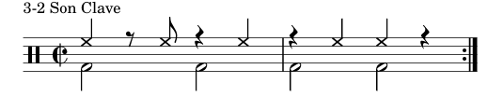
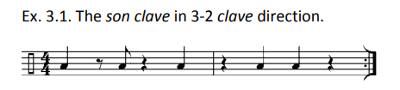
Figure[29] [31]
[29] Clave Patterns (PDF compilation: son/rumba 3–2 & 2–3, and 6/8). (sambasavannah.org)
2.2.2 Metronome
A metronome is a device that marks musical tempo with evenly spaced clicks (beats per minute, BPM). The classic form is a spring-driven pendulum; modern versions are electronic or app-based.[30] Beyond steady clicks, today’s digital/app metronomes typically add accent patterns, subdivisions, polyrhythm presets, tap-tempo, and flexible meters, making them useful practice tools for drummers and ensemble players. In your project, the metronome runs on the Web Audio clock and is scheduled ahead of time for sample-accurate clicks; it also drives visual accents in the HUD and supports clave-style patterns for Afro-Cuban practice. Besides, it also play as a choice for those who prefer it to clave.
[30] Merriam-Webster. Metronome — concise definition. URL: METRONOME Definition & Meaning - Merriam-Webster
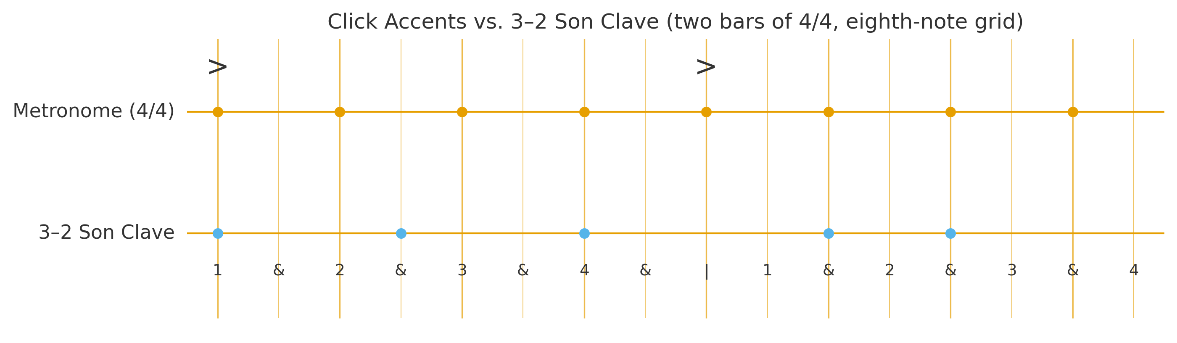
Figure(self-draw)

2.2.3 Percussion Notes
The notation of unpitched percussion remains largely unstandardized, with multiple ways to represent the same rhythmic and timbral information. For clarity, the following section draws on Alex Pertout’s master’s thesis[31], which presents a systematic account of the conga’s sound/technique system.
- Palm(heel): This sound is achieved by striking the drum head with the entire hand in a flat position.
- Tip(toe): This sound is achieved by striking the lower drum head area with the fingertips.
- Bass: This sound is achieved by striking and retracting the palm from the center of the drum head.
- Open Tone: This sound is achieved by striking the edge of the drum head with the ridge of the palm, while the extended fingers are in an elevated closed position.
- Muffled Tone: This sound is achieved by striking the edge of the drum head with the ridge of the palm, while pressing the drum head with the extended fingers in a lowered closed position.
- Slap: This sound is achieved by striking the edge of the drum head with the ridge of the palm, while the extended fingers in an open position simultaneously strike and grab the drum head.
- Muffled Slap: This sound is achieved as per the slap method described above, with the incorporation of the other hand muting the drum head.
- Open Slap: This sound is achieved by striking the edge of the drum head with the ridge of the palm, while the extended fingers in an elevated open position, strike then retract from the drum head.
The above outlines the basic set of conga strokes. In most practical scores, however, the strokes used most frequently are Open tone (O), Slap (S), tip–heel (T–P; also called heel–toe), and Bass (B). Accordingly, this project focuses on these core techniques.
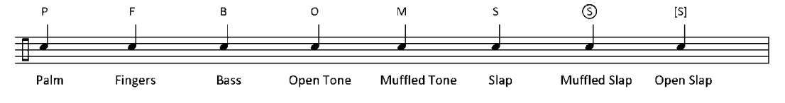
Figure[31]
[31] Pertout, Alex. "The Conga drum: development, technique, styles, improvisations and the contribution of master drummer Ramon'Mongo'Santamaria." (2008).

2.2.4 Drum Types
The conga family typically consists of three differently sized drums: the small quinto (highest pitch, often leading and improvising in rumba and related styles), the medium conga (mid-range, forming the ensemble’s rhythmic backbone), and the large tumba (lowest pitch, providing the low-frequency foundation). Common commercial head diameters are approximately 11" (quinto), 11.75" (conga), and 12.5" (tumba); some makers also offer a smaller 9.75" requinto and a larger 14" super tumba to extend the range. This division of roles and sizing is standard in contemporary salsa, rumba, and Afro-Cuban jazz settings.[32]
[31]Wikipedia. Conga. URL: Conga - Wikipedia
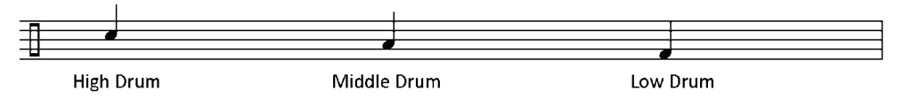
Figure various conga drums[31]
This figure illustrates a preferred tuning and drum-set layout. The circles representing the drumheads vary in size to indicate different conga head diameters. Pitch labels (letters, sometimes in brackets) are given as degrees of the chromatic scale. The diagram also includes a narrow rectangular piece at the back, indicating either the stool on which the player may sit or the spot where the player stands behind the drums. Figure 2.1 shows the standard two-conga tuning and placement: the smaller, higher-pitched drum is positioned directly in front of the player, and the larger, lower-pitched drum is placed to the player’s right.
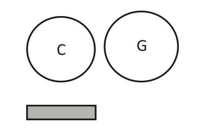
Figure[31] The basic two drums set up

2.3 Existing Solutions
2.3.1 Percussion Pro[33]
Percussion Pro, developed by Jakub Baluch for Afro-Cuban percussionists, is a “listening-based” app designed to improve rhythmic control for learners of African drums. Its feature set is relatively complete: in Practice mode, users can work with son clave patterns and receive timing feedback—early, on time, or late. This directly informed my project: the app moves a sliding bar across the notation and compares the actual strike time with the expected time to generate feedback. In addition, a Listen mode lets users hear standard reference patterns. Finally, the Analyzer function outputs waveform spectrograms, which inspired me to explore developing a stroke recognizer from physical features such as waveform shape and frequency content.
[33]Jakub Baluch. Percussion Pro. Accessed 27/05/2025. URL: https://github.com/ph22432/ PercussionPro.

2.3.2 PercussionTutor[34]
PercussionTutor is an educational app for “world percussion” that ships with an extensive library of grooves and notated scores, allowing users to select the material they want to study. It includes a built-in metronome and time-stretching so practice tempo can be slowed down or sped up without changing pitch, and it offers a Listen mode for auditioning reference performances. The metronome and time-stretching features in this project were inspired by PercussionTutor, and many of the practice scores are sourced from it. Its main limitation, however, is the lack of real-time feedback.
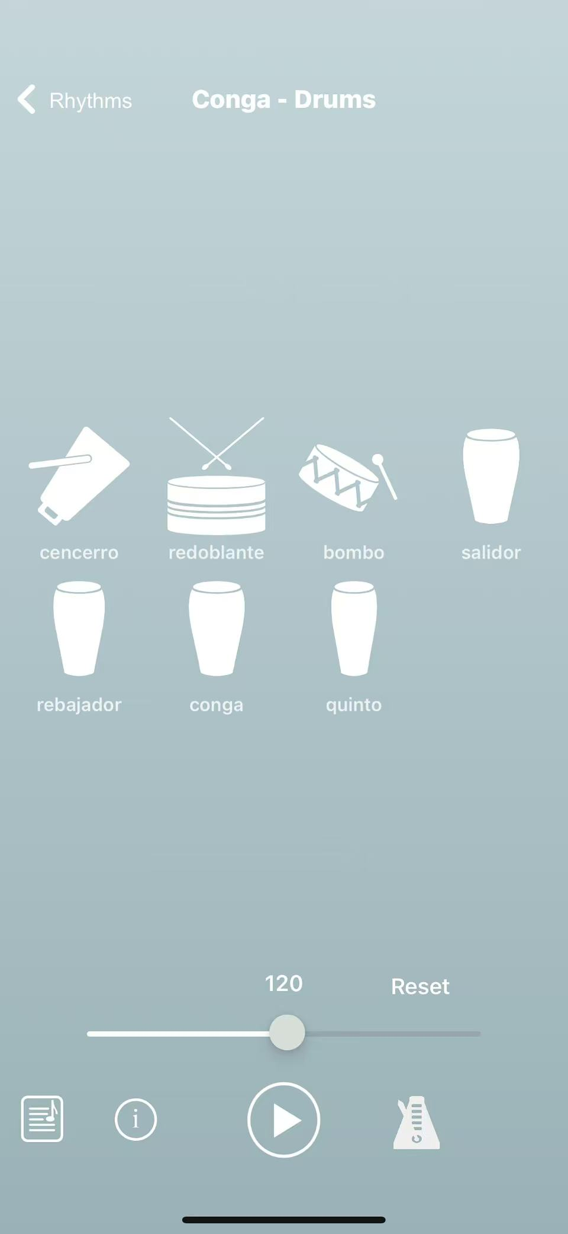Figure[34] the interface of the app
[34] PercussionTutor. PercussionTutor — Official Website (App, Book, Tools). Accessed 29 Aug 2025. URL: Home - PercussionTutor, an iPhone app for world percussion enthusiasts

2.3.3 Sonic Tools
The Sonic tools suite—developed at Queen Mary University of London’s C4DM—comprises Sonic Visualiser (GUI for waveform/spectrogram viewing and layered annotation with Vamp plugins), Sonic Annotator (command-line batch feature extraction to CSV/RDF), the Vamp plugin framework including the QM plugin set (onset/beat/tempo and core descriptors), and Sonic Lineup (time-alignment and comparison of multiple takes).[35] In my project, these tools directly shaped the methodology: I used Sonic Visualiser to “health-check” practice recordings (waveform/spectrum) and calibrate hit-detection thresholds and windows; Sonic Annotator + QM plugins to extract onsets, RMS, spectral centroid, and band energies as ground truth for comparison with my web real-time detector; and Sonic Lineup to align different takes and evaluate timing stability and improvement. This informed a browser-based acquire–analyze–decide–display loop and a reproducible evaluation pipeline, and it guided the feature design for my subsequent stroke recognizer.
[35] Rikki Systems Inc. Sonic Tools SVM (iOS app) — Apple App Store. Accessed 29 Aug 2025. URL: Sonic Tools SVM on the App Store
Chapter 3: Development Work
This project adopted an agile software methodology overall, advancing with short cycles, small iterative steps, and rapid feedback. We treated the supervisor as the core user and product owner, decomposing the teaching and research use cases into a set of user stories with acceptance criteria. Each iteration (about 3-4 days) followed a closed loop of requirements clarification → low-fidelity prototyping → minimum viable product (MVP) implementation → review/demo → retrospective and improvement.
3.2 Prototype
To build my own initial prototype, I first broke down the framework of PercussionPro: its core is divided into Practice and Listen. Practice carries the main functionality—users practice along with a backing track and receive feedback. I noticed it uses a moving bar over a fixed score: when the bar sweeps across a note, the app listens for a strike and judges it. In actual use, however, the moving bar causes several issues: (1) your eyes must constantly chase a moving target, which tires beginners and makes anticipation difficult; (2) at high BPM the bar moves too fast, increasing reading pressure and mis-hits; (3) on small screens the bar can obscure upcoming notes; (4) any frame-rate jitter makes the bar’s speed unstable and undermines the sense of pulse; (5) hit traces are hard to overlay in a single coordinate system, so post-hoc review is not intuitive. Based on this, I switched to a fixed judgment line with a scrolling score: (a) gaze stays in one place, making early/late errors easier to perceive; (b) hit traces and error ticks can be accumulated at the line for clearer review; (c) it is friendlier to high BPM and low-power devices, with less impact from jitter; (d) it matches reading habits in rhythm trainers/games and DAW timelines.
In addition, the original app does not save practice sessions for review. Given percussion learning’s reliance on process feedback and replay (especially for beginners), my prototype adds session logging and playback (hit timestamps, error in milliseconds, verdicts, and summary stats) for later inspection and comparison. Moreover, it currently records only whether a hit occurred, not which stroke type (e.g., O, S, T–P, B). Although this is challenging, I planned a stroke-classification path from the outset: start with waveform/RMS, sub-band energies, spectral centroid as rule/threshold features, then iterate toward a lightweight ML classifier. Meanwhile, to accommodate users unfamiliar with formal notation, I simplified the score with icon/TUBS-style symbols, keeping the core O/S/T–P/B marks so players can focus on playing well; advanced users can switch to a more traditional notation view. The Listen section provides reference examples played over a son clave; its design remains minimal and primarily for listening, with limited interaction.
Based on these observations and trade-offs, the following pages present the improvements and designs I implemented in the prototype.
3.2.1 Layout
Following the KISS (Keep it Simple, Stupid) principle—while balancing usability and visual consistency—I designed the UI to be clean, straightforward, and subtly polished. Leveraging the web’s rendering strengths (high-DPI canvas, vector icons, and a consistent spacing/grid system), the interface remains lightweight yet refined. In the first UI iteration, beyond the basic Start and Pause controls, I added a speed (BPM) slider: it enables quick tempo adjustments and can also couple to “judgment difficulty,” aligning with PercussionPro’s difficulty settings to suit different proficiency levels.
I also replaced the original moving play bar over a static score with a fixed judgment line and a scrolling score, which improves readability and adds a more game-like feel. Advantages include: (1) the gaze can remain on a single judgment point, making early/late deviations easier to perceive; (2) hit traces and error ticks can accumulate at the line for clearer post-take review; (3) the layout reads better at high BPM and on small screens, and frame-rate jitter has less effect on perceived timing; (4) it matches familiar timelines used in rhythm trainers/games and DAWs, enhancing immersion and learnability.
In addition to moving beyond purely “listen & watch” feedback, I planned practice logging and replay (hit timestamps, millisecond errors, and summary statistics) to support staged review for beginners; and from the outset I reserved interfaces for stroke recognition, to be developed using features such as waveform/RMS, sub-band energies, and spectral centroid.
By the way, the drumhead UI— which lights up at the corresponding note positions—helps players know exactly where on the head each stroke should land, making the patterns easier to understand and learn. + （参考了太鼓达人的游戏机制）
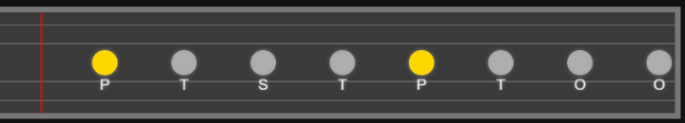
Figure the scroll-move pattern, all the notes will move from right to left
3.2.3 Notes Classifier
To distinguish between different conga stroke types, I trained an Audio project in Teachable Machine. I collected labeled samples for Open (O), Slap (S), Tip–Heel / Heel–Toe (T/H), and Bass (B), trained the model in the browser, then exported it to TensorFlow.js and integrated it into my Web Audio pipeline. At runtime, the microphone stream is windowed and converted to model-ready features (internally, TM derives a time–frequency representation), and the classifier returns per-frame probabilities, which I smooth over time to produce a coarse real-time stroke label.
Current limitations are mainly data-related. The training set is still small and lacks diversity, so the model is only reliable for basic “hit vs. hit-type” discrimination and can be inconsistent under changing conditions. To achieve precise stroke classification, I will need substantially more data gathered across varied environments—e.g., different rooms and microphones, background-noise levels, player dynamics and hand positions, and even instrument state (e.g., head tension/humidity effects). At this stage, the dataset is focused on simple hit detection, so generalization is limited.
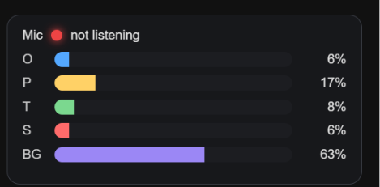
Figure notes classifier
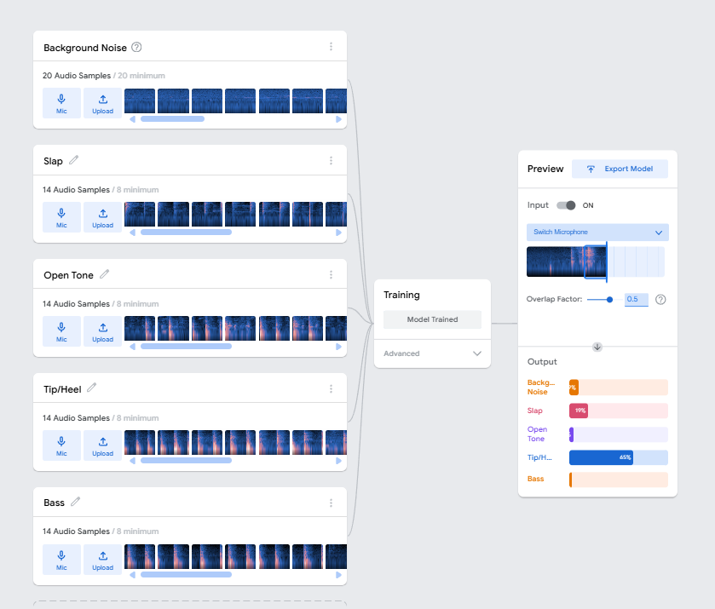
Figure process to train a model
3.2.4 Metronome
To integrate the metronome seamlessly with the scrolling-score HUD, I use a 4/4 strong–weak–weak–weak click scheme: the downbeat (beat 1) is visually accented in yellow while the other beats use neutral colors, all strictly aligned to the judgment line. As the score scrolls, the downbeat marker pre-highlights slightly in advance to cue the upcoming accent, helping players internalize the cycle and target their strike point.
Tempo (BPM) is adjusted in real time via a single Speed slider and applied synchronously to both audio and visuals, meeting different practice intensities and avoiding A/V mismatch when changing speed. Overall, this “auditory accent = visual accent” design reduces reading load, helps beginners internalize the beat more quickly, and improves timing stability.
3.2.5 Feedback
Compared with PercussionPro’s moving play bar, my fixed judgment line + scrolling score approach performs better in real-time hit detection and the speed of feedback.
That said, my supervisor’s feedback highlights two areas for improvement:
- Feedback granularity. Although the system reports miss / good / perfect, he prefers metronome-style dot feedback that shows the time offset between the actual strike and the target (whether it was early or late, and by how many milliseconds) rather than a coarse miss.
- Stroke classification stability. The current note/stroke classifier appears to identify specific strokes, but in practice it often behaves randomly, with low accuracy and poor localization, and therefore cannot yet reliably indicate the current stroke.
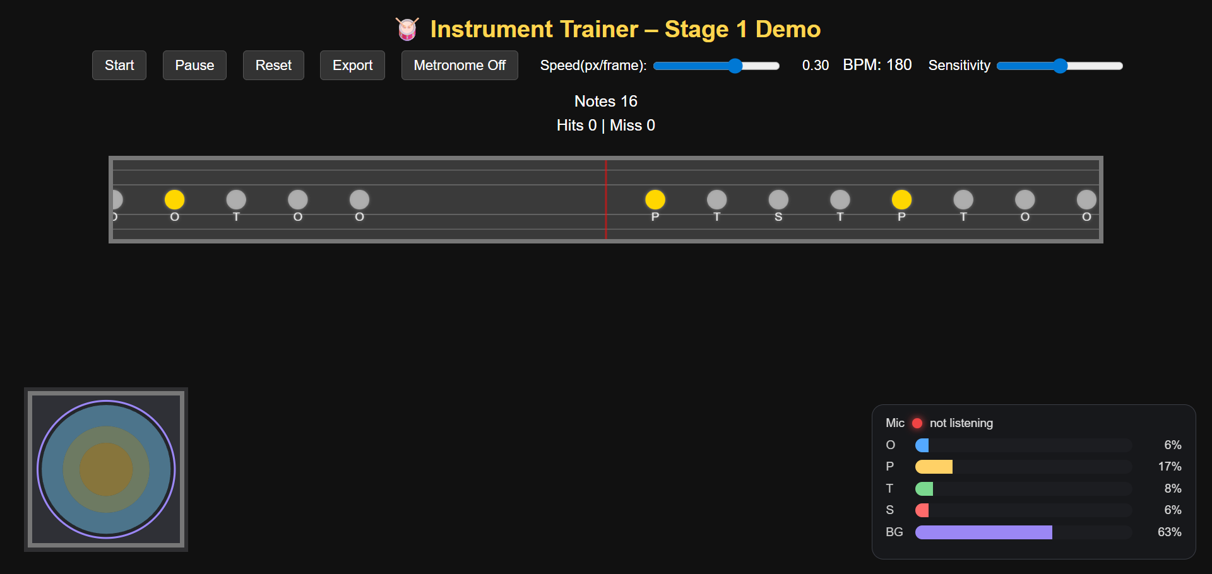
Figure the overall interface of the prototype

3.3 Second Version
3.3.1 Amplitude HUD
During prototype testing, I found that the microphone input fluctuated considerably, causing hits that crossed the hit line to go unrecognized. After investigation, we introduced an Amplitude HUD, which intuitively visualizes strike intensity and stability and promptly surfaces issues such as level anomalies or excessive noise. By visualizing the noise floor and instantaneous peaks, we can set the hit-detection threshold more precisely, reducing both false positives and false negatives. This module also enables quick diagnostics—verifying whether the microphone is enabled, whether the input gain is too low or clipping/overloaded, and whether ambient noise is abnormally high.
As illustrated in Figurexx, the spectrogram scrolls at a speed identical to that of the top note score, but in the opposite direction, yielding visual synchrony. In addition, blue reference lines—spaced to mirror the notes in the top score—are superimposed on the spectrogram. The transients produced by each strike can then be aligned with these references, enabling an intuitive assessment of playing timing and precision.
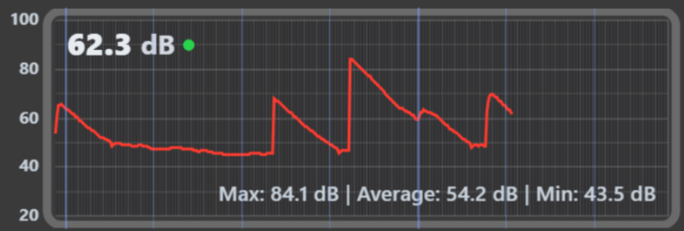
Figure The amplitude HUD
3.3.2 Professional Pattern
Given the greater scientific rigor and practical utility of PercussionPro’s “moving bar” notation in information representation and operability, I plan to add it as an enhancement module that works alongside the existing scrolling-note score, offering performers and learners multiple modes. The current scrolling score mainly provides coarse-grained feedback—Miss/Good/Perfect—and lacks precise, real-time localization of strike positions. By contrast, the moving-bar score records the time and position of each strike in real time, allowing users to quickly pinpoint problem areas during pause/review and thereby creating a more intuitive and transparent practice-and-correction loop.
3.3.3 UI Improvement
The original UI layout lacked visual polish. Usability testing showed that during performance, participants’ gaze focused primarily on the scrolling score at the top and seldom on the drum-surface UI or the Note Classifier HUD; at this stage, these two auxiliary elements contribute little to real-time feedback. To maintain overall visual consistency, we reorganized the interface as illustrated: the top scrolling score serves as the primary focus area, while the newly added, more refined notation—closer to PercussionPro’s “moving bar” style—is placed at the bottom to reduce distractions and strengthen the visual hierarchy.
In addition, to more clearly distinguish the high drum from the low drum, I placed them on two separate horizontal lanes: the upper lane for the high drum and the lower lane for the low drum. This vertical separation aligns with common percussion-notation practice and, in a fast-scrolling interface, reduces visual clutter and eye movement, improving legibility and hit accuracy. Following PercussionPro’s notation system[33], I also replaced the previous letter labels (e.g., O, P) for stroke/timbre with a more universal symbolic notation, and kept the legend consistent across both the score and the HUD. This not only enhances cross-language and cross-platform readability, but also leaves room to extend to more instruments and stroke types (e.g., open, slap, bass), yielding a more standardized interface with a clearer information hierarchy.
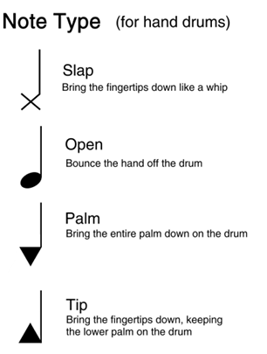
Figure[33]

3.3.4 Feedback
In informal testing of this prototype, participants commonly reported that the amplitude HUD’s rise–fall dynamics are mismatched: it captures peaks very quickly but decays too slowly, which prevents it from staying in sync with the scrolling score. Often the next strike is triggered before the previous waveform has fully decayed, producing a saw-toothed pattern. In addition, the waveform’s drawing speed does not match the leftward motion of the blue reference line on the score, leading to overall rhythmic confusion. The drumUI also failed to provide substantive benefit and instead distracted performers. Another issue is that when adjusting the top-row speed slider, inconsistencies in timekeeping and algorithmic handling cause the spacing between notes on the scrolling score to change, so the metronome can no longer align one-to-one with the notes. This stems from a conflict between p5.js’s wall-clock millis() and my custom visual time rm._t(), where mixing these time sources breaks consistency between scheduling and rendering.

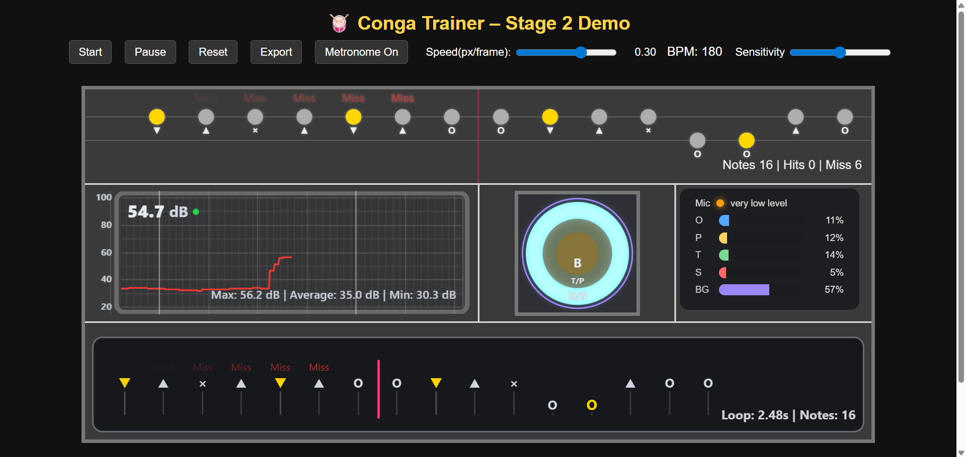
Figure overall interface of version 2

3.4 Third Version
3.4.1 Amplitude HUD Improvement
To address a series of Amplitude HUD issues (slow decay, desynchronization, and “saw-tooth” artifacts), I redesigned the microphone signal chain with reference to common sonic analysis tools[34] and the p5.sound API: first, I implemented two switchable analysis modes, RMS and AMP; second, I added a Fast Response toggle to achieve snappy attack and release; third, I introduced optional dynamic auto-scaling and overload smoothing so peaks fall back quickly after strong transients instead of lingering. The resulting amplitude trace responds and decays faster while remaining visually stable across different input levels.
In implementation, AMP mode uses p5.Amplitude.getLevel() to obtain a 0–1 loudness value: in Fast mode the smoothing factor is set to 0 for near-instant rise and fall, while Smooth mode uses the user’s smoothing factor (the panel badge shows AMP or AMP*, where the asterisk indicates Fast). RMS mode pulls the time-domain buffer via p5.FFT.waveform(512), computes RMS energy, and then applies an exponential moving average (EMA): Fast mode uses a higher α for quicker decay; Smooth mode derives α from the user’s smoothing factor (badge RMS or RMS*). We keep both because AMP (an envelope follower based on p5.Amplitude) is lightweight and straightforward—bind with setInput(mic) and control smoothing via smooth()—which is ideal for a quick, normalized loudness envelope; RMS (waveform-derived energy) affords fine-grained control over windowing and decay and, especially in Fast mode, yields a very clean, rapid fall-off that avoids the lingering responsible for prior alignment drift.[5][6]
[5] M. Puckette, “Envelope following,” Theory and Techniques of Electronic Music, UCSD. Defines envelope follower as a time-varying power estimate (low-pass of rectified/squared signal). Available online.
[6] Ø. Brandtsegg et al., “A toolkit for experimentation with signal interaction,” Proc. DAFx-15, Trondheim, 2015. Uses an exponential moving average with separate rise/fall coefficients for envelope smoothing.
To further improve readability and stability, the HUD includes several supporting mechanisms: dynamic auto-scaling, where a rolling _maxLevel determines an effective vertical scale so crests occupy about 80% of panel height (target fill), with an AUTO indicator when scaling clamps the gain; overload indication and instant adaptation, which flags OVERLOAD when the instantaneous level exceeds a threshold (default 0.8 on a 0–1 scale) and, if Instant Adapt is enabled, temporarily accelerates peak-decay after large spikes so the envelope doesn’t bleed into the next hit; a history buffer and dB readout, storing one sample per horizontal pixel and rendering a clean polyline with real-time dBFS (−20·log10(level)) for legibility at any size; and a one-switch Fast/Smooth toggle via setFastResponse, which in AMP mode also calls p5.Amplitude.smooth() to keep the smoothing factor in sync.[7]
[7]U.S. Federal Agencies Digital Guidelines Initiative, “dBFS (decibels relative to full scale),” Digitization Guidelines Glossary. Definition and usage of dBFS in digital audio systems.
[34] Matsugaki, T. (n.d.). Sonic Tools SVM [GitHub repository]. GitHub. Retrieved August 31, 2025. URL: tmatsugaki/Sonic-Tools-SVM
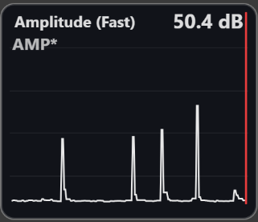
Figure Fast/AMP mode
3.4.2 Frequency HUD (for machine learning distinguishment, from a tutorial link)
In order to support the ML pipeline for recognizing hit notes end-to-end, I added an FFTPanel spectrum analyzer HUD. It enables visual band selection and feature targeting so you can pick appropriate mel band counts and frequency limits and apply band emphasis instead of feeding irrelevant spectrum to the model [35]; by inspecting peak and decay trends, you can design dataset slicing around onsets (e.g., log-mel patches centered on the hit with ±250–300 ms context) and sample silence/noise as negatives to suppress false positives [36,37]; for feature engineering and baselines, derive log-mel (≈40–64 bands), MFCC (13+Δ+ΔΔ), spectral centroid/roll-off/bandwidth, flatness, flux, and ZCR, then train a linear/RBF-SVM or small MLP before upgrading to a lightweight CNN over log-mel patches for end-to-end time-frequency classification [38,39]; moreover, use FFTPanel to set thresholds and normalization by estimating the noise floor and dynamic range, selecting log compression, mean/variance normalization, and detection thresholds, and applying an adaptive noise baseline at inference to mitigate room/mic domain shift [40]; finally, it provides evidence for data augmentation—design random gain/noise, RIR convolution for reverberation, mild time-stretch (±5%), light pitch-shift, and band-wise perturbations (masking/notch/pass) to improve robustness to device and room variability [41,42].
For the spectrum-visualization design, I was strongly inspired by the p5.sound tutorials[43]: building on their FFT/Amplitude visualization paradigm, I render short-time spectra per bin (switchable bars/lines), apply dB compression and exponential smoothing to improve readability, and add 1 kHz/2 kHz ticks with a grid, peak-frequency labels, and dynamic vertical scaling based on recent peaks, so the display remains clear and stable across different signal levels and noise conditions .
[35] D. P. W. Ellis, “PLP and RASTA (and MFCC, and inversion) in MATLAB,” 2005. (Practical mel/MFCC front-ends)
[36] J. P. Bello et al., “A tutorial on onset detection in music signals,” IEEE Trans. ASLP, 13(5), 2005. (Onset characteristics and framing)
[37] S. Dixon, “Onset detection revisited,” DAFx-06, 2006. (Onset cues and window/hop choices)
[38] G. Tzanetakis and P. Cook, “Musical genre classification of audio signals,” IEEE Trans. SAP, 10(5), 2002. (Centroid, roll-off, flux, MFCC baselines)
[39] S. Hershey et al., “CNN architectures for large-scale audio classification,” ICASSP, 2017. (Log-mel CNNs on AudioSet)
[40] P. C. Loizou, Speech Enhancement: Theory and Practice, CRC Press, 2013. (Noise floors, dynamic range, log compression)
[41] T. Ko et al., “Audio augmentation for speech recognition,” Interspeech, 2015. (Speed perturbation, noise, reverberation)
[42] D. S. Park et al., “SpecAugment: A simple data augmentation method for automatic speech recognition,” Interspeech, 2019. (Time/frequency masking on spectrograms)
[43] The Coding Train, “Sound Visualization: Frequency Analysis,” The Coding Train — Sound Track (p5.sound). Accessed Aug. 31, 2025. URL: https://thecodingtrain.com/tracks/sound/sound/11-sound-visualization-frequency-analysis
3.4.5 Clave
To better align with Afro-Cuban percussion practice, I added a Clave mode on top of the basic metronome. Players can switch between Metronome and Clave with a single click, while preserving continuity of BPM, time signature, and phase during the switch. Drummers who prefer the clave as their rhythmic backbone can therefore align and practice in a familiar pattern, rather than being limited to an evenly spaced metronome click.
3.4.6 Setting Panel
To consolidate features and provide built-in guidance, I added a Settings panel. It includes: (1) a hotkey reference with usage notes; and (2) concise teaching tips and examples for conga hand shapes/strokes. I also introduced a microphone sensitivity slider to more reliably detect low-volume strokes (e.g., tip) and to quickly calibrate detection thresholds to the ambient noise, improving overall recognition stability.
3.4.7 Export Improvement
I upgraded the export feature from “a single image with little feedback” to a rolling window of 10 images. Internally it uses a first-in, first-out (FIFO) queue: each new screenshot is enqueued, and when capacity is reached the oldest one is automatically evicted, so the most recent 10 key moments are always preserved with complete coverage and correct ordering. The UI also shows export status (index, timestamp, etc.). This brings several benefits: it enables side-by-side comparison of early/late timing deviations across takes; supports longitudinal tracking of practice trends (mean error, stability, hit rate) to judge real improvement; makes review and coaching easier by packaging snapshots for an instructor or reports; and improves parameter tuning, allowing immediate before/after contrasts after adjusting thresholds, BPM, speed factor, or AMP/RMS mode.
3.4.8 UI simplification
Given that drumUI and the Beat Notes Classifier have underperformed in the current iteration—the former consuming valuable screen space, increasing visual load, and offering limited practical assistance to performers; and the latter’s sorting (classification) function still failing to run stably, thereby compromising assessment accuracy—to preserve the clarity and usability of the core training workflow, both modules have been removed in this release.
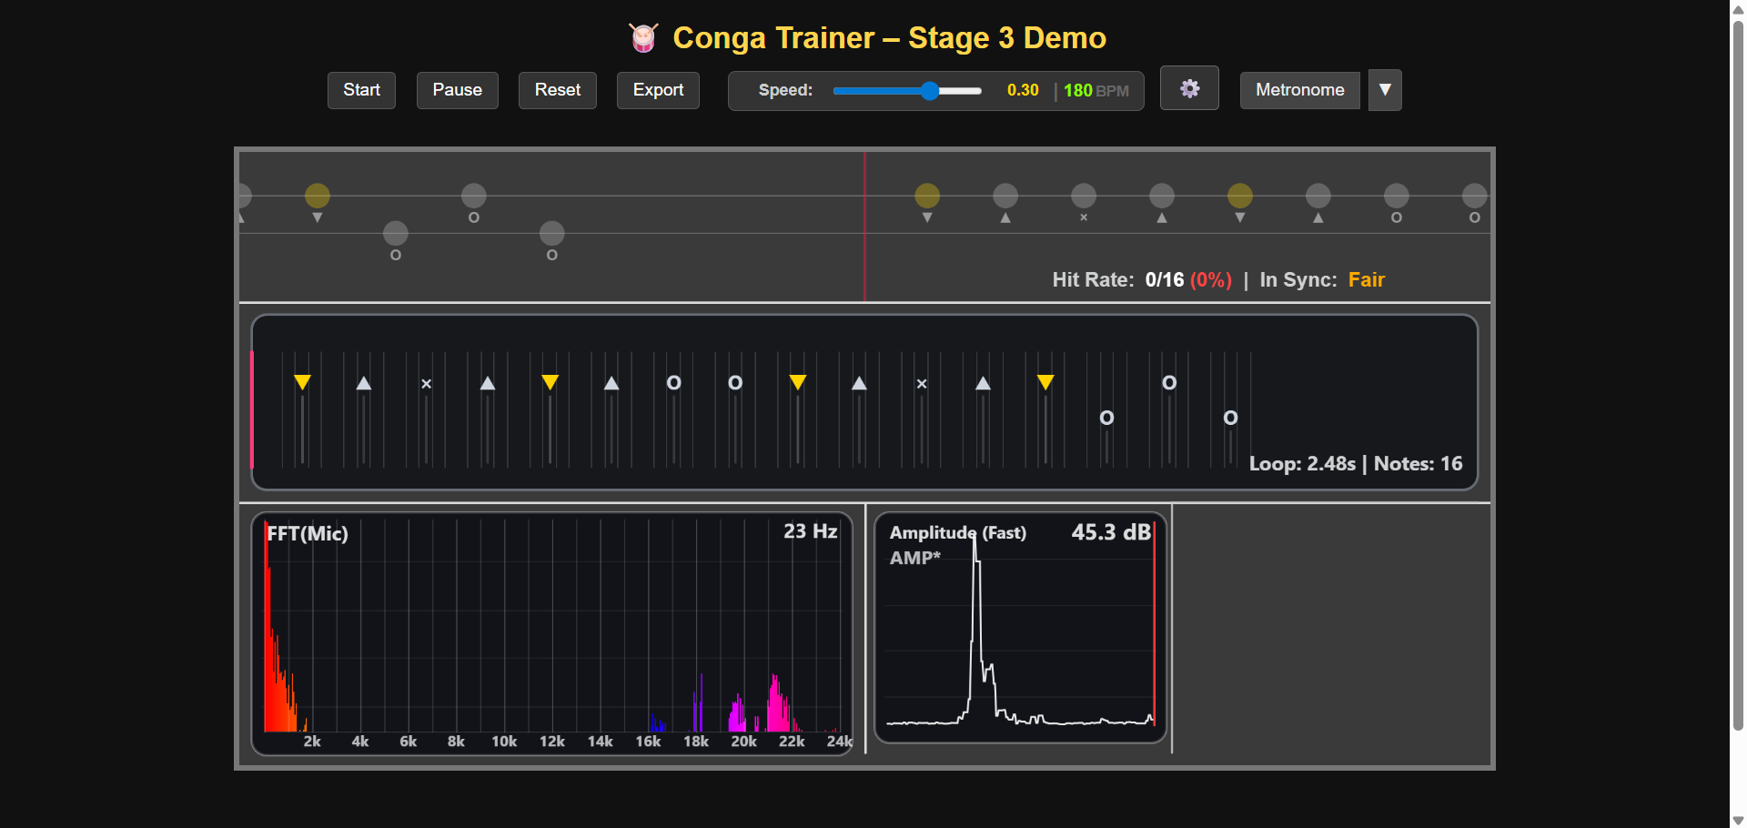
Figure the overall interface of the version 3
3.5 Forth Version
3.5.1 Mobile Sync (fix the problem in mobile in IOS and Android like mic→signal problem and screen flip)
原先在mobile端存在很多问题，比如虽然麦克风能够接收到信号但是其击打反馈一直不起作用（给代码，分析下原因），并且其没法做到很好的自适应（例如自动翻转，UI排布的等等），这可能取决于手机屏幕的限制，导致很多的功能没办法在上面体现（CPU和处理器的差别）

3.5.2 Game Feedback (add some fun feature, make the whole app more like a game)
为了丰富界面的功能和使用者的体验，我考虑像游戏一样给其加入反馈机制。
目前的处理方向主要有两个：第一个是在simple pattern部分加入更加抓人眼球的反馈（当演奏者的打击触发原先所在perfect效果时（为了界面整洁我将原先的miss，good，perfect等作了隐藏），会生成三个星星的视觉效果，这样玩家可以通过此知道是否达到了perfect的演奏结果。第二个则是在右下角的面板上添加了很多小部件：Fun和Learn滑块，Combo反馈，充电解锁喜欢的歌曲和击打方式识别（又重新将其作为补充功能添加回来）。将其放在右下角是由于作为一个教具，其功能上更多应该聚焦实时反馈和正误识别上，如果将其放在太显眼的位置可能会喧宾夺主？（找个文献支持下）。Combo反馈和电池充电都算是combo激励的一种，不同的是前者更加直接：我做成了3个星星，和simple pattern部分满分打击爆出3个星星相呼应，达到一定程度的combo后就可以达到三颗星星的优秀成绩，这对于演奏者来说也是一种激励。对于电池充电来说，每次在simple pattern上获得good打击或者perfect打击时都能起到充电的功能，不同的是在perfect打击（爆出3个星星）下每次加3%的电量（普通1%），能够更快实现下一个模组的功能（前端特效，鼠标交互种树，喜欢的歌，动态频谱）。在这下一个模组中，我设置了四个灯，原先状态下他们都是上锁的 ，每次充电达到100%能解锁一个，这四个灯能对于使用者喜欢的四首歌曲。当灯解锁时，演奏者只需要切换下模式从learn到fun就能和这四个灯按钮互动，点开后页面会跳转到一个动态频谱界面，通过鼠标的滑动就可以播放他们喜欢的歌曲，并且鼠标在滑动过程中还会生成一颗颗“树”，伴随着不同颜色的变化使其整体看起来非常的酷炫。
3.5.3 Chart Selector (allow player the choose the specific chart to play)
In this iteration, I introduced a “Score Selector” that lets users quickly choose practice charts based on their goals (currently including examples such as Son clave 2–3, Rumba clave 3–2, Tumbao, and Merengue). The selector supports filtering by difficulty, instrument, and meter; provides key previews such as BPM, time signature, and length; and enables one-click loading with automatic alignment to the metronome and the scrolling score. It also remembers the last selection, supports Favorites and Recents, and leaves room for extensibility via JSON/local/cloud score libraries. As a result, it significantly reduces page switching and manual configuration overhead, improves continuity and targeting in practice, facilitates tiered teaching and comparative exercises, and lays the groundwork for large-scale library expansion and personalized recommendations.
3.5.4 Dual-View Sync & Precise Timing
In earlier versions, only the central HUD recorded the precise timestamp of each strike in real time, while the top scrolling score provided only basic feedback. Following suggestions from my supervisor and test users, I have added precise strike-time logging to the scrolling score as well. Unlike the central HUD, the scrolling score presents this information as simple dot markers; this dot layer is intended for in-session alignment and review and is excluded from the export output. Both visualizations now appear on the same page and remain tightly synchronized (aligned time axis and refresh cadence), allowing users to focus on whichever view they prefer.
3.5.5 Stars Effect
To reduce the interface’s empty, plain look, I implemented a dynamic starfield effect[1]—that interacts with both the mouse and the microphone. An adjustable control panel in the bottom-right lets users switch between “Mouse” and “Microphone” modes: in Mouse mode, the stars respond to the cursor’s position and movement; in Microphone mode, their sizes scale in real time with the input volume.
[1] A. Tavoosi, “Audio Reactive Particles,” CodePen. [Online]. Accessed: Aug. 31,2025. URL: Available: https://codepen.io/Amirtvs/pen/OPJzebY.

3.5.6 hit classifier improved （有空再弄）

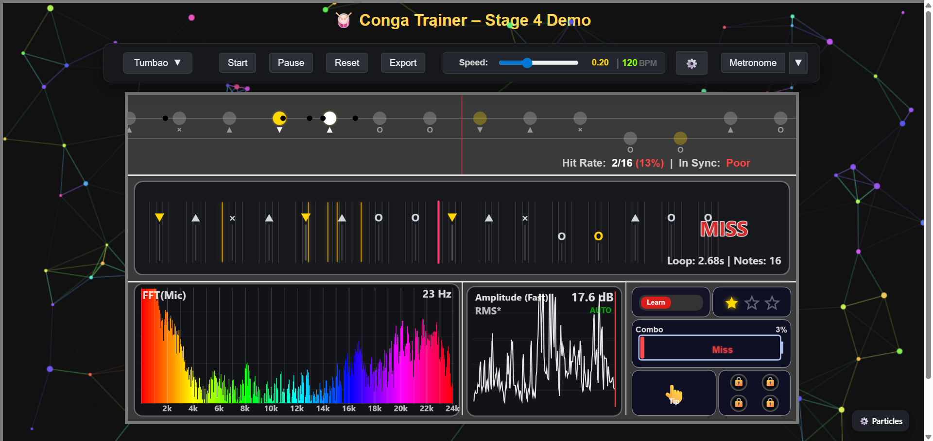
Figure: the overall interface of version 4
（最后加了啥，搞个类图，加了设置，处理了哪些问题）

Chapter 4： Critical Evaluation
4.1 Technical Evaluation
4.1.1 Latency Test
4.1.2 Results
4.2 User Evaluation

4.3.2 Methodology
4.3.3 Result and Analysis
4.2.3 Feedback
Timing Feedback

（overview，technical evaluation，user evaluation， result and analysis， feedback， limitations）画SUS，给图表
Chapter 5：Conclusion
（main contribution，project status， future plans）
Bibliography
Bibliography

