How Conservative and Liberal News Media See Current Economic Condition: CNN vs Fox News
Enkhsaikhan Usny-Ekh, 2400414

Introduction
Consumer confidence plays a significant role in shaping economic outcomes, and news media are among the most influential factors affecting consumer perceptions of the economy. This study examines how liberal- and conservative-leaning news outlets portray U.S. economic conditions in 2025, using CNN and Fox News as comparative case studies. To identify difference in coverage, the analysis employs bigram frequency analysis with log-odds ratio to compare thematic emphasis across outlets, and the AFINN lexicon to measure article-level sentiment. The study further investigates how sentiment varies across economic categories, its relationship with U.S. GDP growth, and the role of political references in shaping the tone of economic reporting.

Data
Economic news articles were scraped directly from the CNN and Fox News website. The data collection process used Python’s Selenium and BeautifulSoup libraries. The scraping procedure consisted of two main stages. First, article links returned by search engines were collected. Second, full news articles were scraped individually using these links.
For CNN, searches were conducted using 41 economic-related keywords, and all resulting articles were scraped. For Fox News, all articles published in 2025 under the U.S. Economy category were collected. For the analysis, 646 articles from CNN and 756 articles from Fox News were retained and used.

Methods
To compare economic news coverage between CNN and Fox New, a combination of textual feature analysis and sentiment analysis are applied. This approach allows us to examine both the content and tone of articles from the two outlets.
- Bigrams
Bigrams are pairs of consecutive words in the text, to capture meaningful phrases that single words alone cannot convey. In order to analyze consecutive words, “n-grams” are used to tokenize adjacent pairs, where “n” is the number of adjacent words being paired together (Shi, Caddel, & Lensing, 2019). Simply, bigrams highlight the phrases and topics emphasized by each outlet, revealing differences in content focus.
In addition, normalization is applied to bigrams related to Donald Trump. Frequently used bigrams include multiple variations of his name, such as President Trump, Trump said, Donald, and Trump. To ensure consistency and avoid fragmentation, all such variations are normalized into a single token: donald_trump.
- Log Odds Ratios
To determine which bigrams are distinctive for each news outlet, log odds ratios are calculated. Log odds ratios measure how strongly a word or phrase is associated with one group relative to another.
First, the log odds are computed for each bigram within each news outlet. The log odds for bigram $b$ in outlet $i$ are defined as:
$$logO_{b}^{i}=\log\left(\frac{f_{b}^{i}}{1-f_{b}^{i}}\right)$$
Where $f_{b}^{i}$ is the relative frequency of bigram b for news outlet i.
Next, the log odds ratio (difference) between two outlets is calculated by subtracting the log odds of one outlet from the other:
$$∆_{bigram}=\log\left(\frac{f_{b}^{i}}{1-f_{b}^{i}}\right)-\log\left(\frac{f_{b}^{j}}{1-f_{b}^{j}}\right)$$
Where $i$ and $j$ represent the two news outlets being compared.
A positive value of $∆_{bigram}$ indicates that the bigram is more strongly associated with outlet $i$, while a negative value suggests a stronger association with outlet $j$.
- Sentiment Analysis using AFINN
Sentiment in the articles is measured using AFINN sentiment lexicon. The newest version of AFINN contains 2,477 unique words, each assignment an integer sentiment score ranging from -5 (very negative) to +5 (very positive) (Nielsen, 2011). For each text, an overall sentiment score is constructed by summing the scores of all words that appear in the AFINN dictionary.
Table 1. Example words from AFINN-165
Word | Sentiment Score | Word | Sentiment Score
Happy | 3 | Problem | -2
Love | 3 | Angry | -3
Amazing | 4 | Abuse | -3
Excellent | 3 | Disaster | -2
Neutral | 0 | Hate | -3
AFFIN offers a transparent and computationally efficient approach that is well suited for large-scale collections of news articles and time-series analysis. However, as a word-lexicon, it does not account for context, negation, or domain-specific language, which may introduce measurement error in news text.

Result
Figure 1 shows the 20 most frequently used bigrams in economic news coverage by CNN and Fox News, revealing clear differences in thematic emphasis. CNN’s top bigrams are dominated by economic indicators and technical terminology, such as (‘labor’, market), (‘health’, ‘care’), (‘interest’, ‘rates’) and (‘us’, ‘economy’). In contrast, Fox New’s top terms are heavily centered on executive power and specific administrative actions such as (‘white’, ‘house’), (‘tax’, ‘cuts’), (‘executive’, ‘order’) and (‘biden’, ‘administration’). While CNN’s most frequent bigram (‘united’, ‘states’) reflects a broad national-level framing, Fox News’s leading bigram (‘white’, ‘house’) indicates a stronger focus on the presidency as the central driver of economic developments. Overall, CNN appears to emphasize economics more through indicators and market impact, while Fox News frames economics more through policy actions and political narratives.
Figure 1. Bigrams Most Frequently Used
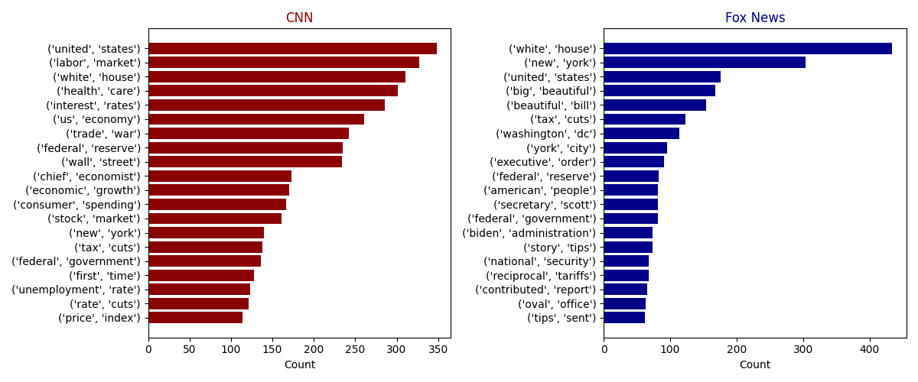
Although the log-odds ratio analysis yields slightly different rankings, the broader pattern remains consistent (Figure 2). CNN’s most distinctive bigrams, such as (‘labor’, ‘market’), (‘interest’ ‘rates’), and (‘federal’, ‘reserve’), highlight a technical and institution-oriented approach to economic reporting, emphasizing measurable indicators and formal policy mechanisms. In contrast, Fox News’s distinctive phrases. including (‘national’, ‘debt’), (‘note’, ‘clients’), and (‘feels’, ‘like’), combine political framing, direct audience address, and a more conversational tone. This suggests that Fox News presents economic issues through a mix of policy discussion, market performance, and subjective interpretation.
Figure 2. Bigrams by log odds ratio
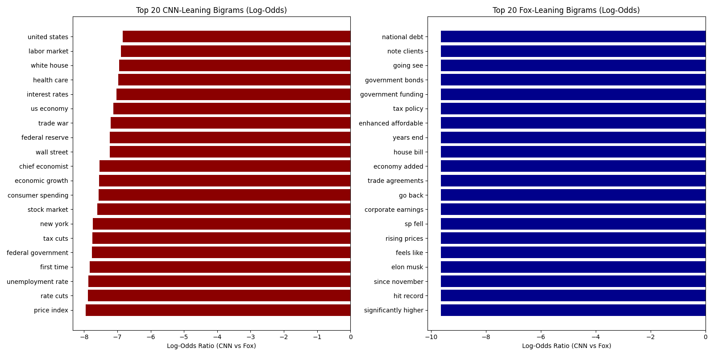
Turning to sentiment analysis, economic news from both outlets is largely natural with a slight positive bias (Table 2). Mean and median sentiment scores indicate that Fox News articles are, on average, marginally more positive than those of CNN, though the difference is small. Fox News also exhibits greater dispersion in sentiment, indicating somewhat more polarized economic coverage, although this difference is similarly modest. The close alignment between mean and median values suggests limited skewness and confirms that the result is not driven by outliers.
Table 2. Sentiment score by news outlets (AFINN)
Source | Count | Mean | STD | Median | Min | Max
CNN | 646.0 | 0.010 | 0.052 | 0.013 | -0.191 | 0.173
Fox | 423.0 | 0.014 | 0.067 | 0.020 | -0.271 | 0.245

Figure 3. Sentiment score distribution
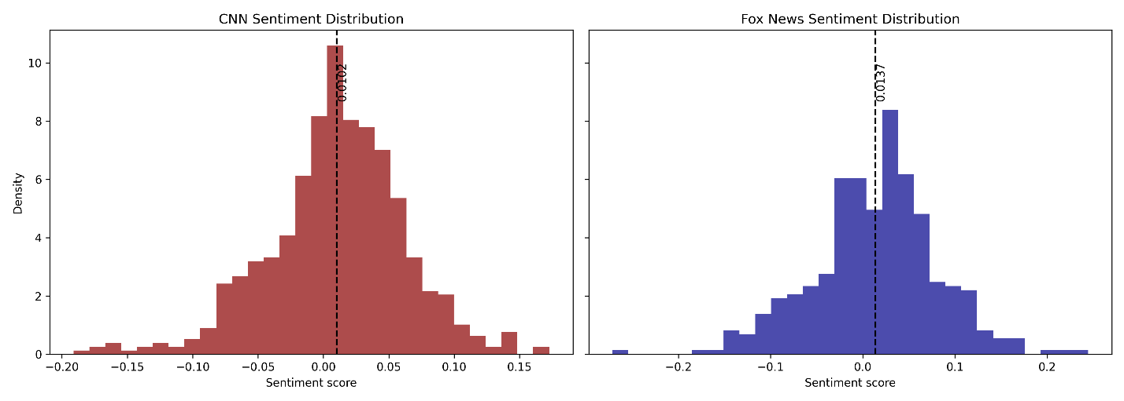
While overall sentiment differences are small, sentiment varies substantially across economic categories. Fox News maintains a higher average sentiment in nearly all categories except Fiscal Policy. The particularly large gaps observed in GDP growth and Commodities suggest that, although both outlets report on the same macroeconomic indicators, their linguistic framing (as captured by the AFINN) differs meaningfully.
Figure 4. Sentiment score by news category
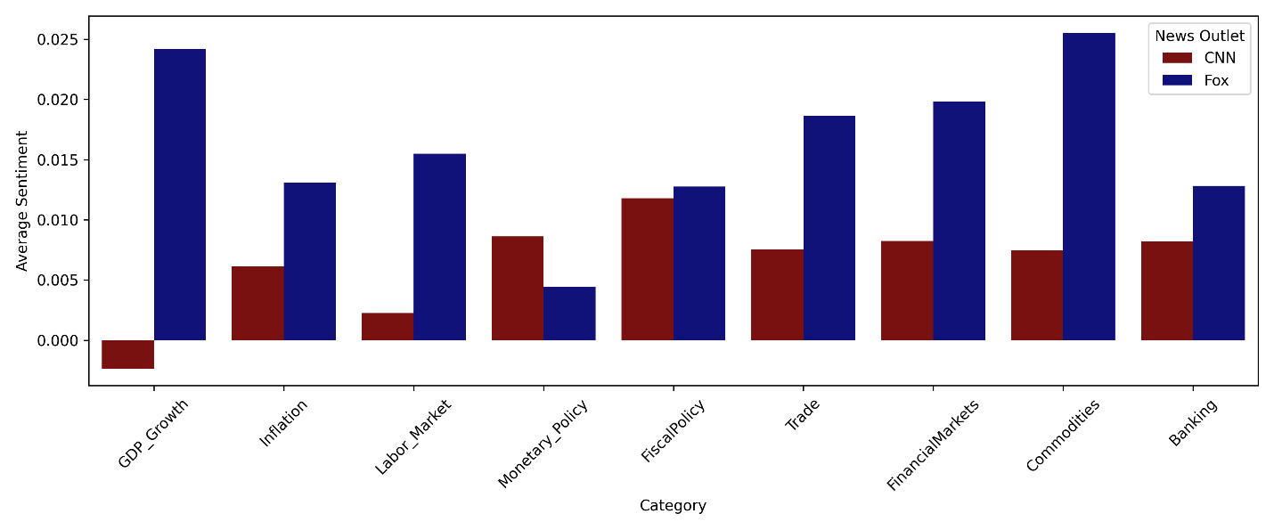
Existing research shows that incorporating media sentiment into traditional macroeconomic models can enhance real-time economic forecasting by capturing high-frequency information that standard indicators often miss. Consistent with this literature, our analysis of the comovement between news sentiment and U.S. GDP growth from 2025Q1 to 2025Q3 shows that, despite the small sample size, both sentiment indices closely track the upward growth trend.
Figure 5. Sentiment score by month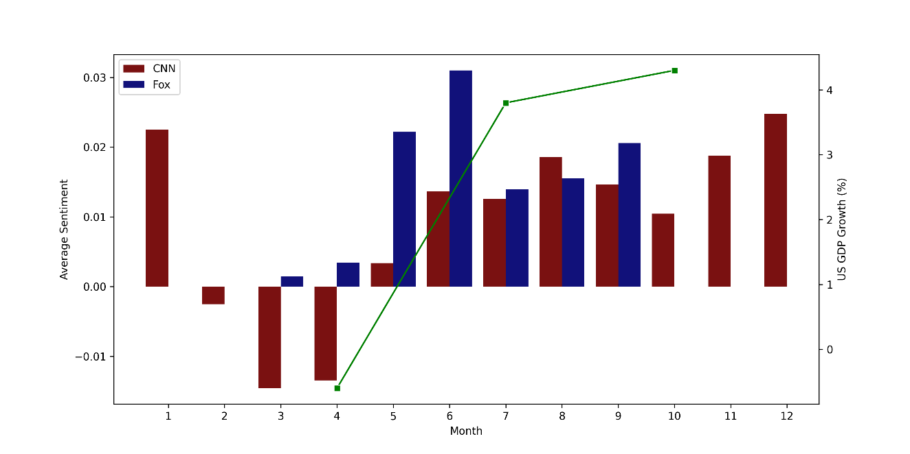
Finally, sentiment differs systematically depending on political references. In both outlets, articles that do not mention Donald Trump exhibit significantly higher positive sentiment, suggesting that non-political or “straight” economic reporting, such as market updates or employment statistics, tends to use more optimistic language. When Trump is mentioned, Fox News still maintains a higher average sentiment score than CNN, consistent with prior findings that Fox News employs more supportive framing, while CNN’s coverage is generally more critical.
Figure 6. Average sentiment by news source and Donal Trump mentions
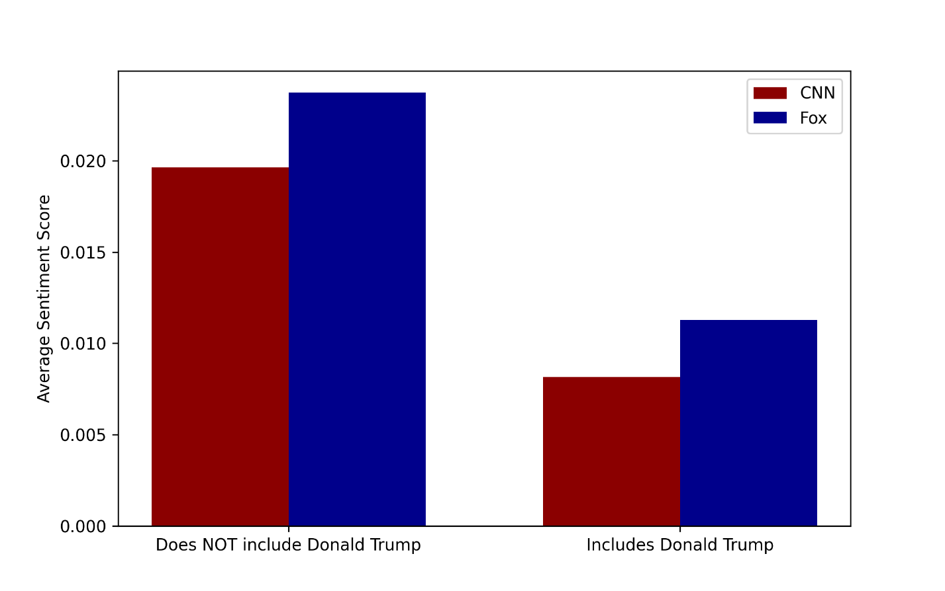

Discussion
Key findings
This study documents systematic differences in how liberal- and conservative-leaning news outlets frame economic conditions, both in terms of thematic emphasis and sentiment. The bigram analysis reveals that CNN and Fox News prioritize distinct dimensions of economic reporting. CNN’ coverage is more heavily oriented toward macroeconomic indicators and institutions such as the labor market, interest rates, and the Federal Reserve, suggesting a technocratic and indicator-driven framing of economic conditions. In contrast, Fox News places greater emphasis on political actors and executive decision-making, with frequent references to the White House, administrative actions, and fiscal responsibility, reflecting a more personalized and policy-centered narrative of the economy.
Despite these clear content differences, sentiment analysis shows that overall tone is broadly similar across outlets. Both CNN and Fox News exhibit sentiment scores close to neutral, with a slight positive bias, and only modest differences in means and dispersion. However, sentiment differences become more pronounced when the analysis is disaggregated by economic category and political references. Fox News consistently displays higher sentiment scores across most categories, particularly for GDP growth and commodities. Moreover, sentiment drops for both outlets when articles reference Donald Trump, although Fox News maintains relatively more positive tone, consistent with ideological alignment.
Limitations
This study has several limitations. First, sentiment is measured using the AFINN lexicon, which operates at the word level and does not account for context, negation, or irony. As a result, sentiment scores may misclassify tone in complex or neutral journalistic language. Second, the analysis is limited to two outlets and a single year, which constrains generalizability and reduces statistical power in time-series comparisons. Finally, bigram analysis captures surface-level phrase usage but cannot fully recover deeper narrative structures or causal framing strategies.
Directions for future research
Future research could extend this analysis in several directions. First, incorporating context-aware sentiment models, such as transformer-based language models, could improve measurement accuracy and better capture nuanced economic tone. Second, expanding the dataset to include additional outlets and a longer time horizon would allow for stronger inference and dynamic analysis around major economic or political events. Finally, linking outlet-specific sentiment to consumer confidence or financial market outcomes would provide deeper insight into the real economic consequences of media framing.

References
Nielsen, F. A. (2011). A new ANEW: Evaluation of a word list for sentiment analysis in microblogs. Proceedings of the Workshop on Making Sense of Microposts, ESWC.
Shi, H., Caddel, J., & Lensing, J. (2019). Analyzing U.S. Army Officer Evaluation Reports with Natural Language Processing; A Log-Odds and Latent Dirichlet Allocation Exploration. Industrial and Systems Engineering Review.
CNN. (2025). CNN.com. https://edition.cnn.com/
Fox News. (2025). FoxNews.com. https://www.foxnews.com/

Appendix
Appendix 1. Bigrams most frequently used before normalization
