# Corrected Sequence Diagrams – Elvis Hamati (UC 9–12)

## UC_9: Bank Employee Views Client Accounts

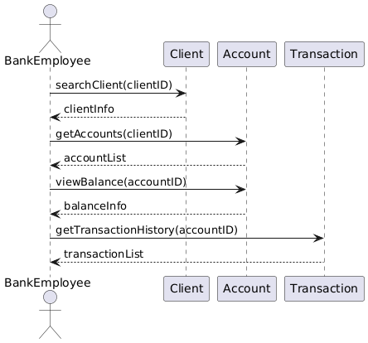

## UC_10: Update Client Account Information

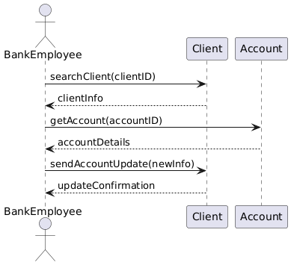

## UC_11: Bank Employee Checks Client Loan Status

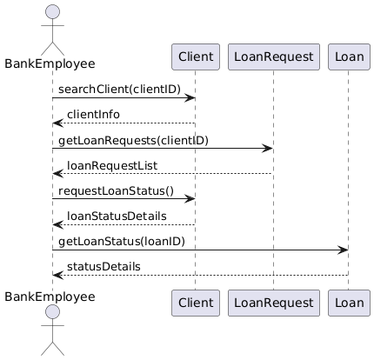

## UC_12: Administrator Manages Employee Accounts

