Tabel Relasional
Relational Table

Lil Fresh
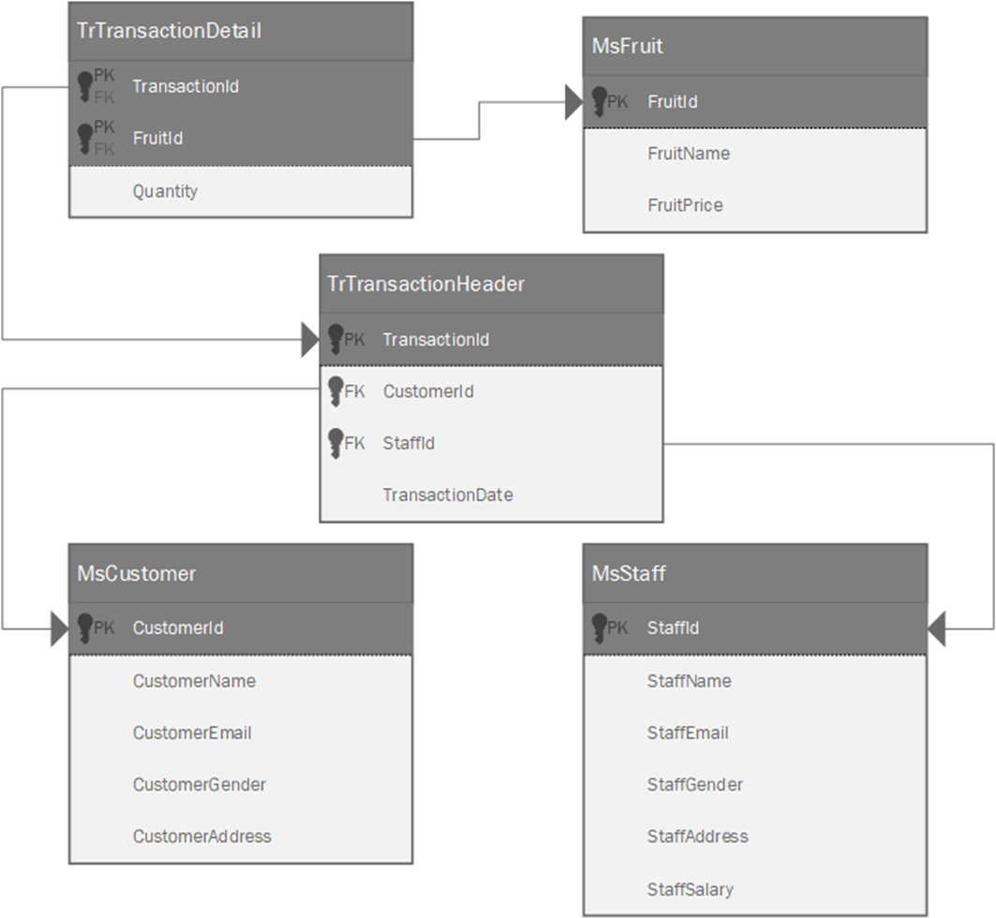
Soal
Case

- Display CustomerName, CustomerEmail, and CustomerAddress for every customer whose name consist of 3 words.
(like)
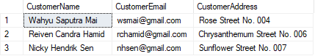

- Display CustomerName and TransactionDate for every transaction that occurs in 'Tuesday'.
(join, datename, weekday)
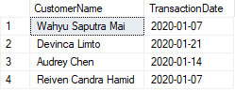

- Display CustomerId, CustomerName, and TotalPurchase (obtained from total transaction of each customer ended with ' transaction(s)') for every customer whose ID is an odd number.
(count, join, cast, right, group by)
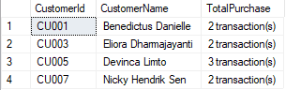

- Display CustomerId, CustomerName (obtained from customer's first name), StaffName (obtained from staff's first name), TotalFruitPurchased (obtained from the sum of fruit's quantity for each customer), and TotalTransaction (obtained from the total transaction for each customer) where the StaffGender is Female and the CustomerGender is Male. Then combine it with CustomerId, CustomerName (obtained from customer's first name), StaffName (obtained from staff's first name), TotalFruitPurchased (obtained from the sum of fruit's quantity for each customer), and TotalTransaction (obtained from the total transaction for each customer) where the StaffGender is Male and the CustomerGender is Female.
(left, charindex, sum, count, group by, join)
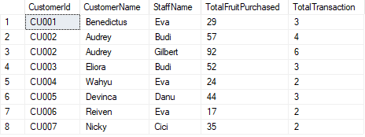

- Display TransactionId, FruitName, FruitPrice (obtained from FruitPrice starts with 'Rp. ' and ends with ',-'), TransactionDate (obtained from TransactionDate with format 'dd mon yyyy') for every transaction which quantity is more than 25 and occurs after the 10th day of the month.
(in, day, convert)
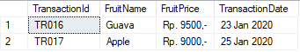

- Display StaffName, StaffEmail (obtained from StaffEmail and replace '@gmail.com' with '@lilfur.com'), StaffGender (obtained from the first letter of StaffGender), and StaffSalary (obtained from StaffSalary starts with 'Rp. ') for every staff whose salary less than or equals to the average of all staff's salary.
(replace, left, cast, alias subquery, avg)
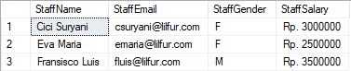

- Create a view named 'WeekendTransaction' to show CustomerName and TransactionDate (obtained from TransactionDate with format 'dd/mm/yyyy') for each transaction that occurs in Sunday.
(create view, datename, weekday, convert)
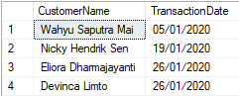

- Create a view named TransactionReport to show TransactionId, TransactionDate (obtained from TransactionDate with format 'Mon dd, yyyy'), TransactionDay (obtained from TransactionDate's weekday name), and TotalProfit (obtained from the sum of all the profits in each day, starts with 'Rp. ').
(convert, datename, weekday, sum)
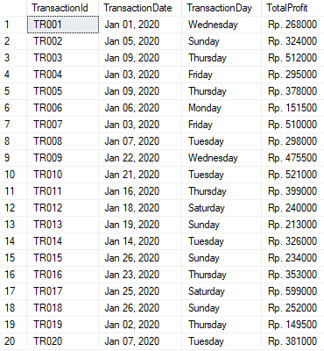
- Add a column named FruitCategory on MsFruit table with varchar(20) data type then add a constraint named FruitValidation to check the FruitCategory must be either 'Small Fruit' or 'Big Fruit'.
(alter table, add, add constraint)
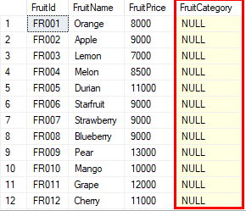

- Update StaffEmail to 'lilfruit@gmail.com' from MsStaff table for every staff who served a transaction at Jan 01, 2020 and served a male customer.
(update)
Before:
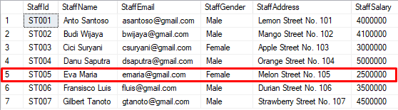

After:
