PathLab Viewer

Free-Tier Classroom Stability System Design

STATUS  Approved |  | OWNER  PathLab Viewer |  | LAST UPDATED  August 14, 2026

Authors | PathLab Engineering
Reviewers | Security, Operations, and Classroom product owners
Related docs | Approved free-tier Classroom design and implementation plan (2026-08-14)
Scope | One static-DZI Classroom, bounded role isolation, recovery, rollout, and fail-closed evidence.

1. Abstract
This approved design scales one PathLab Classroom to 1,200 students plus one teacher for 60 minutes on the existing OCI Always Free A1 2 OCPU/12 GB host and 200 GB storage. Caddy serves privacy-passed static DZI directly, a dedicated single-worker Classroom role owns the in-memory hub, and the general API, tile, upload, and conversion roles remain isolated.
The design also requires a strict 1,500-student 10-minute headroom stage, guarded 1,750/2,000 breakpoint stages, component-local recovery, and aggregate-only evidence bound to the exact deployed SHA and current browser CI. It adds no paid infrastructure and makes no host-level high-availability or browser-instance claim; capacity remains NOT CERTIFIED until live gates pass.

2. Goals and Non-Goals
Goals | Non-goals
Sustain 1,200 students plus one teacher for 60 minutes on the existing free VM. | Add paid compute, database, cache, load balancer, CDN, storage, or another OCI instance.
Pass a strict 1,500-student 10-minute headroom stage and measure 1,750/2,000 breakpoints. | Claim host, region, or free-instance-reclamation high availability.
Preserve Classroom interactions while sentinels cover annotations, shares, ingest, conversion, viewing, and Desktop pairing. | Describe protocol-client concurrency as thousands of real browser instances.
Contain component failures and publish reproducible aggregate evidence tied to exact SHA and current browser CI. | Treat a heavy-stress breakpoint or partial stage as sustained capacity certification.

3. Background and Problem Statement
The current combined API and historical 300-user evidence cannot defend a 1,200-seat production claim. Roster work, reconnect bursts, SQLite contention, component recovery, and evidence identity must be bounded before raising the participant limit, while preserving every Classroom interaction.
The system boundary is one existing free-tier VM. Caddy owns public ingress and static tiles; general and Classroom HTTP roles split API work; tile-service, tusd, and worker retain image delivery and ingest duties. Admission, queues, pools, prewarm, recovery, and certification all fail closed.

4. Proposed Architecture

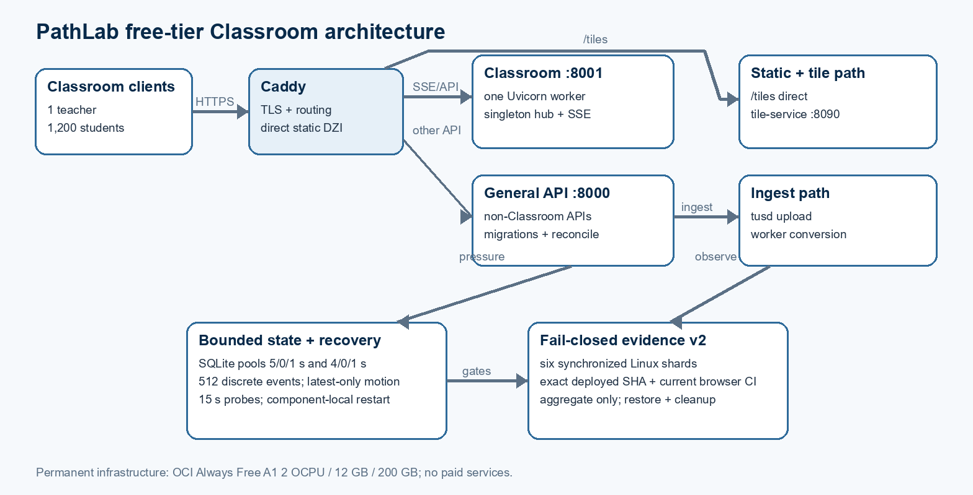
Figure 1. PathLab free-tier Classroom request, data, recovery, and evidence boundaries.

Core components

Component | Responsibility | Primary storage | Failure behavior
Caddy | TLS ingress; route Classroom/general APIs; serve /tiles directly. | Read-only published DZI and Caddy state | Readiness fails; no API bypass or alternate unreviewed tile path.
General API | Non-Classroom APIs, migrations, reconciliation; pool 5/0/1 s. | SQLite and /data | Bounded failure remains outside Classroom hub; no 30-second pool wait.
Classroom API | Classroom HTTP/SSE, exact admission, singleton hub; pool 4/0/1 s. | In-memory presence/hub plus bounded SQLite access | 503 CLASSROOM_BUSY; component-local restart after guarded failures.
Tile and ingest | tile-service rendering/cache; tusd upload; worker conversion/recovery. | Originals, tile cache, upload and derivative storage | Backpressure and health gates; direct static DZI remains isolated.
Recovery and evidence | 15-second component probes; six-shard aggregate schema v2 certification. | Sanitized aggregate artifacts only | Abort, diagnose, recover, restore, and mark NOT CERTIFIED on any missing gate.

5. Request Lifecycle
- A student or teacher enters through Caddy; static /tiles requests remain direct while Classroom and admin Classroom paths route to the single Classroom worker.
- Authentication and authorization run at the API boundary. Admission is serialized and atomically returns 409 CLASSROOM_FULL above the configured 1..2000 ceiling.
- The Classroom role loads the validated schema, bounded pool policy, singleton hub, and current room state; it skips migrations and storage reconciliation.
- Aliases use join-token HMAC with bounded collision retries. Students take one hubEpoch/stateVersion snapshot, then consume SSE and resynchronize only on a gap or version mismatch.
- Presenter/pointer state is latest-only; questions, control, pins, and teaching marks enter a bounded 512-entry discrete queue. Presence connect/disconnect performs no database write.
- Classroom tile concurrency starts at two and never exceeds four; guided switches jitter 0-250 ms. Saturation returns 503 CLASSROOM_BUSY with Retry-After instead of long waits.
- Observers capture aggregate host/service evidence. On abort or completion, recovery is measured and a trap restores configuration, removes synthetic fixtures and credentials, and closes Bastion sessions.

6. API and Data Contracts

Primary data contract

Field | Type | Required | Description
PATHLAB_SERVICE_ROLE | enum | Yes | general | classroom | development-only all; production rejects all.
PATHLAB_CLASSROOM_SERVICE_URL | URL | Yes | Internal fixed route http://classroom:8001 used by Caddy.
PATHLAB_CLASSROOM_MAX_PARTICIPANTS | integer | Yes | Configured range 1..2000; evidence determines the final production ceiling.
participants?after=&limit=&q= | HTTP query | Teacher | Keyset roster search; limit no more than 100; returns items/total/nextCursor/rosterVersion.
participantCount / rosterVersion | integer | Teacher state | Added without removing embedded participants; supports bounded reconciliation.
roster-changed | SSE event | Teacher | Teacher-only, coalesced at most once per second; signals roster refresh.
CLASSROOM_BUSY / CLASSROOM_FULL | HTTP errors | Conditional | 503 plus Retry-After on saturation; 409 on exact capacity rejection.

Contract guarantees

- Admission is exact and serialized; no participant above the active ceiling is admitted, and excess joins receive 409 CLASSROOM_FULL.
- Exactly one production Classroom worker owns the singleton hub; each participant has one live SSE stream, with a replacement closing the stale stream.
- hubEpoch, stateVersion, rosterVersion, and participantCount make gaps and reconnect convergence observable without removing the compatibility participant payload.
- Only exact-SHA, current-browser-CI, six-shard, aggregate-only evidence with complete recovery and cleanup may certify capacity; partial, historical, synthetic-only, or breakpoint results cannot.
The versioned schema or interface definition is published at
PathLab capacity evidence schema v2 in the repository; update it with each contract release.

7. Consistency, Idempotency, and Replay

Client-visible state is versioned and convergence-based. Latest-only motion may be superseded, but critical discrete events cannot be lost. Bounded timeouts expose pressure explicitly, and recovery never rewrites a failed or partial stage into a pass.
Scenario | Expected behavior | Reasoning
Duplicate join or reconnect | Serialized admission and one replacement SSE stream; versioned resync only when needed. | Prevents over-admission, stale streams, and full-room scans.
Pool or queue pressure | Return bounded 503/Retry-After or stop escalation; never wait 30 seconds. | Makes contention visible and protects event-loop/general API latency.
Gap, timeout, or partial event | Snapshot resync on version mismatch; critical events remain lossless within queue bounds. | Separates supersedable motion from discrete teaching state.
Component/release divergence | Diagnostics and component-local recovery; exact-SHA/topology evidence fails. | A partial recovery or mismatched deployment cannot certify capacity.

8. Security and Privacy Considerations

- Teacher and administrative routes require their existing authenticated authorization boundaries; student join tokens never enter published evidence.
- Production stress uses synthetic fixtures only, runs with no active real Classroom, and publishes aggregate percentiles/counts rather than participant, slide, URL, address, or event records.
- GitHub, OCI, application, and Bastion credentials are masked, held only for the protected run, and removed by an always-run cleanup step.
- Production rejects PATHLAB_SERVICE_ROLE=all. General annotations remain disabled until migration, security, browser, sentinel, and live-capacity gates pass.
- Artifacts are retained only as sanitized aggregates. Cleanup must restore the prior participant limit and configuration, remove fixtures, verify zero Bastion sessions, and fail closed on any missing gate.

9. Operational Readiness
Signal | SLO or alert | Owner | Launch gate
Failures and convergence | Failures <0.1%; complete reconnect/state convergence; zero lost critical events. | Classroom + QA | Required
Latency | Presenter SSE <=250 ms; API/control <=500 ms; static tile <500 ms; poster <1.5 s; question <=2 s. | Platform | Required
Pressure | CPU <80%; memory <85%; no swap growth, queue overflow, pool timeout, SQLite lock, OOM, or unexpected restart. | Operations | Required
Release and topology | Exact workflow/deployed/browser-CI SHA; exact approved five- or six-service environment topology. | Release | Required
Recovery and cleanup | Recovery to 1,200; prior config/limit restored; fixtures/credentials removed; zero Bastion sessions. | Operations + Security | Required
Rollout constraint: Production only 02:00-05:00 ICT, no real Classroom, verified backup/restore and rollback release, annotations disabled, synthetic fixtures, six synchronized Linux shards, egress below 9 TB, SGD 0 cost, and trap-based fail-closed cleanup.

10. Alternatives Considered

Alternative | Why it was considered | Why it was not selected
Additional OCI or managed services | Simpler scale and redundancy. | Violates the permanent $0 and existing-resource constraint.
Third-party tile CDN | Could improve static-tile latency. | Changes privacy, dependency, and evidence boundaries.
Multiple Classroom workers | Horizontal fanout appears attractive. | Breaks singleton hub ownership and SQLite consistency.
Raise limits only | Minimal configuration change. | Does not fix admission, reconnect, roster, presence, pressure, recovery, or evidence paths.

11. Open Questions
- Static-tile p95 below 500 ms has not passed even in the historical 300-user public-tile test; it remains a hard certification gate.
- The single Always Free VM remains a host and region single point of failure and may be reclaimed under Oracle policy; this design does not claim infrastructure high availability.
- The final production participant ceiling is selected only by strict live evidence: 1500, 1200, or rollback to 300 with NOT CERTIFIED.
- Distributed-generator drift/saturation tolerances and the egress projection method are supplied by the Task 6 harness before protected production execution.

12. Decision and Next Steps
Implement the approved design in bounded milestones, validate locally and in protected CI, then run the guarded live stages only in the approved window. Deployment, activation, and capacity certification remain separate decisions; the evidence-derived ceiling is applied only after cleanup succeeds.
Milestone | Deliverable | Exit criteria
M1 | Design artifact, observer/workflow repair, and aggregate evidence schema v2. | Topology, exact-SHA/current-browser-CI, privacy, abort/recovery/cleanup, cost, and egress contracts pass.
M2 | Role isolation plus bounded backend/frontend Classroom scaling. | Focused tests prove pools, admission, aliases, SSE, roster, reconnect, tile concurrency, and feature preservation.
M3 | Component watchdog and production-safety preflight/postflight. | Backup/restore, rollback, no-real-room, component recovery, resource, cleanup, and zero-cost gates pass.
M4 | Distributed protocol load and cross-browser sentinels in the protected live window. | Strict evidence applies 1500, 1200, or 300/NOT CERTIFIED exactly; no partial result is promoted.

Historical 300-user public static-tile evidence missed the strict <500 ms p95 target and does not certify this design or the current release.

