**ШИНЖЛЭХ УХААН ТЕХНОЛОГИЙН ИХ СУРГУУЛЬ**

**Мэдээлэл холбооны технологийн сургууль**



**ЛАБОРАТОРИЙН АЖЛЫН**

**ТАЙЛАН - 4**

**Сүлжээний програмчлал I (F.NS351)**

**2022-2023 оны хичээлийн жилийн хавар**

**Лабораторийн ажлын нэр: Си програмчлалын хэлийг судлах-2**

**Хичээл заасан багш:** Б.Мөнхбаяр /Ph.D/

**Лабораторийн ажил гүйцэтгэсэн:** Уламбаяр /В200970314/

**Лабораторийн цаг:** 4-2

Улаанбаатар хот

2023 он

**Гарчиг**

Лабораторийн ажлын зорилго............................................................................3

Даалгавар….........................................................................................................4

Дүгнэлт................................................................................................................9

Ашигласан материал..........................................................................................9

**ЛАБОРАТОРИЙН АЖЛЫН ЗОРИЛГО, ЗОРИЛТ**

Энэхүү лабораторийн зорилго нь дараах шаардлагатай мэдлэг чадварыг олж авах явдал юм. Үүнд:

* socket programming
* client and server programming

**ЛАБОРАТОРИЙН АЖИЛ**

Даалгавар-2: Дараах даалгавруудыг гүйцэтгэнэ үү.

1. Клиент (tcp-socket-client.c) болон сервер (tcp-socket-server.c)-ийн эх кодыг

компайлдаад ажиллуулж үзнэ. Жич: Энэ бол жишээ код. Өөрсдөө эхнээс нь бас

өөрсдийнхөөрөө бичиж болно.

Tcp-socket-client.c

| #include <stdio.h> #include <stdlib.h> #include <string.h> #include <unistd.h> #include <sys/socket.h> #include <arpa/inet.h>  int main(int argc, char *argv[]) {  // Check for correct number of arguments  if (argc != 3) {  printf("Usage: %s <Server IP> <Server Port>\n", argv[0]);  exit(1);  }   // Create a socket  int sock = socket(AF_INET, SOCK_STREAM, 0);  if (sock == -1) {  perror("Socket creation failed");  exit(1);  }   // Set up the server address  struct sockaddr_in server_addr;  memset(&server_addr, 0, sizeof(server_addr));  server_addr.sin_family = AF_INET;  server_addr.sin_addr.s_addr = inet_addr(argv[1]);  server_addr.sin_port = htons(atoi(argv[2]));   // Connect to the server  if (connect(sock, (struct sockaddr *)&server_addr, sizeof(server_addr)) == -1) {  perror("Connection failed");  exit(1);  }   // Send a message to the server  char message[1024] = "Hello, server!";  if (send(sock, message, strlen(message), 0) == -1) {  perror("Send failed");  exit(1);  }   // Receive a message from the server  while (1) {  char buffer[1024];  int num_bytes = recv(sock, buffer, sizeof(buffer), 0);  if (num_bytes == -1) {  perror("Receive failed");  exit(1);  }   // Print the message received from the server  buffer[num_bytes] = '\0';  printf("Received message from server: %s\n", buffer);  printf("Send message to server:");  char message[1024];  scanf("%s",&message);  if (send(sock, message, strlen(message), 0) == -1) {  perror("Send failed");  exit(1);  }  // Close the socket    }  close(sock);  return 0; } |
| --- |

Tcp-socket-server.c

| #include <stdio.h> #include <stdlib.h> #include <string.h> #include <unistd.h> #include <sys/socket.h> #include <arpa/inet.h>  #define MAX_CLIENTS 10  int main(int argc, char *argv[]) {  // Check for correct number of arguments  if (argc != 2) {  printf("Usage: %s <Server Port>\n", argv[0]);  exit(1);  }   // Create a socket  int server_sock = socket(AF_INET, SOCK_STREAM, 0);  if (server_sock == -1) {  perror("Socket creation failed");  exit(1);  }   // Set up the server address  struct sockaddr_in server_addr;  memset(&server_addr, 0, sizeof(server_addr));  server_addr.sin_family = AF_INET;  server_addr.sin_addr.s_addr = htonl(INADDR_ANY);  server_addr.sin_port = htons(atoi(argv[1]));   // Bind the socket to the server address  if (bind(server_sock, (struct sockaddr *)&server_addr, sizeof(server_addr)) == -1) {  perror("Bind failed");  exit(1);  }   // Listen for incoming connections  if (listen(server_sock, MAX_CLIENTS) == -1) {  perror("Listen failed");  exit(1);  }   printf("Server started listening on port %s...\n", argv[1]);   // Accept incoming connections  struct sockaddr_in client_addr;  socklen_t client_addr_len = sizeof(client_addr);  int client_sock;  char buffer[1024];  client_sock = accept(server_sock, (struct sockaddr *)&client_addr, &client_addr_len);  if (client_sock == -1) {  perror("Accept failed");  exit(1);  }  printf("Client connected: %s:%d\n", inet_ntoa(client_addr.sin_addr), ntohs(client_addr.sin_port));  while (1) {  // Receive a message from the client  int num_bytes = recv(client_sock, buffer, sizeof(buffer), 0);  if (num_bytes == -1) {  perror("Receive failed");  exit(1);  }   // Print the message received from the client  buffer[num_bytes] = '\0';  printf("Received message from client: %s\n");  printf("Send message to client: \n");  char message[1024];  scanf("%s",&message);  if (send(client_sock, message, strlen(message), 0) == -1) {  perror("Send failed");  exit(1);  }  }  } |
| --- |

2. Гараас авсан дурын текстийг клиент, сервер хоёрын хооронд дамжуулна.

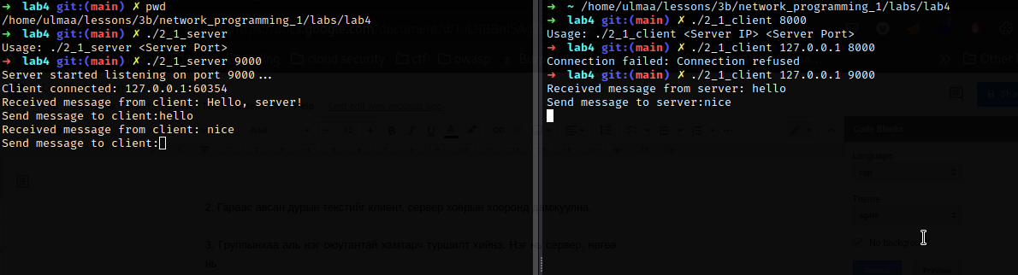

3. Группынхаа аль нэг оюутантай хамтарч туршилт хийнэ. Нэг нь сервер, нөгөө нь

клиент болоод хоорондоо текст дамжуулах буюу чатлана.

4. netstat командаар TCP холболт үүссэн эсэхийг шалгаж үзнэ. (Жишээ команд:

netstat -a | grep 8087).

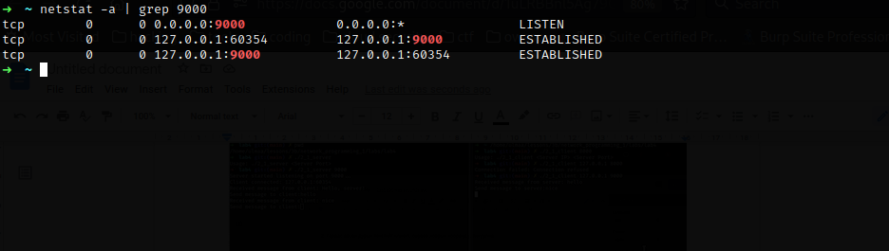

5. Wireshark програмаар клиент, сервер хоёрын хооронд өгөгдөл дамжиж байгаа

эсэхийг шалгаж үзнэ.

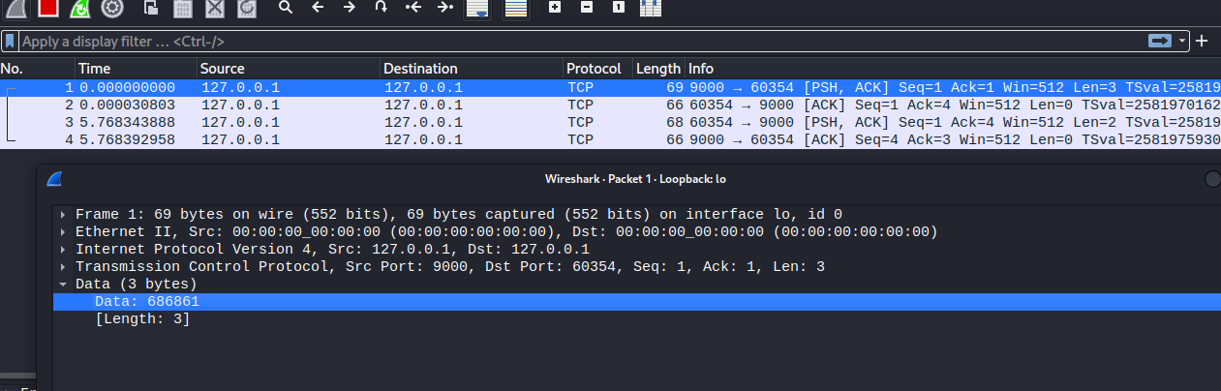

Даалгавар-3: Дараах даалгавруудыг гүйцэтгэнэ үү.

1. Клиент нь сервер лүү 1-12 хүртлэх тооны аль нэгийг дамжуулахад тухайн

тоотой тэнцүү сарын нэрийг сервер нь клиент рүү буцаадаг байна.

| #include <stdio.h> #include <stdlib.h> #include <string.h> #include <unistd.h> #include <sys/socket.h> #include <arpa/inet.h>  #define MAX_CLIENTS 10 char* numberToMonth(int month) {  char* months[] = {  "January", "February", "March", "April", "May", "June",  "July", "August", "September", "October", "November", "December"  };   if (month < 1 || month > 12) {  return "Invalid month";  }   return months[month-1]; } int main(int argc, char *argv[]) {  // Check for correct number of arguments  if (argc != 2) {  printf("Usage: %s <Server Port>\n", argv[0]);  exit(1);  }   // Create a socket  int server_sock = socket(AF_INET, SOCK_STREAM, 0);  if (server_sock == -1) {  perror("Socket creation failed");  exit(1);  }   // Set up the server address  struct sockaddr_in server_addr;  memset(&server_addr, 0, sizeof(server_addr));  server_addr.sin_family = AF_INET;  server_addr.sin_addr.s_addr = htonl(INADDR_ANY);  server_addr.sin_port = htons(atoi(argv[1]));   // Bind the socket to the server address  if (bind(server_sock, (struct sockaddr *)&server_addr, sizeof(server_addr)) == -1) {  perror("Bind failed");  exit(1);  }   // Listen for incoming connections  if (listen(server_sock, MAX_CLIENTS) == -1) {  perror("Listen failed");  exit(1);  }   printf("Server started listening on port %s...\n", argv[1]);   // Accept incoming connections  struct sockaddr_in client_addr;  socklen_t client_addr_len = sizeof(client_addr);  int client_sock;  char buffer[1024];  client_sock = accept(server_sock, (struct sockaddr *)&client_addr, &client_addr_len);  if (client_sock == -1) {  perror("Accept failed");  exit(1);  }  printf("Client connected: %s:%d\n", inet_ntoa(client_addr.sin_addr), ntohs(client_addr.sin_port));    // Receive a message from the client  int num_bytes = recv(client_sock, buffer, sizeof(buffer), 0);  if (num_bytes == -1) {  perror("Receive failed");  exit(1);  }  // Print the message received from the client  buffer[num_bytes] = '\0';  printf("Received message from client: %s\n");  printf("%s",buffer);  int num = strtol(buffer, NULL, 10);  printf("number: %d",num);  if (send(client_sock, numberToMonth(num), strlen(numberToMonth(num)), 0) == -1) {  perror("Send failed");  exit(1);  } } |
| --- |

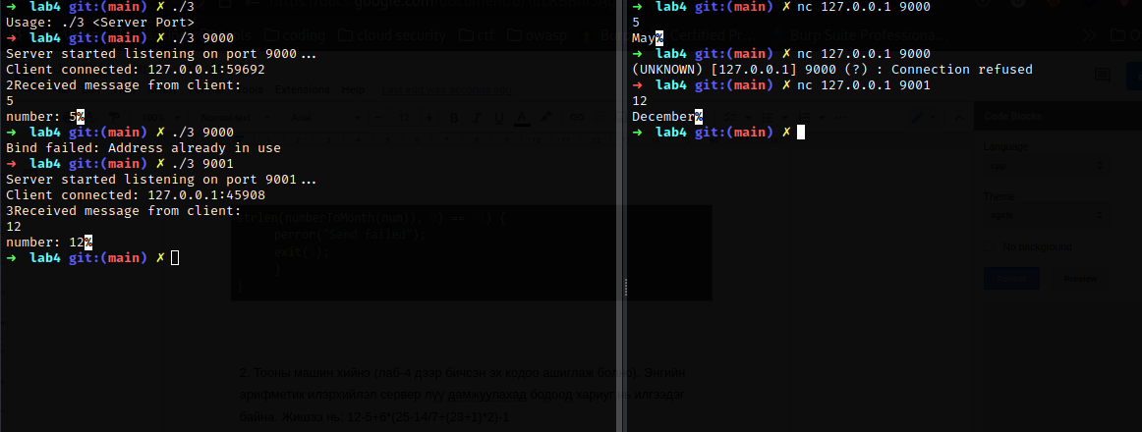

2. Тооны машин хийнэ (лаб-4 дээр бичсэн эх кодоо ашиглаж болно). Энгийн

арифметик илэрхийлэл сервер лүү дамжуулахад бодоод хариуг нь илгээдэг

байна. Жишээ нь: 12-5+6*(25-14/7+(23+1)*2)-1

| #include <stdio.h> #include <stdlib.h> #include <string.h> #include <unistd.h> #include <sys/socket.h> #include <arpa/inet.h> #include <math.h> float evaluate_expression(char *exp);  float parse_number(char *exp, int *pos) {  float num = 0;  int decimal_point = 0;   while (exp[*pos] >= '0' && exp[*pos] <= '9' || exp[*pos] == '.') {  if (exp[*pos] == '.') {  decimal_point = 1;  } else {  num = num * 10 + (exp[*pos] - '0');  if (decimal_point) {  decimal_point *= 10;  }  }  (*pos)++;  }   if (decimal_point) {  num /= decimal_point;  }   return num; }  float parse_factor(char *exp, int *pos) {  float result;  int is_negative = 0;   if (exp[*pos] == '-') {  is_negative = 1;  (*pos)++;  }   if (exp[*pos] == '(') {  (*pos)++;  result = evaluate_expression(exp);  if (exp[*pos] != ')') {  printf("Error: missing closing parenthesis\n");  return NAN;  }  (*pos)++;  } else {  result = parse_number(exp, pos);  }   if (is_negative) {  result = -result;  }   return result; }  float parse_term(char *exp, int *pos) {  float left, right;  char op;   left = parse_factor(exp, pos);   while (exp[*pos] == '*' || exp[*pos] == '/') {  op = exp[*pos];  (*pos)++;  right = parse_factor(exp, pos);  if (op == '*') {  left *= right;  } else {  left /= right;  }  }   return left; }  float parse_expression(char *exp, int *pos) {  float left, right;  char op;   left = parse_term(exp, pos);   while (exp[*pos] == '+' || exp[*pos] == '-') {  op = exp[*pos];  (*pos)++;  right = parse_term(exp, pos);  if (op == '+') {  left += right;  } else {  left -= right;  }  }   return left; }  float evaluate_expression(char *exp) {  int pos = 0;  return parse_expression(exp, &pos); }   #define MAX_CLIENTS 10 int main(int argc, char *argv[]) {  // Check for correct number of arguments  if (argc != 2) {  printf("Usage: %s <Server Port>\n", argv[0]);  exit(1);  }   // Create a socket  int server_sock = socket(AF_INET, SOCK_STREAM, 0);  if (server_sock == -1) {  perror("Socket creation failed");  exit(1);  }   // Set up the server address  struct sockaddr_in server_addr;  memset(&server_addr, 0, sizeof(server_addr));  server_addr.sin_family = AF_INET;  server_addr.sin_addr.s_addr = htonl(INADDR_ANY);  server_addr.sin_port = htons(atoi(argv[1]));   // Bind the socket to the server address  if (bind(server_sock, (struct sockaddr *)&server_addr, sizeof(server_addr)) == -1) {  perror("Bind failed");  exit(1);  }   // Listen for incoming connections  if (listen(server_sock, MAX_CLIENTS) == -1) {  perror("Listen failed");  exit(1);  }   printf("Server started listening on port %s...\n", argv[1]);   // Accept incoming connections  struct sockaddr_in client_addr;  socklen_t client_addr_len = sizeof(client_addr);  int client_sock;  char buffer[1024];  client_sock = accept(server_sock, (struct sockaddr *)&client_addr, &client_addr_len);  if (client_sock == -1) {  perror("Accept failed");  exit(1);  }  printf("Client connected: %s:%d\n", inet_ntoa(client_addr.sin_addr), ntohs(client_addr.sin_port));    // Receive a message from the client  char exp[] = "1+1";    int num_bytes = recv(client_sock, buffer, sizeof(buffer), 0);  if (num_bytes == -1) {  perror("Receive failed");  exit(1);  }  // Print the message received from the client  buffer[num_bytes] = '\0';   printf("Received message from client: %s\n");  printf("%s",buffer);  float result = evaluate_expression(buffer);  printf("%s = %.6f\n", buffer, result);  sprintf(buffer, "%f", result);  if (send(client_sock, buffer, strlen(buffer), 0) == -1) {  perror("Send failed");  exit(1);  } }#include <stdio.h> #include <stdlib.h> #include <string.h> #include <unistd.h> #include <sys/socket.h> #include <arpa/inet.h> #include <math.h> float evaluate_expression(char *exp);  float parse_number(char *exp, int *pos) {  float num = 0;  int decimal_point = 0;   while (exp[*pos] >= '0' && exp[*pos] <= '9' || exp[*pos] == '.') {  if (exp[*pos] == '.') {  decimal_point = 1;  } else {  num = num * 10 + (exp[*pos] - '0');  if (decimal_point) {  decimal_point *= 10;  }  }  (*pos)++;  }   if (decimal_point) {  num /= decimal_point;  }   return num; }  float parse_factor(char *exp, int *pos) {  float result;  int is_negative = 0;   if (exp[*pos] == '-') {  is_negative = 1;  (*pos)++;  }   if (exp[*pos] == '(') {  (*pos)++;  result = evaluate_expression(exp);  if (exp[*pos] != ')') {  printf("Error: missing closing parenthesis\n");  return NAN;  }  (*pos)++;  } else {  result = parse_number(exp, pos);  }   if (is_negative) {  result = -result;  }   return result; }  float parse_term(char *exp, int *pos) {  float left, right;  char op;   left = parse_factor(exp, pos);   while (exp[*pos] == '*' || exp[*pos] == '/') {  op = exp[*pos];  (*pos)++;  right = parse_factor(exp, pos);  if (op == '*') {  left *= right;  } else {  left /= right;  }  }   return left; }  float parse_expression(char *exp, int *pos) {  float left, right;  char op;   left = parse_term(exp, pos);   while (exp[*pos] == '+' || exp[*pos] == '-') {  op = exp[*pos];  (*pos)++;  right = parse_term(exp, pos);  if (op == '+') {  left += right;  } else {  left -= right;  }  }   return left; }  float evaluate_expression(char *exp) {  int pos = 0;  return parse_expression(exp, &pos); }   #define MAX_CLIENTS 10 int main(int argc, char *argv[]) {  // Check for correct number of arguments  if (argc != 2) {  printf("Usage: %s <Server Port>\n", argv[0]);  exit(1);  }   // Create a socket  int server_sock = socket(AF_INET, SOCK_STREAM, 0);  if (server_sock == -1) {  perror("Socket creation failed");  exit(1);  }   // Set up the server address  struct sockaddr_in server_addr;  memset(&server_addr, 0, sizeof(server_addr));  server_addr.sin_family = AF_INET;  server_addr.sin_addr.s_addr = htonl(INADDR_ANY);  server_addr.sin_port = htons(atoi(argv[1]));   // Bind the socket to the server address  if (bind(server_sock, (struct sockaddr *)&server_addr, sizeof(server_addr)) == -1) {  perror("Bind failed");  exit(1);  }   // Listen for incoming connections  if (listen(server_sock, MAX_CLIENTS) == -1) {  perror("Listen failed");  exit(1);  }   printf("Server started listening on port %s...\n", argv[1]);   // Accept incoming connections  struct sockaddr_in client_addr;  socklen_t client_addr_len = sizeof(client_addr);  int client_sock;  char buffer[1024];  client_sock = accept(server_sock, (struct sockaddr *)&client_addr, &client_addr_len);  if (client_sock == -1) {  perror("Accept failed");  exit(1);  }  printf("Client connected: %s:%d\n", inet_ntoa(client_addr.sin_addr), ntohs(client_addr.sin_port));    // Receive a message from the client  char exp[] = "1+1";    int num_bytes = recv(client_sock, buffer, sizeof(buffer), 0);  if (num_bytes == -1) {  perror("Receive failed");  exit(1);  }  // Print the message received from the client  buffer[num_bytes] = '\0';   printf("Received message from client: %s\n");  printf("%s",buffer);  float result = evaluate_expression(buffer);  printf("%s = %.6f\n", buffer, result);  sprintf(buffer, "%f", result);  if (send(client_sock, buffer, strlen(buffer), 0) == -1) {  perror("Send failed");  exit(1);  } } |
| --- |

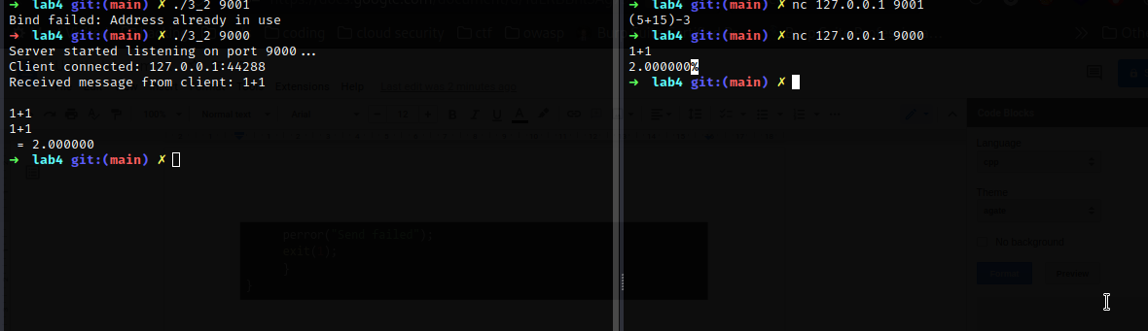

Даалгавар-4: Клиент болон серверийн жишээ кодыг чатын програм болгох.

Одоогийн байдлаар клиент болон серверийн жишээ код нь сөөлжиж ажиллаж байгаа.

Ө.х нэг тал нь өгөгдлийг илгээхэд нөгөө тал нь хүлээж аваад хариуг өгнө. Хариуг нь

илгээгээгүй тохиолдолд дахиад өгөгдөл илгээж болохгүй байгаа.

1. Клиент, сервер хоёрыг чатлагч хоёр тал гэж үзээд аль нэг тал нь заавал хариуг

хүлээхгүйгээр дараалуулаад хэдэн ч мессежийг илгээж болдог байна

| #include <stdio.h> #include <stdlib.h> #include <string.h> #include <unistd.h> #include <sys/socket.h> #include <arpa/inet.h> #include <pthread.h>  #define PORT 8080  int client_sockets[100]; int num_clients = 0;  pthread_mutex_t lock = PTHREAD_MUTEX_INITIALIZER;  void *handle_client(void *arg) {  int client_socket = *(int*)arg;  char buffer[1024] = {0};   while (1) {  int valread = read(client_socket, buffer, 1024);  if (valread <= 0) {  break;  }   pthread_mutex_lock(&lock);  for (int i = 0; i < num_clients; i++) {  if (client_sockets[i] != client_socket) {  send(client_sockets[i], buffer, strlen(buffer), 0);  }  }  pthread_mutex_unlock(&lock);   memset(buffer, 0, 1024);  }   pthread_mutex_lock(&lock);  for (int i = 0; i < num_clients; i++) {  if (client_sockets[i] == client_socket) {  client_sockets[i] = client_sockets[num_clients-1];  num_clients--;  break;  }  }  pthread_mutex_unlock(&lock);   close(client_socket);  return NULL; }  int main(int argc, char const *argv[]) {  int server_fd, new_socket;  struct sockaddr_in address;  int opt = 1;  int addrlen = sizeof(address);   if ((server_fd = socket(AF_INET, SOCK_STREAM, 0)) == 0) {  perror("socket failed");  exit(EXIT_FAILURE);  }   if (setsockopt(server_fd, SOL_SOCKET, SO_REUSEADDR | SO_REUSEPORT, &opt, sizeof(opt))) {  perror("setsockopt");  exit(EXIT_FAILURE);  }   address.sin_family = AF_INET;  address.sin_addr.s_addr = INADDR_ANY;  address.sin_port = htons(PORT);   if (bind(server_fd, (struct sockaddr *)&address, sizeof(address))<0) {  perror("bind failed");  exit(EXIT_FAILURE);  }   if (listen(server_fd, 3) < 0) {  perror("listen");  exit(EXIT_FAILURE);  }   while (1) {  if ((new_socket = accept(server_fd, (struct sockaddr *)&address, (socklen_t*)&addrlen))<0) {  perror("accept");  exit(EXIT_FAILURE);  }  printf("Connection");  pthread_t tid;  pthread_create(&tid, NULL, handle_client, &new_socket);   pthread_mutex_lock(&lock);  client_sockets[num_clients] = new_socket;  num_clients++;  pthread_mutex_unlock(&lock);  }   return 0; } |
| --- |

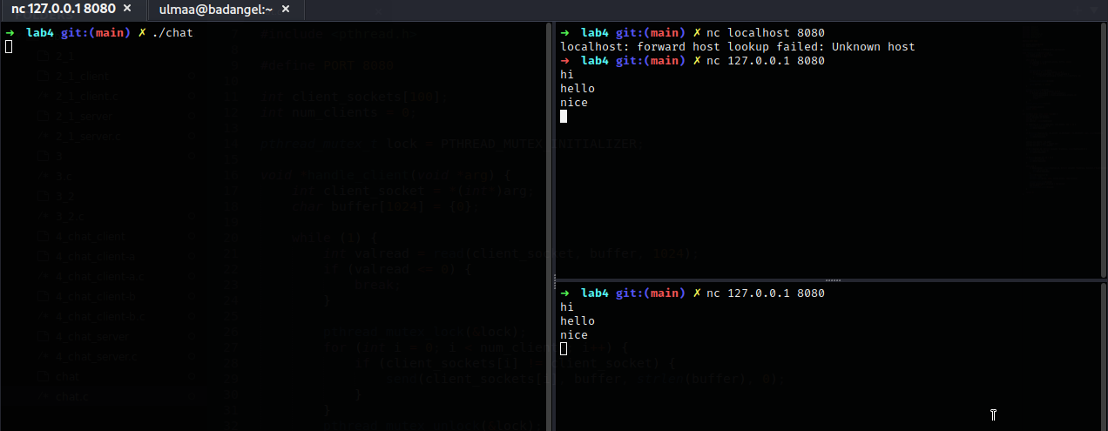

**Дүгнэлт**

Энэхүү лабораторийн ажлаар “Сүлжээний програмчлал 1” хичээлийн суурь ойлголт болох socket programming талаар судалж мэдэж авсан ба өгөгдсөн бодлогуудын программыг бичэж гүйцэтгэсэн билээ.

**Ашигласан материал**

[1] “F.NS351 Сүлжээний програмчлал 4 хичээлийн лекцийн агуулга” 2022 он, Улаанбаатар хот, Монгол Улс

[2] “laboratory 4.pdf ” - Лабораторийн ажлын заавар

[3] https://www.tutorialspoint.com/cprogramming/

[4] https://www.tutorialspoint.com/cprogramming/c_basic_syntax.htm