Hong Kong College of Technology

Higher Diploma in Computer Studies

(Mobile Applications and Game Development) Year 2

**Software Engineering and Professional Practice**

Assignment 2

Group Member

Lai Joe Wing 20807626

Ng Yik Lok 11075836

Wong Sau Hang Alex 21561403

Sin Ho Yeung Louie 21562477

Lam Yin Ying Elayne 21537561

Introduction

This is a attendance system for visual programming courses. Students are grouped by year 1 and year 2.

PERT chart

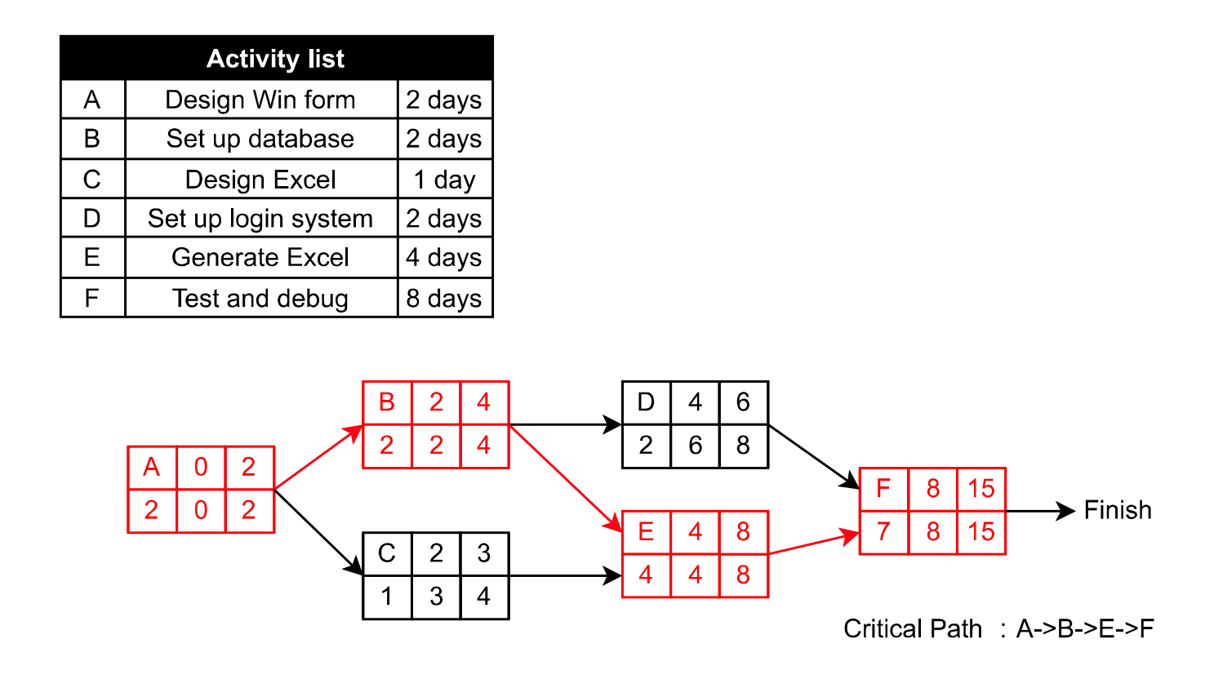

Resource Planning

|  |  |
| --- | --- |
| Lai Joe Wing | Win form UI design  JSONbin connection |
| Lam Yin Ying Elayne |
| Ng Yik Lok | Set up database  Design Excel  Generate Excel |
| Sin Ho Yeung |
| Wong Sau Hang Alex |

Login page

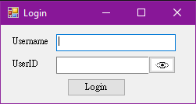  
Eye button：display input text normally

(before) (after)

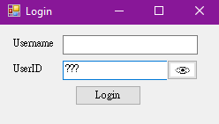 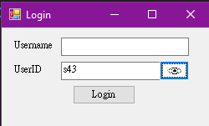

Login button ：check role of user by checking with database

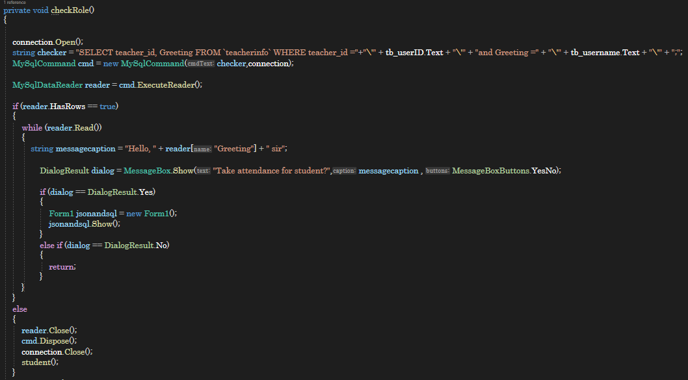

Form for teacher take attendance：

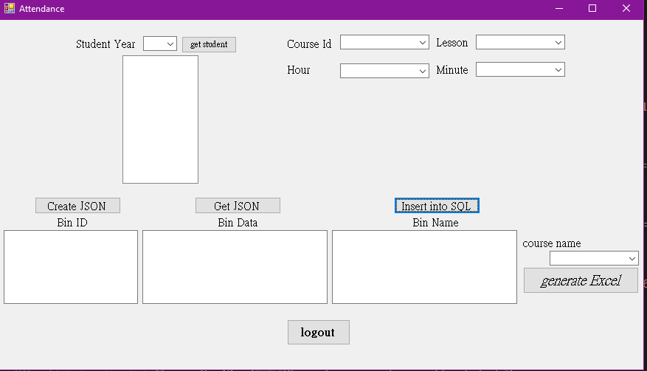

Get student button：generate student name in the checkbox list according to selected student year

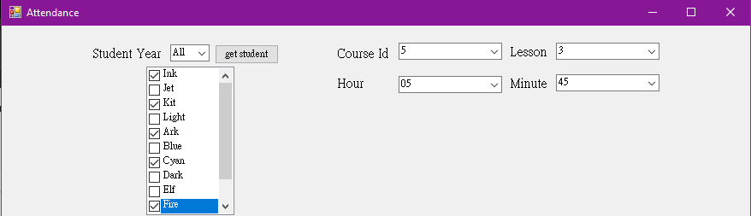

Create JSON button；create JSONbin according the number of selected students  
(bin name：selected students’ id | selected course id |   
date of selected lesson + selected hour and minute)

Date of selected lesson：

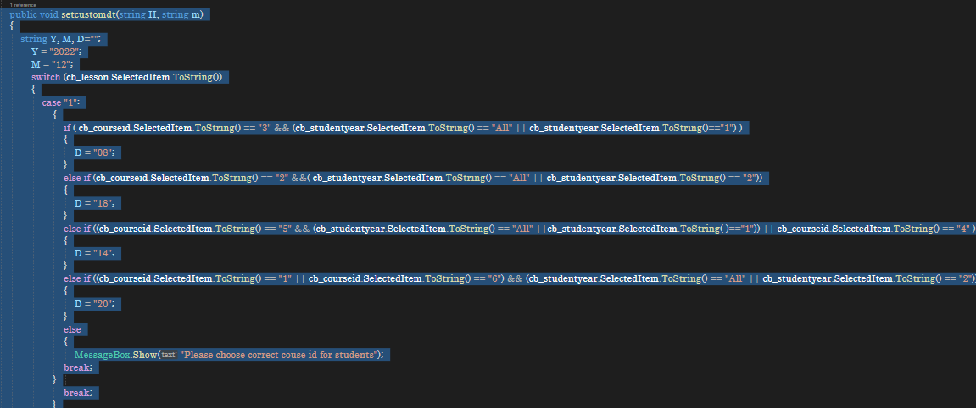

Adding bins according to student id of selected students

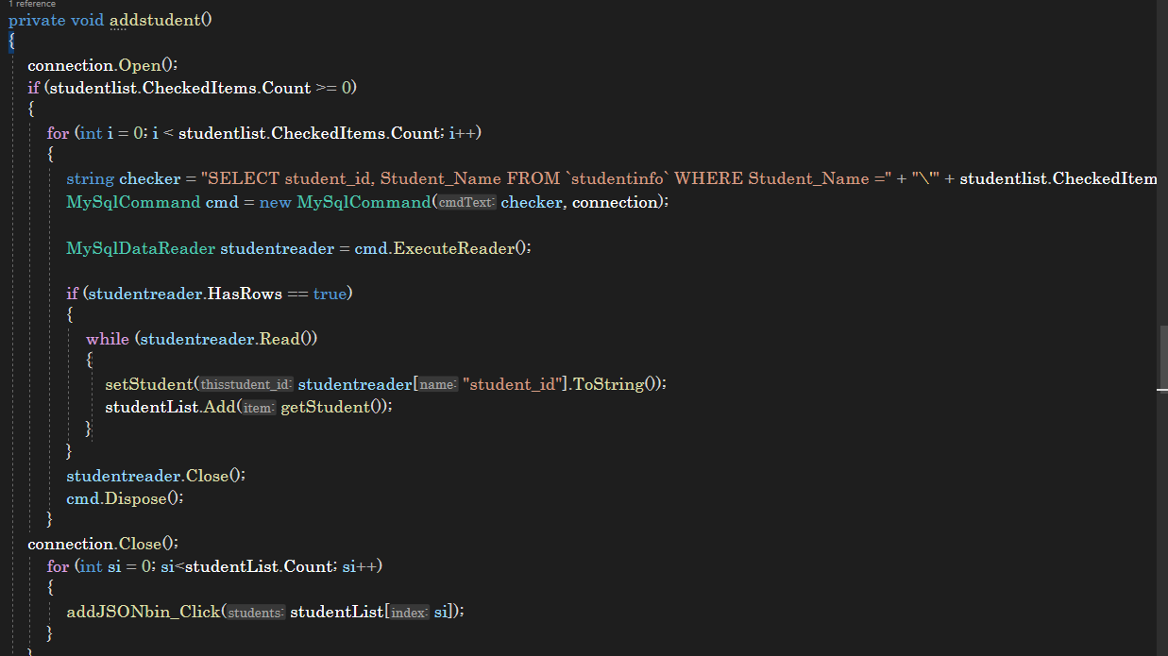

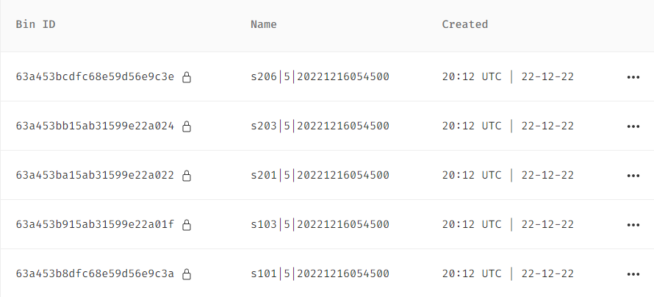

Get JSON button：display all bin name and bin id + backup all bin name in the collection

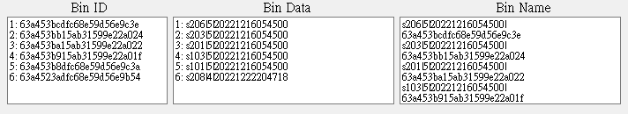

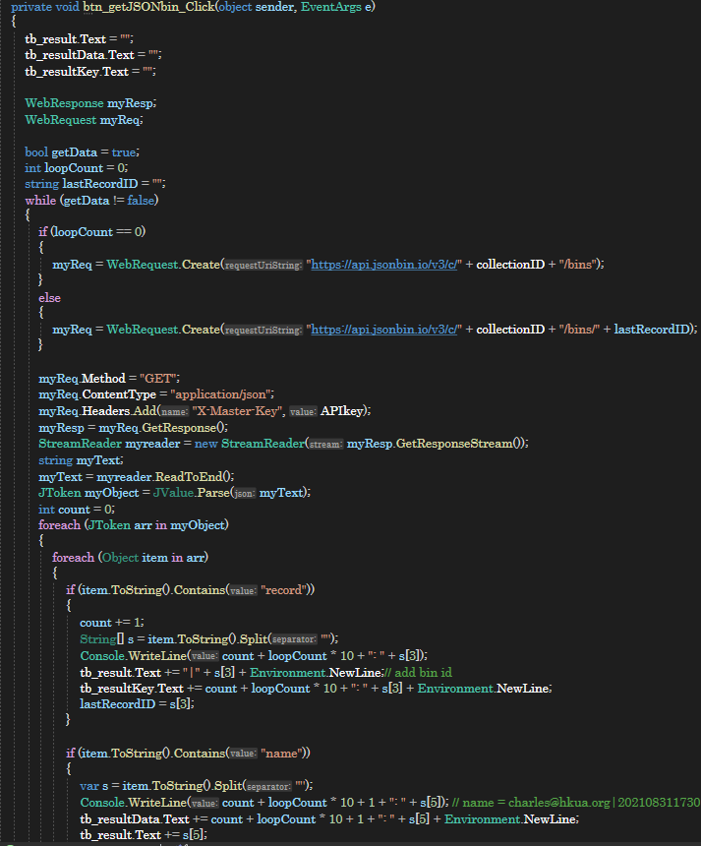

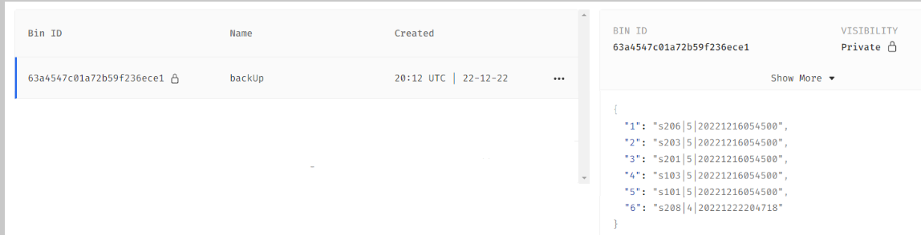

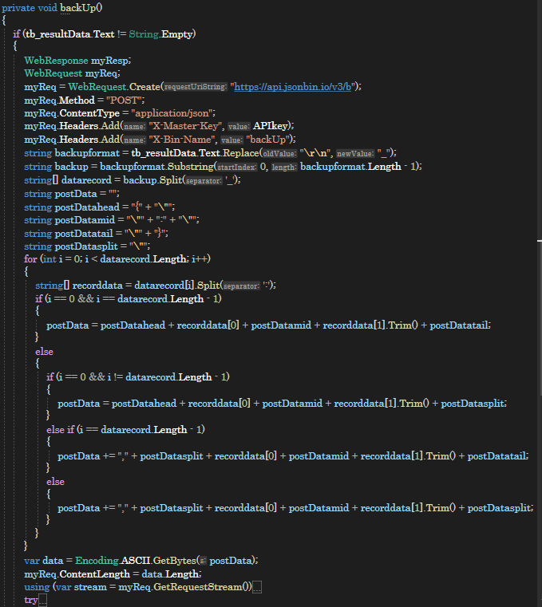

Insert into SQL button：insert bin name into SQL + delete all displayed bin name

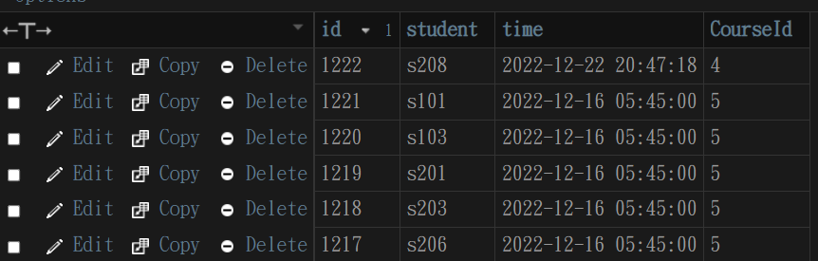

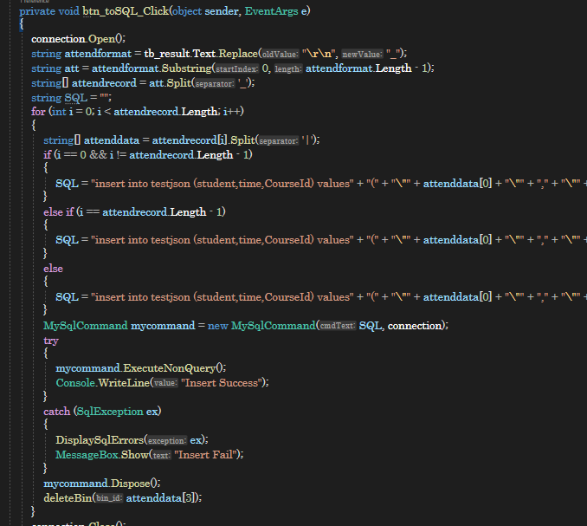

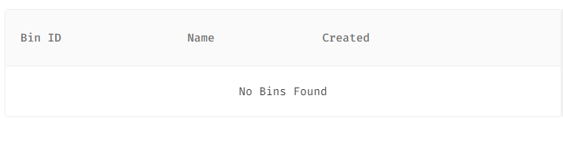

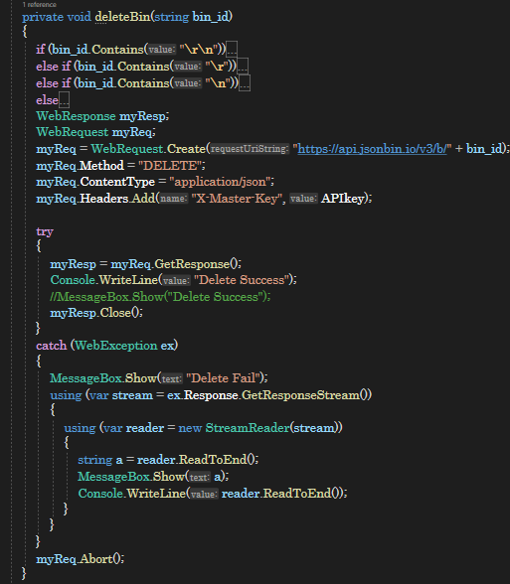

Form for students taking attendance：

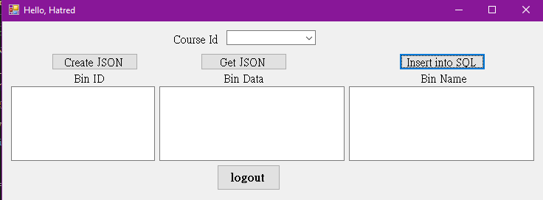

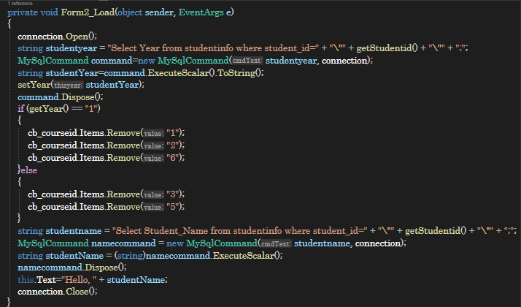

year 2 students；

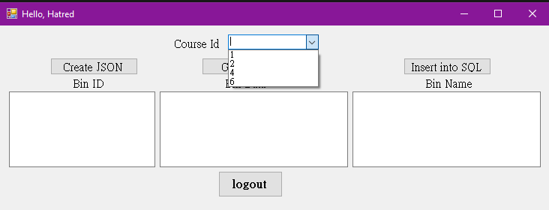

year 1 students；

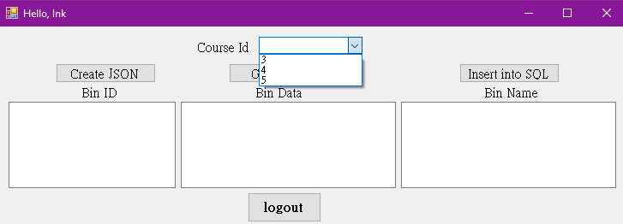

Create JSON button；create a JSONbin   
(bin name：current student id | selected course id| datetime of click button)

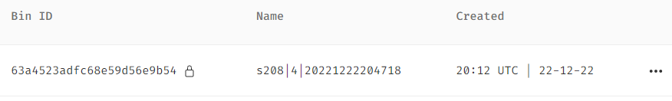

Current student id is detected by comparing with SQL data

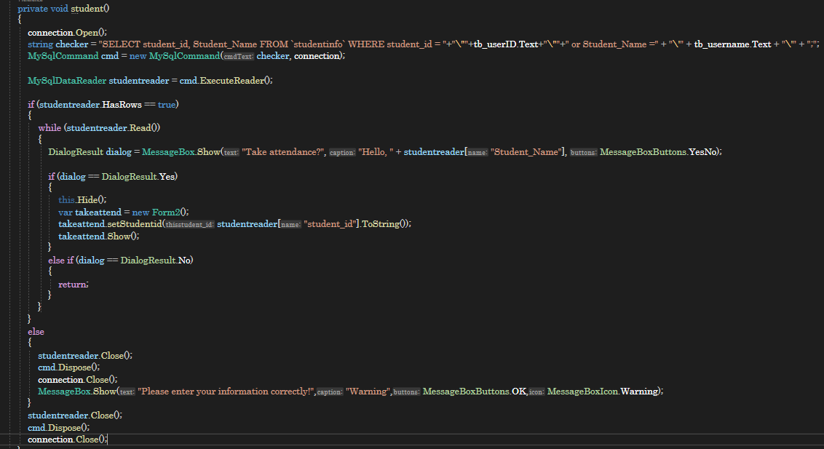

Attendance Report (Excel)

Course for Year 1 students

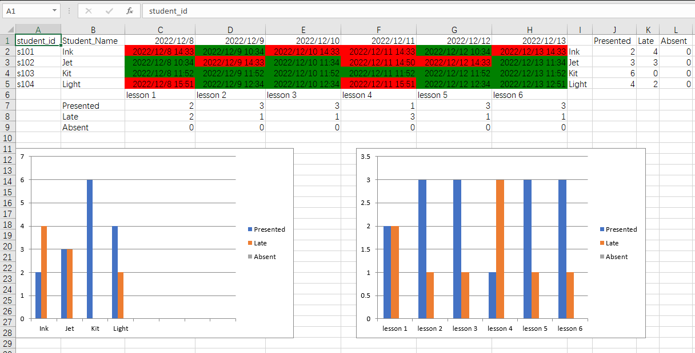

Course for Year 2 students

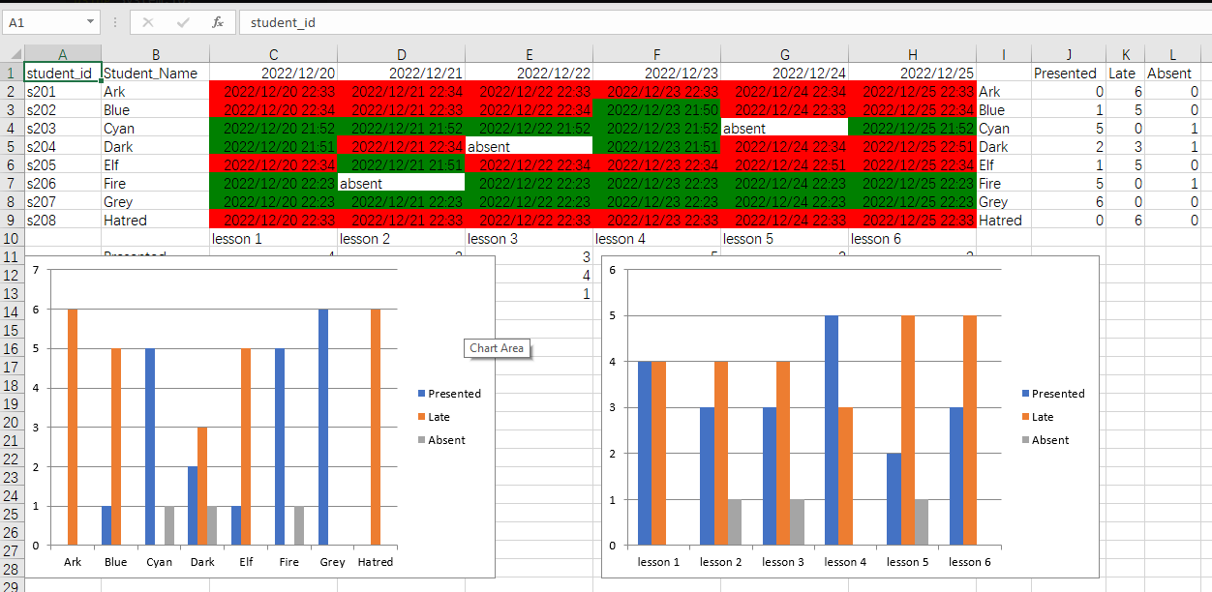

Course for all students

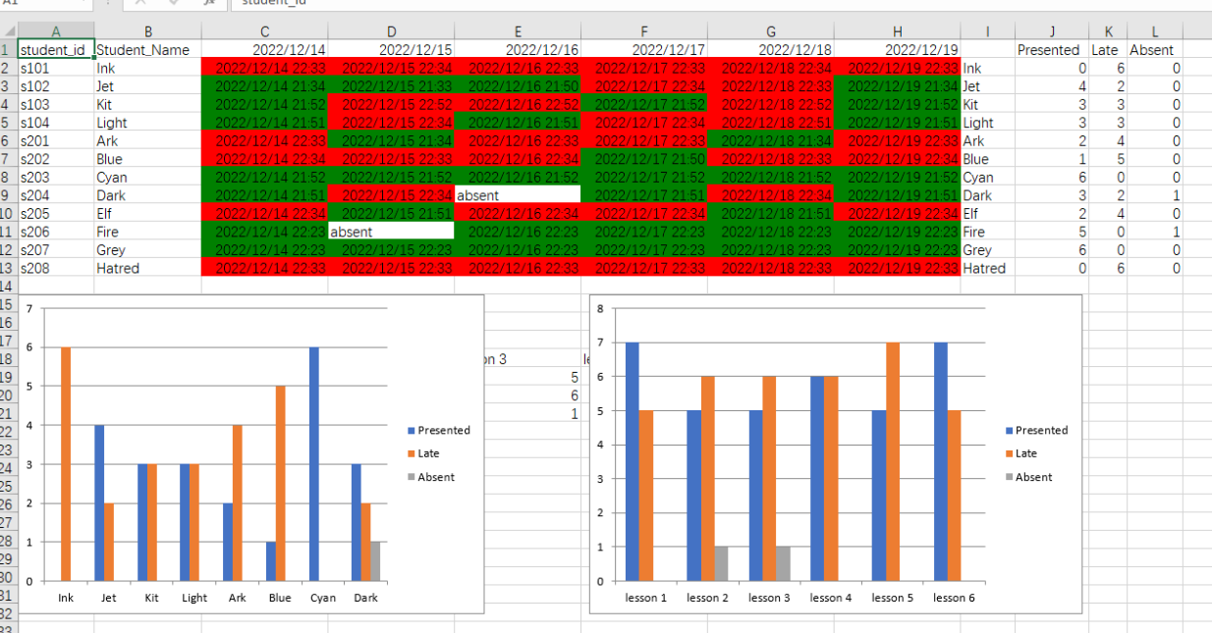

SQL Database structure

