**2:**

F = @(t,y)-20*y + 20*sin(t) + cos(t);

tInitial = 0.0; % Initial time

tFinal = 2.0; % Final time

yInitial = 1; % Initial value of y

h = 0.1;

N=(tFinal- tInitial)/h;

%Euler's

y = zeros(N+1,1);

t = zeros(N+1,1);

t(1) = tInitial;

y(1) = yInitial;

for i = 1:N

t(i+1) = t(i) + h;

y(i+1) = y(i) + h*F(t(i),y(i));

end

plot(t, y, 'DisplayName','Euler')

hold on

%RK4

y = zeros(N+1,1);

t = zeros(N+1,1);

t(1) = tInitial;

y(1) = yInitial;

for i = 1:N

s1 = F(t(i), y(i));

s2 = F(t(i), y(i) + h/2*s1);

s3 = F(t(i), y(i) + h/2*s2);

s4 = F(t(i), y(i) + h*s3);

t(i+1) = t(i) + h;

y(i+1) = y(i) + h*(1/6*s1 + 1/3*s2 + 1/3*s3 + 1/6*s4);

end

plot(t, y, 'DisplayName','RK4')

hold on

%Trapezoidal

y = zeros(N+1,1);

t = zeros(N+1,1);

t(1) = tInitial;

y(1) = yInitial;

for i = 1:N

t(i+1) = t(i) + h;

y(i+1) = 0.5*(sin(t(i))+0.05*cos(t(i))+sin(t(i+1))+0.05*cos(t(i+1)));

end

plot(t, y, 'DisplayName','Trapezoidal')

hold on

%Exact

y = zeros(N+1,1);

t = zeros(N+1,1);

t(1) = tInitial;

y(1) = yInitial;

for i = 1:N

t(i+1) = t(i) + h;

y(i+1) = sin(t(i+1)) + exp(-20*t(i+1));

end

plot(t, y, 'DisplayName', 'Exact')

hold on

tPlotMin = tInitial;

tPlotMax = tFinal;

yPlotMin = -1.0;

yPlotMax = 2.0;

axis([tPlotMin,tPlotMax,yPlotMin,yPlotMax]);

legend

title('Problem 2')

xlabel('t')

ylabel('y(t)')

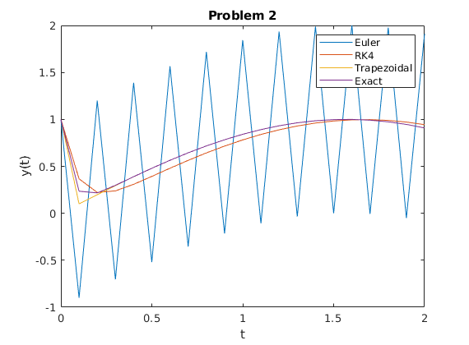

**3:**

F = @(y)10*(y-y^2);

tInitial = 0;

tFinal = 5;

h = 0.01;

yInitial = 0.5;

N = (tFinal - tInitial)/h;

y = zeros(N+1,1);

t = zeros(N+1,1);

t(1) = tInitial;

y(1) = yInitial;

for i = 1:N

s1 = F(y(i));

s2 = F(y(i)+h*s1);

t(i+1) = t(i) + h;

y(i+1) = y(i) + h/2*(s1+s2);

end

plot(t, y, 'DisplayName', 'RK2')

hold on

tPlotMin = tInitial;

tPlotMax = tFinal;

yPlotMin = 0.0;

yPlotMax = 2.0;

axis([tPlotMin,tPlotMax,yPlotMin,yPlotMax]);

legend

title('Problem 3 obtained with RK2''s method ')

xlabel('t')

ylabel('y(t)')

