**Problem 1.1**

F = @(t,y)-5*y+5*t^2+2*t;

yInitial = 1/3;

tInitial = 0;

tFinal = 1;

h = 0.1;

N = (tFinal - tInitial)/h;

y = zeros(N+1,1);

t = zeros(N+1,1);

t(1) = tInitial;

y(1) = yInitial;

%RK4

t(2) = 0.1;

s1 = F(t(1), y(1));

s2 = F(t(1)+h/2, y(1) + h/2*s1);

s3 = F(t(1)+h/2, y(1) + h/2*s2);

s4 = F(t(1)+h, y(1) + h*s3);

y(2) = y(2) + h*(1/6*s1 + 1/3*s2 + 1/3*s3 + 1/6*s4);

%AB2

for i = 2:N

y(i+1) = y(i) + h*(3/2*F(t(i),y(i)) - 1/2*F(t(i-1),y(i-1)));

t(i+1) = t(i) + h;

end

plot(t, y, 'DisplayName','AB2')

hold on

%exact

for i = 1:N

t(i+1) = t(i)+h;

y(i+1) = t(i+1)^2 + 1/3*exp(-5*t(i+1));

end

plot(t, y, 'DisplayName','exact')

hold on

tPlotMin = tInitial;

tPlotMax = tFinal;

yPlotMin = -1.0;

yPlotMax = 2.0;

axis([tPlotMin,tPlotMax,yPlotMin,yPlotMax]);

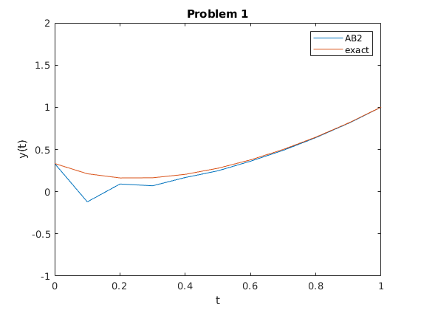legend

title('Problem 1')

xlabel('t')

ylabel('y(t)')

**Problem 1.3**

F = @(t,y)-5*y+5*t^2+2*t;

yInitial = 1/3;

tInitial = 0;

tFinal = 1;

h = 0.1;

N = (tFinal - tInitial)/h;

y = zeros(N+1,1);

t = zeros(N+1,1);

t(1) = tInitial;

y(1) = yInitial;

%RK4

t(2) = 0.1;

s1 = F(t(1), y(1));

s2 = F(t(1)+h/2, y(1) + h/2*s1);

s3 = F(t(1)+h/2, y(1) + h/2*s2);

s4 = F(t(1)+h, y(1) + h*s3);

y(2) = y(2) + h*(1/6*s1 + 1/3*s2 + 1/3*s3 + 1/6*s4);

%AM2

for i = 2:N

y(i+1) = (y(i)+h*(5/12*(5*t(i+1)^2+2*t(i+1))+8/12*F(t(i),y(i))-1/12*F(t(i-1),y(i-1))))/(1+25/12*h);

t(i+1) = t(i) + h;

end

plot(t, y, 'DisplayName','AM2')

hold on

%exact

for i = 1:N

t(i+1) = t(i)+h;

y(i+1) = t(i+1)^2 + 1/3*exp(-5*t(i+1));

end

plot(t, y, 'DisplayName','exact')

hold on

tPlotMin = tInitial;

tPlotMax = tFinal;

yPlotMin = -1.0;

yPlotMax = 2.0;

axis([tPlotMin,tPlotMax,yPlotMin,yPlotMax]);

legend

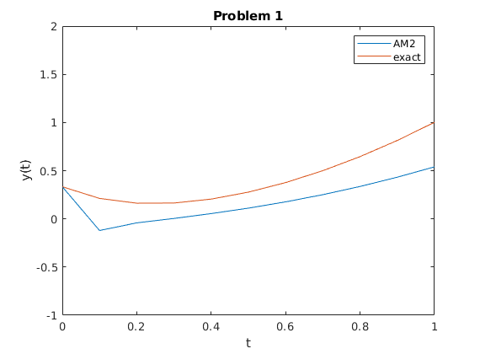title('Problem 1')

xlabel('t')

ylabel('y(t)')

**Problem 2**

tInitial = 0;

tFinal = 3;

yInitial = 1;

h = 0.1;

N = (tFinal - tInitial)/h;

%exact solution

y = zeros(N+1,1);

t = zeros(N+1,1);

t(1) = tInitial;

y(1) = yInitial;

for i = 1:N

t(i+1) = t(i) + h;

y(i+1) = 43/36*exp(t(i+1)) + 1/4*exp(-t(i+1)) - 4/9*exp(-2*t(i+1)) + 1/6*t(i+1)*exp(t(i+1));

end

plot(t, y, 'DisplayName','exact')

hold on

%RK2

v = cell(N+1);

t = zeros(N+1,1);

t(1) = tInitial;

v{1} = [1;2;0];

mat = [0,1,0;0,0,1;2,1,-2];

for i = 1:N

t(i+1) = t(i) + h;

vstar = v{i} + h * mat * v{i} + [0;0;exp(t(i))];

s1 = mat * v{i} + [0;0;exp(t(i))];

s2 = mat * vstar + [0;0;exp(t(i+1))];

v{i+1} = v{i} + h/2*(s1+s2);

end

y = zeros(N+1,1);

for i = 1:N+1

y(i) = v{i}(1);

end

plot(t, y, 'DisplayName','RK2')

hold on

legend

title('Problem 2')

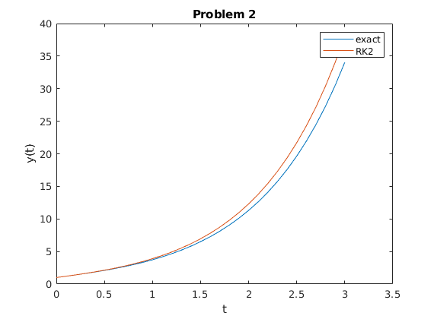xlabel('t')

ylabel('y(t)')