Problem 3.1

L = [0,0,0,0,0,0;-1,0,0,0,0,0;0,-1,0,0,0,0;-1,0,0,0,0,0;0,-1,0,-1,0,0;0,0,-1,0,-1,0];

U = [0,-1,0,-1,0,0;0,0,-1,0,-1,0;0,0,0,0,0,-1;0,0,0,0,-1,0;0,0,0,0,0,-1;0,0,0,0,0,0];

D = [4,0,0,0,0,0;0,4,0,0,0,0;0,0,4,0,0,0;0,0,0,4,0,0;0,0,0,0,4,0;0,0,0,0,0,4];

A = L + D + U;

N = 1000;

r = 0.01;

b = transpose([2,1,2,2,1,2]);

%Jacobi

x = cell(N+1);

x{1} = transpose([0,0,0,0,0,0]);

k=1;

T = -inv(D)\*(L+U);

g = inv(D)\*b;

norm = [];

while k <= N

x{k+1} = T\*x{k} + g;

residualvector = b - A \* x{k+1};

norm(k) = sqrt(sum(residualvector.^2));

if norm(k) <= r

break;

else

k = k + 1;

end

end

plot((1:k), norm, 'DisplayName','Jacobi')

hold on

legend

title('Problem 3')

xlabel('r')

ylabel('k')

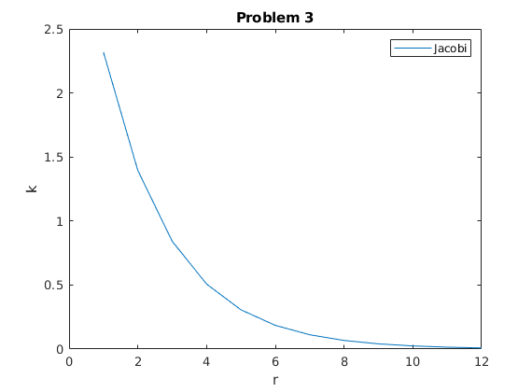

Problem 3.2

L = [0,0,0,0,0,0;-1,0,0,0,0,0;0,-1,0,0,0,0;-1,0,0,0,0,0;0,-1,0,-1,0,0;0,0,-1,0,-1,0];

U = [0,-1,0,-1,0,0;0,0,-1,0,-1,0;0,0,0,0,0,-1;0,0,0,0,-1,0;0,0,0,0,0,-1;0,0,0,0,0,0];

D = [4,0,0,0,0,0;0,4,0,0,0,0;0,0,4,0,0,0;0,0,0,4,0,0;0,0,0,0,4,0;0,0,0,0,0,4];

A = L + D + U;

N = 1000;

r = 0.01;

b = transpose([2,1,2,2,1,2]);

%Gauss-Seidel

x = cell(N+1);

x{1} = transpose([0,0,0,0,0,0]);

k=1;

T = -inv(L+D)\*U;

g = inv(L+D)\*b;

norm = [];

while k <= N

x{k+1} = T\*x{k} + g;

residualvector = b - A \* x{k+1};

norm(k) = sqrt(sum(residualvector.^2));

if norm(k) <= r

break;

else

k = k + 1;

end

end

plot((1:k), norm, 'DisplayName','Gauss-Seidel')

hold on

legend

title('Problem 3')

xlabel('r')

ylabel('k')

