Stats 10 Lab 1 Submission
Name: Enmin Zhou
UID: 104756697
Section 1
1) a)
> heights <- c(69.29133858, 64, 63)
> print(heights)
[1] 69.29134 64 63

b)
> names <- c("Enmin", "Meredidhe", "Sam")
> print(names)
[1] "Enmin" "Meredidhe" "Sam"

c)
> cbind(heights, names)
heights names
[1,] "69.29133858" "Enmin"
[2,] "66.92913386" "A"
[3,] "64.96062992" "B"

This command make “heights” and “names” into two rows of a matrix. This new object is “matrix”.

2) a)
> NCBirths <- read.csv("~/Desktop/stats10/births.csv")

b)
> head(NCBirths)
Gender Premie weight Apgar1 Fage Mage Feduc Meduc TotPreg Visits Marital Racemom Racedad Hispmom Hispdad Gained Habit MomPriorCond
1 Male No 124 8 31 25 13 14 1 13 Married White White NotHisp NotHisp 40 NonSmoker None
2 Female No 177 8 36 26 9 12 2 11 Unmarried White White Mexican Mexican 20 NonSmoker None
3 Male No 107 3 30 16 12 8 2 10 Unmarried White Unknown Mexican Unknown 70 NonSmoker At Least One
4 Female No 144 6 33 37 12 14 2 12 Unmarried White White NotHisp NotHisp 50 NonSmoker None
5 Male No 117 9 36 33 10 16 2 19 Married White Black NotHisp NotHisp 40 NonSmoker At Least One
6 Female No 98 4 31 29 14 16 3 20 Married White White NotHisp NotHisp 21 NonSmoker None
BirthDef DelivComp BirthComp
1 None At Least One None
2 None At Least One None
3 None At Least One None
4 None At Least One None
5 None None None
6 None None None

3) a)
> find.package("maps")
[1] "/home/enminz/R/x86_64-pc-linux-gnu-library/3.4/maps"

b)
> library(maps)
> map("state")
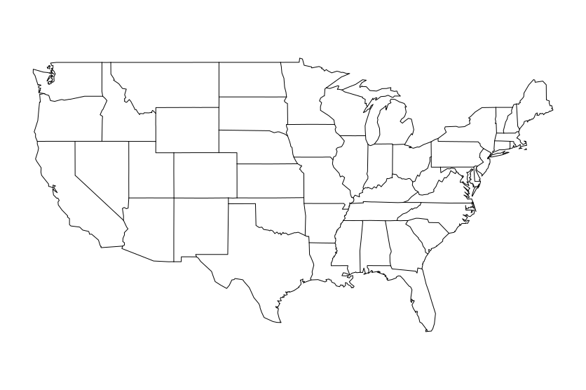
4) a)
> weights <- NCBirths$weight

b)
The numbers in ‘weights’ are around 100. So I think the unit is ounce.

c)
> weights_in_pounds <- weights / 16

d)
> weights_in_pounds[1:20]
[1] 7.7500 11.0625 6.6875 9.0000 7.3125 6.1250 9.1875 8.6250 6.5000 7.6875 9.5625 8.0625 7.4375 6.7500 6.6250 7.8125 7.1875
[18] 8.0000 8.2500 5.1875

Section 2
1)
> mean(weights_in_pounds)
[1] 7.2532

2)
> tally(NCBirths$Habit)
X
NonSmoker Smoker
1805 187
The percentage is 9.38755%.

3)
11.61245%.

Section 3
1)
> dotchart(weights_in_pounds)
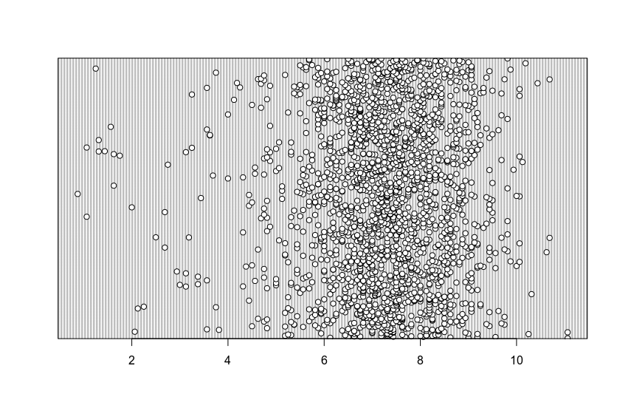

2)
> histogram(weights_in_pounds, breaks=3)
> histogram(weights_in_pounds, breaks=20)
> histogram(weights_in_pounds, breaks=100)

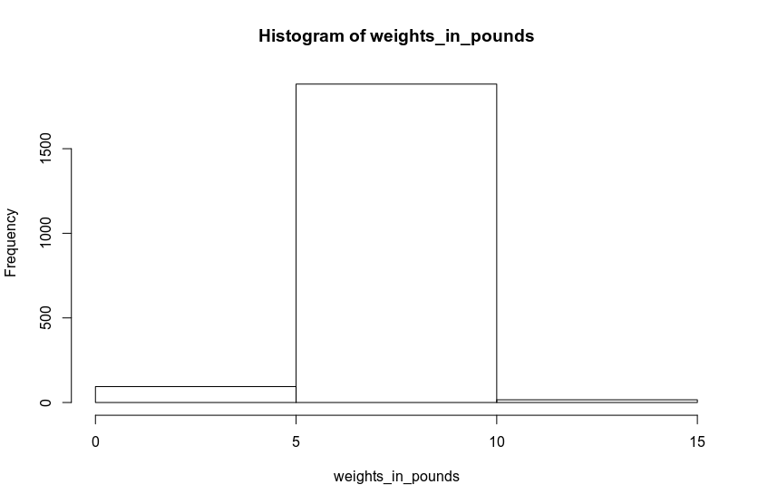
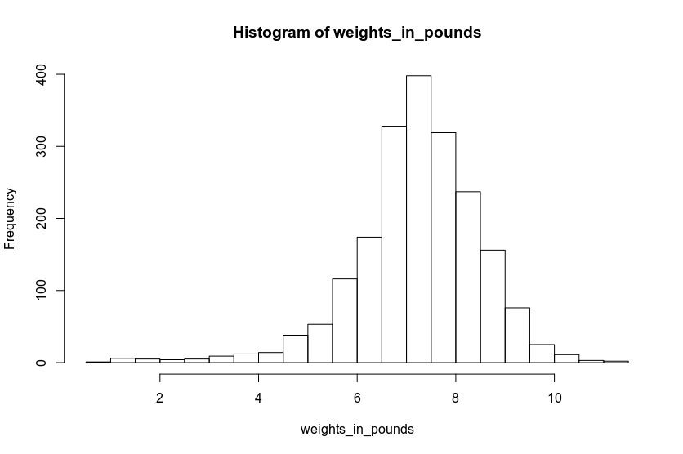

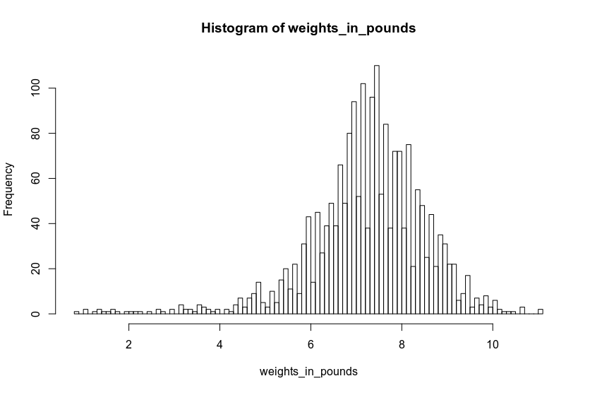
The histogram with 20 bins gives the best visualization because it clearly shows the trend of the data.

3)
> boxplot(NCBirths$Fage, NCBirths$Mage)
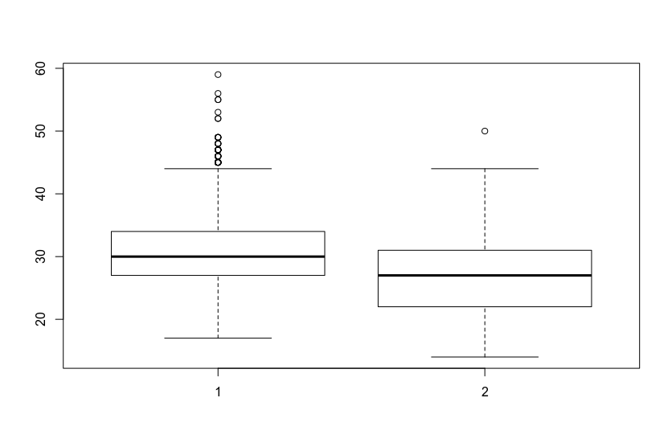
The left is Fage and the right is Mage. The male tends to be older.

4)

Section 4
1)
> tally(~BirthDef| Habit, data = NCBirths, format = "proportion")
BirthDef NonSmoker Smoker
At Least One 0.006648199 0.016042781
None 0.993351801 0.983957219
Moms who are smokers have more BirthDef babies that those who are nonsmokers.

Section 5
1)
> plot(NCBirths$weight ~ NCBirths$Mage, col = "red", cex = 1.5, pch = 3, xlab= "Mom's age", ylab = "Baby weight (oz.)", main = "Weight vs Mom's age")
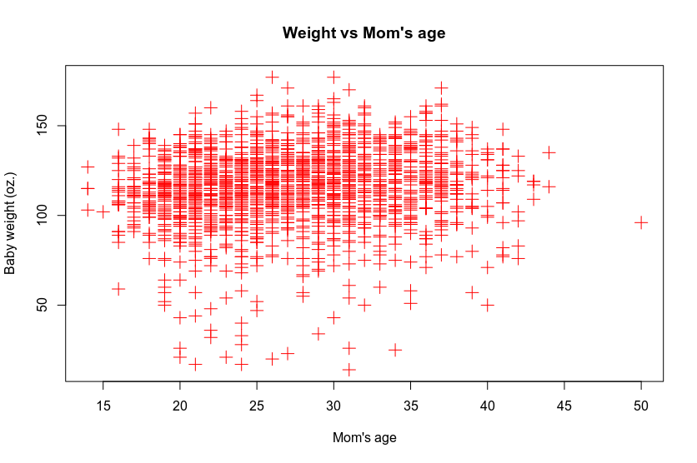
Section 6
1)
