Stats 10 Lab 1 Submission
Name: Enmin Zhou
UID: 104756697
Exercise 1
1) a)
> flint <- read.csv("~/Desktop/stats10/lab2/flint.csv")
b)
> mean(flint$Pb >= 15)
[1] 0.04436229
c)
> region <- flint$Region
> copper <- flint$Cu
> is_north <- region == "North"
> north_cu <- copper[is_north]
> mean(north_cu)
[1] 44.6424
d)
> pb <- flint$Pb
> is_danger <- pb >= 15
> danger_cu <- copper[is_danger]
> mean(danger_cu)
[1] 305.8333
e)
> mean(flint$Cu)
[1] 54.58102
> mean(flint$Pb)
[1] 3.383272
f)
> boxplot(flint$Pb, main="mean of lead levels")
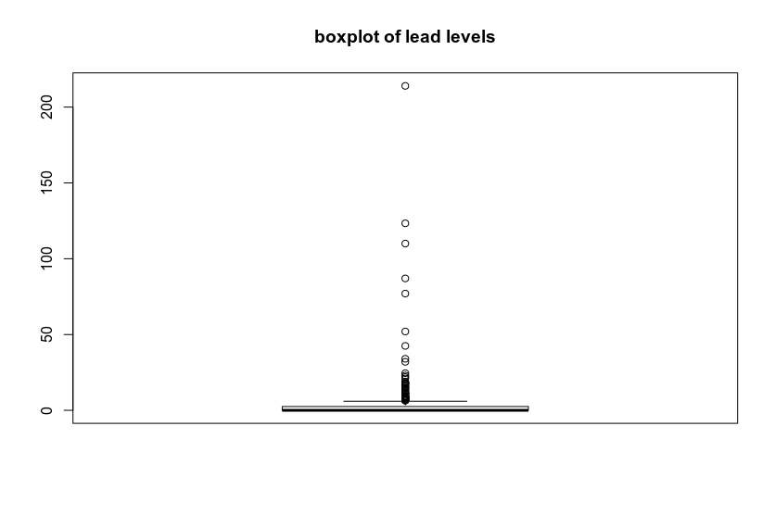
g)No. I think the median is 0. The IQR is 2.5. The Q1 is 0 and Q3 is 2.5.

Exercise 2
2) a)
> life<-read.table("http://www.stat.ucla.edu/~nchristo/statistics12/countries_life.txt", header=TRUE)
> plot(life$Income, life$Life, xlab="income", ylab="Life", main="Life against Income")
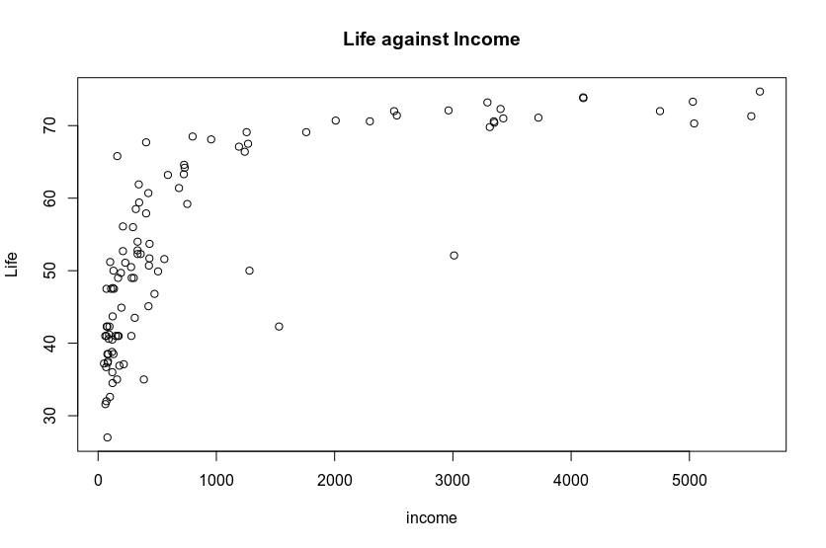
b)
> boxplot(life$Income, main="boxplot of Income")
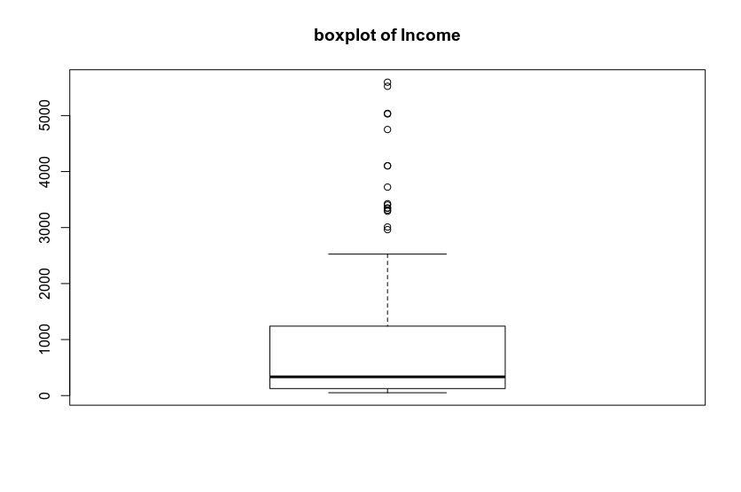
> histogram::histogram(life$Income, main="histogram of Income")
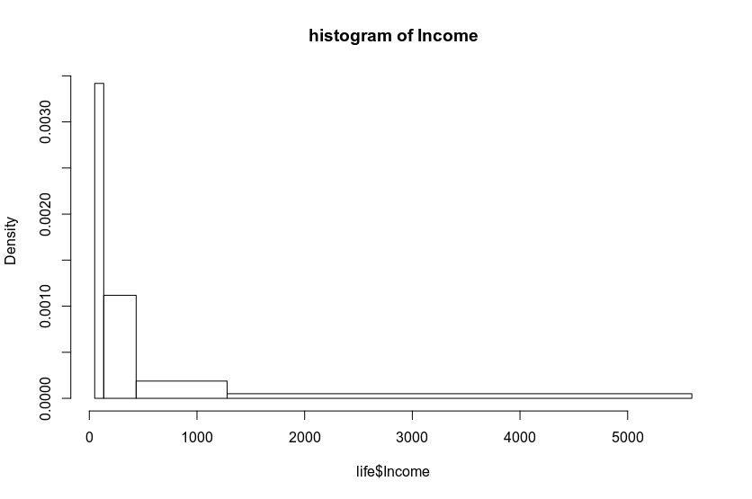
c)
> income <- life$Income
> is_above <- income >= 1000
> is_below <- income < 1000
> above_1000 <- life[is_above,]
> below_1000 <- life[is_below,]

d)
> plot(below_1000$Income, below_1000$Life, xlab="income", ylab="Life", main="Life against Income")
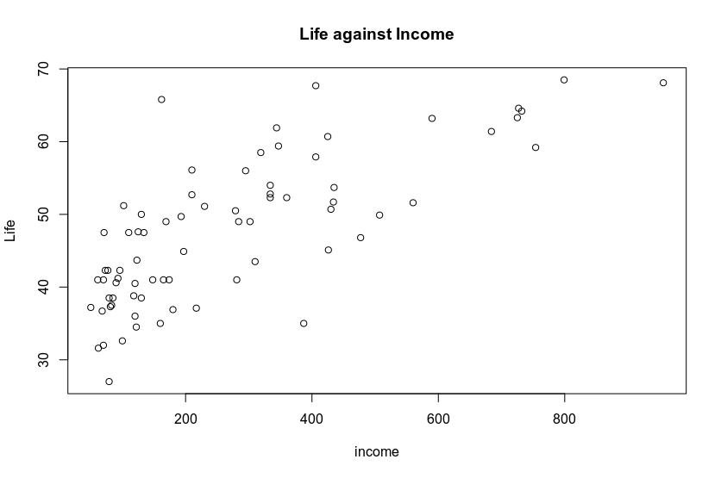
> cor(below_1000$Income, below_1000$Life)
[1] 0.752886

Exercise 3
3) a)
> maas<-read.table("http://www.stat.ucla.edu/~nchristo/statistics12/soil.txt", header=TRUE)
> summary(maas$lead)
Min. 1st Qu. Median Mean 3rd Qu. Max.
37.0 72.5 123.0 153.4 207.0 654.0
> summary(maas$zinc)
Min. 1st Qu. Median Mean 3rd Qu. Max.
113.0 198.0 326.0 469.7 674.5 1839.0
b)
> histogram(maas$lead, main="histogram of lead")
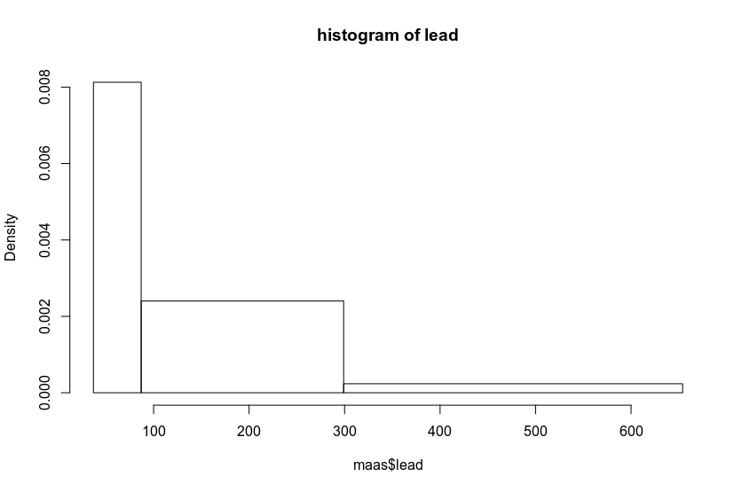
> histogram(log(maas$lead), main="histogram of log(lead)")
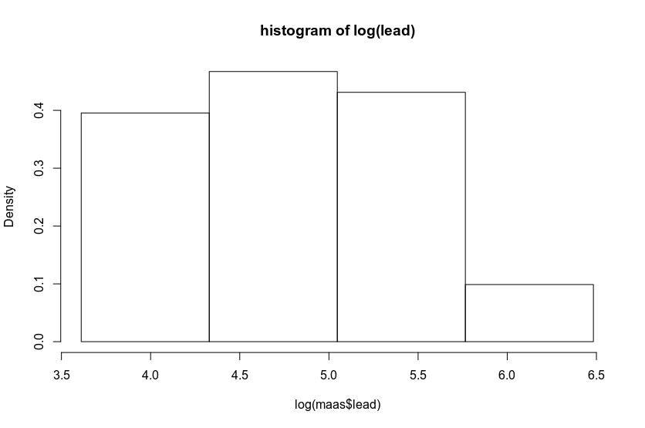

c)
> plot(log(maas$lead), log(maas$zinc), xlab="log(lead)", ylab="log(zinc)", main="log(lead) vs log(zinc)")
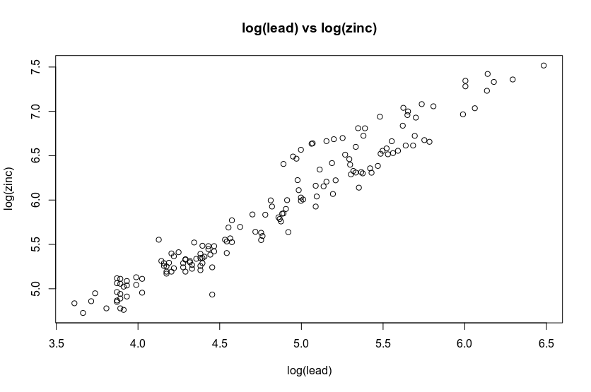
From the plot, I observe that there is a high positive correlation between log(lead) and log(zinc).

d)
> ppm_colors <- c("green", "yellow", "red")
> ppm_levels <- cut(maas$lead, c(0,150,400, 1000))
> plot(maas$x, maas$y,xlab="longtitude", ylab="lattitude", main="ppm plot", "n")
> points(maas$x, maas$y, cex=maas$lead/mean(maas$lead), col=ppm_colors[as.numeric(ppm_levels)], pch=19)
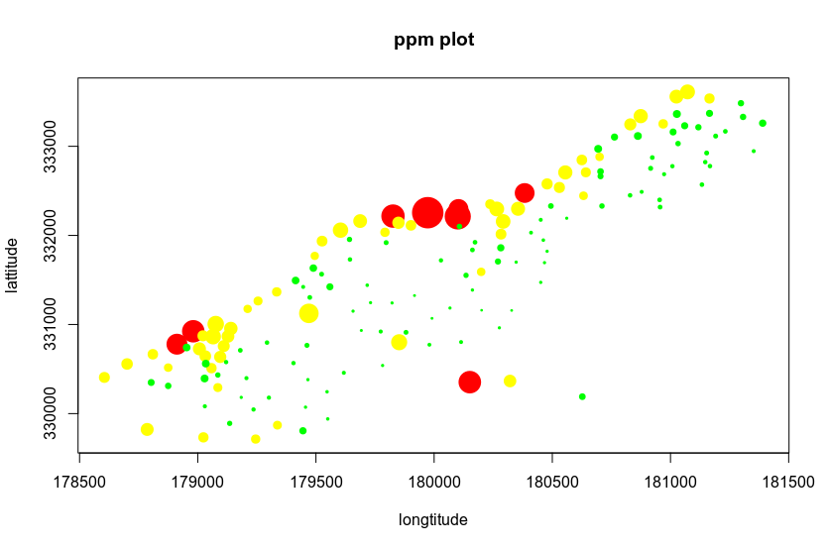
Exercise 4
4) a)
> LA <-read.table("http://www.stat.ucla.edu/~nchristo/statistics12/la_data.txt", header=TRUE)
> plot(LA$Longitude, LA$Latitude, xlim=c(-119,-118), ylim=c(33.5,35), xlab="longtitude", ylab="lattitude", main="LA plot", "n")
> map("county", "california", add = TRUE)
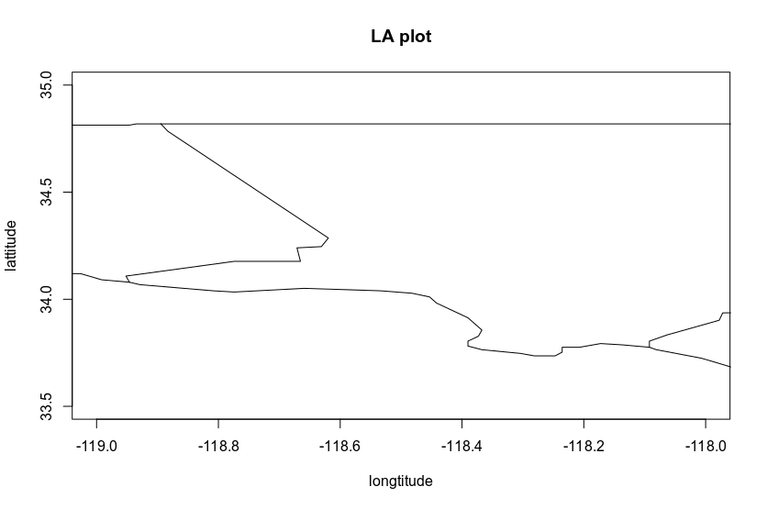
b)
> zero_school <- LA$Schools != 0
> LA_subset <- LA[zero_school,]
> plot(LA_subset$Income, LA_subset$Schools, main="Schools vs Income")
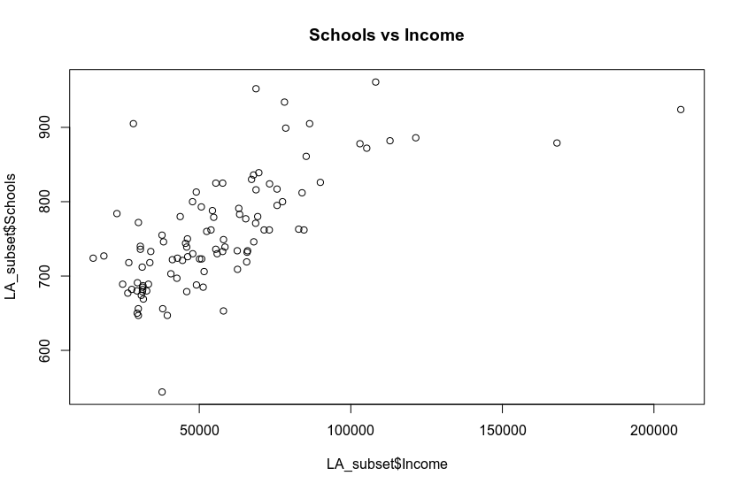
There is a weak positive correlation between the income and schools in LA county.

