Stats 10 Lab 3 Submission
Name: Enmin Zhou
UID: 104756697
Exercise 1
1) a)
> soil<-read.table("http://www.stat.ucla.edu/~nchristo/statistics_c173_c273/soil_complete.txt", header=TRUE)
> linear_model <- lm(soil$lead ~ soil$zinc)
> summary(linear_model)

Call:
lm(formula = soil$lead ~ soil$zinc)

Residuals:
Min 1Q Median 3Q Max
-79.853 -12.945 -1.646 15.339 104.200

Coefficients:
Estimate Std. Error t value Pr(>|t|)
(Intercept) 17.367688 4.344268 3.998 9.92e-05 ***
soil$zinc 0.289523 0.007296 39.681 < 2e-16 ***
---
Signif. codes: 0 ‘***’ 0.001 ‘**’ 0.01 ‘*’ 0.05 ‘.’ 0.1 ‘ ’ 1

Residual standard error: 33.24 on 153 degrees of freedom
Multiple R-squared: 0.9114, Adjusted R-squared: 0.9109
F-statistic: 1575 on 1 and 153 DF, p-value: < 2.2e-16

b)
> plot(soil$lead ~ soil$zinc, xlab="zinc", ylab="lead", main="regression of lead on zinc")
> abline(linear_model, col="red", lwd=2)
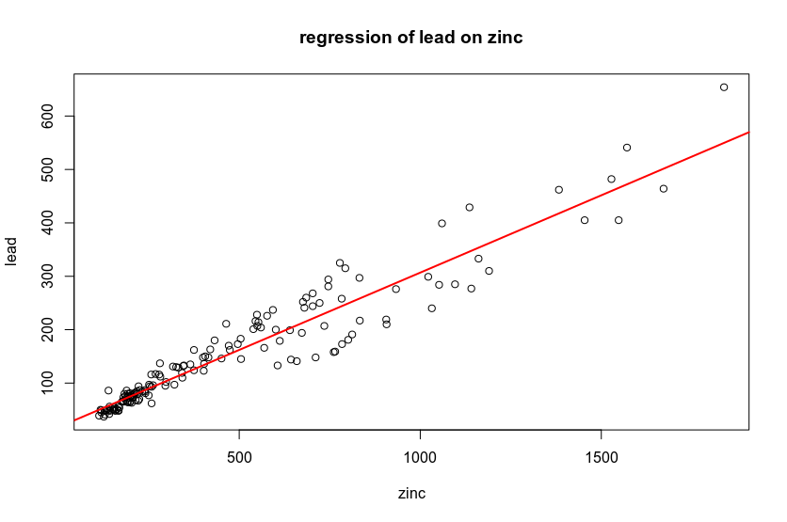

c)
> plot(linear_model$residuals ~ soil$zinc, main="residual plot")
> abline(a=0, b=0,col='red',lwd=2)
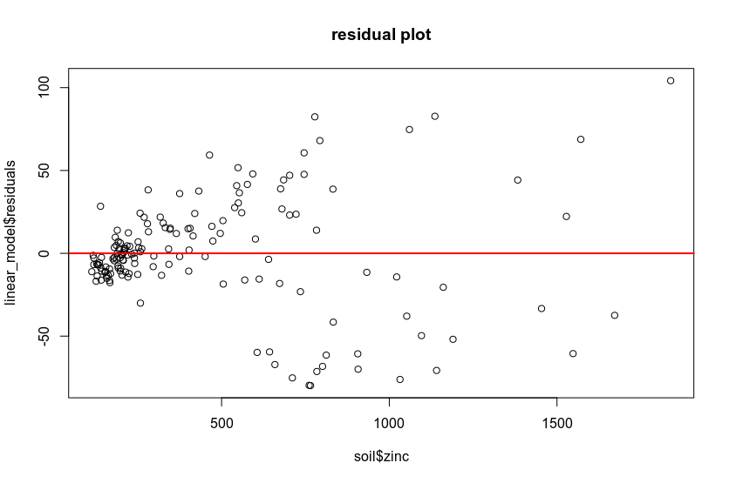
d)
lead=17.367688 + 0.289523*zinc
e)
17.36788+0.289523*1000 = 306.8909 ppm
f)
0.289523*100 = 28.9523 ppm higer
g)
0.91, it means that 91 percent of the change in the lead level can be explained by the zinc level.
h)
Linearity and symmetry assumptions are satisfied. The equal variance assumption is violated.

Exercise 2
2) a)
> linear_model2 <- lm(ice$Extent ~ ice$Date)
> summary(linear_model2)

Call:
lm(formula = ice$Extent ~ ice$Date)

Residuals:
Min 1Q Median 3Q Max
-9.445 -5.439 1.442 5.599 7.564

Coefficients:
Estimate Std. Error t value Pr(>|t|)
(Intercept) 1.011e+01 1.558e+00 6.486 4.11e-10 ***
ice$Date 1.438e-04 1.411e-04 1.019 0.309
---
Signif. codes: 0 ‘***’ 0.001 ‘**’ 0.01 ‘*’ 0.05 ‘.’ 0.1 ‘ ’ 1

Residual standard error: 5.654 on 273 degrees of freedom
Multiple R-squared: 0.003787, Adjusted R-squared: 0.0001377
F-statistic: 1.038 on 1 and 273 DF, p-value: 0.3093

b)
> plot(ice$Extent ~ ice$Date, xlab="date", ylab="extent", main="regression of extent on time")
> abline(linear_model2, col="red", lwd=2)
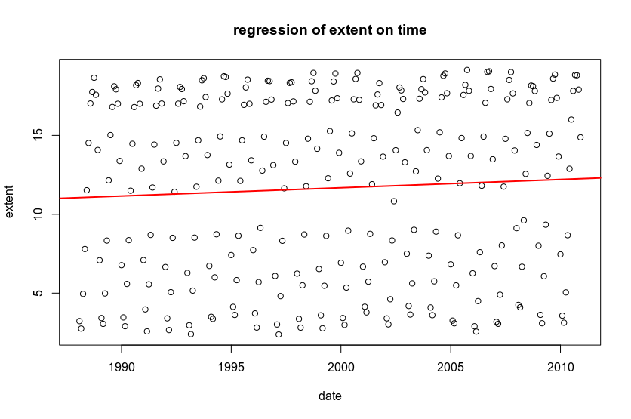
No.
c)
> plot(linear_model2$residuals ~ ice$Date, main="residual plot")
> abline(a=0, b=0,col='red',lwd=2)
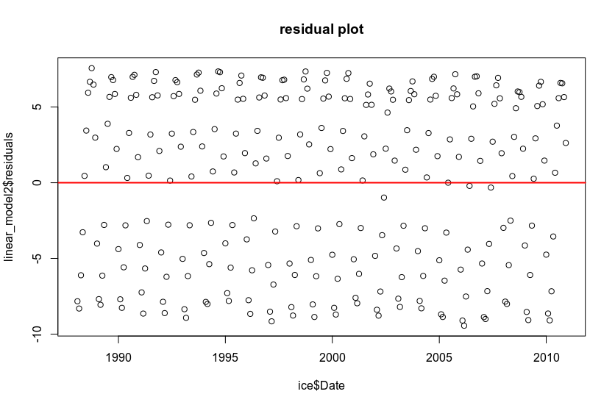
The linearity is violated. The symmetry and equal variance assumption are satisfied.
Exercise 3
3) a)
double: 1/6*1/6*3*2 + 1/6*1/6*2 = 2/9
lose: 1/6*1/6*2 + 1/6*1/6*2 + 1/6*1/6*2 = 1/6
b)
> set.seed(123)
> numbers = 1:6
> rand_dice = replicate(5000, sample(numbers, 2, replace = TRUE))
> outcome <- colSums(rand_dice)
> histogram(outcome)
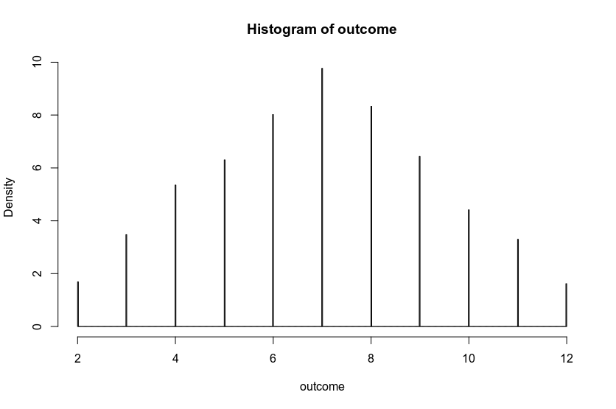
c)
>> t<-table(outcome)
> double <- (t[6] + t[10])/5000
> lose <- (t[1]+t[2]+t[11])/5000
Double: 0.2226, Lose:0.1156
d)
These two events are disjoint since Adam cannot get (7,11) and (2,3,12) at the same time.
e)
P(double) = 2/9, P(lose) = 1/6, P(double & lose) = 0. Therefore they are not independent events.

Exercise 4
4)a)
p = 0.4, n = 365
b)
mean: np = 146, standard deviation: sqrt(np(1-p)) = 9.36
c)
> dbinom(145, size = 365, prob = 0.4)
[1] 0.04239996
Probability is 0.04239996
d)
> pbinom(175, size = 365, prob = 0.4) - pbinom(125, size = 365, prob = 0.4)
[1] 0.98543
Probability is 0.98543
e)
> 1-pnorm(230, mean=200, sd=20)
[1] 0.0668072
Probability is 0.0668702

