**Question 1**

**(a) Use Thompson’s construction to convert this regular expression into an NFA.**

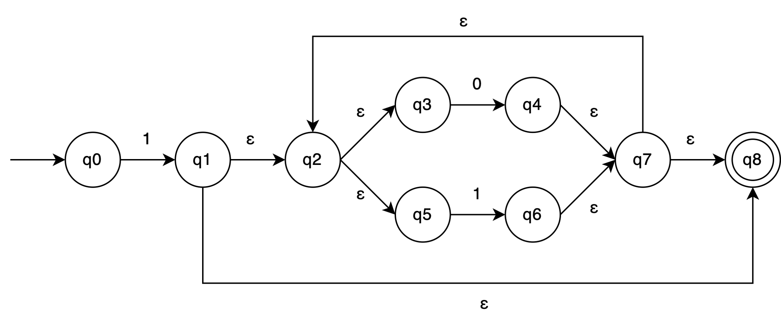

**(b) Use the subset construction to convert the NFA of (a) into a DFA.**

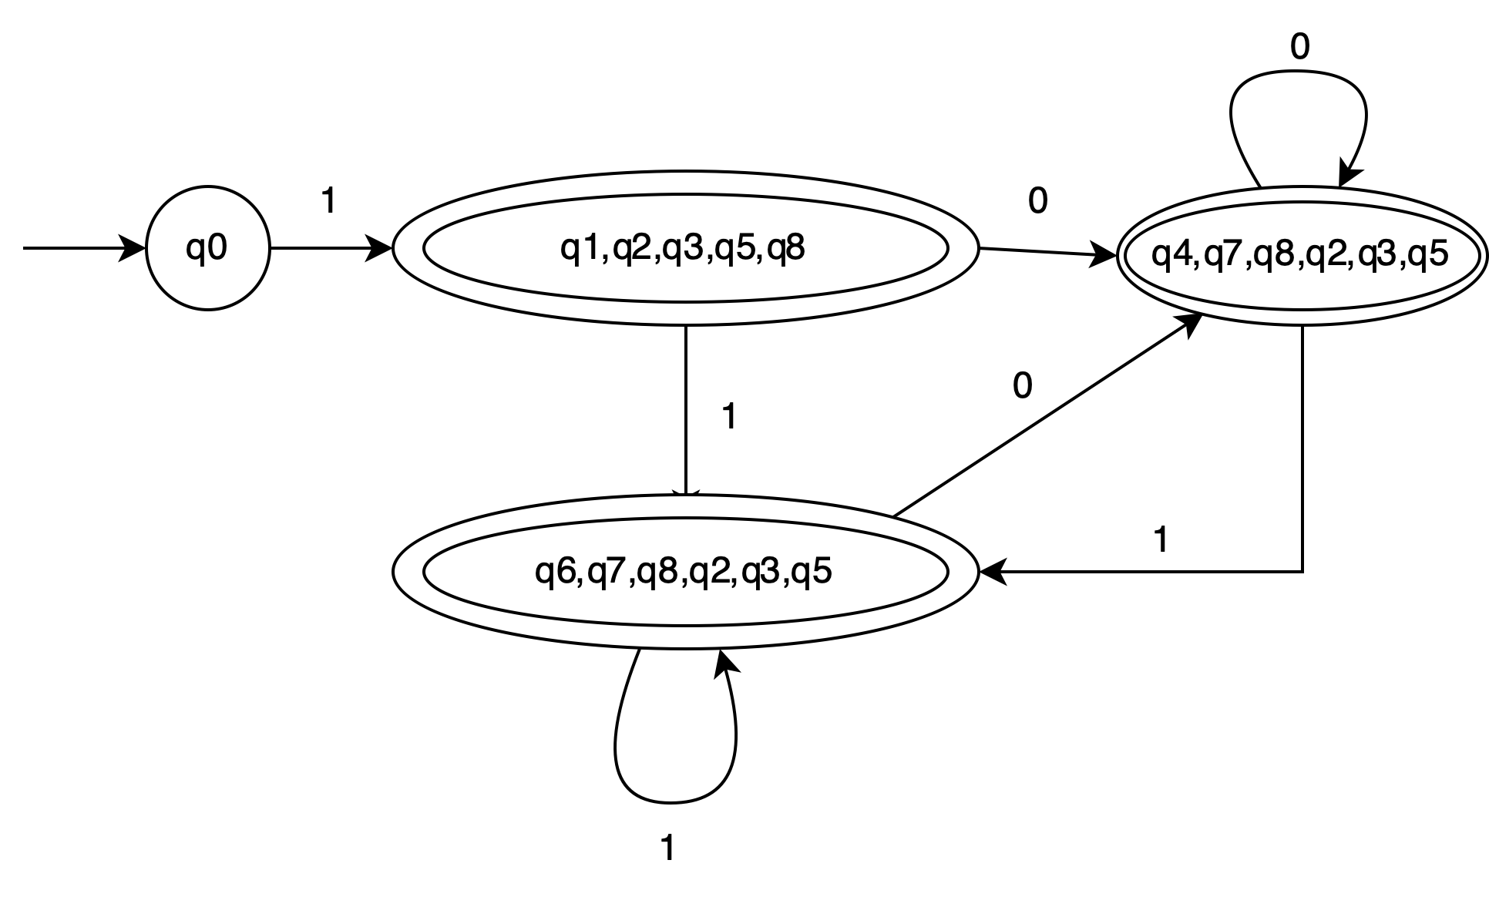

**(c) Convert the DFA of (b) into a minimal-state DFA.**

