**Question 2**

**(b) Draw a parse tree for this sentence.**

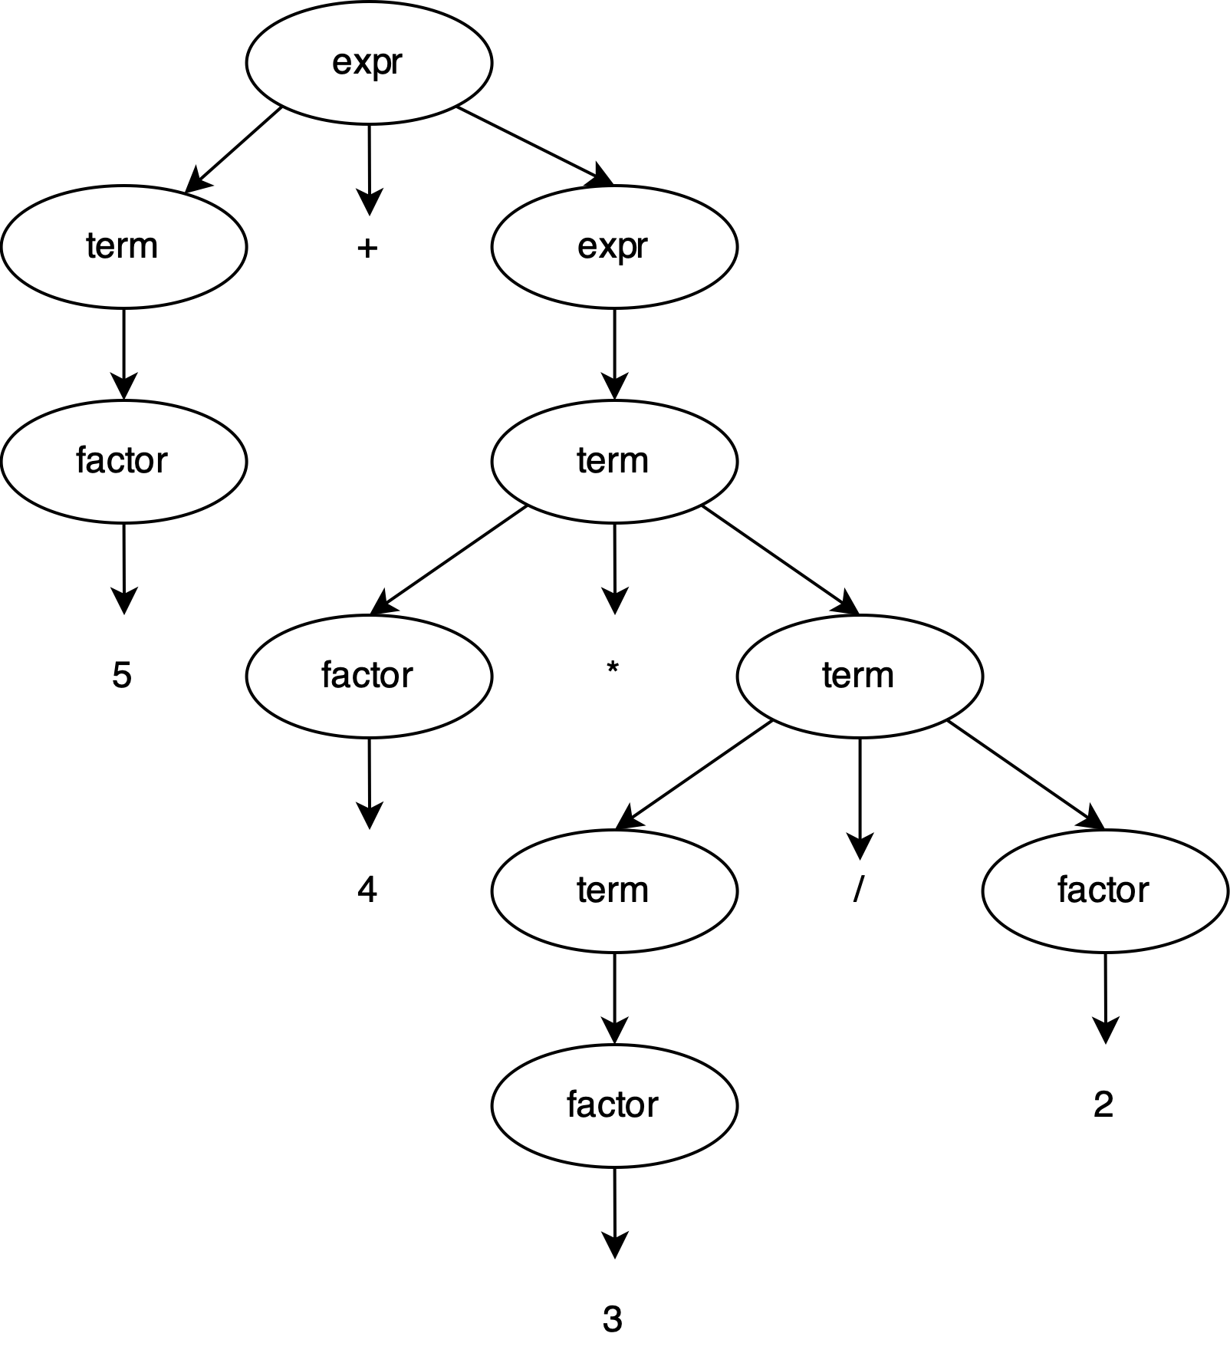

**(d) Is this grammar ambiguous? Justify your answer.**

It's ambiguous.

Consider the string "1*3/2". Following are 2 different valid parse trees for the string from the CFG:

Parse Treen 1:

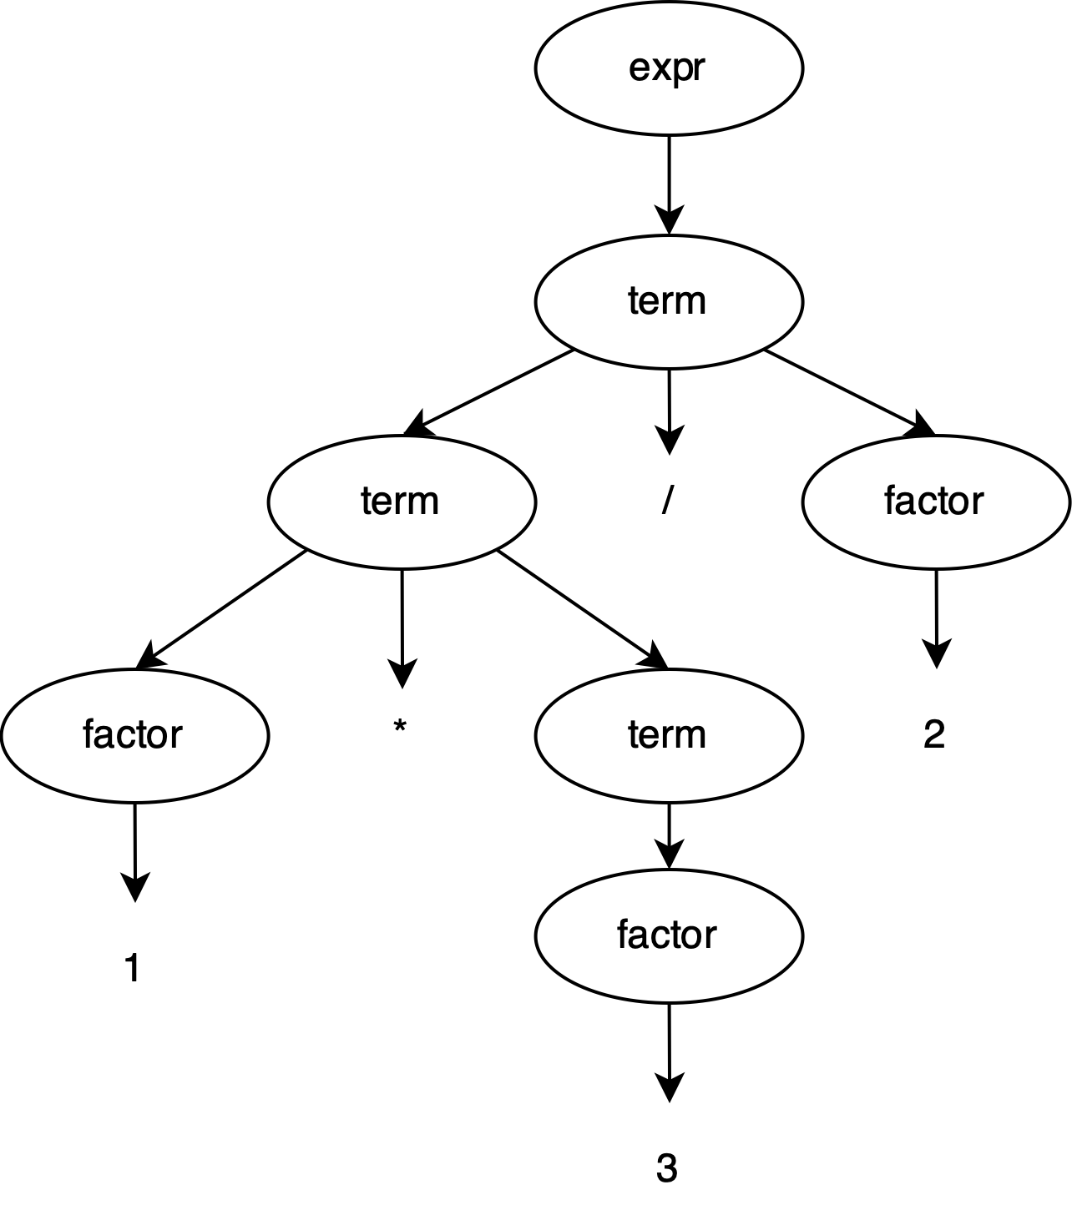

Parse Treen 2:

