**Lab Exercise 2: HTTP & Socket Programming**

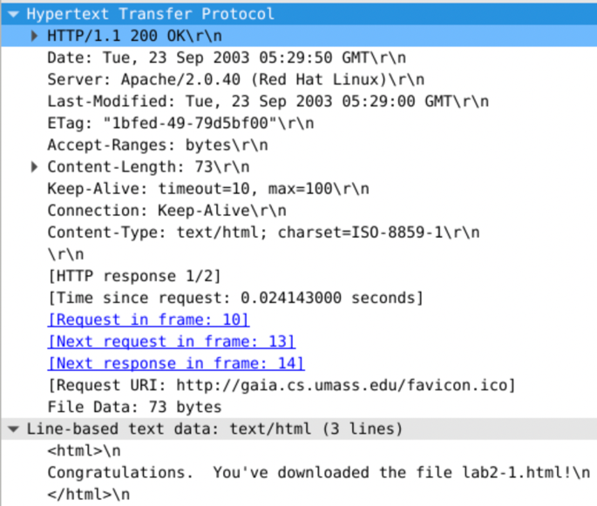**Exercise 3: Using Wireshark to understand basic HTTP request/response messages**

**Question 1: What is the status code and phrase returned from the server to the client browser?**

The status code: 200

Phrase: OK

**Question 2:** **When was the HTML file that the browser is retrieving last modified at the server? Does the response also contain a DATE header? How are these two fields different?**

Last-Modified: Tue, 23 Sep 2003 05:29:00 GMT\r\n

The response does indeed contain a DATE header, which is that indicates the time when a packet is generated on the source server which can be viewed how long the packet has been cached.

Last-modified is that indicates the time when the resource was last modified on the source server.

**Question 3: Is the connection established between the browser and the server persistent or non-persistent? How can you infer this?**

Keep-Alive: timeout=10, max=100\r\n

The connection between the browser and the server is persistent, it can be inferred by checking the request and response connection header is Keep-Alive.

**Question 4: How many bytes of content are being returned to the browser?**

File Data: 73 bytes

**Question 5: What is the data contained inside the HTTP response packet?**

<html>

Congratulations. You've downloaded the file lab2-1.html!

</html>**Exercise 4: Using Wireshark to understand the HTTP CONDITIONAL GET/response interaction**

**Question 1: Inspect the contents of the first HTTP GET request from the browser to the server. Do you see an “IF-MODIFIED-SINCE” line in the HTTP GET?**

No.

**Question 2: Does the response indicate the last time that the requested file was modified?**

Yes. Last-Modified: Tue, 23 Sep 2003 05:35:00 GMT\r\n

**Question 3: Now inspect the contents of the second HTTP GET request from the browser to the server. Do you see an “IF-MODIFIED-SINCE:” and “IF-NONE-MATCH” lines in the HTTP GET? If so, what information is contained in these header lines?**

If-Modified-Since: Tue, 23 Sep 2003 05:35:00 GMT\r\n

If-None-Match: "1bfef-173-8f4ae900"\r\n

If-Modified-Since includes the date, daytime, time, and time zone. If-None-Match contains Etag value.

**Question 4: What is the HTTP status code and phrase returned from the server in response to this second HTTP GET? Did the server explicitly return the contents of the file? Explain.**

Status code: 304

Phrase: Not modified

This indicates to the browser that the server has not modified the page after “If-Modified-Since” time in the request. The “If-Modified-Since” value and “If-None-Match” value are the same with the value return from the server. Therefore, the phrase is Not Modified.

**Question 5: What is the value of the Etag field in the 2nd response message and how it is used? Has this value changed since the 1st response message was received?**

Etag Value: 1bfef-173-8f4ae900

The Etag value has not changed since the 1st response showing that the content has not been modified.

**Exercise 5: Ping Client Sample Output**

PingServer Output 2

Received from 127.0.0.1: PING 0 1646143325532

Reply not sent.

Received from 127.0.0.1: PING 1 1646143326154

Reply sent.

Received from 127.0.0.1: PING 2 1646143326290

Reply sent.

Received from 127.0.0.1: PING 3 1646143326475

Reply not sent.

Received from 127.0.0.1: PING 4 1646143327076

Reply sent.

Received from 127.0.0.1: PING 5 1646143327127

Reply not sent.

Received from 127.0.0.1: PING 6 1646143327731

Reply not sent.

Received from 127.0.0.1: PING 7 1646143328333

Reply sent.

Received from 127.0.0.1: PING 8 1646143328368

Reply sent.

Received from 127.0.0.1: PING 9 1646143328493

Reply sent.

Received from 127.0.0.1: PING 10 1646143328699

Reply sent.

Received from 127.0.0.1: PING 11 1646143328818

Reply not sent.

Received from 127.0.0.1: PING 12 1646143329420

Reply sent.

Received from 127.0.0.1: PING 13 1646143329561

Reply sent.

Received from 127.0.0.1: PING 14 1646143329634

Reply sent.

PingClient Output 2

ping to 127.0.0.1, seq = 0, Time Out

ping to 127.0.0.1, seq = 1, rtt = 124 ms

ping to 127.0.0.1, seq = 2, rtt = 184 ms

ping to 127.0.0.1, seq = 3, Time Out

ping to 127.0.0.1, seq = 4, rtt = 51 ms

ping to 127.0.0.1, seq = 5, Time Out

ping to 127.0.0.1, seq = 6, Time Out

ping to 127.0.0.1, seq = 7, rtt = 35 ms

ping to 127.0.0.1, seq = 8, rtt = 124 ms

ping to 127.0.0.1, seq = 9, rtt = 205 ms

ping to 127.0.0.1, seq = 10, rtt = 119 ms

ping to 127.0.0.1, seq = 11, Time Out

ping to 127.0.0.1, seq = 12, rtt = 141 ms

ping to 127.0.0.1, seq = 13, rtt = 73 ms

ping to 127.0.0.1, seq = 14, rtt = 154 ms

--- ping localhost statistics ---

15 packets transmitted, 10 packets received, 33.0% packet loss

round trip min/avg/max = 35.0/121.0/205.0 ms

PingClient Output 1

ping to 127.0.0.1, seq = 0, rtt = 92 ms

ping to 127.0.0.1, seq = 1, rtt = 188 ms

ping to 127.0.0.1, seq = 2, rtt = 108 ms

ping to 127.0.0.1, seq = 3, rtt = 131 ms

ping to 127.0.0.1, seq = 4, rtt = 13 ms

ping to 127.0.0.1, seq = 5, rtt = 181 ms

ping to 127.0.0.1, seq = 6, Time Out

ping to 127.0.0.1, seq = 7, rtt = 60 ms

ping to 127.0.0.1, seq = 8, Time Out

ping to 127.0.0.1, seq = 9, Time Out

ping to 127.0.0.1, seq = 10, rtt = 197 ms

ping to 127.0.0.1, seq = 11, Time Out

ping to 127.0.0.1, seq = 12, Time Out

ping to 127.0.0.1, seq = 13, rtt = 48 ms

ping to 127.0.0.1, seq = 14, rtt = 71 ms

--- ping localhost statistics ---

15 packets transmitted, 10 packets received, 33.0% packet loss

round trip min/avg/max = 13.0/108.0/197.0 ms

PingServer Output 1

Received from 127.0.0.1: PING 0 1646142983144

Reply sent.

Received from 127.0.0.1: PING 1 1646142983242

Reply sent.

Received from 127.0.0.1: PING 2 1646142983431

Reply sent.

Received from 127.0.0.1: PING 3 1646142983539

Reply sent.

Received from 127.0.0.1: PING 4 1646142983670

Reply sent.

Received from 127.0.0.1: PING 5 1646142983683

Reply sent.

Received from 127.0.0.1: PING 6 1646142983864

Reply not sent.

Received from 127.0.0.1: PING 7 1646142984475

Reply sent.

Received from 127.0.0.1: PING 8 1646142984535

Reply not sent.

Received from 127.0.0.1: PING 9 1646142985136

Reply not sent.

Received from 127.0.0.1: PING 10 1646142985738

Reply sent.

Received from 127.0.0.1: PING 11 1646142985936

Reply not sent.

Received from 127.0.0.1: PING 12 1646142986539

Reply not sent.

Received from 127.0.0.1: PING 13 1646142987140

Reply sent.

Received from 127.0.0.1: PING 14 1646142987188

Reply sent.