**Lab Exercise 3: DNS & Socket Programming**

**Exercise 3: Digging into DNS (marked, include in the lab report)**

**Question 1. What is the IP address of**[**www.eecs.berkeley.edu**](https://eecs.berkeley.edu/)**. What type of DNS query is sent to get this answer?**

IP address: 23.185.0.1

DNS query: Type A

**Question 2. What is the canonical name for the eecs.berkeley webserver? Suggest a reason for having an alias for this server.**

live-eecs.pantheonsite.io.

fe1.edge.pantheon.io.

Because the canonical name is difficult to remember and spell. Alias is normally included the familiar name which is easier to remember and access.

**Question 3. What can you make of the rest of the response?**

The Authority section is included four authoritative name servers. (edge.panthoen.io.)

The Additional section is included the IP address of the four authoritative name servers.

(ns-233.awsdns-29.com. 205.251.192.233)

(ns-644.awsdns-16.net. 205.251.194.132)

(ns-1213.awsdns-23.org. 205.251.196.189)

(ns-2013.awsdns-59.co.uk. 205.251.199.221)

**Question 4. What is the IP address of the local nameserver for your machine?**

129.94.242.2

**Question 5. What are the DNS nameservers for the “eecs.berkeley.edu.” domain? Find out their IP addresses? What type of DNS query is sent to obtain this information?**

ns.CS.berkeley.edu. A 169.229.60.61

ns.CS.berkeley.edu. AAAA 2607:f140:8:1260::30

ns.eecs.berkeley.edu. A 169.229.60.153

ns.eecs.berkeley.edu. AAAA 2607:f140:8:2160::30

adns1.berkeley.edu. A 128.32.136.3

adns2.berkeley.edu. A 128.32.136.14

adns3.berkeley.edu. A 192.107.102.142

adns3.berkeley.edu. AAAA 2607:f140:a000:d::abc

DNS query: Type NS

**Question 6. What is the DNS name associated with the IP address 111.68.101.54? What type of DNS query is sent to obtain this information?**

DNS name: webserver.seecs.nust.edu.pk.

DNS query: PTR

**Question 7. Run dig and query the CSE nameserver (129.94.242.33) for the mail servers for Yahoo! Mail. Did you get an authoritative answer? Why?**

;; flags: qr rd ra; QUERY: 1, ANSWER: 3, AUTHORITY: 5, ADDITIONAL: 8

No, if it is aa then it is Authoritative answer and the flag is not included aa flag.

**Question 8. Repeat the above (i.e. Question 7) but use one of the nameservers obtained in Question 5. What is the result?**

;; flags: qr rd; QUERY: 1, ANSWER: 0, AUTHORITY: 0, ADDITIONAL: 1

No, if it is aa then it is Authoritative answer, the flag is not included aa flag.

**Question 9. Obtain the authoritative answer for the mail servers for Yahoo! Mail. What type of DNS query is sent to obtain this information?**

98.138.11.157 is IP address of ns4.yahoo.com.

DNS query: Type MX

**Question 10. In this exercise, you simulate the iterative DNS query process to find the IP address of your machine (e.g. lyre00.cse.unsw.edu.au). If you are using VLAB Then find the IP address of one of the following: lyre00.cse.unsw.edu.au, lyre01.cse.unsw.edu.au, drum00.cse.unsw.edu.au or drum01.cse.unsw.edu.au. First, find the name server (query type NS) of the "." domain (root domain).**

**Query this nameserver to find the authoritative name server for the "au." domain.**

**Query this second server to find the authoritative nameserver for the "edu.au." domain.**

**Now query this nameserver to find the authoritative nameserver for "unsw.edu.au".**

**Next query the nameserver of unsw.edu.au to find the authoritative name server of cse.unsw.edu.au.**

**Now query the nameserver of cse.unsw.edu.au to find the IP address of your host.**

**How many DNS servers do you have to query to get the authoritative answer?**

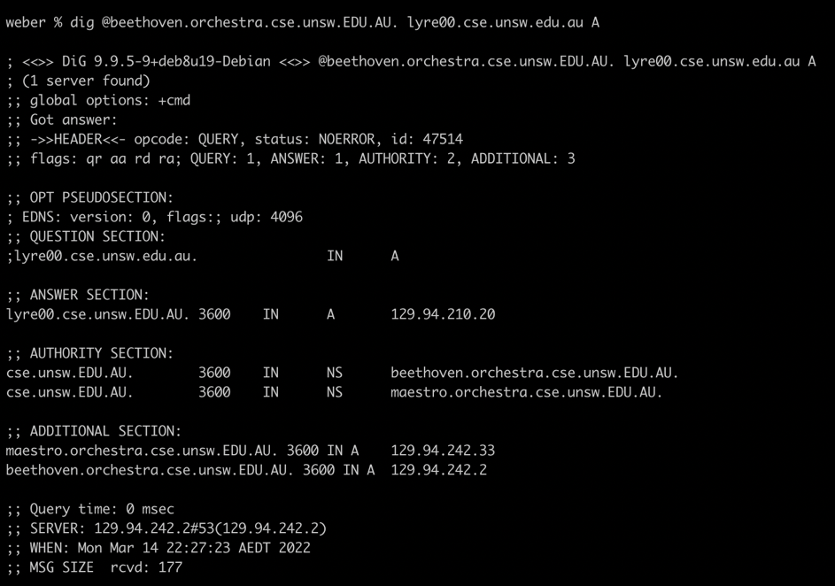

Through root NS, .au, .edu.au, .unsw.edu.au, .cse.unsw.edu.au. Total DNS server is 5.

**Question 11. Can one physical machine have several names and/or IP addresses associated with it?**

Yes. A physical machine can have multiple names and associated IP addresses.